Supplementary files
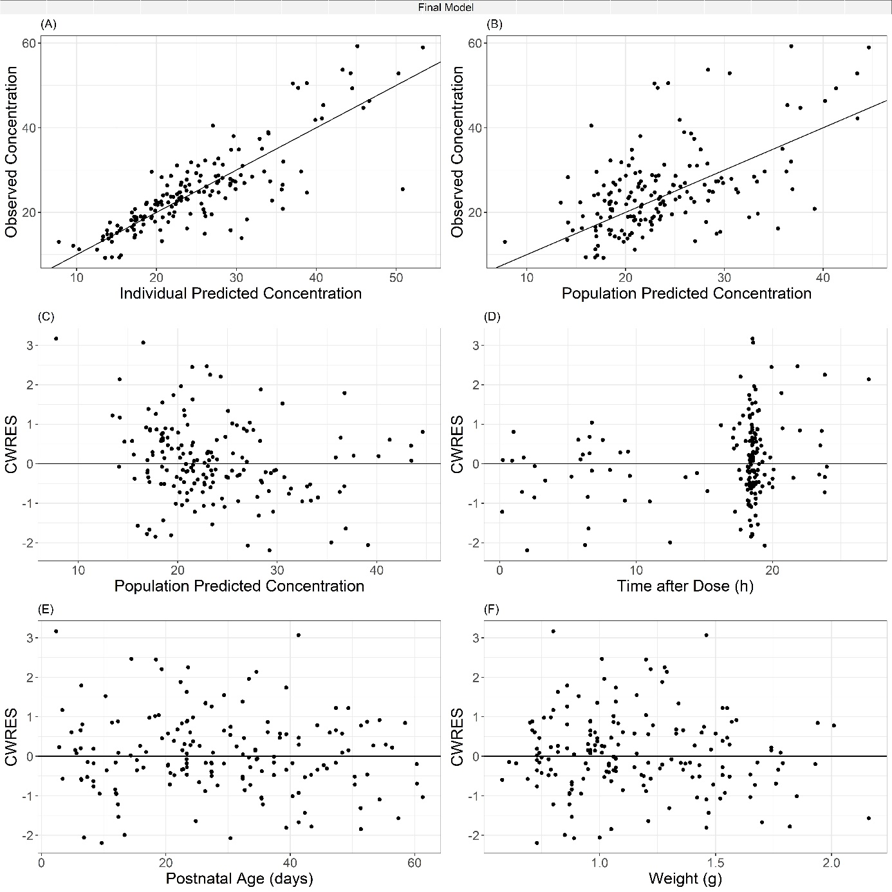
Supplementary Figure 1 Goodness of fit plots of the final pharmacokinetic model. A:Observed concentration versus individual predicted concentrations, B: observed concentrations versus population predicted concentrations, C: conditional weighted residuals (CWRES) versus population predicted concentrations, D: CWRES versus time after last caffeine dose, E: CWRES versus postnatal age, F: CWRES versus current body weight.

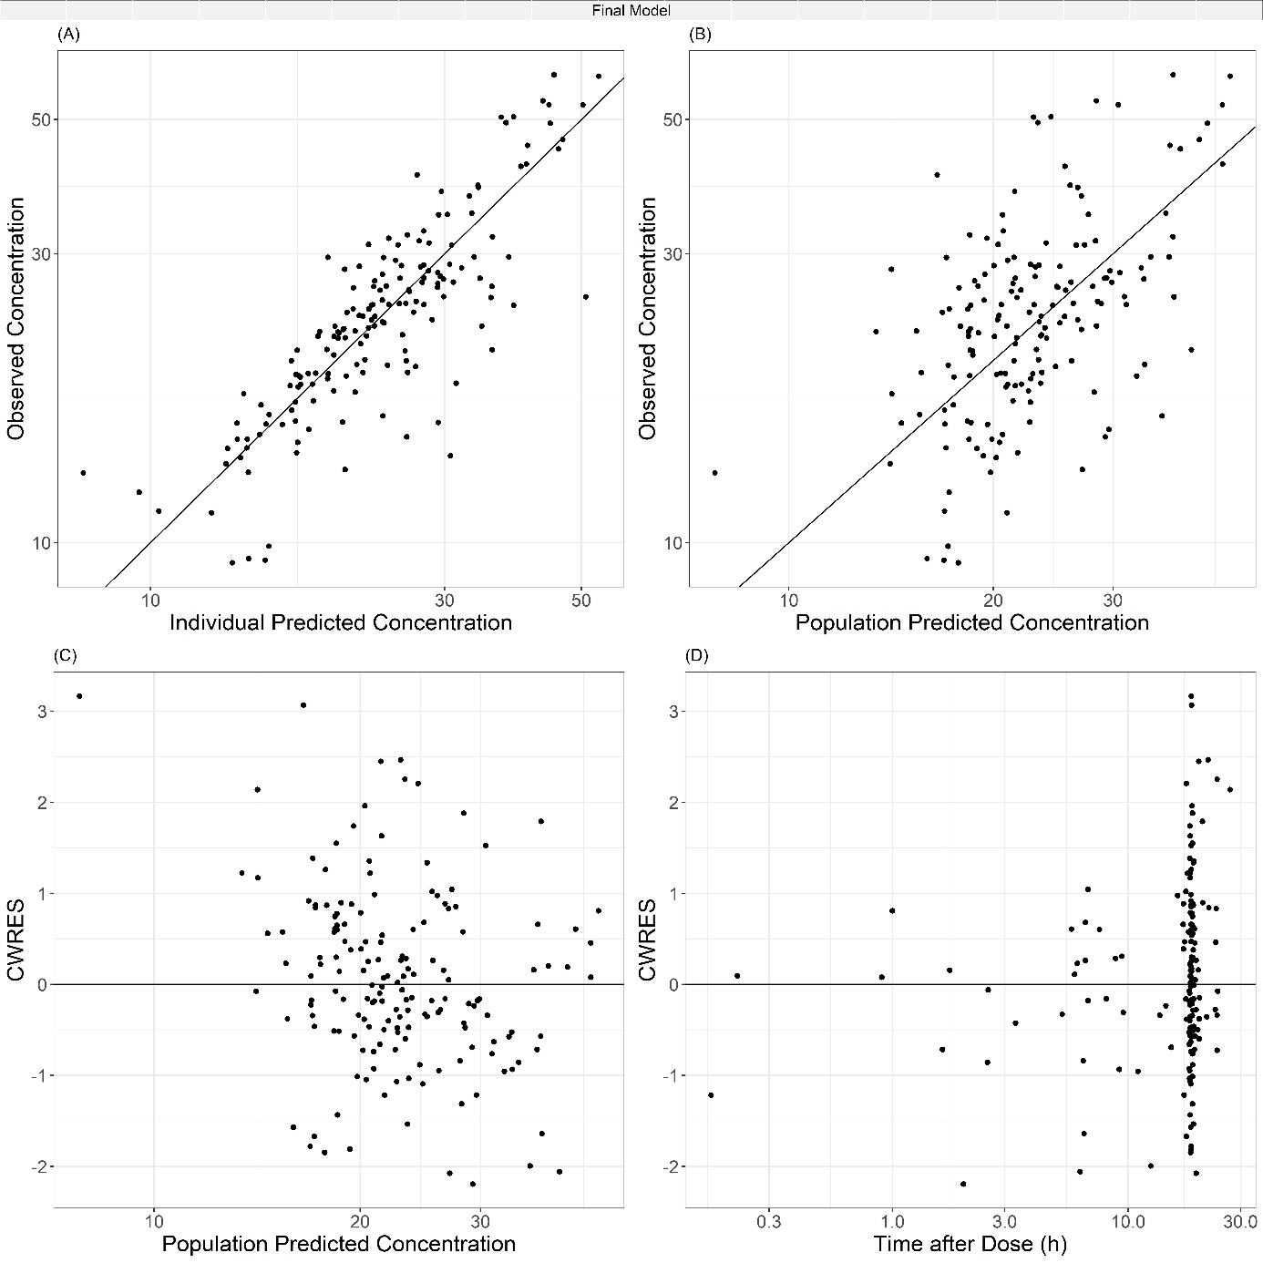
Supplementary Figure 2 Goodness of fit plots of the final pharmacokinetic model on a log-scale. A:Observed concentration versus individual predicted concentrations, B: observed concentrations versus population predicted concentrations, C: conditional weighted residuals (CWRES) versus population predicted concentrations, D: CWRES versus time after last caffeine dose.
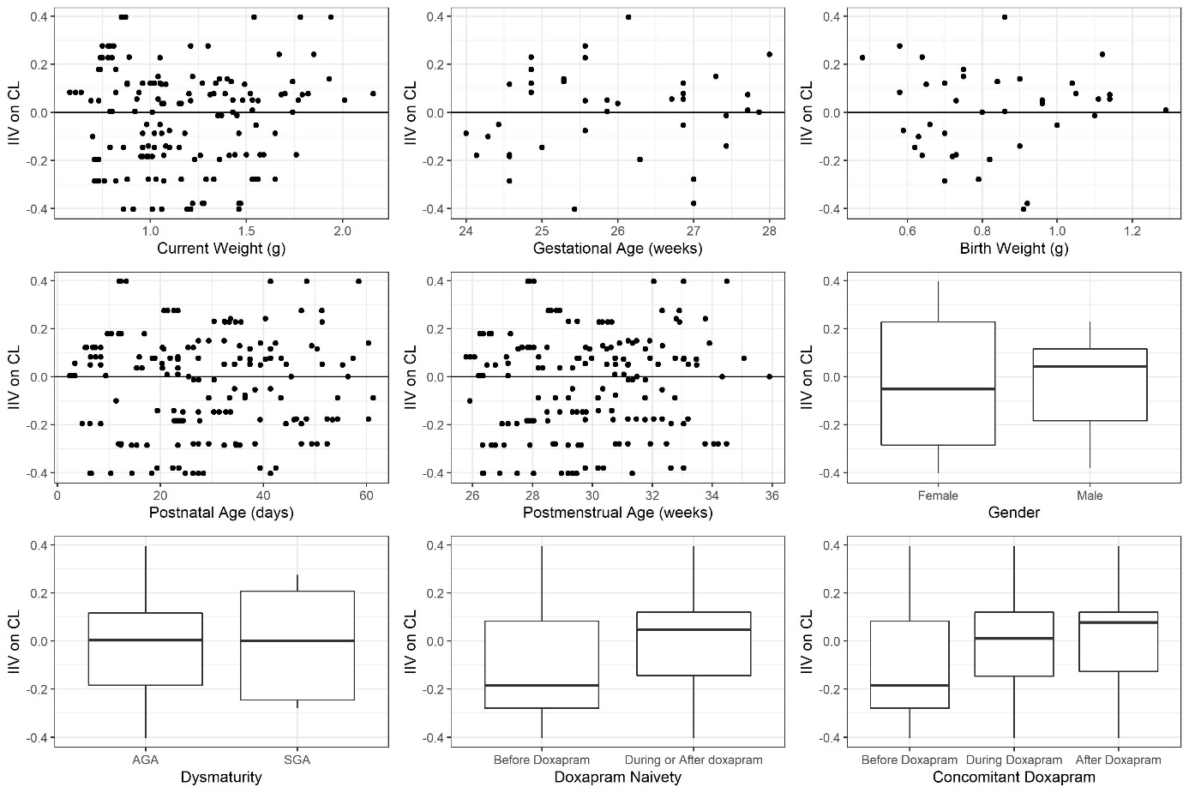
Supplementary Figure 3 Interindividual variability plots versus available covariates of the final population pharmacokinetic model.

Supplementary Figure 4 Results of the normalized prediction distribution errors (npde), based on 1000 simulations of the final population pharmacokinetic model. Top left: quantile-quantile plot, top right: npde quantiles with a normal distribution overlay, bottom left: npde versus time after dose in hours, bottom right: npde versus and predicted concentrations in mg/L.

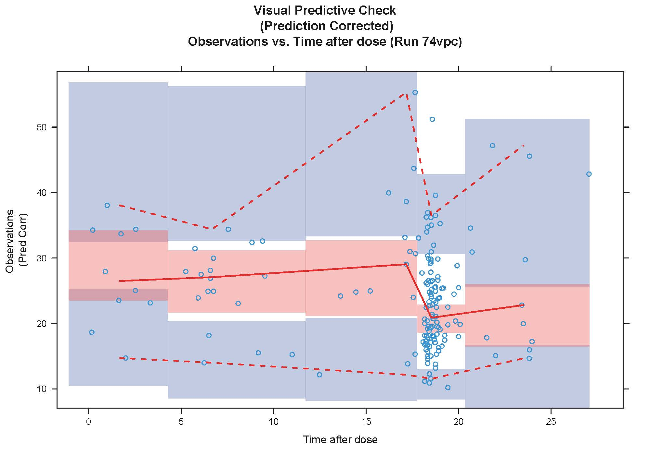
Supplementary Figure 5 Prediction corrected visual predictive check of the final model, based on 1000 simulations.

