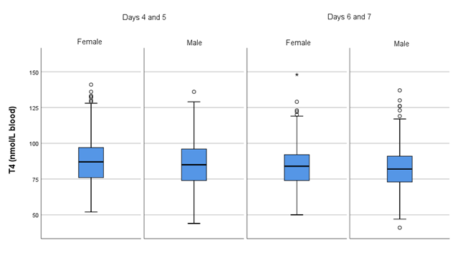Fig. S1. T4 concentrations of reference subjects divided by subgroups: females and males with newborn screening sampling days 4 and 5, and days 6 and 7.
Measurements were performed in (full) blood.
Data are presented as boxplots.

