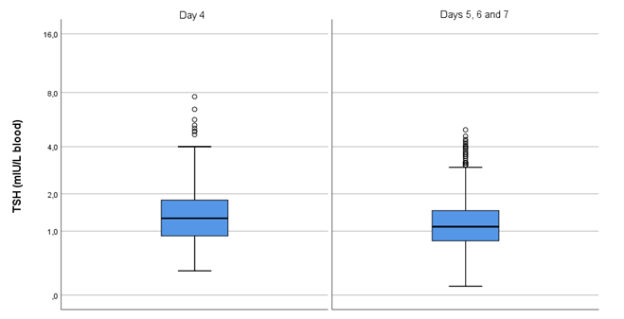Fig. S2. TSH concentrations of reference subjects divided by subgroup: newborn screening sampling day 4 and days 5, 6 and 7.
Measurements were performed in (full) blood.
Data are presented as boxplots.
TSH concentrations are displayed on a logarithmic scale.

