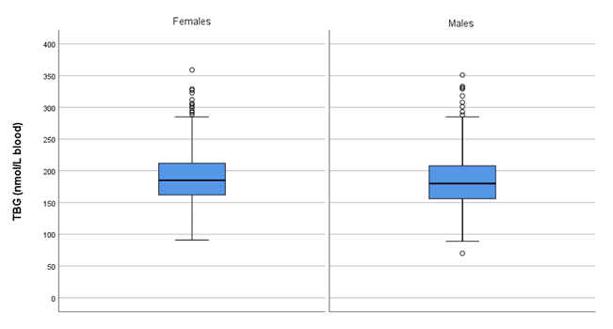Fig. S3. TBG concentrations of reference subjects divided by subgroup: females and males.
Measurements were performed in (full) blood.
Data are presented in boxplots.

