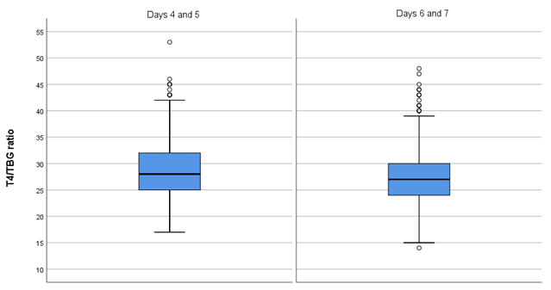Fig. S4. T4/TBG ratios of reference subjects divided by subgroup: NBS sampling days 4 and 5, and days 6 and 7.
Data are presented in boxplots.

