The evolution of the neonatal QRS axis during the first four weeks of life

Supplementary Data

Maria Munk Pærregaard¹, MD; Jesper Kock¹, MSc; Christian Pihl¹, MD; Adrian Pietersen¹, MD, DMSc; Kasper Karmark Iversen¹, MD, DMSc; Henning Bundgaard², MD, DMSc; Alex Hørby Christensen^{1,2*}, MD, PhD.

¹ Department of Cardiology, Herlev-Gentofte Hospital, Copenhagen University Hospital, Copenhagen, Denmark.
² The Capital Regions Unit for Inherited Cardiac Diseases, Department of Cardiology, The Heart Center, Rigshospitalet, Copenhagen University Hospital, Copenhagen, Denmark.

Disclosures: none.

*Corresponding author:
Alex Hørby Christensen, Consultant, Associate professor, PhD
Department of Cardiology, Herlev-Gentofte Hospital, Copenhagen University Hospital
Borgmester Ib Juuls Vej 1, DK-2730 Herlev, Denmark
E-mail: alexhc@dadlnet.dk; Phone: +45 50517681
Supplementary Figure 1
A
QRS axis 61°

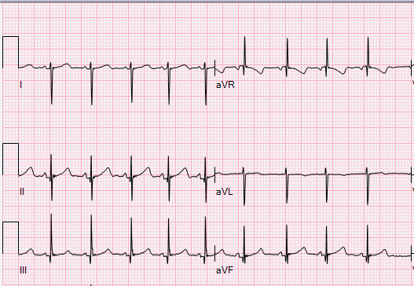
B
QRS axis 145°

C
QRS axis –66°

Supplementary Figure 2

Supplementary Figure 3
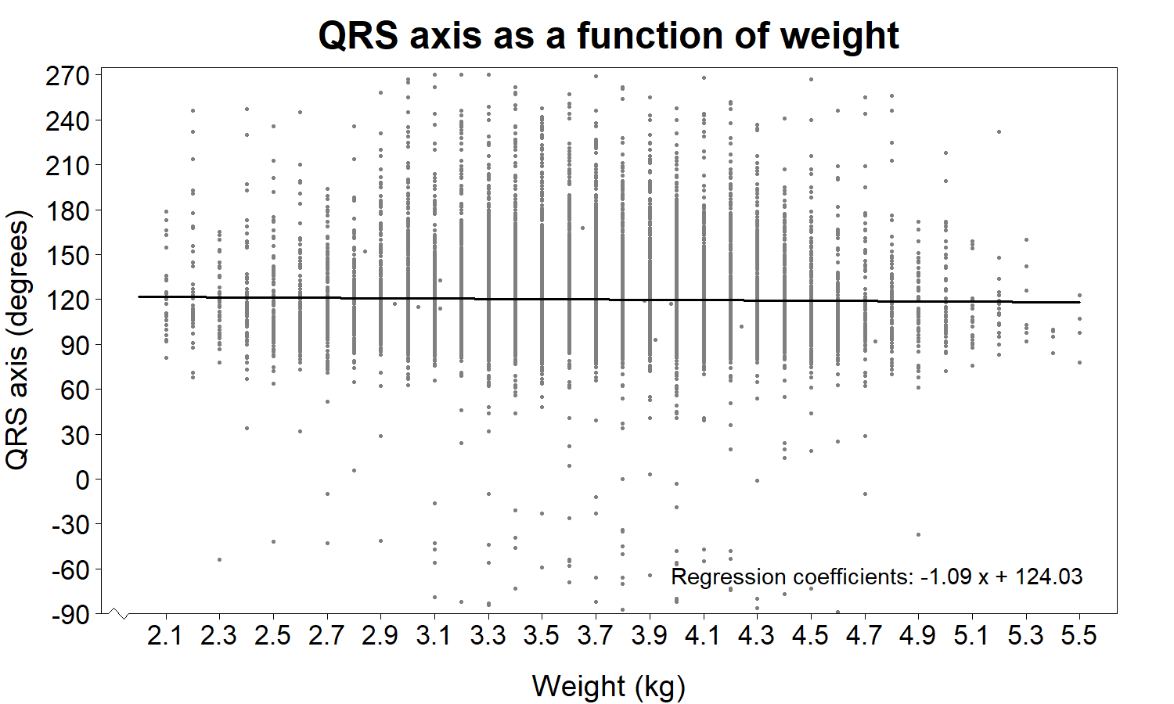
A
B
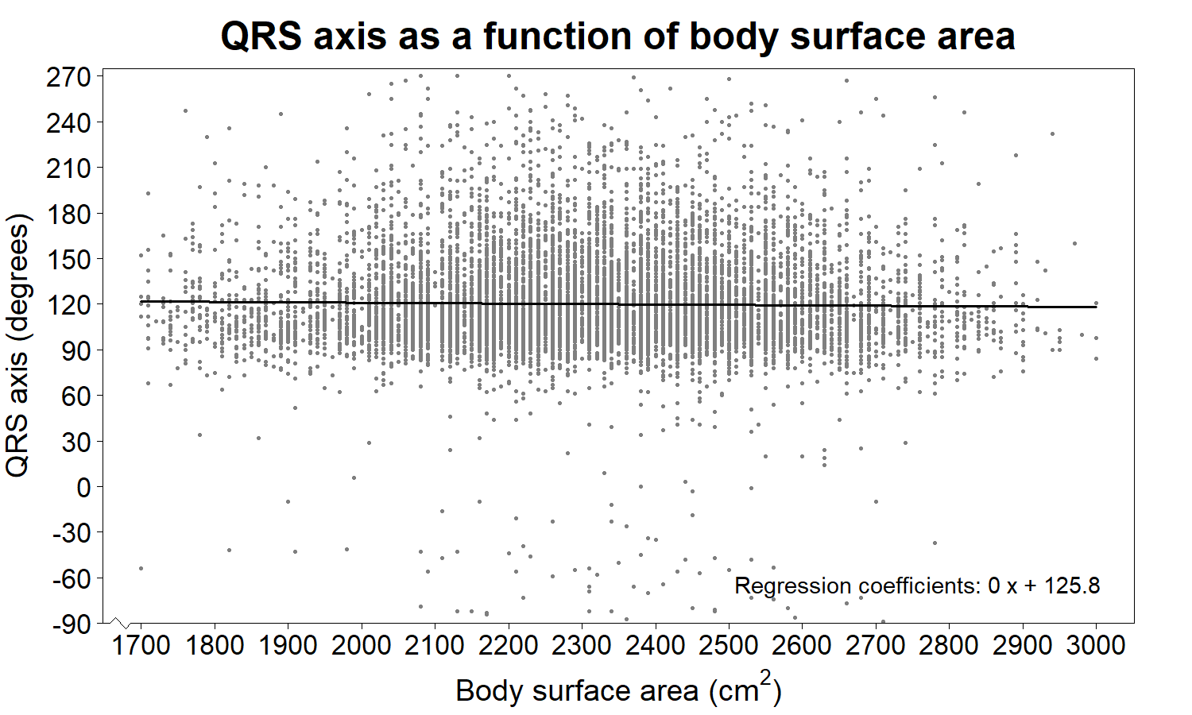
Supplementary Figure 4
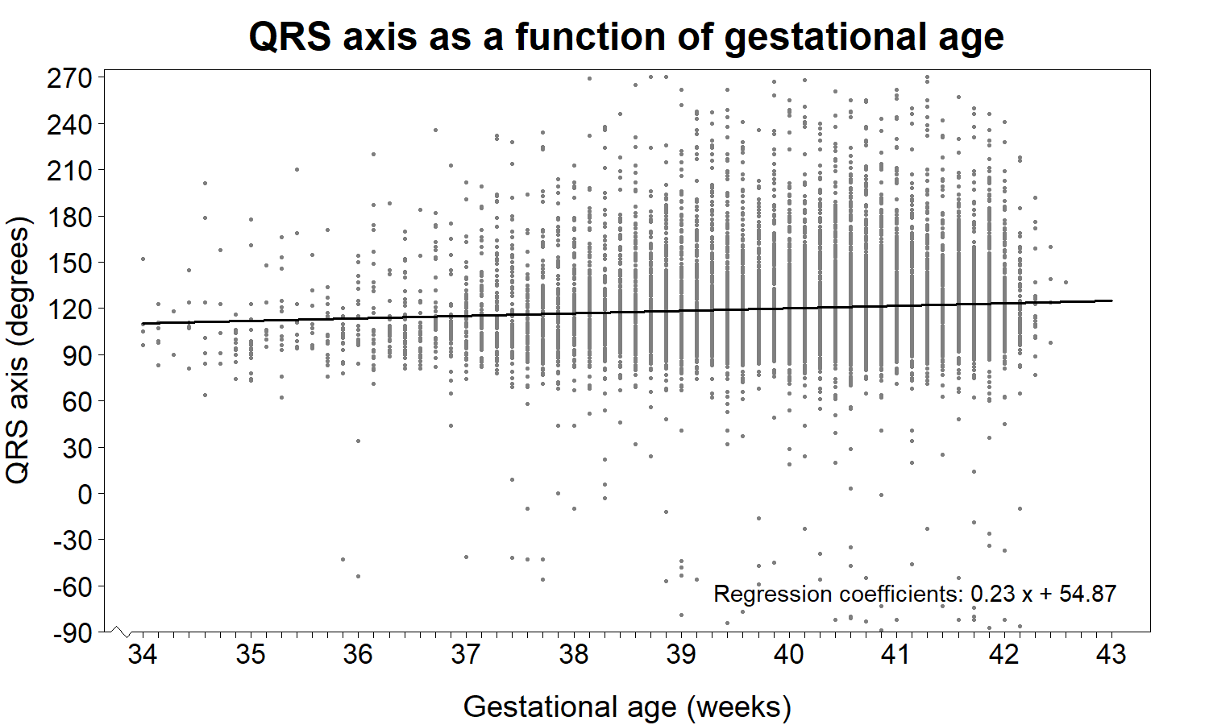

Supplementary Figure Legends

Supplementary Figure 1. Representative electrocardiograms from newborns. A) ECG from a 28 day old boy with an QRS axis of 61°. B) ECG from a 2 day old girl with an QRS axis of 145°. C) ECG from a 10 days old girl with an QRS axis of -66°.

Supplementary Figure 2. Pie chart showing the gradually leftward-shift of the QRS axis for the first four weeks of life within the hexaxial reference system, divided in parts by the adult classifications; right axis deviation (RAD, +91° to +180°), extreme axis deviation (EAD, +181° to +270°), left axis deviation (LAD, 0° to -90°) and “Normal axis” (+1° to +90°). Arrows originating from the circle center indicate the median QRS axis values for the four weeks.

Supplementary Figure 3. QRS axis as a function of weight (in kg, kilogram) and body surface area (BSA, in cm²). A) Scatter plot showing no significant change in QRS axis with increasing body weight. B) Scatter plot showing no association between QRS axis and body surface area.

Supplementary Figure 4. QRS axis as a function of gestational age (GA, in weeks). The scatter plot shows an increase (right-shift) in QRS axis with increasing gestational age.

Supplementary text
Electrocardiogram
Electrocardiograms were recorded with a MAC 5500 HD system (GE ECG System, Milwaukee, USA) with speed 25 mm/sec, sensitivity at 10 mm/mV, sample rate of 500 samples per second, and bandwidth filter 0.16–150 Hz. We recorded lead I, II, III, aVR, aVL, aVF, V1, and in most cases V6. The electrocardiograms were performed while the infant was calm or sleeping. All tracings were acquired digitally and ECG intervals, amplitudes, axis, etc. were automatically analyzed using GE’s Marquette 12SL ECG Analysis Program and stored in a widely available ECG management system (MUSE, Version 8, GE Healthcare, Milwaukee, USA). The computer-based algorithm generated a representative median QRS complex for each lead and on- and offsets of P, QRS, and T wave then found in a specific order. The algorithm calculated the QRS mean axis using a formula provided by the proprietary GE 12SL ECG Analysis Program calculating the inverse tangent function of the net amplitudes of three leads I, II, and III. ECGs with very poor data quality were excluded. This primarily due to noise and muscle artefacts on the ECGs, which given the age of the study population, could not be completely avoided.

Echocardiography
Transthoracic echocardiographies were performed with Vivid E9 ultrasound equipment (GE Healthcare, Horten, Norway) and performed by physicians or sonographers trained in pediatric echocardiography. Standard sub-xiphoid, apical, left parasternal and suprasternal views were acquired with 12 MHz and 6 MHz cardiac sector transducers and measurements were performed in accordance with the American Society of Echocardiography’s guidelines for pediatric echocardiography. All raw data (cine loops and measurements) were acquired using EchoPac software (GE Healthcare, Horten, Norway) and all echocardiographic findings suspected to be abnormal were reviewed by a specialist in pediatric echocardiography.

Statistical analyses
R statistical software v. 3.6.0. (Auckland, New Zealand) was used for statistical analyses. Baseline characteristics are presented as median values with interquartile ranges. The distribution of median QRS axis as a function of age is shown as median values with 2nd and 98th percentiles. Scatter plots with regressions lines was determined using the fitting linear models function in R. Comparisons between groups were performed with Student’s t-test and Wilcoxon’s rank sum test when appropriate. A p-value less than 0.05 was considered significant.

