Supplemental Table 1. Comparison between patients with the peak total bilirubin level after the last day of phototherapy and those with the peak total bilirubin level before the last day of phototherapy

 | The peak TB level after the last day of phototherapy  N = 30 | The peak TB level before the last day of phototherapy  N = 31 | P value
Sex (M:F) | 18:12 | 20:11 | 0.80
Gestational age (wks)* | 25.5 (22-30) | 26.0 (22-33) | 0.39
Birthweight (g)* | 788 (414-1941) | 864 (498-2374) | 0.18
The last day of phototherapy* | 6 (3-23) | 22 (5-58) | < 0.001
Peak TB levels (mg/dL)* | 10.6 (7.0-19.3) | 13.9 (4.3-22.2) | 0.029
The day of peak TB levels* | 19.5 (4-49) | 20 (3-41) | 0.76
Peak DB levels (mg/dL)* | 1.2 (0.3-7.73)  N = 23 | 1.7 (0.8-9.0)  N = 21 | 0.17
The day of peak DB levels* | 33 (2-55)  N = 23 | 25 (1-55)  N = 21 | 0.32
Peak DB ≥ 2 mg/dL | 8/23 (35%) | 8/19 (42%) | 0.75
Peak DB ≥ 4 mg/dL | 2/23 (9%) | 2/19 (11%) | > 0.99
TB: total bilirubin, DB: direct bilirubin
*: Values are shown as median (range).
We could compare clinical variables from 61 patients with sufficient information. Numerical and categorical values were analyzed by Mann-Whitney U test and Fisher exact probability test, respectively.

Supplemental Table 2. The existing treatment criteria of neonatal jaundice proposed in Japan

The treatment criteria of neonatal jaundice proposed by Murata and Imura
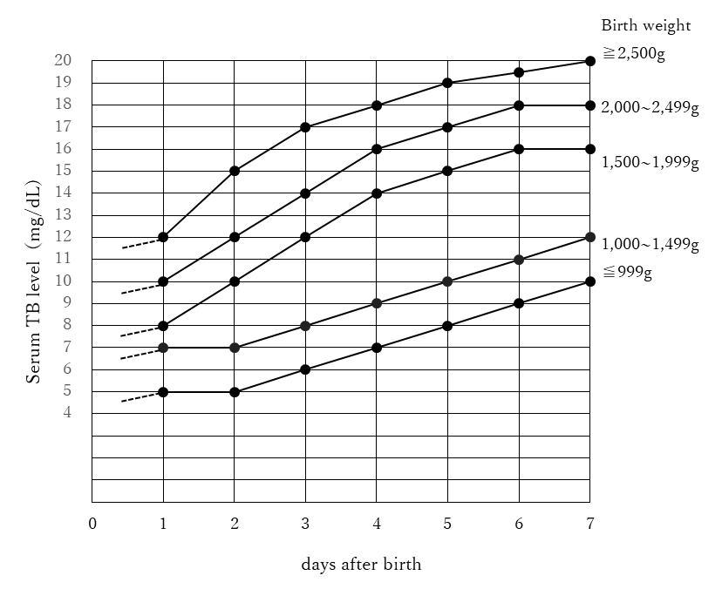
TB: total bilirubin
1: Phototherapy should be started when serum TB level is above the reference line according to the age after birth and birth weight.
2: Phototherapy according to the one-rank lower reference line should be considered, when there is at least one of the risk factors for kernicterus
1. Perinatal asphyxia (5 minute Apgar score < 3)
2. Respiratory distress (PaO₂ ≤ 40 mmHg lasting for 2 hrs or longer)
3. Acidosis (pH ≤ 7.15)
4. Hypothermia (rectal temperature < 35°C lasting for 1 hr or longer)
5. Hypoproteinemia (serum total protein ≤ 4.0g/dL or serum albumin ≤ 2.5g/dL)
6. Hypoglycemia
7. Hemolysis
8. Central nervous system disorders including sepsis
3: Criteria of discontinuation; serum TB value of 2~3 mg/dL below the reference line according to the age.

Exchange transfusion is not described in this treatment criteria.

The treatment criteria of neonatal jaundice proposed by Nakamura
Birth weight | TB (mg/dL) |  |  |  |  |  | UB (µg/dL)
 | < 24 hrs | < 48 hrs | < 72 hrs | < 96 hrs | < 120 hrs | ≥ 120 hrs | At any age
< 1,000 g | 5/8 | 6/10 | 6/12 | 8/12 | 8/15 | 10/15 | 0.3/0.8
< 1,500 g | 6/10 | 8/12 | 8/15 | 10/15 | 10/18 | 12/18
< 2,500 g | 8/10 | 10/15 | 12/18 | 15/20 | 15/20 | 15/20 | 0.6/1.0
≥ 2,500 g | 10/12 | 12/18 | 15/20 | 18/22 | 18/25 | 18/25
Values are shown as an indication of phototherapy/exchange transfusion.
Phototherapy or exchange transfusion is indicated, when the TB or UB value exceeds the reference value.
TB; total bilirubin, UB: unbound bilirubin

References
1. Imura S. Phototherapy of neonatal jaundice: its indication and prevention of adverse effects. Nihon Rinsho 1985; 43(8): 1741-1748. in Japanese.
2. Morioka I. Hyperbilirubinemia in preterm infants in Japan: New treatment criteria. Pediatr Int. 2018; 60(8): 684-690.

