Supplementary Material
Figure S1. Baseline urine KIM-1 was not correlated with eGFR, global and segmental sclerosis, interstitial fibrosis or tubular atrophy
(A) KIM-1*eGFR (Spearman’s rho=-0.01 p=0.98) | (B) KIM-1*Global Sclerosis (Spearman’s rho=-0.23 p=0.26)
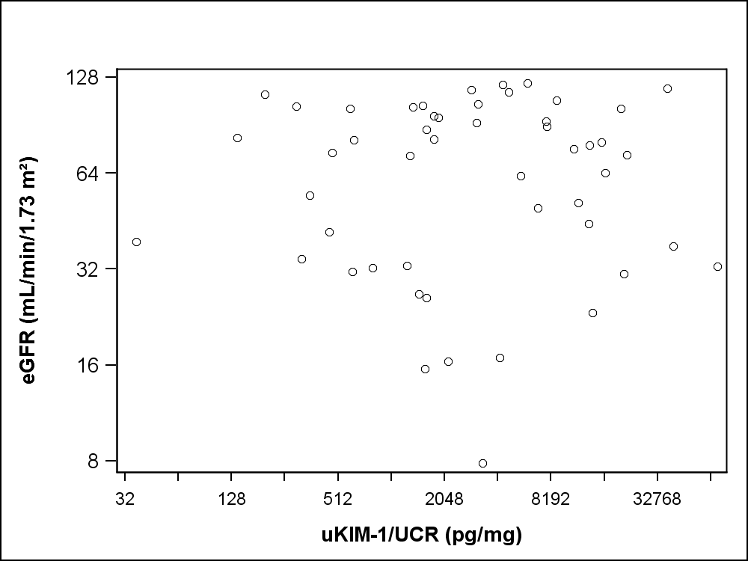 | 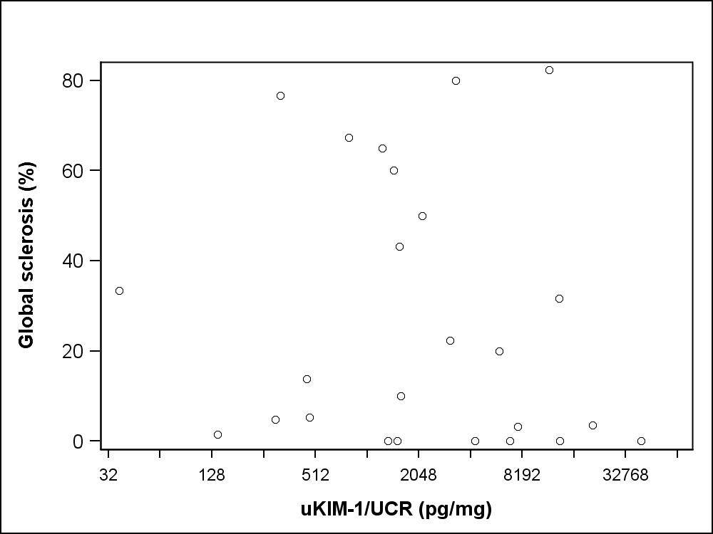
(C) KIM-1*Segmental Sclerosis (Spearman’s rho=0.28 p=0.17) | (D) KIM-1*Intestinal fibrosis (Spearman’s rho=0.06 p=0.72)
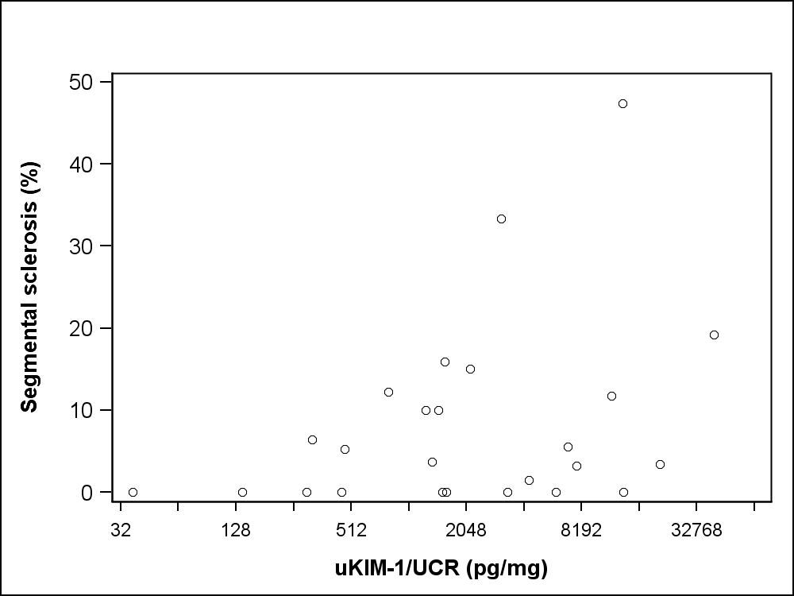 | 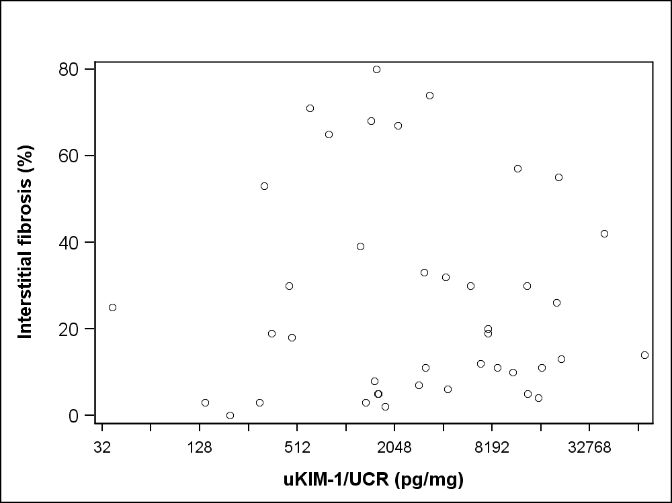
(E) KIM-1*Tubular atrophy (Spearman’s rho=0.04 p=0.81)
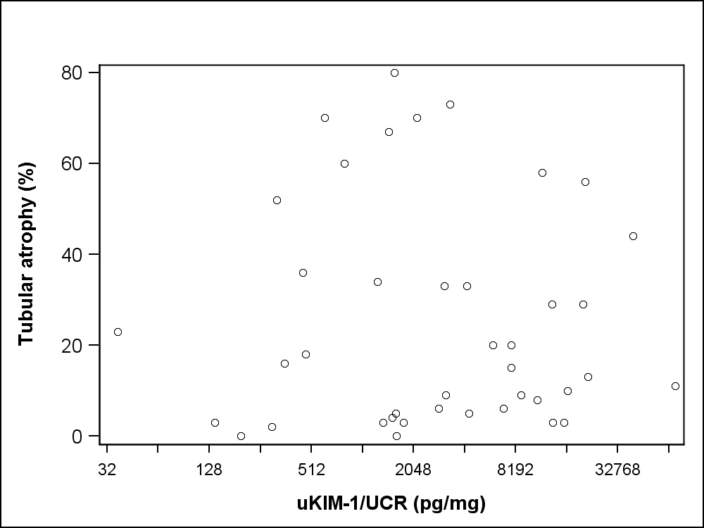
KIM1, kidney injury molecule; uKIM-1/UCR, urine KIM-1/urine creatinine concentration

Figure S2. Baseline urine POSTN was not correlated with global and segmental sclerosis, interstitial fibrosis or tubular atrophy, foot process effacement or time to complete remission
(A) POSTN*Global Sclerosis (Spearman’s rho=0.11 p=0.61) | (B) POSTN*Segmental Sclerosis (Spearman’s rho=0.31 p=0.13)
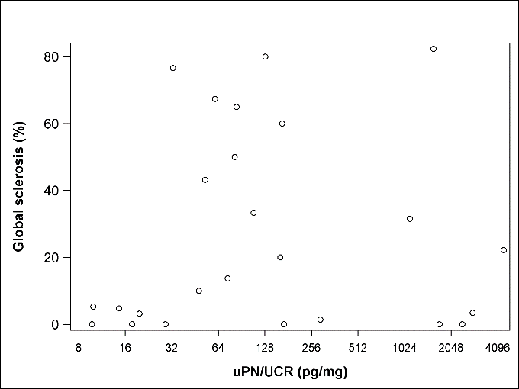 | 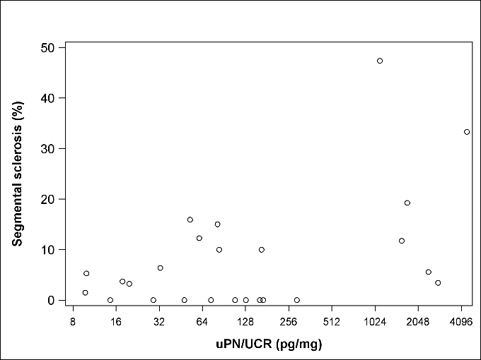
(C) POSTN*Intestinal fibrosis (Spearman’s rho=0.31 p=0.05) | (D) POSTN *Tubular atrophy (Spearman’s rho=0.29 p=0.06)
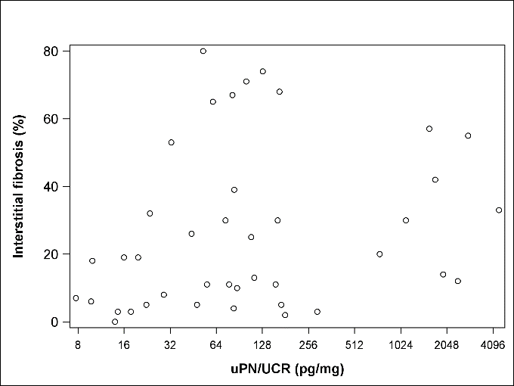 | 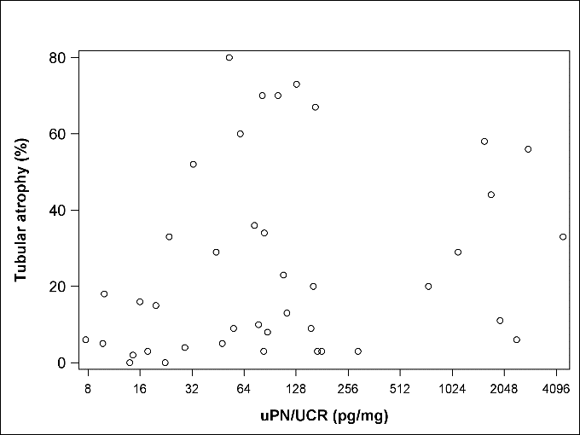
(E) POSTN*Foot process effacement (Spearman’s rho=0.28p=0.11) | (F) POSTN*Time to complete remission (p=0.17)
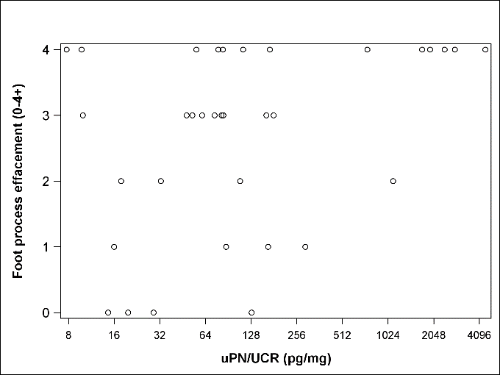 | 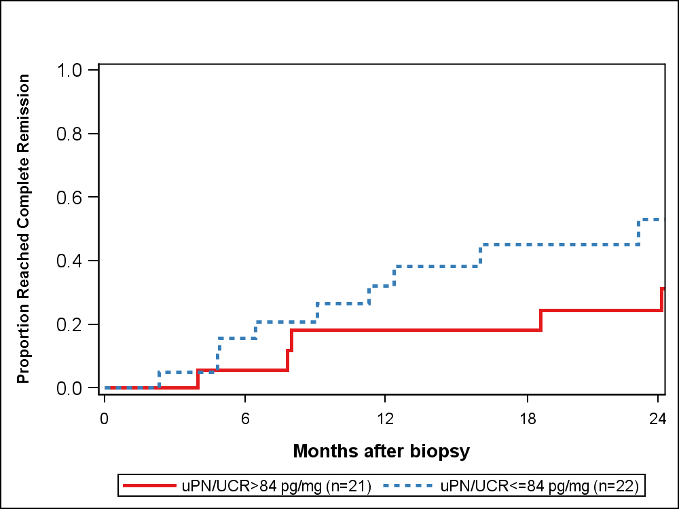
POSTN, Periostin; uPN/UCR, urine periostin/urine creatinine concentration

Figure S3 Glomerular KIM-1 expression was not correlated with interstitial fibrosis, tubular atrophy, or global sclerosis
KIM-1-Glom p=0.06 rho=0.19 | KIM-1-Glom p=0.08 rho=0.18
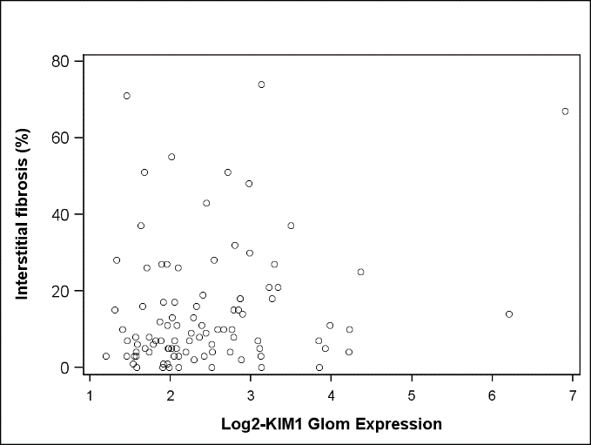 | 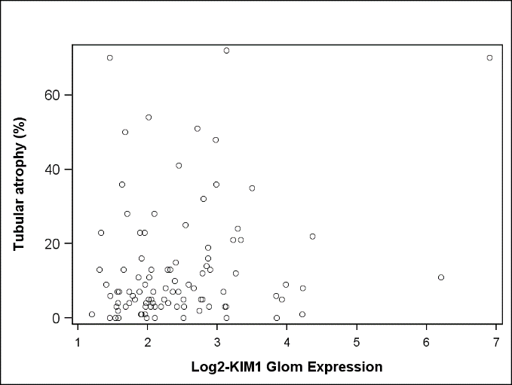
KIM-1-Glom p=0.95 rho=-0.01
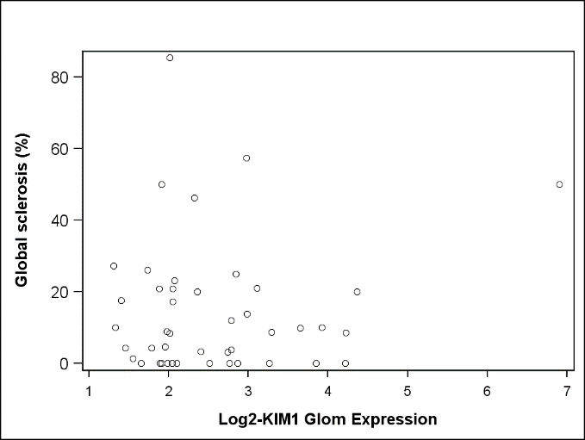

Figure S4. No relationship with POSTN expression and biopsy morphology
POSTN-TI p=0.61 | POSTN-Glom p=0.19
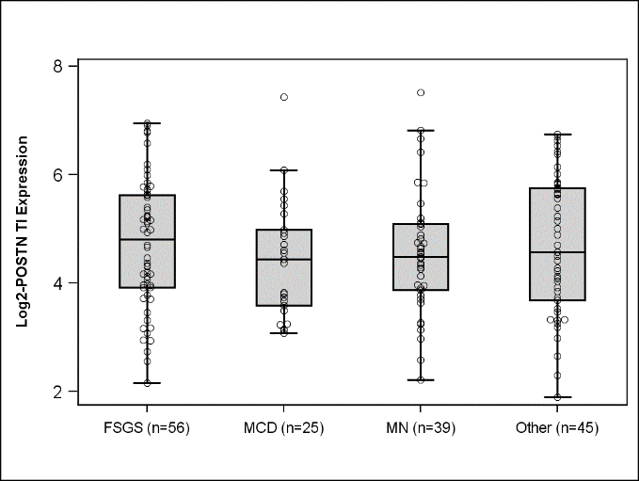 | 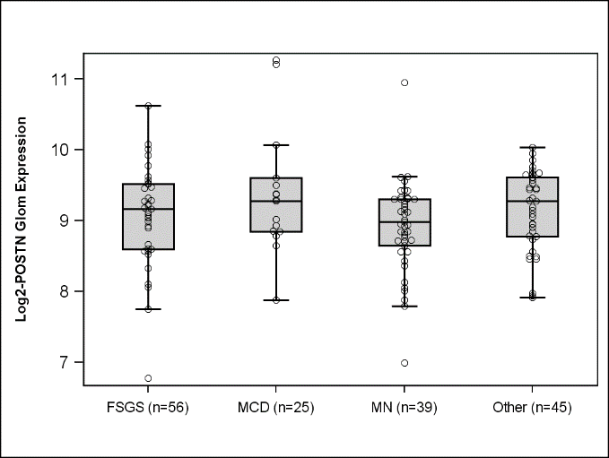
POSTN-TI p=0.05 rho=0.19 | POSTN-Glom p=0.96rho=0.01
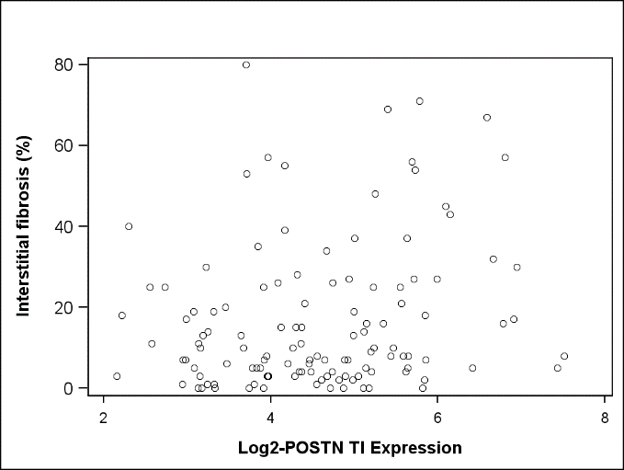 | 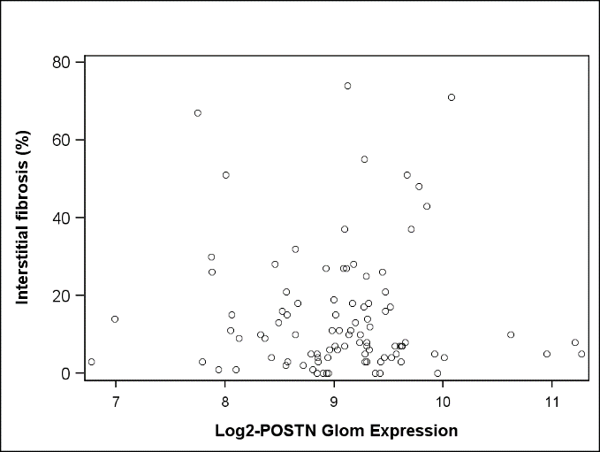
POSTN-TI p=0.06 rho=0.17 | POSTN-Glom p=0.92rho=-0.01
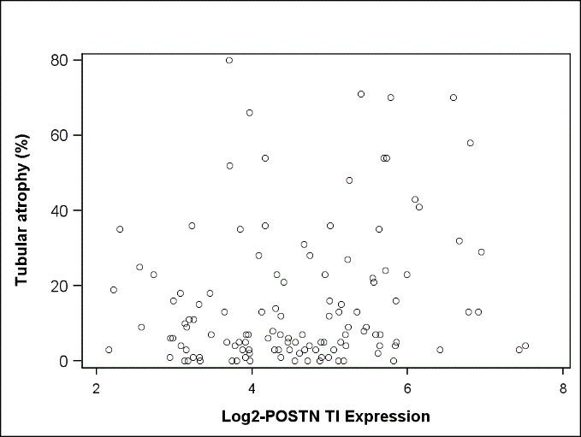 | 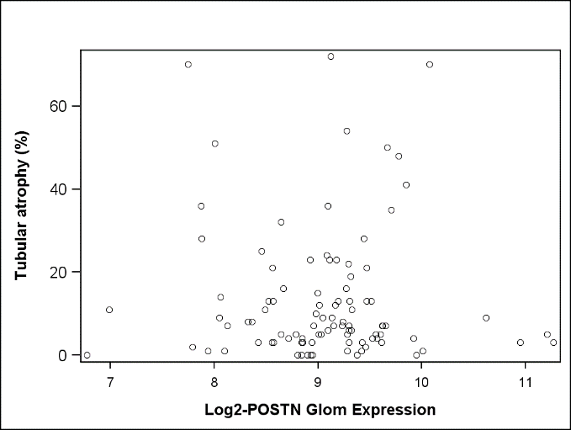
POSTN-TI p=0.32 rho=0.12 | POSTN-Glom p=0.32rho=0.15
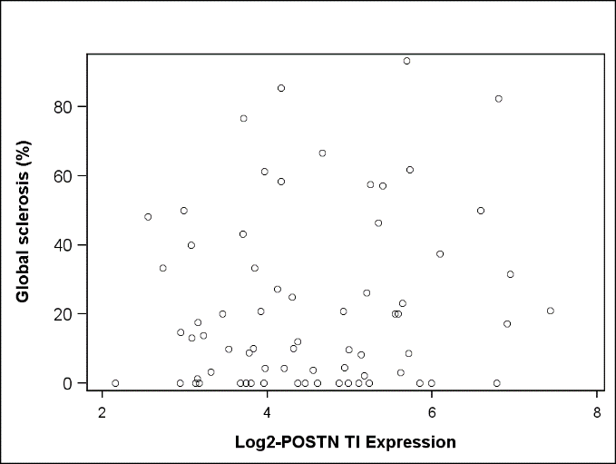 | 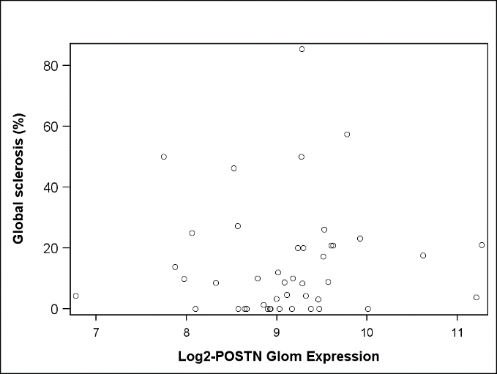
Glom, glomerular; POSTN, Periostin; TI, tubulointerstitial;
Figure S5 The relationship between UACR and KIM-1 and POSTN expression
(A) KIM-1-TI p<0.001 rho=0.35 | (B) KIM-1-Glom p=0.02 rho=0.25
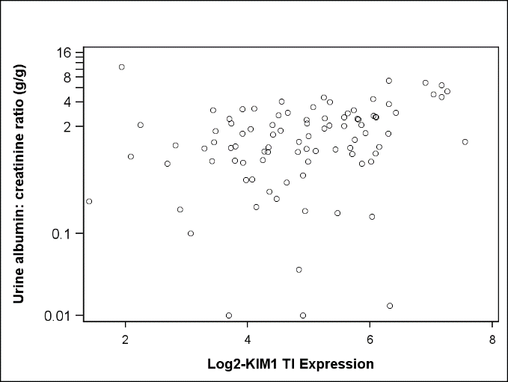 | 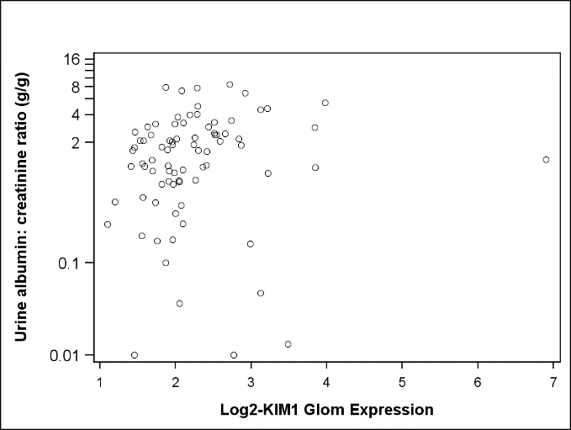
(C) POSTN-TI p=0.02 rho=0.24 | (D) POSTN-Glom p=0.94 rho=0.01
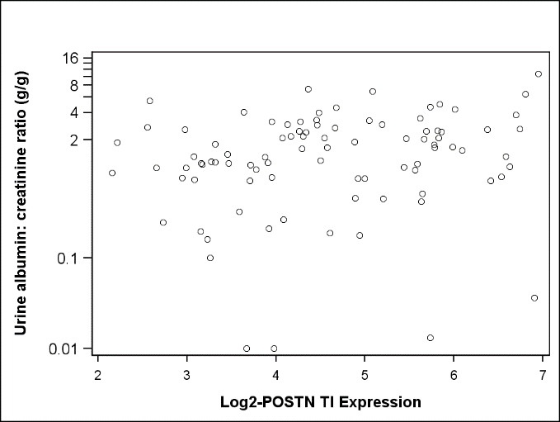 | 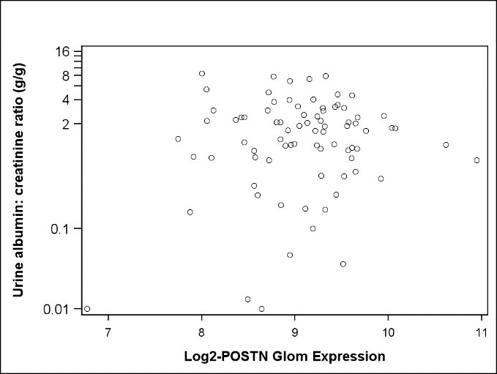
Glom, glomerular; KIM-1, kidney injury molecule-1; POSTN, Periostin; TI, tubulointerstitial;

Table S1. Descriptive characteristics of high and low urinary KIM-1 (median split)
Characteristic | Low KIM1 | High KIM1 | p-value
Age at baseline, median (IQR) | 38 (24, 57) | 43 (29, 47) | 0.73
Children (age <18), n (%) | 4 (16) | 3 (12)
Female, n (%) | 12 (48) | 11 (44) | 0.78
Race, n (%) |  |  | 0.50
Asian/Asian American | 2 (8) | 5 (20)
Black/African American | 7 (28) | 6 (24)
White/Caucasian | 13 (52) | 13 (52)
Other | 3 (12) | 1 (4)
Diagnosis, n (%) |  |  | 0.16
Minimal change disease | 6 (24) | 2 (8)
Focal segmental glomerulosclerosis | 12 (48) | 9 (36)
Membranous nephropathy | 3 (12) | 8 (32)
Other glomerulopathy | 4 (16) | 6 (24)
Urine protein: creatinine ratio at eligibility (g/g), median (IQR) | 1.3 (0.9, 2.9) | 5.3 (2.5, 11.7) | <0.001
>3.0g/g, n (%) | 6 (24) | 18 (72)
eGFR at baseline (mL/min/1.73m²), median (IQR) | 74 (33, 97) | 76 (44 to 102) | 0.58
Treatment after baseline, n (%)
Steroids | 4 (16) | 10 (40) | 0.06
Calcineurin inhibitors | 1 (4) | 4 (16) | 0.16
Mycophenolate mofetil | 2 (8) | 5 (20) | 0.22
Cyclophosphamide | 0 (0) | 1 (4) | 0.31
Total months of follow-up, median (IQR) | 30 (13, 53) | 44 (23, 54) | 0.39
eGFR, estimated glomerular filtration rate; IQR, interquartile range; NEPTUNE, Nephrotic Syndrome Study Network

Table S2. Spearman correlation of glomerular and tubular KIM1, POSTN, and MCP1 expression
 |  | Glomerular |  |  | Tubulointerstitial
 |  | KIM-1 | POSTN | MCP-1 | KIM-1 | POSTN | MCP-1
Glomerular | KIM-1 | --- | -0.22* | 0.01 | 0.53* | 0.07 | 0.33*
 | POSTN | -0.22* | --- | 0.19* | -0.05 | 0.23* | -0.03
 | MCP-1 | 0.01 | 0.19* | --- | 0.18 | 0.23* | 0.33*
Tubulointerstitial | KIM-1 | 0.53* | -0.05 | 0.18 | --- | 0.27* | 0.67*
 | POSTN | 0.07 | 0.23* | 0.23* | 0.27* | --- | 0.43*
 | MCP-1 | 0.33* | -0.03 | 0.33* | 0.67* | 0.43* | ---
*p<0.05

