Neonatal-onset Familial Mediterranean Fever in an infant with human parainfluenza virus 4 infection

Alexandre Michev, MD§, Alessandro Borghesi, MD, PhD§, Caterina Tretti, Maddalena Martella, PhD, Amelia Di Comite, MD, Alessandra Biffi, MD, PhD, Antonio Marzollo, MD*, Silvia Bresolin, PhD*

§,* equal contributions

Online supplementary material

Supplementary figure 1. Patient’s clinical course during the first hospital stay in neonatal intensive care unit (NICU).
Antibiotics and dexamethasone (DXM) are shown as administered during hospital stay. The table shows the average body temperature (ABT) in Celsius degrees (ºC) and the trend of acute phase reactants C-Reactive Protein (CRP) and Procalcitonin (PCT).

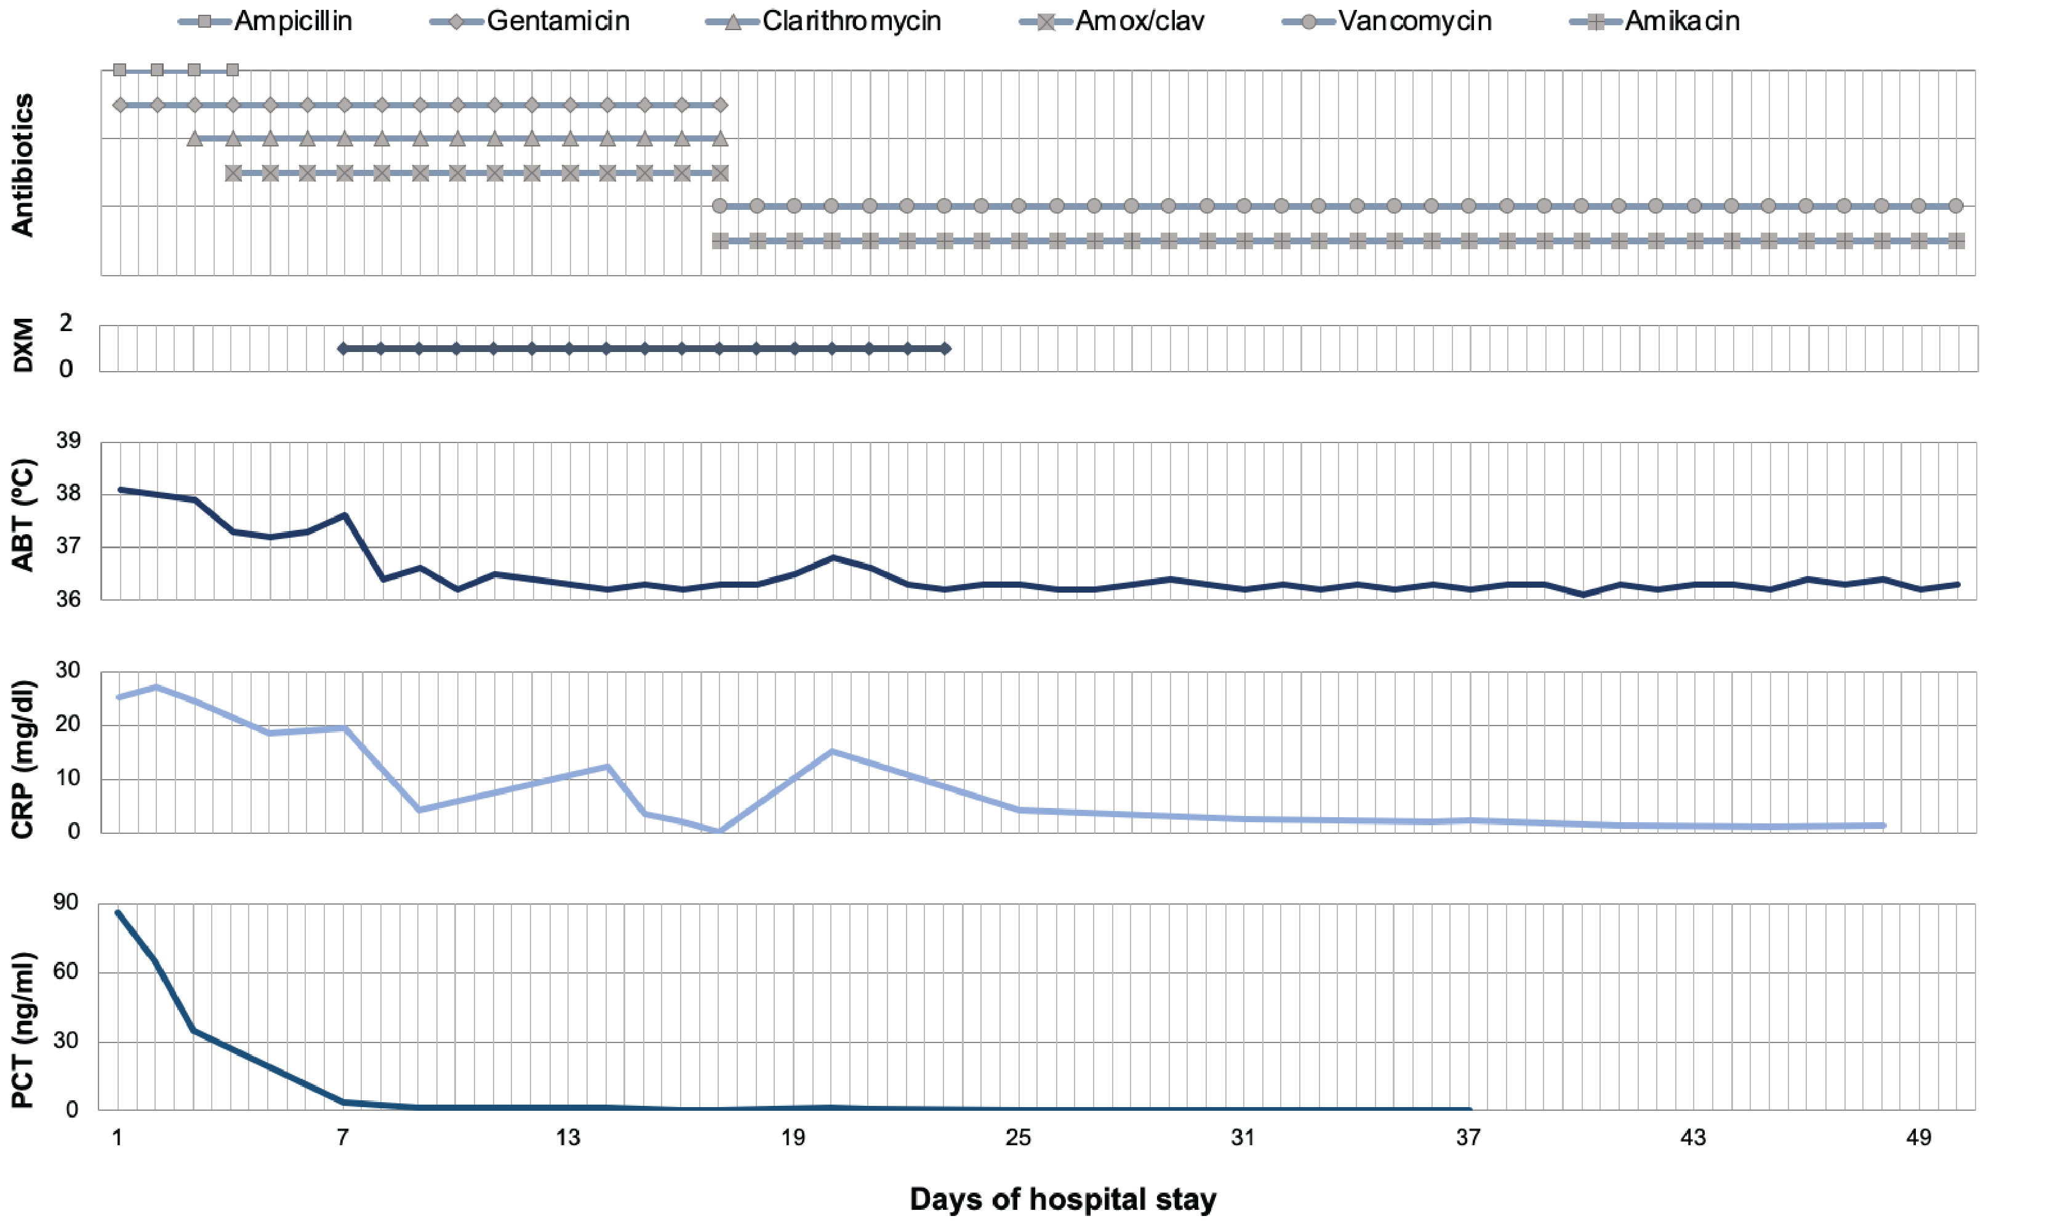

Supplementary figure 2. Patient’s clinical course during the second hospital stay in neonatal intensive care unit (NICU).
The course of acute phase reactants during the second hospital stay is reported. An initial increase in CRP and PCT, not explained by infection, is depicted. During hospital stay, further mild, occasional and unexplained increases in inflammatory markers were detected.

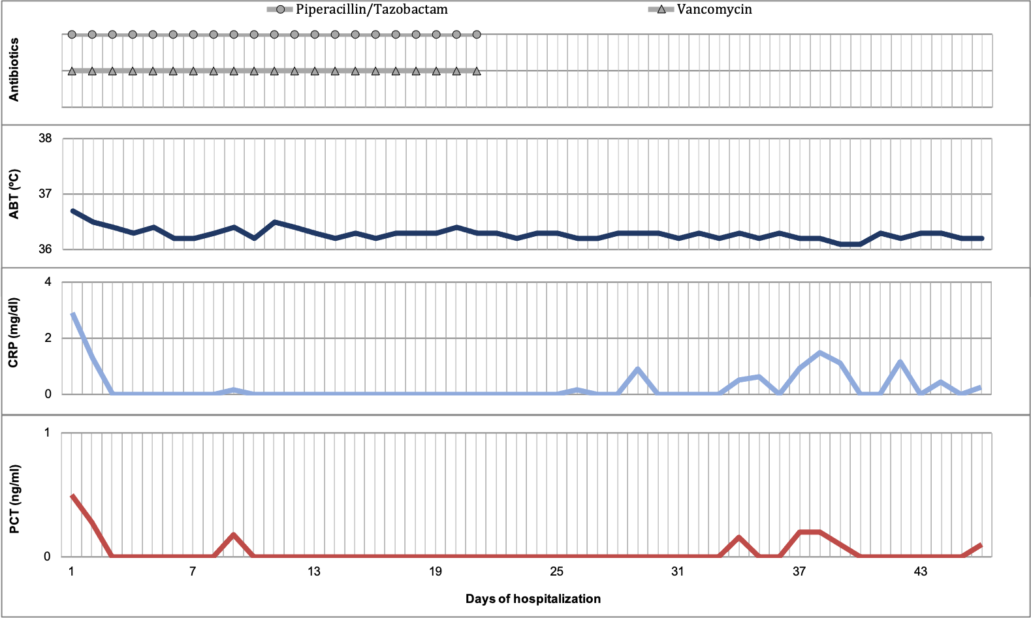

ONLINE METHODS AND RESULTS
Genetic testing
First-line immunological tasting is unable to detect PIDs without an overt immunological phenotype (altered T, B, NK cell numbers and Ig levels) or PIDs with autoinflammation. Clinical genetic testing with next generation sequencing (NGS)-based exome sequencing or gene panels for known PID genes is able to detect previously described genetic variants that have been demonstrated to cause a PID phenotype. Thus, a custom gene panel sequencing was performed with SeqCap EZ Prime Choice Probes Nimblegen design (Roche) kit and Illumina® sequencing technology on DNA extracted from peripheral blood. Germline variants from target panel data were called using an in-house developed pipeline derived from iWhale (1), as previously described (2).

Identification of the causative genetic variants
The custom gene panel included the 331 PID genes in the 2017 IUIS classification (3). Two previously described, heterozygous, pathogenic variations in MEFV were identified, namely NM_000243.2:c.[2040G>C];[2082G>A], resulting in NP_000234.1:p.[Met680Ile]; [Met694Ile] (Supplementary Figure 2). Information regarding the phase of the variants was obtained through the analysis of the NGS reads (Supplementary Figure 3). Since no reads containing both variants were identified and all reads contained one of the two variants, we concluded that the variants are in trans and thus the patient carries biallelic damaging MEFV variants.

Supplementary figure 3. Sanger sequencing of both MEFV variants on peripheral blood in the proband.

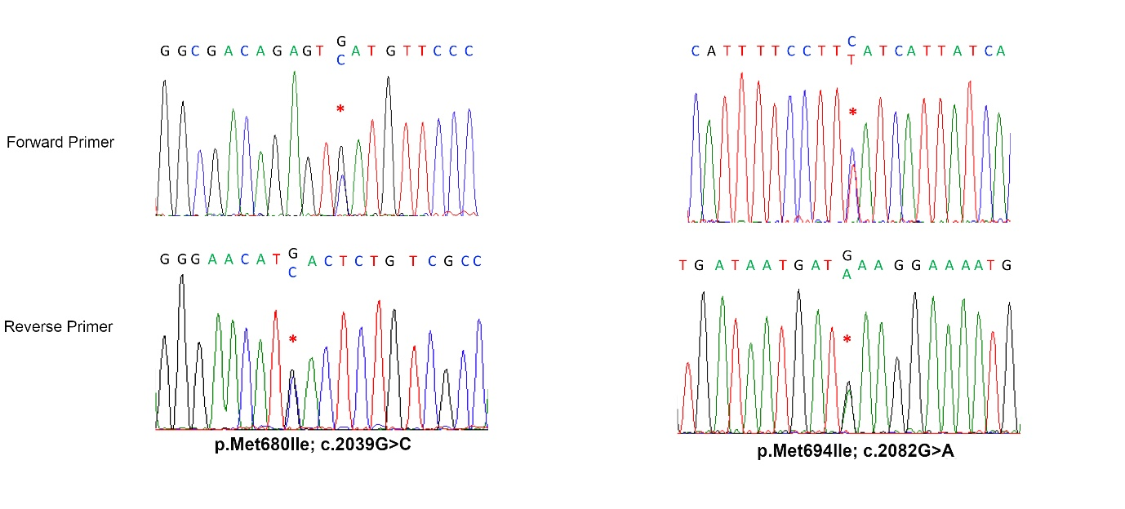

Supplementary figure 4. Integrated Genomics Viewer (IGV) aligned reads demonstrating the phase of the identified genetic variants. Reads were aligned to hg38 genome around the genomic position of MEFV variations.

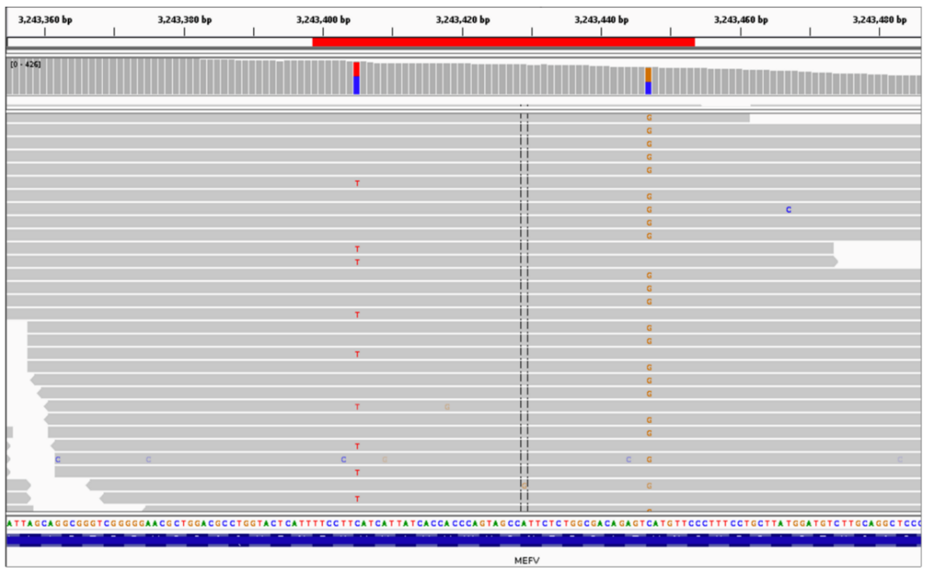

Supplementary table 1. List of filtered variants identified in the proband by NGS and subsequently evaluated by manual curation.
Applied filters are: SNFeff: “MODERATE” or “HIGH”; gnomAD_genome_ALL frequency < 0.001.
The list is provided as an additional supplementary pdf file.

Supplementary table 2. Diagnostic criteria for Familial Mediterranean Fever (FMF).
1) Tel-Hashomer criteria.
Major crieria | Minor criteria
Recurrent episodes of fever and serositis (peritonitis, synovitis or pleuritis) | Recurrent episodes of fever
Primary AA type amyloidosis | Erysipelas-like erythema
Favorable response to colchicine treatment | Documented FMF in a first-degree relative
Diagnosis is made if ≥ 2 major criteria or 1 major + 2 minor criteria are satisfied.
2) Simplified criteria ⁴
Major criteria | Minor criteria
Typical attacks* | Incomplete attacks# involving either or both the following site:
Generalized peritonitis | 1. Chest
Unilateral pleuritis or pericarditis | 2. Joint
Monoarthritis (of hip, knee, ankle) | Exertional leg pain
Fever alone | Favorable response to colchicine treatment
Incomplete abdominal attack
Diagnosis is made if ≥ 1 major or ≥ 2 minor criteria are satisfied.
- Typical attacks are defined as: recurrent (at least three episodes), febrile (rectal temperature ≥ 38 °C) and short in duration (12 hours to 3 days).
# Incomplete attacks are defined as recurrent attacks that differ from Typical* in one or two of the following features: a) temperature <38 °C; b) duration longer or shorter than a typical attack, but no less than six hours and no more than seven days); c) no signs of peritonitis during the attacks; d) localized abdominal attacks; e) arthritis in a location other than the hip, knee or ankle.

Supplementary table 3. Cases of documented neonatal-onset FMF in the literature.
Study  (year) | Total patients  (n) | Median age (range) at disease onset | Symptoms at onset  (n) | Median age at treatment start  (range) | MEFV mutations
 |  |  |  |  | Genotype | n (%)
Çelikel et al. (2019) ⁵ | 19 | 20 days  (10-30 days) | Fever (13)  Restlessness (6) | 3.5 y  (7 m – 17 y) | p.M694V/p.M694Vp.M694V/- p.M694V/p.E148Q  p.M694V/p.M680I  p.V726A/-  p.M680I/-  Negative | 8 (42.1)  3 (15.8)  2 (10.5)  1 (5.3)  1 (5.3)  1 (5.3)  3 (15.8)
One single study in the literature was found, reporting neonatal-onset FMF (Familial Mediterranean Fever). m=months; y=years.

References
1. Binatti A, Bresolin S, Bortoluzzi S, Coppe A. iWhale: a computational pipeline based on Docker and SCons for detection and annotation of somatic variants in cancer WES data. Brief Bioinform [Internet]. 2020 May 20 [cited 2020 Aug 26]; Available from: https://pubmed.ncbi.nlm.nih.gov/32436933/
2. Marzollo A, Maestrini G, La Starza R, Elia L, Malfona F, Pierini T, et al. A novel germline variant in PIK3R1 results in SHORT syndrome associated with TAL/LMO T-cell Acute Lymphoblastic Leukaemia. Am J Hematol. 2020 accepted for publication;
3. Picard C, Bobby Gaspar H, Al-Herz W, Bousfiha A, Casanova J-L, Chatila T, et al. International Union of Immunological Societies: 2017 Primary Immunodeficiency Diseases Committee Report on Inborn Errors of Immunity. J Clin Immunol [Internet]. 2018 Jan 11;38(1):96–128. Available from: http://link.springer.com/10.1007/s10875-017-0464-9
4. Livneh A, Langevitz P, Zemer D, et al. Criteria for the diagnosis of familial Mediterranean fever, Arthritis Rheum, 1997; 40:1879-85.
5. Çelikel E, Özçakar ZB, Özdel S, Çakar N, Aydin F, Şahin S, et al. Neonatal onset familial Mediterranean fever. Mod Rheumatol 2019;29:647–50. https://doi.org/10.1080/14397595.2018.1500874.

