Supplemental Information

Chitin, chitin oligosaccharide and chitin disaccharide metabolism of Escherichia coli revisited: reassignment of the roles of ChiA, ChbR, ChbF and ChbG

Axel Walterª, Simon Frizª, and Christoph Mayerª*
ªMicrobiology/Glycobiology, Interfaculty Institute of Microbiology and Infection Medicine,
University of Tübingen, Germany
Short title: chitin metabolism of E. coli

Supplemental Materials: 2 Tables, 1 Figure

Supplemental Tables

Table S1. Strains, plasmids and primers used in the study
Strain | Characteristics | References
E. coli
K12, Strain BW25113  “wild-type” (wt) | Δ(araD-araB)567, ΔlacZ4787(::rrnB-3); λ⁻, rph-1, Δ(rhaD-rhaB)568, hsdR514 | Yale Genetic Stock Center
JW1723-1  ΔchbF::kan | F-, Δ(araD-araB)567, ΔlacZ4787(::rrnB-3), λ⁻, ΔchbF733::kan, rph-1, Δ(rhaD-rhaB)568, hsdR514 | Yale Coli Genetic Stock Center
JW1722-2  ΔchbG::kan | F-, Δ(araD-araB)567, ΔlacZ4787(::rrnB-3), λ⁻, ΔchbG733::kan, rph-1, Δ(rhaD-rhaB)568, hsdR514 | Yale Coli Genetic Stock Center
DH5α | SupE44 hsdR17 recA1 endA1 gyrA96 thi-1 relA1 | [Hanahan, 1983]
BL21 (DE3) | fhuA2 [lon] ompT gal (λ DE3) [dcm] ΔhsdS λDE3 = λ sBamHIo ΔEcoRI-B int::(lacI::PlacUV5::T7 gene1) i21 Δnin5 | New England Biolabs
BL21(DE3)  pET28a-ChbF | fhuA2 [lon] ompT gal (λ DE3) [dcm] ΔhsdS λDE3 = λ sBamHIo ΔEcoRI-B int::(lacI::PlacUV5::T7 gene1) i21 Δnin5, pET28a-ChbF | this work
BL21(DE3)  pET22b-ChiA | fhuA2 [lon] ompT gal (λ DE3) [dcm] ΔhsdS λDE3 = λ sBamHIo ΔEcoRI-B int::(lacI::PlacUV5::T7 gene1) i21 Δnin5, pET22b-ChiA | this work
BL21(DE3)  pET28a-Csn | fhuA2 [lon] ompT gal (λ DE3) [dcm] ΔhsdS λDE3 = λ sBamHIo ΔEcoRI-B int::(lacI::PlacUV5::T7 gene1) i21 Δnin5, pET28a-Csn | this work
ΔchbG::kan  pQE32-ChbBCA | F-, Δ(araD-araB)567, ΔlacZ4787(::rrnB-3), λ⁻, ΔchbG733::kan, rph-1, Δ(rhaD-rhaB)568, hsdR514,  pQE32-chbBCA | this work
BL21(DE3)  pET28a-CwlC | fhuA2 [lon] ompT gal (λ DE3) [dcm] ΔhsdS λDE3 = λ sBamHIo ΔEcoRI-B int::(lacI::PlacUV5::T7 gene1)  i21 Δnin5, pET28a-CwlC | [Müller et al., 2021]
BL21(DE3)  pET16b-NagZ | fhuA2 [lon] ompT gal (λ DE3) [dcm] ΔhsdS λDE3 = λ sBamHIo ΔEcoRI-B int::(lacI::PlacUV5::T7 gene1) i21 Δnin5, pET16b-NagZ | [Litzinger et al., 2010a;Litzinger et al., 2010b]
BL21(DE3)  pET28a-Atl(Glc) | fhuA2 [lon] ompT gal (λ DE3) [dcm] ΔhsdS λDE3 = λ sBamHIo ΔEcoRI-B int::(lacI::PlacUV5::T7 gene1) i21 Δnin5, pET28a-Atl(Glc) | [Müller et al., 2021]
B. subtilis
strain 168  (wild-type) | trpC2; genome sequenced B. subtilis type strain | Bacillus Genetic  Stock Center
plasmid
pET28a(+) | KanR, T7 promoter, ori pBR322, lacI,  C/N-terminal His₆-tag | Novagen
pET22b(+) | AmpR, T7 promotor, lacI, C-terminal His₆-tag | Novagen
pQE32 | AmpR, T5 promoter/lac operator, N-terminal His₆-tag | Qiagen
pET28a-ChbF | KanR, T7 promoter, ori, pBR322, lacI,  adds C-terminal His₆-tag to chbF | this work
pET22b(+)-ChiA | AmpR, T7 promotor, lacI,  adds C-terminal His₆-tag to chiA | this work
pET28a-Csn | KanR, T7 promoter, ori, pBR322, lacI,  adds C-terminal His₆-tag to csn | this work
pET28a-CwlC | KanR, T7 promoter, ori, pBR322, lacI,  adds C-terminal His₆-tag to cwlC | [Müller et al., 2021]
pET16b-NagZ | AmpR, T7 promotor, lacI,  adds N-terminal His₁₀-tag to nagZ | [Litzinger et al., 2010a;Litzinger et al., 2010b]
pET28a-Atl(Glc) | KanR, T7 promoter, ori, pBR322, lacI,  adds C-terminal His₆-tag to atl(glc) | [Müller et al., 2021]
pQE32-ChbBCA | AmpR, T5 promoter/lac operator,  chbBCA without N-terminal His₆-tag | this work
primer
pET28a-chbF-NcoI-for | CACCATGGGAAGCCAGAAATTAAAAGTCGT | this work
pET28a-chbF-XhoI-rev | CACTCGAGATGTGCTTTTTTAAGCTCTG | this work
pET22b-chiA-NdeI-for | GGCCCCCATATGAAATTAAATATATTTACTAAATC | this work
pET22b-chiA-HindIII-rev | CCAAGCTTTTGCTTAGTAAACGGCGCGA | this work
pET28a-csn-NcoI-for | CCACCATGGGAGCGGGACTGAATAAAGATCA | this work
pET28a-csn-XhoI-rev | CCACTCGAGTTTGATTACAAAATTACCGT | this work
pQE32-chBCA-GA-for | CAGAATTCATTAAAGAGGAGAAATTAACTATGGAAAAGAAACACATTTATCTGTTTTGT | this work
pQE32-chBCA-GA-rev | TCTATCAACAGGAGTCCAAGCTCAGCTAATTATGCCTTCAGTTTTTCATGAAGC | this work
pET28a-cwlC-NcoI-for | GCTCCATGGCGGTTAAAATTTTTATTGATCCTGGACAT | [Müller et al., 2021]
pET28a-cwlC-XhoI-rev | GCTAGCTCGAGTGATTCTAGGATCACAATAGC | [Müller et al., 2021]
pET16b-nagZ-NdeI-for | AAAACCATGGGCCATATGTTTTTCGGGGCCAGACAGAC | [Litzinger et al., 2010a;Litzinger et al., 2010b]
pET16b-nagZ-XhoI-rev | TTTTCTCGAGTTAAAGCGGTCTTCCCGTTTTG | [Litzinger et al., 2010a;Litzinger et al., 2010b]
pET28a-atl(glc)-NcoI-for | CAGCTCCATGGCTTATACTGTTACTAAACCAC | [Müller et al., 2021]
pET28a-atl(glc)-XhoI-rev | GCGCCTCGAGTTTATATTGTGGGATGTCGAAG | [Müller et al., 2021]

Table S2. Exact monoisotopic masses of chitin, chitosan and PGN metabolites
Overview of chitin, chitosan and PGN metabolites and their exact neutral masses and masses with proton adducts in positive ionization mode.

Name | Formula | exact monoisotopic mass [M] | exact monisotopic mass of the proton adduct [M+H]⁺
chitobiose  (GlcN-GlcN) | C₁₂H₂₄N₂O₉ | 340.1482 | 341.1555
chitotriose  (GlcN-GlcN-GlcN) | C₁₈H₃₅N₃O₁₃ | 501.2170 | 502.2243
chitotetraose  (GlcN-GlcN-GlcN-GlcN) | C₂₄H₄₆N₄O₁₇ | 662.2858 | 663.2931
diacetyl-chitobiose  (GlcNAc-GlcNAc) | C₁₆H₂₈N₂O₁₁ | 424.1693 | 425.1766
triacetyl-chitotriose  (GlcNAc-GlcNAc-GlcNAc) | C₂₄H₄₁N₃O₁₆ | 627.2487 | 628.2560
monoacetyl-chitotriose  (GlcN-GlcNAc-GlcN) | C₂₀H₃₇N₃O₁₄ | 543.2276 | 544.2348
MurNAc-GlcNAc | C₁₉H₃₂N₂O₁₃ | 496.1904 | 497.1977
(MurNAc-GlcNAc)-4P | C₃₇H₆₁N₇O₂₁ | 939.3921 | 940.3993
(GlcNAc-MurNAc)-3P*  (MurNAc-GlcNAc)-3P* | C₃₄H₅₇N₇O₁₉ | 867.3709 | 868.3782
3P*  tri-peptide (1x amidation) | C₁₅H₂₇N₅O₇ | 389.1910 | 390.1983
3P  tri-peptide | C₁₅H₂₆N₄O₈ | 390.1751 | 391.1823
4P  tetra-peptide | C₁₈H₃₁N₅O₉ | 461.2122 | 462.2195
3P-4P  tri-tetra-peptide | C₃₃H₅₅N₉O₁₆ | 833.3767 | 834.3840
4P-4P  tetra-tetra-peptide | C₃₆H₆₀N₁₀O₁₇ | 904.4138 | 905.4211
3P*-4P*  tri-tetra-peptide  (2x amidations) | C₃₃H₅₇N₁₁O₁₄ | 831.4086 | 832.4159
3P-4P*  tri-tetra-peptide  (1x amidation) | C₃₃H₅₆N₁₀O₁₅ | 832.3927 | 833.3999

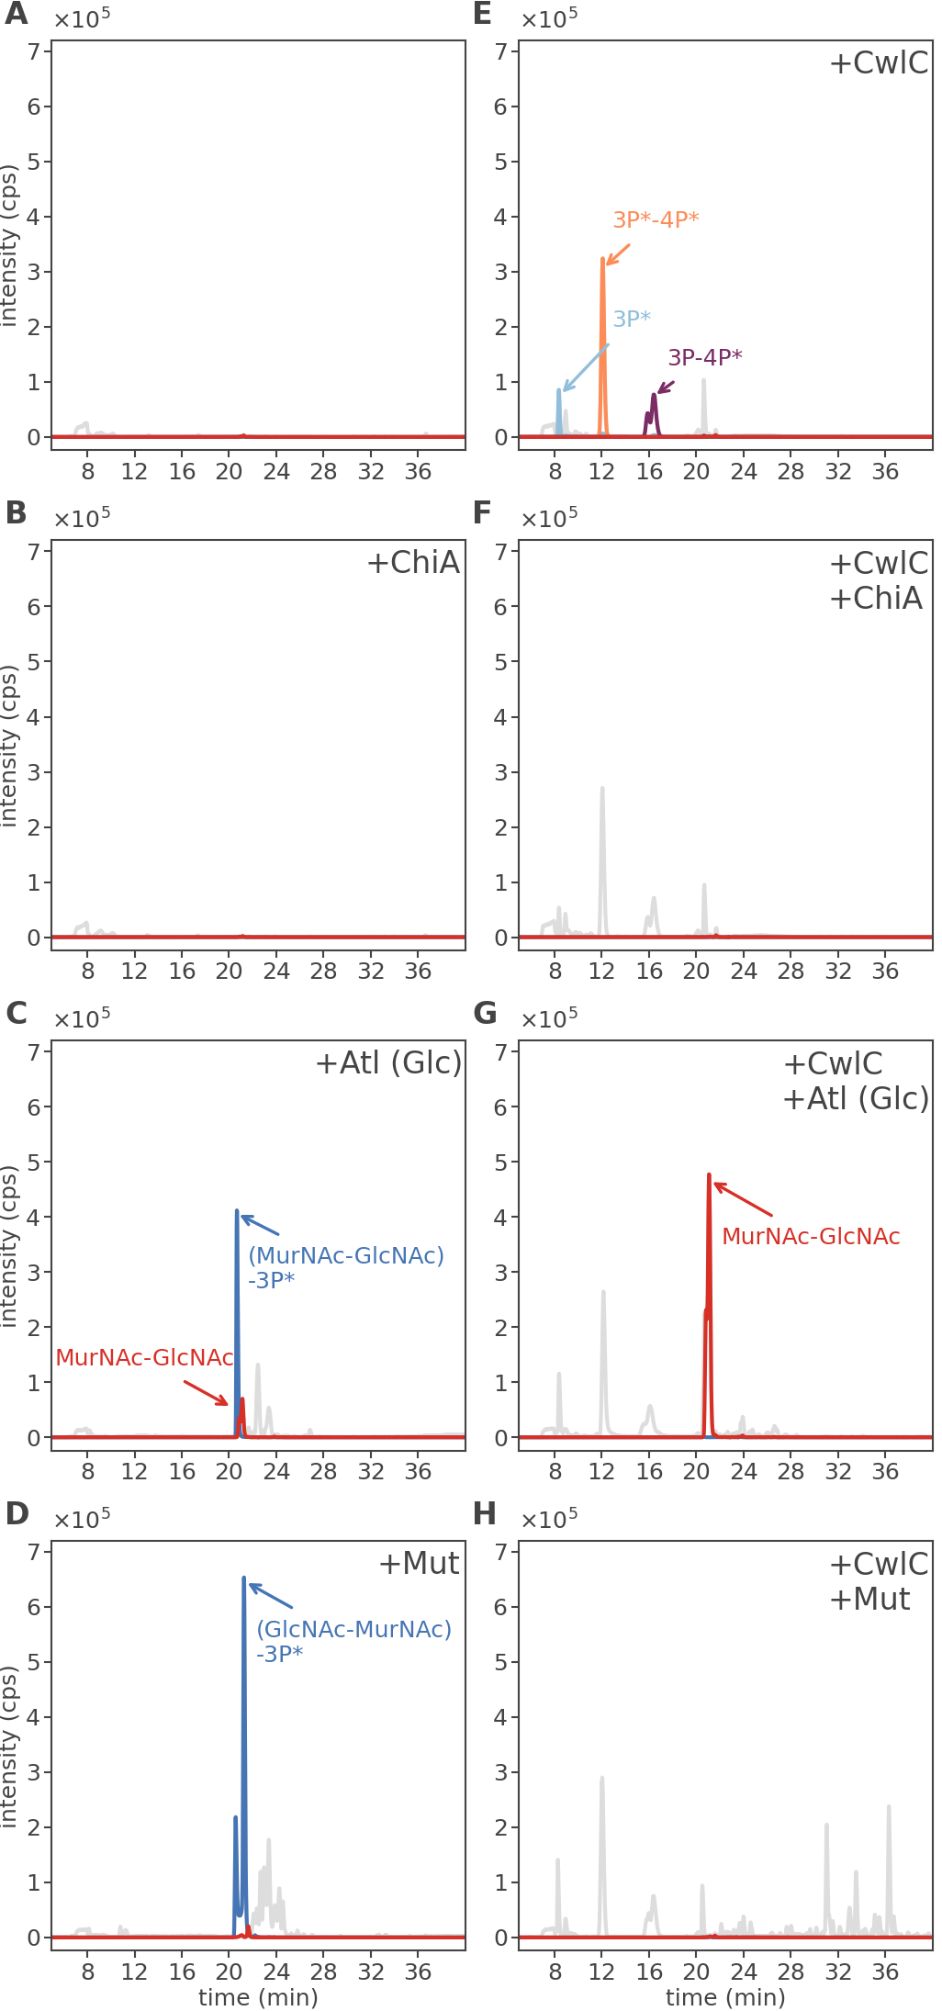
Supplemental Figures
Fig. S1. ChiA does not cleave B. subtilis peptidoglycan. Intact peptidoglycan, derived from B. subtilis (left panels), and denuded peptidoglycan (right panels), i.e. treated with the amidase CwlC to remove the peptide stems, were incubated with ChiA, the endo-glucosaminidase Atl (Glc) of S. aureus or Mutanolysin. The formation of reaction products was analyzed by LC-MS. (A) Uncleaved B. subtilis peptidoglycan (control). (B) Incubation of B. subtilis peptidoglycan with ChiA (+ChiA), which does not release any soluble products. (C) Incubation of B. subtilis peptidoglycan with Atl (Glc) (-Atl (Glc)) releases large amounts of (MurNAc-GlcNAc)-tripeptide (amidated) (M+H)⁺ m/z = 868.3701 (MurNAc-GlcNAc-3P*; blue) and to a lesser extent MurNAc-GlcNAc (M+H)⁺ m/z = 497.1902 (red). (D) Mutanolysin (+Mut) exclusively releases (GlcNAc-MurNAc)-3P* (M+H)⁺ m/z = 868.3675 (blue). (E) CwlC (+CwlC) removes amidated tri- (M+H)⁺ m/z = 390.1978 (3P*, light blue), tri-tetra (M+H)⁺ m/z = 833.3943 (3P-4P*, purple) and double amidated tri-tetra peptides (M+H)⁺ m/z = 832.4122 (3P*-4P*, orange) from B. subtilis peptidoglycan. (F) From (E) ChiA (+CwlC+ChiA) is unable to cleave denuded peptidoglycan. (G) From (E), Atl (Glc) (+CwlC+Atl (Glc)) is able to release large amounts of MurNAc-GlcNAc (M+H)⁺ m/z = 497.1954 (red). Intriguing, no MurNAc-GlcNAc-4P could be detected, indicating the complete removal of the stem peptides from the peptidoglycan by CwlC. (H) From (E), Mutanolysin (+CwlC+Mut), on the other hand, does not release disaccharides from the glycan chain, which indicates that this enzyme is not able to cleave denuded peptidoglycan. Shown are the base peak chromatogram (BPC) mass range (M+H)⁺ m/z = 200 – 2000 (gray) and the extracted ion chromatograms (EIC) based on the exact masses of displayed compounds (Table S2).

References

Hanahan D. Studies on transformation of Escherichia coli with plasmids. J Mol Biol. 1983 Jun 5;166(4):557-80.
Litzinger S, Duckworth A, Nitzsche K, Risinger C, Wittmann V, Mayer C. Muropeptide rescue in Bacillus subtilis involves sequential hydrolysis by β-N-acetylglucosaminidase and N-acetylmuramyl-L-alanine amidase. J Bacteriol. 2010a Jun;192(12):3132-43.
Litzinger S, Fischer S, Polzer P, Diederichs K, Welte W, Mayer C. Structural and kinetic analysis of Bacillus subtilis N-acetylglucosaminidase reveals a unique Asp-His dyad mechanism. J Biol Chem. 2010b Nov 12;285(46):35675-3584.
Müller M, Calvert M, Hottmann I, Kluj RM, Teufel T, Balbuchta K, et al. Exo-β-N-acetylmuramidase NamZ of Bacillus subtilis is the founding member of a family of exo-lytic peptidoglycan hexosaminidases. bioRxiv 2021:2021.01.10.425899.

