Supplementary Material
Table S1. OR by Investigator Assessment per RECIST 1.1 According to PD-L1 Status (N = 22)
Immune Cell Score | < 1% | ≥ 1% | Unknown
No. of patients | 3 | 17 | 2
Confirmed best overall response, n (%)
Complete response | 0 | 0 | 0
Partial response | 0 | 3 (17.6) | 0
Stable disease | 1 (33.3) | 10 (58.8) | 1 (50.0)
Progressive disease | 1 (33.3) | 4 (23.5) | 1 (50.0)
Not evaluable | 1 (33.3)ª | 0 | 0
ORR (95% CI), % | 0 (0.0-70.8) | 17.6 (3.8-43.4) | 0 (0.0-84.2)
DCR (95% CI), % | 33.3 (0.8-90.6) | 76.5 (50.1-93.2) | 50.0 (1.3-98.7)

DCR, disease control rate; OR(R), objective response (rate); RECIST, Response Evaluation Criteria in Solid Tumors.
ª No post-baseline assessment.

Table S2. ORR by Investigator Assessment per RECIST 1.1 and mRECIST for HCC and OS in HCC-Specific Subgroups
Subgroup | n | ORR per RECIST 1.1  (95% CI), % | ORR per mRECIST  for HCC  (95% CI), % | Median OS (95% CI), months
All patients | 22 | 13.6 (2.9-34.9) | 31.8 (13.9-54.9) | 14.1 (8.0-NE)
Baseline AFP
< 400 ng/mL | 13 | 15.4 (1.9-45.4) | 46.2 (19.2-74.9) | NE (8.0-NE)
≥ 400 ng/mL | 9 | 11.1 (0.3-48.2) | 11.1 (0.3-48.2) | 9.2 (2.8-NE)
Vascular invasion
Yes | 6 | 0 (0-45.9) | 33.3 (4.3-77.7) | 7.8 (2.8-NE)
No | 16 | 18.8 (4.0-45.6) | 31.3 (11.0-58.7) | NE (8.7-NE)
Extrahepatic spread
Yes | 11 | 27.3 (6.0-61.0) | 27.3 (6.0-61.0) | 15.4 (8.0-NE)
No | 11 | 0 (0-28.5) | 36.4 (10.9-69.2) | 12.7 (6.1-NE)
Intrahepatic tumor
Yes | 19 | 10.5 (1.3-33.1) | 31.6 (12.6-56.6) | 11.8 (6.7-NE)
No | 3 | 33.3 (0.8-90.6) | 33.3 (0.8-90.6) | NE (NE-NE)
Extrahepatic/intrahepatic status
Both | 8 | 25.0 (3.2-65.1) | 25.0 (3.2-65.1) | 10.4 (2.8-NE)
Extrahepatic only/  intrahepatic only/  none | 14 | 7.1 (0.2-33.9) | 35.7 (12.8-64.9) | NE (6.4-NE)
Etiology
Hepatitis B | 8 | 12.5 (0.3-52.7) | 12.5 (0.3-52.7) | 8.3 (4.6-11.8)
Hepatitis C | 5 | 0 (0-52.2) | 60.0 (14.7-94.7) | NE (6.7-NE)
Non-viral | 9 | 22.2 (2.8-60.0) | 33.3 (7.5-70.1) | NE (2.8-NE)

AFP, alpha-fetoprotein; HCC, hepatocellular carcinoma; (m)RECIST, (modified) Response Evaluation Criteria in Solid Tumors; NE, not estimable; ORR, objective response rate; OS, overall survival.

Figure S1. Best Percent Change in Target Lesions From Baseline in Evaluable Patients per RECIST 1.1 (A) and mRECIST for HCC (B) (N = 21). Only includes patients with target lesions at baseline and ≥ 1 non-missing postbaseline assessment up to time of PD or new anticancer therapy. HCC, hepatocellular carcinoma; (m)RECIST, (modified) Response Evaluation Criteria in Solid Tumors; PD, progressive disease.
A
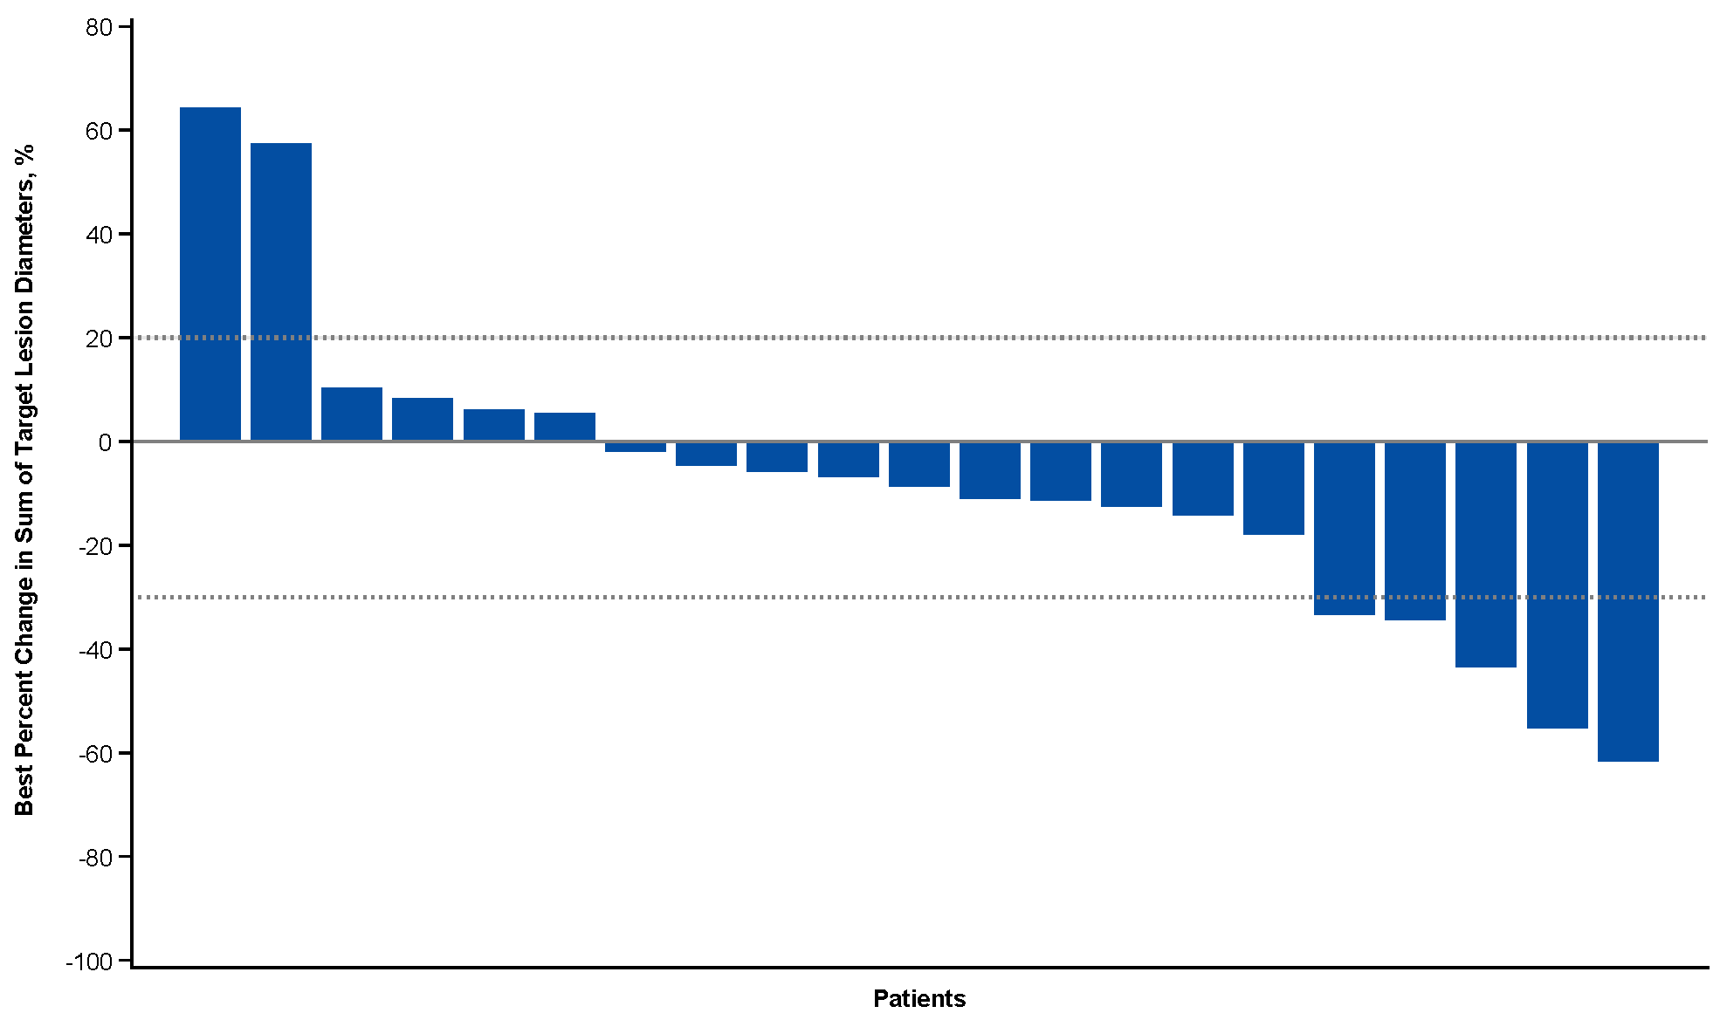
B
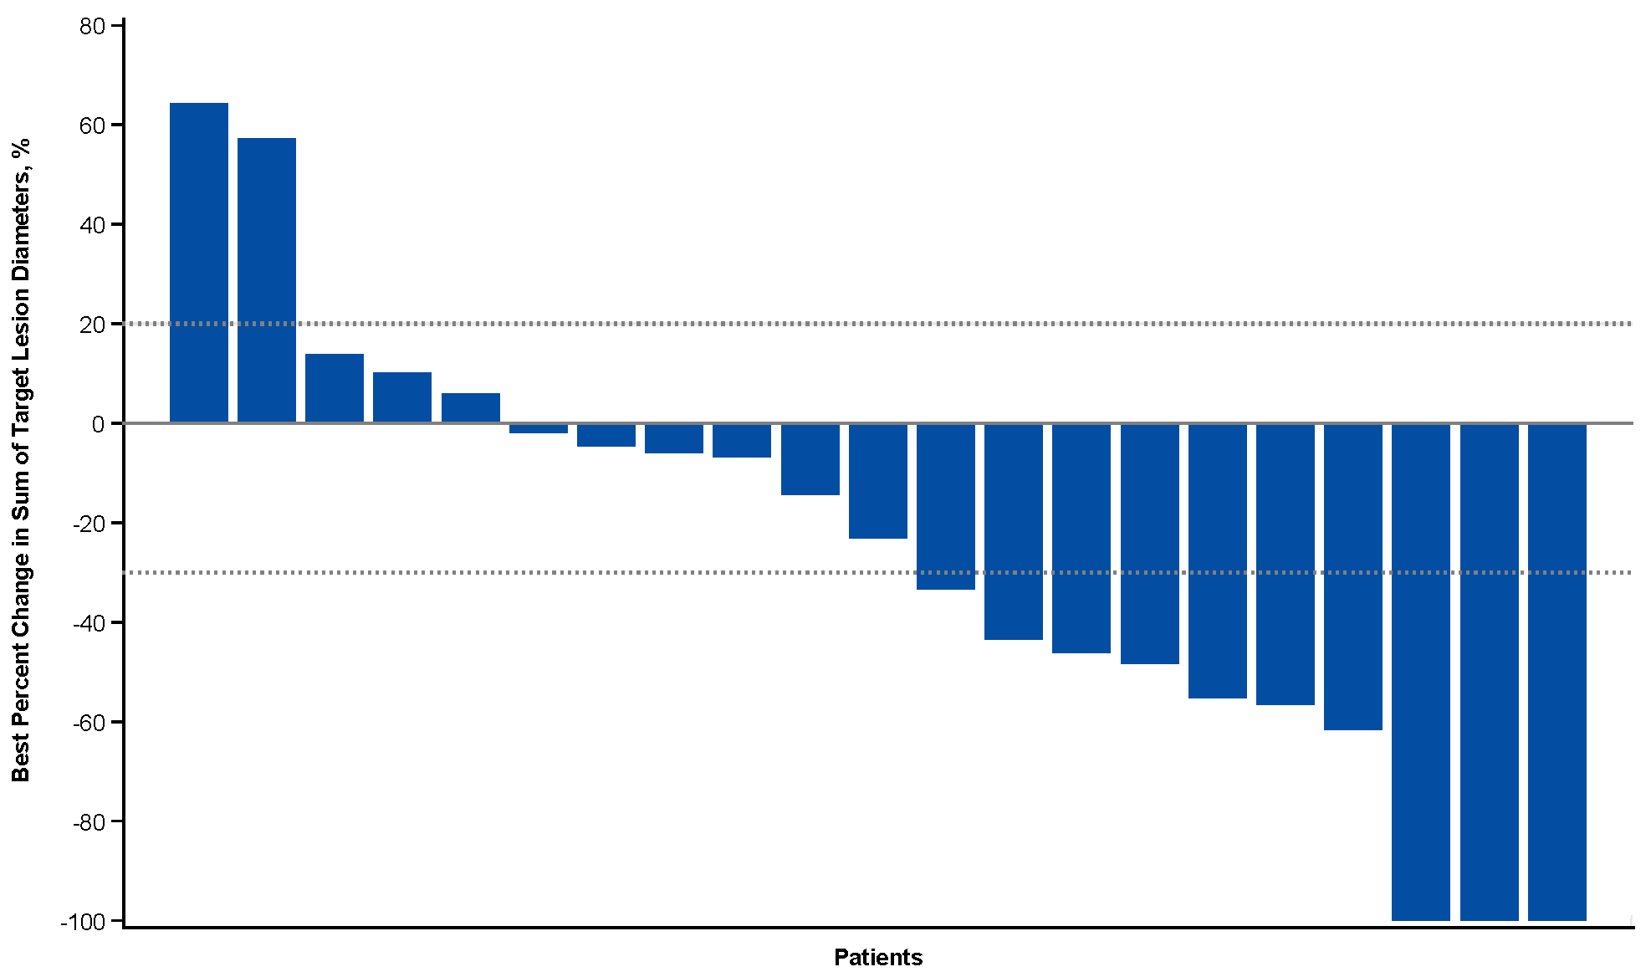
Figure S2. TTR and DOR by Investigator Assessment per mRECIST for HCC
(N = 22). Vertical axis label: AFP value at screening (ng/mL) – Vascular invasion status (Vas/Non) – Extrahepatic/intrahepatic status (Ex/In/Bo). AFP, alpha-fetoprotein; Bo, both; DOR, duration of response; Ex, extrahepatic only; HCC, hepatocellular carcinoma; In, intrahepatic only; mRECIST, modified Response Evaluation Criteria in Solid Tumors; Non, no vascular invasion; OR, objective response; PD, progressive disease; TTR, time to response; Vas, vascular invasion.

Figure S3. PFS by Investigator Assessment per RECIST 1.1 (A) and mRECIST for HCC (B) (N = 22). HCC, hepatocellular carcinoma; (m)RECIST, (modified) Response Evaluation Criteria in Solid Tumors; PFS, progression-free survival.
A
B

Figure S4. PFS by PD-L1 Status by Investigator Assessment per RECIST 1.1. PFS, progression-free survival; RECIST, Response Evaluation Criteria in Solid Tumors.
