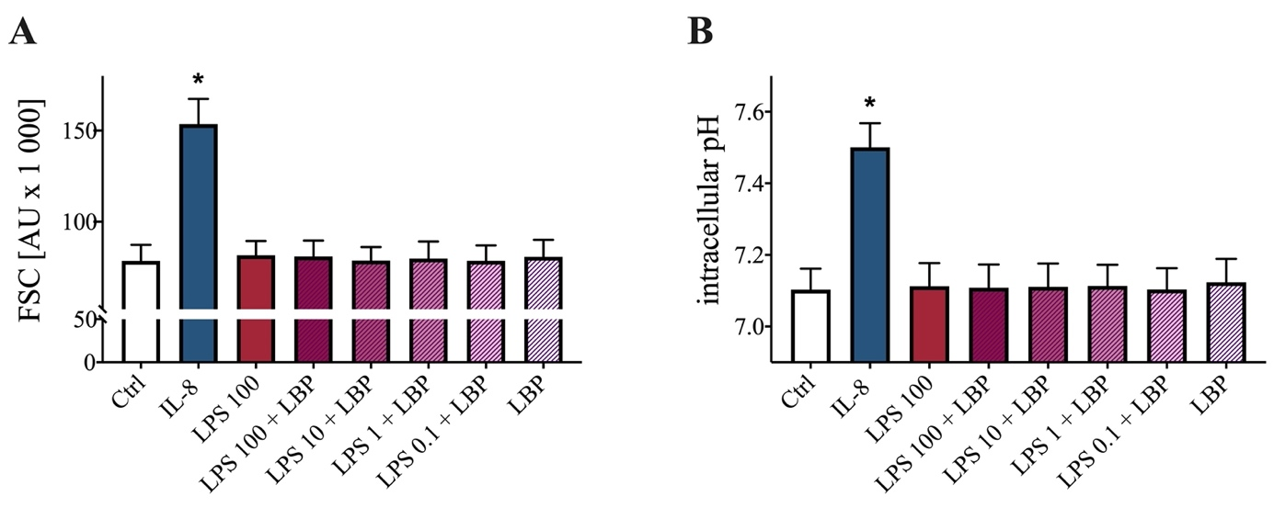

Supplemental Figure 2: Dose-dependent response of the changes in FSC and intracellular pH after stimulation with 0.1–100 ng/ml LPS with or without 2 ng/ml LBP in comparison to unstimulated cells (Ctrl) or neutrophils stimulated with Interleukin 8 (IL-8, 50 ng/ml). (A) Effect of various LPS concentrations on the neutrophil cell shape after 10 min of stimulation; n = 6; *p < 0.05 vs. Ctrl; (Wilcoxon Signed Rank Test). (B) Change in intracellular pH after 5 min of Stimulation with altered LPS concentrations; n = 6; *p < 0.05 vs. Ctrl; (Wilcoxon Signed Rank Test).

