***Supplementary Figures and Tables***

***Current management of Inherited Retinal Degenerations (IRD) patients in Europe. Results of a multinational survey by the European Vision Institute Clinical Research Network EVICR.net***

Birgit Lorenza, b, *, Joana Tavaresc, *, L Ingeborgh van den Bornd, João P Marquese, f, g, Hendrik P N Schollh, i, j

a Department of Ophthalmology, Justus-Liebig-University Giessen, Giessen, Germany

b Department of Ophthalmology, University Hospital Bonn, Bonn, Germany

c Association for Innovation and Biomedical Research on Light and Image (AIBILI), Coimbra, Portugal

d Rotterdam Eye Hospital and Rotterdam Ophthalmic Institute, Rotterdam, the Netherlands

e Center for Clinical Trials, Association for Innovation and Biomedical Research on Light and Image (AIBILI), Coimbra, Portugal

f Department of Ophthalmology, Centro Hospitalar e Universitário de Coimbra (CHUC), Coimbra, Portugal

g Faculty of Medicine, University of Coimbra (FMUC), Coimbra, Portugal

h Institute of Molecular and Clinical Ophthalmology Basel (IOB), Basel, Switzerland

i Department of Ophthalmology, University of Basel, Basel, Switzerland

j Wilmer Eye Institute, Johns Hopkins University, Baltimore, Maryland, United States

* These authors contributed equally.

**Supplementary Figures**



Fig. S1. Age range at IRD patients first visit. Box plot of the percentage of IRD patients/age range at first visit: the box signifies the third quartile (Q3) and first quartile (Q1) range of data, and the median is represented by a black line within the box for each age range. Data falling outside the Q1 – Q3 range are plotted as outliers of the data and are depicted by black dots.

Fig. S2. Mean time between inquiry of appointment and first contact with a retina expert for IRD patients distributed by country. The percentage of centers per country was calculated based on the total number of centers that replied for each country.



Fig. S3. Mean time between inquiry of appointment and final ophthalmological diagnosis for IRD patients distributed by country. The percentage of centers per country was calculated based on the total number of centers that replied for each country.



Fig. S4. Mean time between inquiry of appointment and final ophthalmological and genetic diagnosis for IRD patients distributed by country. The percentage of centers per country was calculated based on the total number of centers that replied for each country.

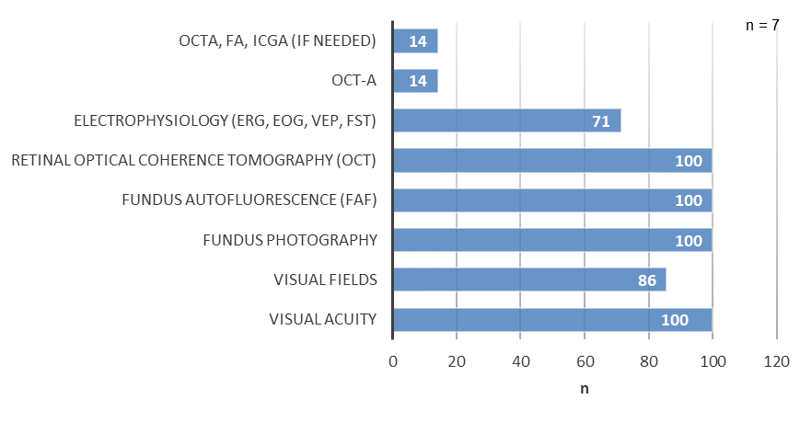

Fig. S5. Basic tests performed in IRD patients referenced to expert centers. Multiple choices allowed.

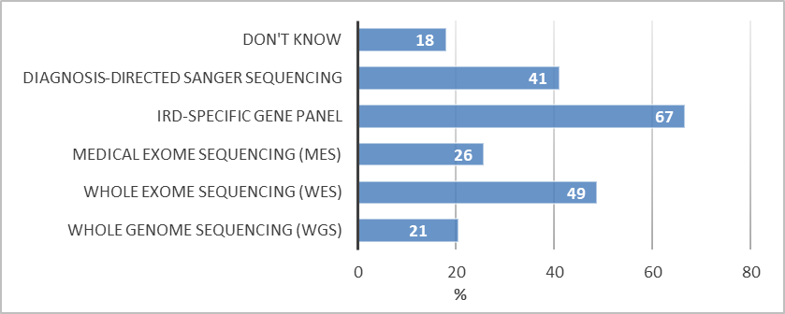

Fig. S6. Technologies to perform genetic testing in IRD patients. Multiple choices allowed.

**Supplementary Tables**

Table S1. Number of IRD patients present in databases distributed by country.

|  |  |  |  |  |
| --- | --- | --- | --- | --- |
|  | *Country* | *No.* | *Total replies per country* | *% per country* |
| < 100 | Germany | 1 | 11 | 9 |
| Italy | 1 | 8 | 13 |
| Portugal | 1 | 6 | 17 |
| Spain | 3 | 9 | 33 |
| United Kingdom | 1 | 2 | 50 |
| 100 - 499 | Belgium | 1 | 2 | 50 |
| France | 1 | 2 | 50 |
| Germany | 3 | 11 | 27 |
| Italy | 5 | 8 | 63 |
| Portugal | 1 | 6 | 17 |
| Spain | 2 | 9 | 22 |
| United Kingdom | 1 | 2 | 50 |
| 500 - 1999 | Austria | 1 | 1 | 100 |
| France | 1 | 2 | 50 |
| Germany | 4 | 11 | 36 |
| Israel | 1 | 1 | 100 |
| Spain | 2 | 9 | 22 |
|  | the Netherlands | 1 | 3 | 33 |
| 2000 - 4999 | Italy | 1 | 8 | 13 |
| the Netherlands | 2 | 3 | 67 |
| > 5000 | Germany | 1 | 11 | 9 |
|  | Spain | 1 | 9 | 11 |
| *Total* | *-* | *36* | *-* | *-* |

Table S2. Current age of the majority of the diagnosed IRD cases.

|  |  |  |
| --- | --- | --- |
|  | *No.* | *%* |
| < 3 years old | 0 | 0 |
| Pre-school (3 - 5 years old) | 1 | 2 |
| School (6 - 17 years old) | 5 | 12 |
| Young adult (18 – 30 years old) | 19 | 45 |
| Adult (> 30 years old) | 14 | 33 |
| Don't know | 3 | 7 |
| *Total* | *42* | *100* |
| *Total of Centers currently managing IRD patients* | *42* | *100* |

Table S3. Visual field testing in patients with IRDs.

Table S3a. Kinetic perimetry devices used in IRD patients.

|  |  |  |
| --- | --- | --- |
|  | *No.* | *%* |
| Goldmann (manual) (Haag-Streit AG, Koeniz, Switzerland)* | 27 | 84 |
| Octopus (Haag-Streit AG, Koeniz, Switzerland) | 10 | 31 |
| Other: Humphrey® Field Analyzer (Carl Zeiss Meditec AG, Jena, Germany) | 2 | 6 |
| Other: OCULUS Twinfield® 2 (Oculus Inc., Wetzlar, Germany) | 1 | 3 |
| *Total* | *40* | *125\*\** |
| *Total of Centers using kinetic perimetry* | *32* | *100* |

*The device is no longer supported technically. Yet, consumables are still available. **Multiple choices allowed.

Table S3b. Static perimetry devices used in IRD patients.

|  |  |  |
| --- | --- | --- |
|  | *No.* | *%* |
| Humphrey® (Carl Zeiss Meditec AG, Jena, Germany) | 32 | 89 |
| Octopus (Haag-Streit AG, Koeniz, Switzerland) | 10 | 28 |
| Twinfield® (Oculus Inc., Wetzlar, Germany) | 4 | 11 |
| Other: Compass (CenterVue Inc., Fremont, CA, USA) | 1 | 3 |
| *Total* | *47* | *131\** |
| *Total of Centers using static perimetry* | *36* | *100* |

*Multiple choices allowed.

Table S3c. Fundus-controlled perimetry devices used in IRD patients.

|  |  |  |
| --- | --- | --- |
|  | *No.* | *%* |
| MP1 (NIDEK Co., LTD, Aichi, Japan) | 2 | 22 |
| MP3 (NIDEK Co., LTD, Aichi, Japan) | 3 | 33 |
| Compass (CenterVue Inc., Fremont, CA, USA) | 1 | 11 |
| Other: MAIA (CenterVue Inc., Fremont, CA, USA) | 4 | 44 |
| *Total* | *10* | *111\** |
| *Total of Centers using fundus-controlled perimetry* | *9* | *100* |

*Multiple choices allowed.

Table S4. Number of genes in each IRD-specific gene panel.

|  | | *No.* | *%* |
| --- | --- | --- | --- |
| General panel | 15 | 1 | 5 |
| 20 | 1 | 5 |
| 108 | 1 | 5 |
| 254 | 1 | 5 |
| 291 | 1 | 5 |
| 346 | 2 | 11 |
| 362 | 1 | 5 |
| 2874 | 1 | 5 |
| 4800 | 1 | 5 |
| All genes described in literature for monogenic causes of blindness | 2 | 11 |
| Regularly updated to published genes | 1 | 5 |
| Don't know | 1 | 5 |
| Not specified | 5 | 26 |
| *Total* | *19* | *100* |
| LCA panel | 9 | 1 | 5 |
| 17 | 1 | 5 |
| 18 | 1 | 5 |
| 20 | 2 | 11 |
| 27 | 1 | 5 |
| 34 | 2 | 11 |
| All genes described in literature for monogenic causes of blindness | 2 | 11 |
| Regularly updated to published genes | 1 | 5 |
| Don't know | 1 | 5 |
| Not specified | 7 | 37 |
| *Total* | *19* | *100* |
| RP panel | 40 | 1 | 5 |
| 58 | 1 | 5 |
| 78 | 1 | 5 |
| 82 | 1 | 5 |
| 91 | 2 | 10 |
| 126 | 1 | 5 |
| 127 | 1 | 5 |
| 256 | 1 | 5 |
| All genes described in literature | 2 | 10 |
| Regularly updated to published genes | 1 | 5 |
| Varies depending on clinical appearance | 1 | 5 |
| Not specified | 7 | 35 |
| *Total* | *20* | *100* |
| CRD panel | 10 | 1 | 6 |
| 22 | 2 | 11 |
| 24 | 1 | 6 |
| 30 | 1 | 6 |
| 47 | 2 | 11 |
| 90 | 1 | 6 |
| All genes described in literature | 2 | 11 |
| Regularly updated to published genes | 1 | 6 |
| Varies depending on clinical appearance | 1 | 6 |
| Not specified | 6 | 33 |
| *Total* | *18* | *100* |
| Optic atrophy panel | 1 | 1 | 6 |
| 4 | 1 | 6 |
| 10 | 1 | 6 |
| 14 | 2 | 11 |
| 16 | 2 | 11 |
| 20 | 1 | 6 |
| All genes described in literature | 2 | 11 |
| Regularly updated to published genes | 1 | 6 |
| Don't know | 2 | 11 |
| Not specified | 5 | 28 |
| *Total* | *18* | *100* |
| Other: Blindness | 260-270 genes covering all known IRD genes (LCA, RP, CRD) | 1 | 100 |
| *Total* | *1* | *100* |
| Other: Macular dystrophy | 16 | 1 | 100 |
| *Total* | *1* | *100* |