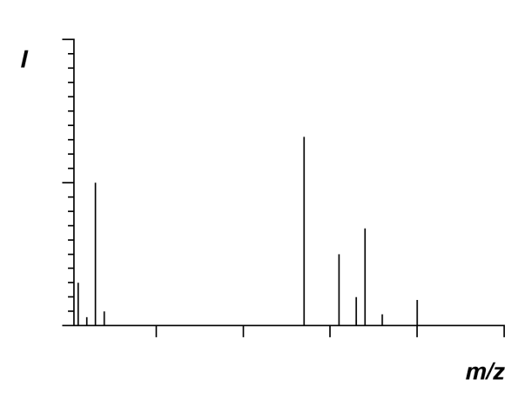
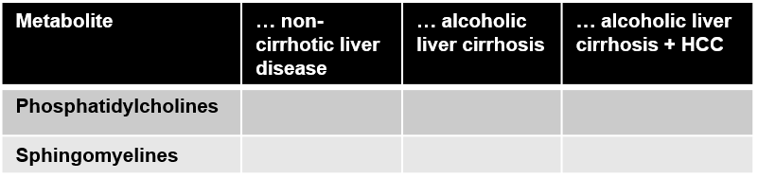
Statistics
Comprehensive metabolomic analysis by mass spectrometry
Healthy controls vs. …

Peripheral blood draw
Blood processing
Storage at
-80°C

Fig. S1: Scheme of experimental workup. Peripheral venous blood was drawn from all individuals, centrifugated and plasma stored at -80°C until further examination. Vials with plasma were sent to Biocrates Life Sciences® where mass spectrometry was performed and data analysis conducted. Further statistics and interpretation of the data was then performed by us.

