**Online Data Supplement**

**Low blood lymphocytes number and lymphocytes decline as key factors in COPD outcomes. A longitudinal cohort study.**

Umberto Semenzato1*, M.D., Davide Biondini1*, M.D., Erica Bazzan1, Ph.D., Mariaenrica Tinè1, M.D., Elisabetta Balestro1, M.D., Barbara Buldini2 M.D., Ph.D., Santiago J Carrizo3,4, M.D., Pablo Cubero5, R.N., Marta Marin-Oto5,6, M.D., Alvise Casara1, M.D., Simonetta Baraldo1 Ph.D., Graziella Turato1 Ph.D., Dario Gregori1, Ph.D., Jose M. Marin3,4,5, M.D., Ph.D., Manuel G. Cosio1,7**, M.D. Marina Saetta1**, M.D.

1Department of Cardiac, Thoracic, Vascular Sciences and Public Health, University of Padova, Padova, Italy; 2Department of Women’s and Children’s Health, University of Padova, Padova, Italy; 3Servicio de Neumología, Hospital Universitario Miguel Servet, IISAragon, Zaragoza, Spain; 4CIBER Enfermedades Respiratorias, Madrid, Spain; 5Unidad de Investigación Traslacional, IISAragon, Zaragoza, Spain; 6Departamento de Neumología, Clinico Universidad de Navarra, Pamplona, Spain; 7Meakins-Christie Laboratories, Respiratory Division, McGill University, Montreal, Quebec, Canada.

* Drs. Semenzato and Biondini contributed equally to this article as first authors.

** Profs. Saetta and Cosio contributed equally to this article as senior authors.

Corresponding author:

Marina Saetta,

Department of Cardiac, Thoracic, Vascular Sciences and Public Health, University of Padova, Via Giustiniani 3, 35128 Padova, Italy.

Email: marina.saetta@unipd.it

**METHODS**

**Patient population**

Participants were recruited consecutively among smokers (>10 pack/years) who first attended the Pulmonary Clinic at the Hospital Universitario Miguel Servet (Zaragoza, Spain) between October 2010 and April 2014. The objective of constituting this cohort was to determine health related outcomes in smokers with and without COPD, free of major comorbidities at recruitment. Eligible individuals were >40 years old smokers who came to the clinic requesting to be included in our smoking cessation program or referred by other doctors to assess their respiratory health. At baseline, all subjects were clinically stable (free of exacerbations and not treated with oral corticosteroids and antibiotics for at least 8 weeks) and they were offered to be included in a smoking cessation program if they were active smokers. All COPD patients received standard treatment at first visit according with current guidelines [E1]. One lung function test and one CBCs done prior to study entry were available in all subjects. Patients who agreed to be included in the cohort signed an informed consent before any procedure was performed.

Of the 2453 smokers who came to the outpatient respiratory clinic during the recruiting period, 1130 subjects did not meet the inclusion criteria (>40 years, >10 pack/years), and 802 were excluded because of concomitant comorbidities. Among the remaining 521, 10 subjects were lost during follow-up, and 511 participants were included in the analysis; 302 with COPD and 209 without COPD (noCOPD) (Fig.E1).

All subjects underwent functional and clinical examination including pulmonary function tests, modified Medical Research Council (mMRC) dyspnea and COPD Assessment Test (CAT) scores evaluation. In COPD subjects FEV1, body mass index, 6MWD and mMRC values were integrated into the BODE index [E2]. Exacerbations were collected and defined as acute worsening of respiratory symptoms that required antibiotics and/or oral corticosteroids (moderate) by medical prescription, or hospitalization/visit at the emergency room (severe) [E1].

**Peripheral blood cell analysis**

Complete blood counts (CBCs) were measured at baseline and at every follow-up visit which was done in stable conditions (>3 months after exacerbation) approximately every year during four years. The lymphocyte value of 1800 cells/µL was used as cut off to define smokers with high (≥1800 cells/µL) or low (<1800 cells/µL) blood lymphocytes (BL) as described in literature [E3]. The difference in BL between the first and the last blood sample drawn was used to calculate the change in BL over time. Decliners were defined as subjects whose BL count were decreased by at least 1% per year (compared to the initial value) in at least 3 years of follow-up.

**Fluorescence-activated cell sorting (FACS) analysis**

In a subgroup of patients lymphocyte subpopulations of T (CD3+), T-helper (CD3+CD4+), T-cytotoxic (CD3+CD8+), B (CD3-CD19+) and NK cells (CD3-CD16+CD56+) were determined by FACS analysis in 50-100 µL aliquots of blood incubated at room temperature with CD45‐FITC, CD3‐PECY5, CD4‐PE, CD8‐ECD, CD56/16‐PE, CD19‐CD fluorochrome-conjugated monoclonal antibodies (Beckman‐Coulter). Then the different lymphocyte subpopulations were identified by immunophenotype markers.

Sample preparation was performed according to the CLSI (H42‐A2) guideline [E4]. In particular, for 15 min after incubation, cytolysis of erythrocytes was performed by TQ‐prep (Beckman‐Coulter) and the samples were analyzed by flow cytometry. The immunophenotyping was performed by 10‐colors flow cytometer Navios (Beckman‐Coulter). Acquisition was run until 25000 events were detected. First the viable part of the sample was selected by physical gating based on forward scatter (FS) and side scatter (SS); the lymphocyte population was identified by the low forward and side scatter and checked for purity by the positivity for CD45.

**Statistical analysis**

Patients characteristics were described using mean±SD or median [range] for continuous variables and counts and percentages for categorical variables. For continuous variables, normal distributions were tested using the Shapiro-Wilk test. Comparisons amonggroups were evaluated with Kruskal-Wallis and Mann-Whitney U tests. Distributions of categorical variables were compared with the χ2-test. In order to confirm BL lymphocytes decline from baseline to every follow-up visit, differences in lymphocytes count were evaluated by the non-parametric test for repeated measures Friedman's two-way analysis of variance by ranks (E5). Analyses of overall survival were performed by Kaplan-Meier survival curves. Multivariate Cox proportional hazard regression model was used to evaluate independent prognostic factors, after adjusting for all non-time-dependent and time-dependent covariates. Variables included in the Cox regression analysis had to be significant in the respective univariate analyses. Hazard ratios (HRs) and 95% confidence intervals (CIs) were estimated for all the variables entered in the final model.

All analyses were performed using SPSS (version 25.0.0.1 for Windows) and R software (version 3.5.3). Statistical significance was assumed for a p value <0.05.

**RESULTS**

**Blood lymphocytes count**

The lymphocytes count in peripheral blood were not different between active smokers and former smokers in the whole population (p=0.195). Similar results were observed also in noCOPD and COPD.

NoCOPD: BL 2250 (1767-2750) cells/µL in former smokers vs 2460 (1970-3100) cells/µL in active smokers (p=0.069).

COPD: BL 1900 (1510-2480) cells/µL in former smokers vs 1820 (1465-2300) cells/µL in active smokers (p=0.122).

**Blood lymphocytes count and comorbidities**

A higher number of subjects with COPD developed at least one comorbidity (other than cancer) during the follow-up period compared to noCOPD (85% vs 77%; p<0.001). The incidence of comorbidities, other than cancer, was not influenced by neither the BL count nor the BL decline in both noCOPD and COPD (Table 2 on the main manuscript).

**SUPPLEMENTARY FIGURES**

**Figure E1: CONSORT diagram. Flow chart of the study design.**



**Figure E2: Distribution of blood lymphocytes.** Mean blood lymphocytes distributions in:

**Panel A)** subjects without COPD (noCOPD) (median, interquartile range: 2300, 1827-2920 cells/μL).

**Panel B)** subjects with COPD (COPD) (median, interquartile range: 1880, 1495-2420 cells/μL).



**Figure E3. FACS analysis of lymphocyte subsets and NK cells.** FACS analysisin subjects without COPD (Panel A) and subjects with COPD (Panel B) divided in subgroups according to high and low BL. Panels show: a) percentage of CD4+ and CD8+ cells; b) CD4/CD8 ratio and c) percentage of B cells and NK cells.



**Figure E4. Dyspnea in smokers with and without COPD.** Percentage of smokers with a dyspnea score (mMRC) ≥2 in:

**Panel A)** smokers without and with COPD;

**Panel B)** smokers without and with COPD divided in subgroups according to high and low BL. The percentage of subjects with mMRC≥2 in COPD with low BL was significantly higher compared to COPD with high BL.

* p=0.006; ** p<0.001.

**Figure E5. Frequency of exacerbations in subjects with COPD according to high and low BL.**

**Panel A)**: COPD with low BL have a significantly higher number of total exacerbations compared to those with high BL (1.27±2.25 vs 0.80±1.29, *p=0.028);

**Panel B):** COPD with low BL have a significantly higher number of severe exacerbations compared to those with high BL (0.08±0.21 vs 0.04±0.11, *p=0.046);

Histograms mean ± SE.

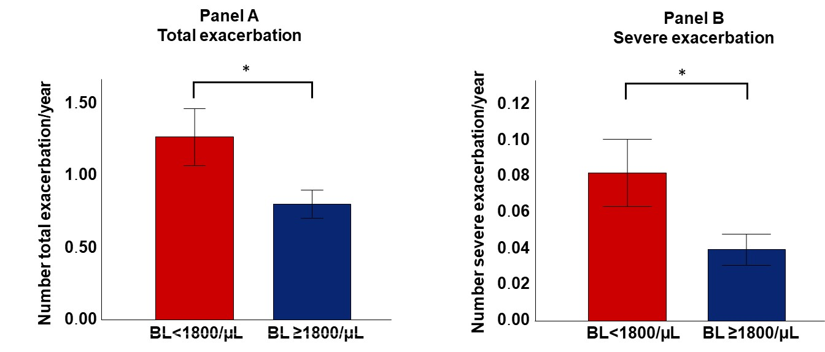

**Figure E6. Causes of death.**

Causes of death (n-%):

**Panel A)** in the 20subjects without COPD (noCOPD) who died;

**Panel B)** in the 114 subjects with COPD (COPD) who died.



**SUPPLEMENTARY REFERENCES**

E1. Global Strategy for the Diagnosis, Management and Prevention of Chronic Obstructive Pulmonary Disease, Global Initiative for Chronic Obstructive Lung Disease (GOLD) 2020. goldcopd.org

E2. Celli BR, G Cote C, Marin JM, et al., The body-mass index, airflow obstruction, dyspnea, and exercise capacity index in chronic obstructive pulmonary disease. N Engl J Med 2004;350:1005-12.

E3. Schaberg T, Theilacker C, Nitschke OT, Lode H. Lymphocyte subsets in peripheral blood and smoking habits. Lung. 1997;175:387–94.

E4. Tosato F, Bernardi D, Sanzari MC, Pantano G, Plebani M. Biological variability of lymphocyte subsets of human adults' blood Clin Chim Acta. 2013;424:159-63.

E5. Bertouch JV, Roberts-Thomson PJ, Bradley J. Diurnal variation of lymphocyte subsets identified by monoclonal antibodies. BMJ. 1983;286:1171-1172