Supplementary Material.
Supplementary Fig 1. Asian subgroup analysis patient disposition.

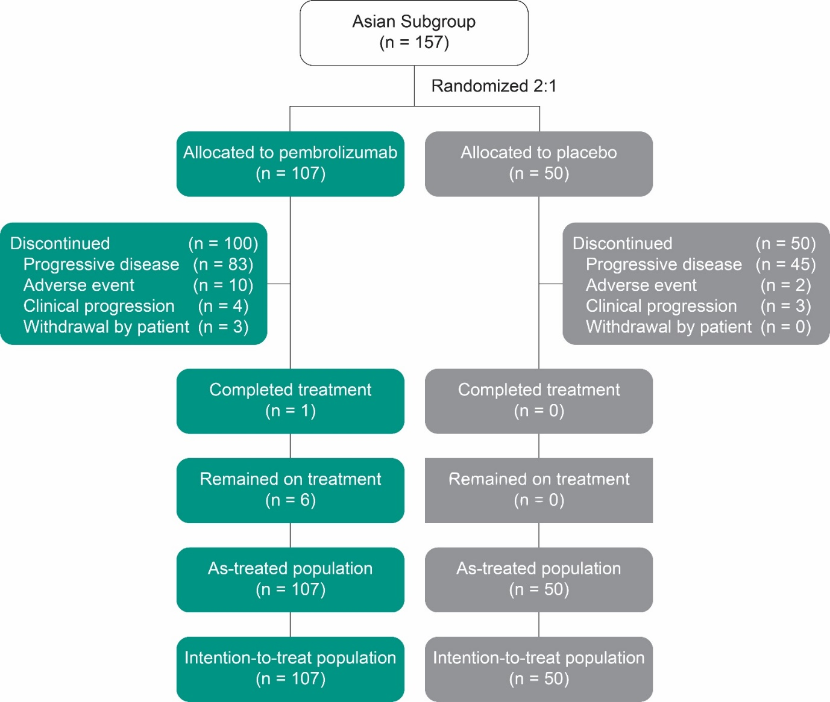

Supplementary Fig 2. Percentage of patients on post-study anticancer therapy among those alive by month.
