Groups | N | Patients
Group 1 | 5 | allergy⁻ asthma⁻ (Control)
Group 2 | 6 | allergy⁻ asthma⁺
Group 3 | 5 | allergy⁺ asthma⁻
Group 4 | 11 | allergy⁺ asthma⁺
Supplementary material

Table S1. The groups of CRSwNP patients

Level of infiltration | Score
< 10 cells/hpf | 1
10 - 24 cells/hpf | 2
25 - 39 cells/hpf | 3
40 - 54 cells/hpf | 4
55 - 69 cells/hpf | 5
70 – 84 cells/hpf | 6
> 85 cells/hpf | 7

Table S2. Scoring system for eosinophil infiltration in NP tissue. The average score of 5 hpfs was used to determine eosinophil infiltration in tissue.

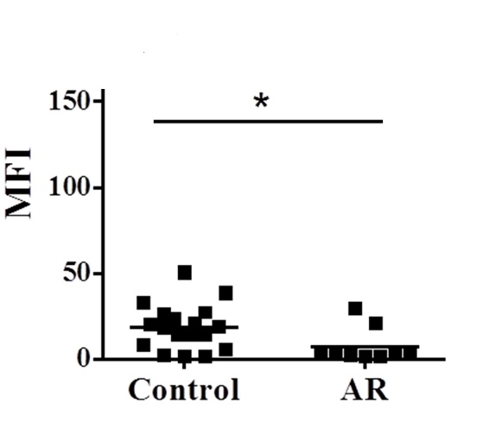
A
B
mCD48
Figure S1 (Supplementary Figure 1)

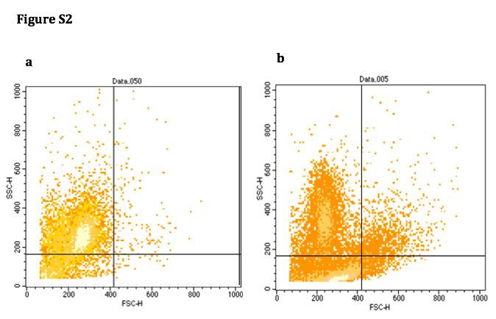
Figure S2: Eosinophils obtained following human NP digestion

After enzymatic digestion, nasal polyps were analyzed by FACS for physical
parameters and CCR3 staining. As expected, nasal polyp eosinophils were CCR3+, SSC^{High}. Eosinophils from asthmatic nasal polyposis patients displayed higher SSC parameters. The data represents two out of nine nasal polyps that were analyzed. S2a: Non-asthmatic donor; S2b: Asthmatic donor.

