Supplementary Figure 2 a: Forest plot showing overall mortality in mixed, surgical and non-surgical patients

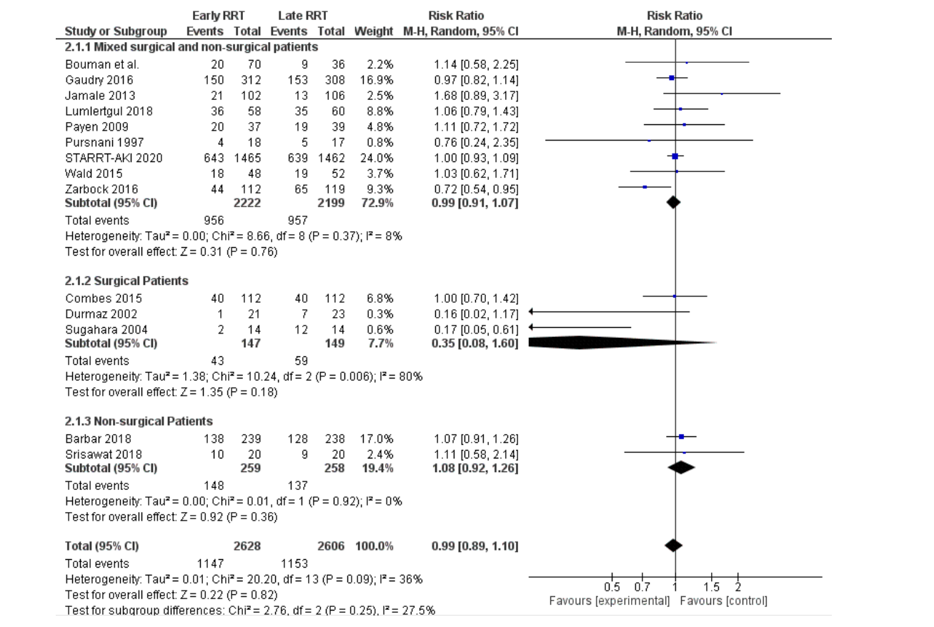

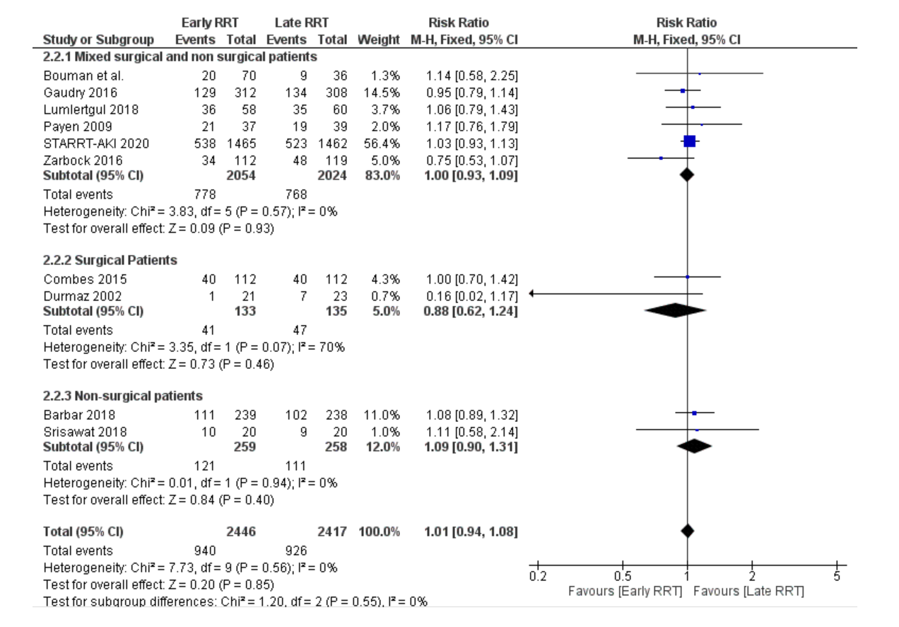

Supplementary Figure 2 b: Forest plot showing mortality on day 30 in mixed, surgical and non-surgical patients

Supplementary Figure 2 c: Forest plot showing mortality on day 90 in mixed, surgical and non-surgical patients

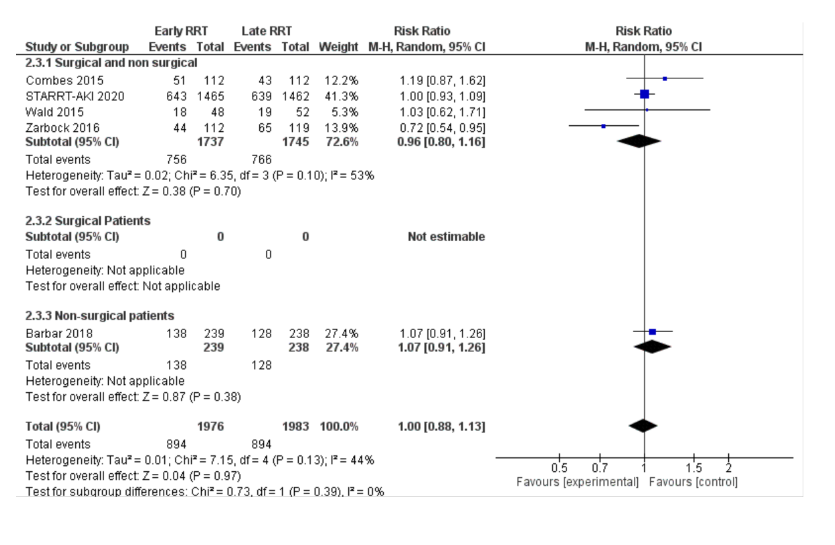

Supplementary Figure 2d: Forest plot showing overall ICU mortality in mixed, surgical and non-surgical patients

