Supplementary Figure 3a: Forest plot showing overall mortality based on severity of disease

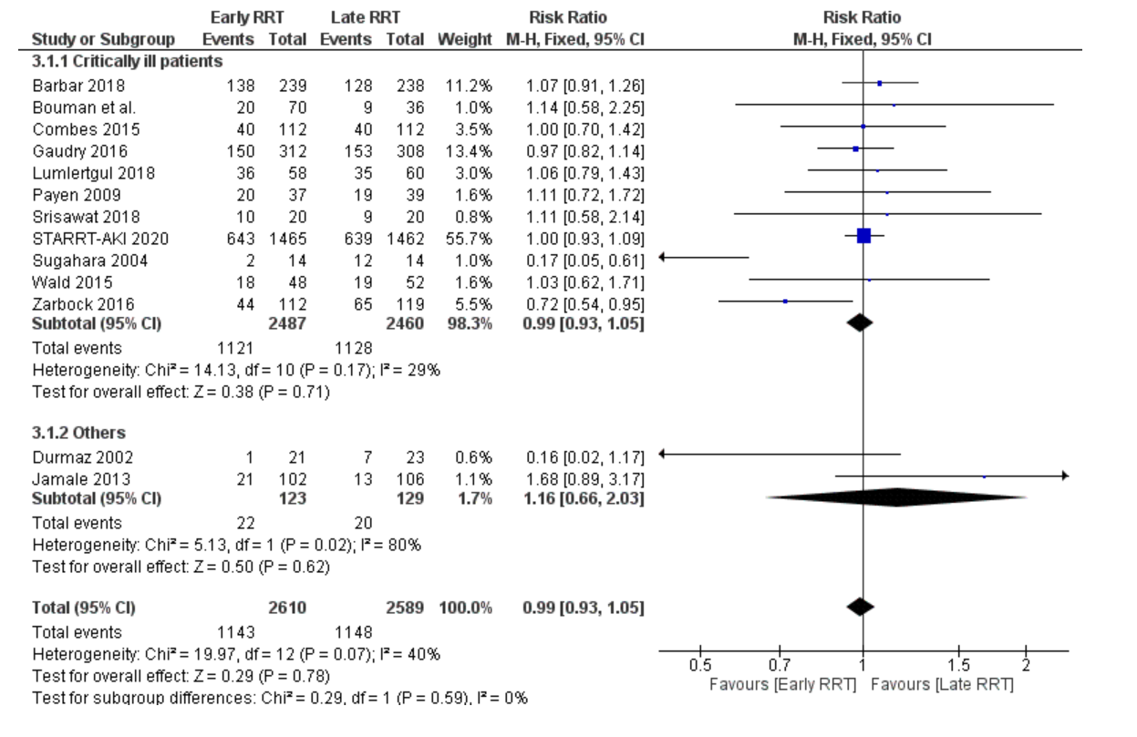

Supplementary Figure 3b: Forest plot showing 30-day mortality based on severity of disease
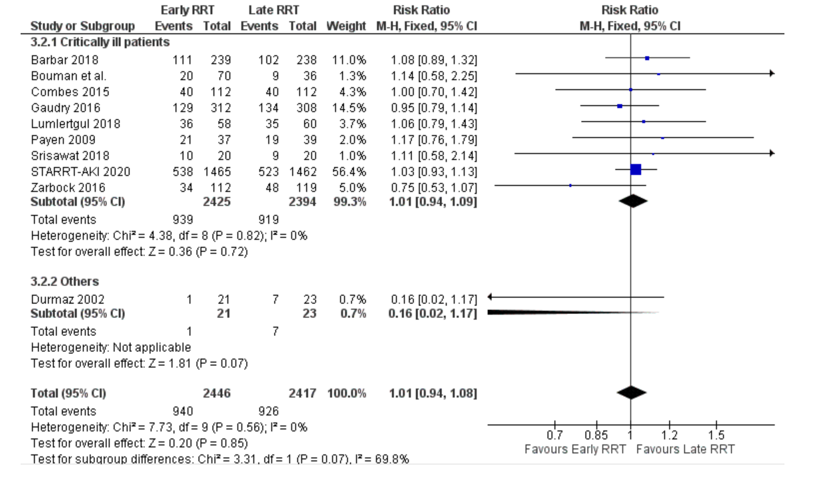

Figure 3c: Forest plot showing 90-day mortality based on severity of disease

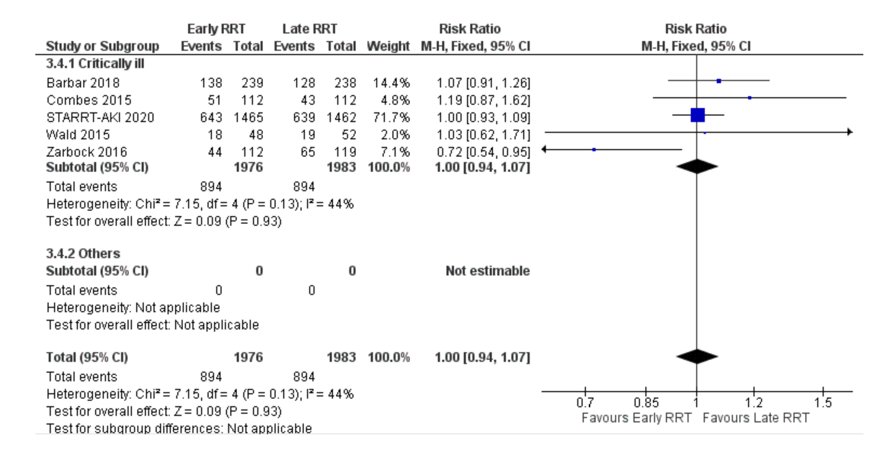

Figure 3 d: Forest plot showing overall mortality based on severity of disease.

