Figure 4a: Forest plot showing overall mortality based on modality of RRT

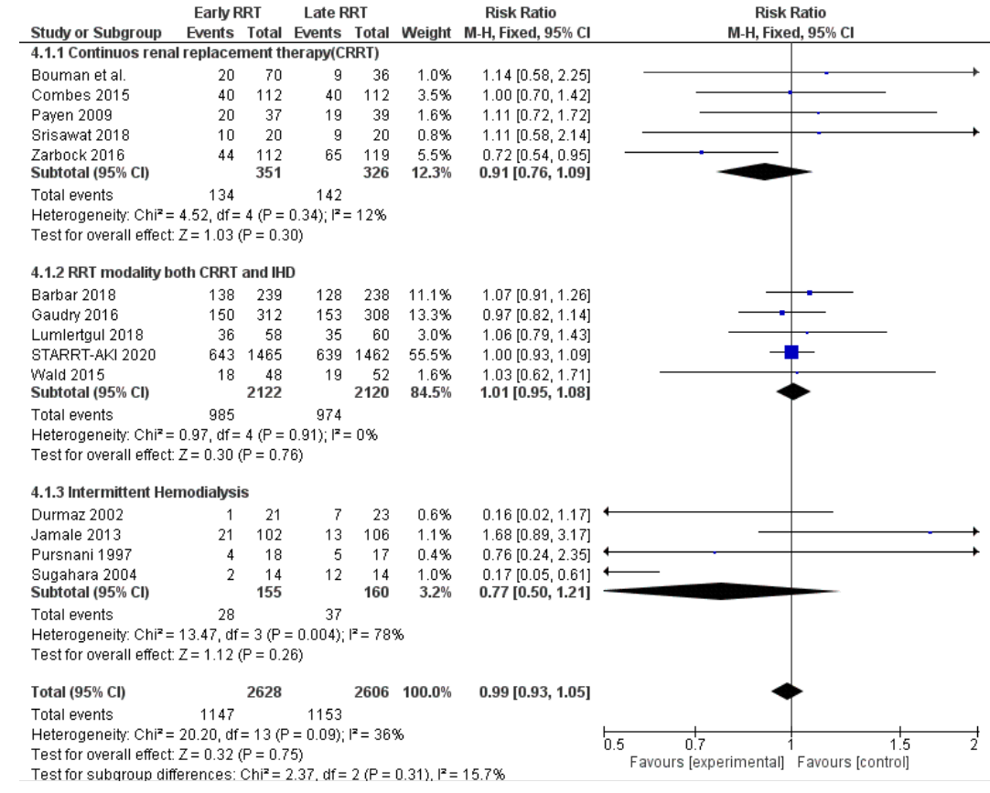

Supplementary Figure 4b: Forest plot showing day 30 mortality based on modality of RRT

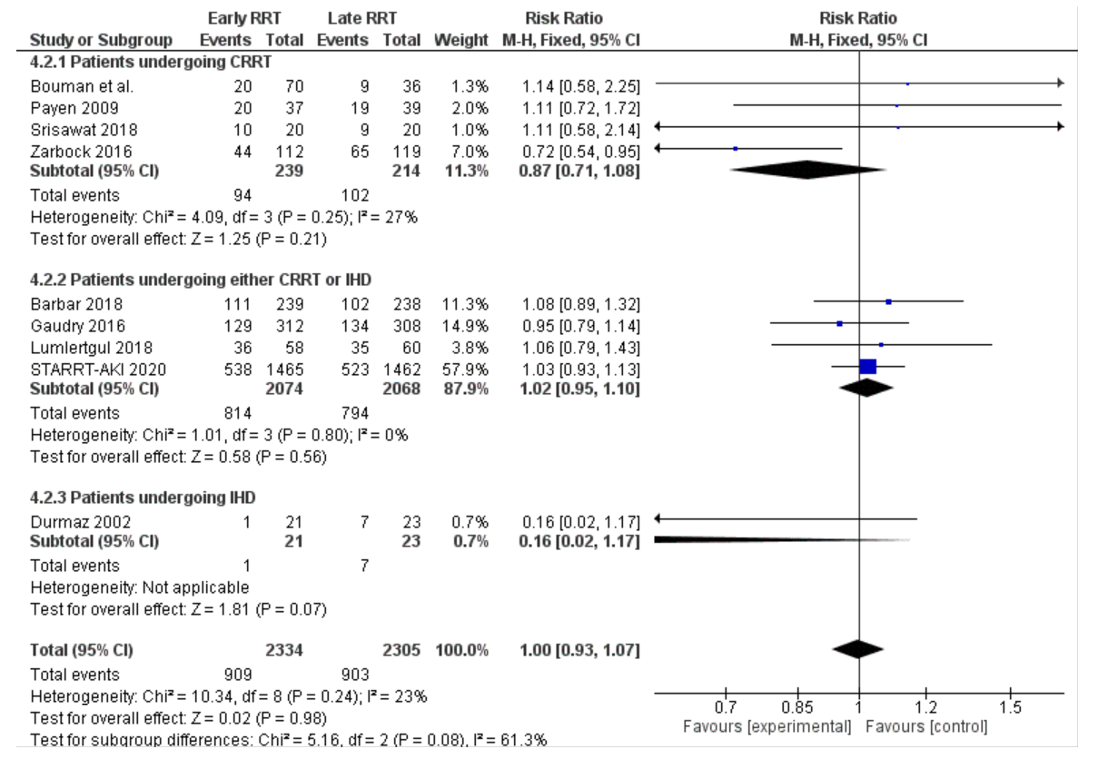

Supplementary Figure 4c: Forest plot showing day 90 mortality based on modality of RRT

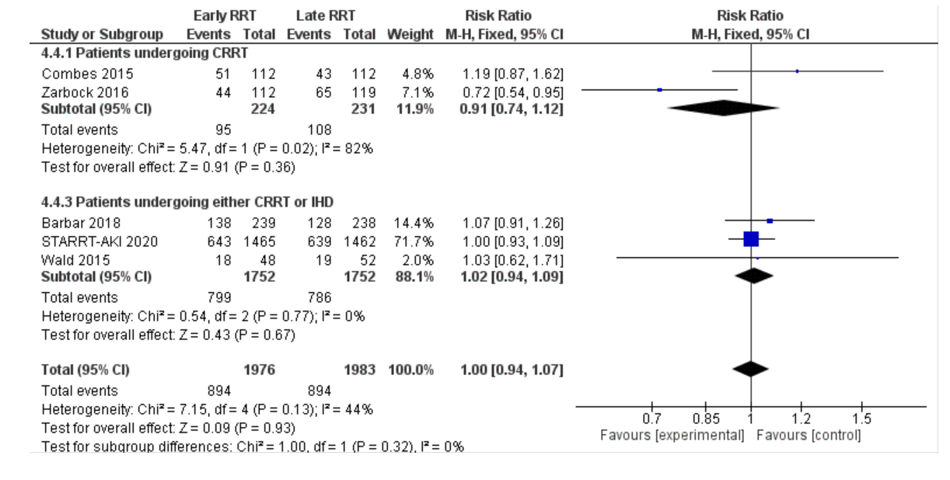

Supplementary Figure 4d: Forest plot showing overall ICU mortality based on RRT modality

