Figure 6a: Overall mortality based on type of study (multicentre versus single centre)

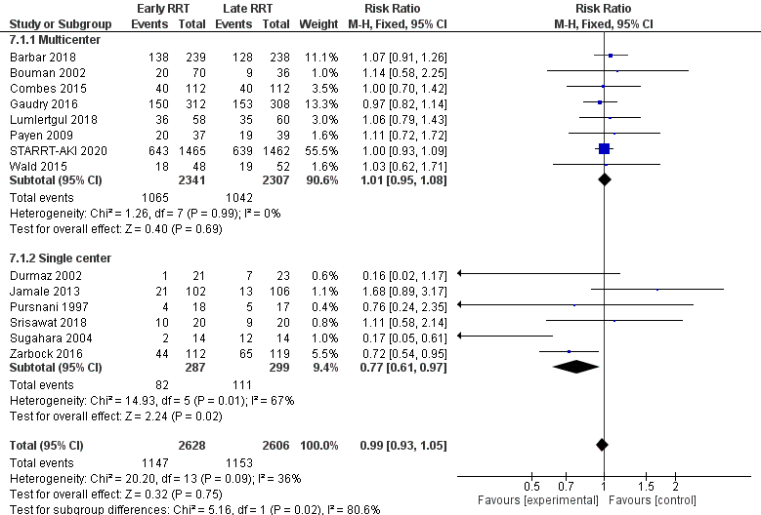

Figure 6 b: Day 60 mortality based on type of study (single center versus multicenter)

