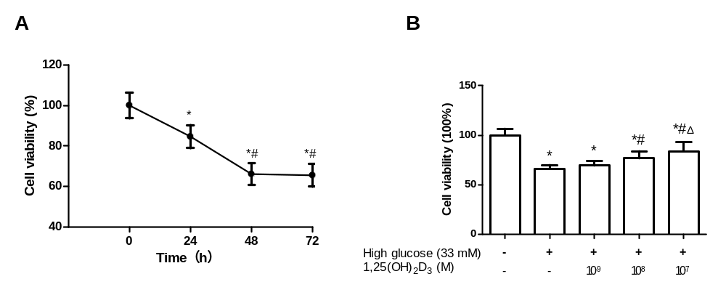
Supplemental figure 1. 1,25(OH)₂D₃ improved cell viability of HUVECs under hyperglycemic condition. A：Time effects of high glucose on cell viability of HUVECs. HUVECs were incubated with high glucose (33 mM) for 0 h, 24 h, 48 h, and 72 h, respectively. Results are expressed as mean ± SD, n = 3; *P<0.05 versus 0 h, #P<0.05 versus 24 h. B: Dose effects of 1,25(OH)₂D₃ on cell viability of HUVECs under hyperglycemic condition. HUVECs were pretreated with vehicle or 1,25(OH)₂D₃ (10⁻⁹~10⁻⁷ M) for 45 min and then exposed to high glucose (33 mM) for 48 h. Results are expressed as mean ± SD, n = 3; *P<0.05 versus control, #P<0.05 versus high glucose (33 mM), ΔP<0.05 versus high glucose (33 mM) + 1,25(OH)₂D₃ (10⁻⁸ M). The comparison was performed by one-way factorial ANOVA followed by a post hoc Scheffé test.
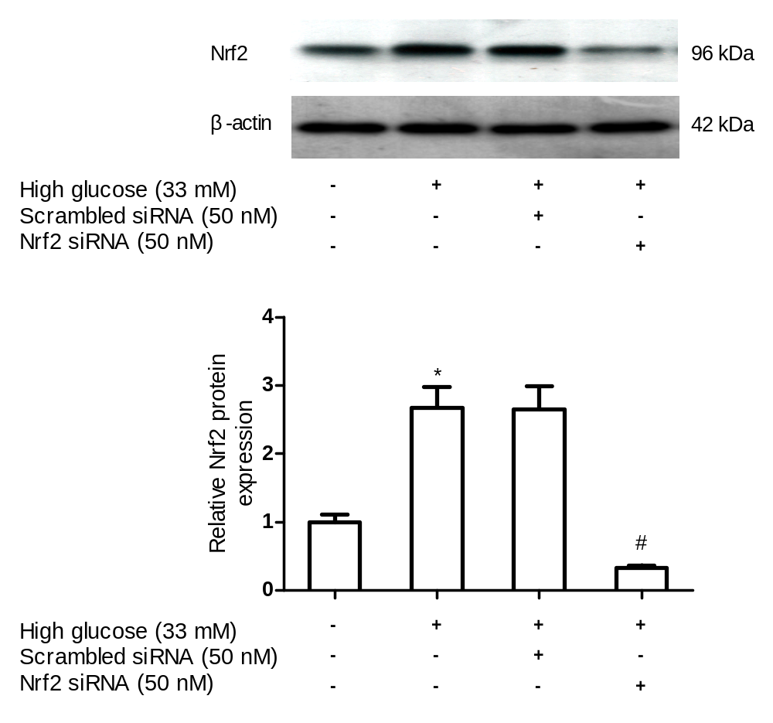
Supplemental figure 2. Effects of Nrf2 specific siRNA transfection on Nrf2 protein expression levels in HUVECs. After Nrf2 specific siRNA transfection for 72 h, HUVECs total proteins were extracted and Nrf2 protein expression levels were measured by immunoblotting analysis. Results are expressed as mean ± SD, n = 5; *P<0 05 versus control, #P<0 05 versus high glucose (33 mM) + Scrambled siRNA (50 nM). The comparison was performed by one-way factorial ANOVA followed by a post hoc Scheffé test.
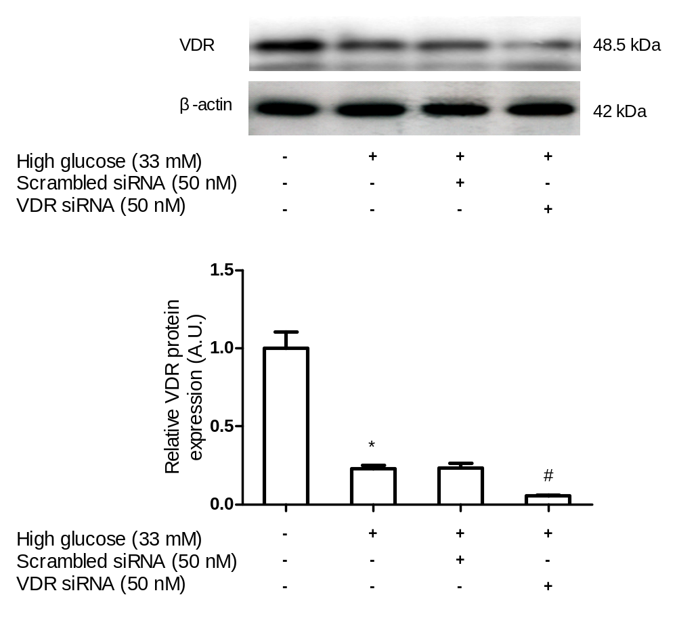
Supplemental figure 3. Effects of VDR specific siRNA transfection on VDR protein expression levels in HUVECs. After VDR specific siRNA transfection for 72 h, HUVECs total proteins were extracted and VDR protein expression levels were measured by immunoblotting analysis. Results are expressed as mean ± SD, n = 5; *P<0 05 versus control, #P<0 05 versus high glucose (33 mM) + Scrambled siRNA (50 nM). The comparison was performed by one-way factorial ANOVA followed by a post hoc Scheffé test.

