Supplementary Material
Methods
MRI Imaging Protocol
An initial coronal localization procedure was performed followed by a 2D Time of Flight (ToF) MR angiogram, which was used to identify the location of the carotid bifurcation and maximal stenosis. Axial images were acquired through the carotid artery, from approximately 40mm below the carotid bifurcation to a point 40mm distal to the extent of the stenosis. Four fast spin-echo pulse sequences, with ECG-gated system, were acquired for carotid plaque tissue characterization, which was T_2 weighted (Repetition Time (TR) = 4040 msec, Time to Echo (TE) = 89 msec), Proton Density (PD) (TR 2720 msec, 29 msec), T_1 weighted (TR 717 msec, 9.9 msec), and short T_1 inversion-recovery. 2D ECG-gated PC-MRI images were acquired at three different locations (common carotid artery (CCA), stenotic region, and internal carotid artery for the patients at approximately 40 equidistant time frames of the cardiac cycle. The scan parameters were TR/TE=24.36/3.59ms, 240 x 240, coronal field of view 111 x 111; velocity encoding (VENC) ranging from 60 to 100 cm/s.
Sample Preparation
After excision, plaque samples were placed in phosphate buffer solution (PBS) and taken for a low energy X-ray at PAH. Further, the samples were transported to the histology facility. There the tissue samples were cut into 3-4mm thick segments, embedded in Optimal Cutting Temperature (OCT) compound (Tissue-Tek OCT, TED Pella Inc CA, USA) and snap-frozen using liquid Nitrogen before storing at -20℃ within 2h of excision. Each segment was used to section 8µm & 30µm thick slices using a cryostat (Leica CM1850). This procedure was repeated for all the samples. Plaque sample preparation and sectioning of different slices is represented in Fig I.
Nano Indentation
To maintain the hydration consistently 2-3 drops of PBS were put on the foam in 20-minute intervals. Following a tip to optics calibration, a trapezoidal load function consisting of loading, holding, and unloading times of 5 seconds each was applied to the indent site. The maximum displacement of 2 µm, with a constant displacement rate of 400 nm/s was used in this study. The indent locations were selected with reference to the histological image of the adjacent section, thereby enabling the mapping of the tissue type with the properties. The number of indents performed on each section depended on the size of the tissue and structural presentation based on histology. The data for the indents that were considered incorrect regarding the indentation depth and partial contact of the tip due to loosely structured tissue was not included in the analysis.

Computational Fluid Dynamics (CFD)
The CFD analysis protocols, mesh size, and time step was used based on the convergence study from our group [1]. Fig II represents the patient-specific carotid bifurcation model and boundary conditions used in this study.
Structural Analysis
Initially, the histology images of the selected segments were co-registered with MRI imaging data with reference from the carotid bifurcation. Later, the corresponding slice was identified based on the calcification and lipids visible from low-energy x-ray and histological images. From the MRI, different components of plaque were manually segmented using an open-source software ImageJ (imagej.nih.gov/ij/), based on our group’s established protocols [2]. The coordinates were saved as a .txt file in the format required for a finite element solver. The text files were imported to Ansys workbench as a curve that is created from the coordinates file, and later the surfaces were generated from the edges. Fig III represents segmentation procedure and boundary conditions used in this study.
Data Analysis
The histological sections were matched to MRI images based on the bifurcation location and the presence of calcification from histology and low energy x-ray. Fibrous cap thickness (FCT) was measured at the location of the least thickness covering the lipid core. Fiji (https://imagej.net/Fiji/Downloads) was used to evaluate the staining intensity of H & E (general morphology and calcification), Oil Red O for lipids (stained in red), Masson’s Trichrome for hemorrhage (stained in dark pink), CD68 for inflammation (stained in brown-fluffy appearance). The area staining of lipids (LA), calcification (CA), hemorrhage (HA), and macrophages (CD68 staining- MA) was reported as the percentage of total plaque area calculated from the H & E stain. Neovessels were identified from CD31 positive staining that highlights the endothelial cells on the inner lining of the lumen. The number of neovessels was manually counted using a grid of 1 mm². The percentage area of staining of different constituents was compared for different sections analysed in the longitudinal direction of each patient and for all the twenty-nine sections analysed. Reduced modulus values obtained from the nanoindentation tests were mapped to the histological images based on the coordinates of the indent location (shown in Fig. IV). WSS distribution was inspected along the length and at different sections of the plaque tissue and the variations were compared with the morphology. Maximum structural stresses and their location for each section were identified and compared with the percentage of lipid, calcification, and inflammation.

Supplementary Figures:
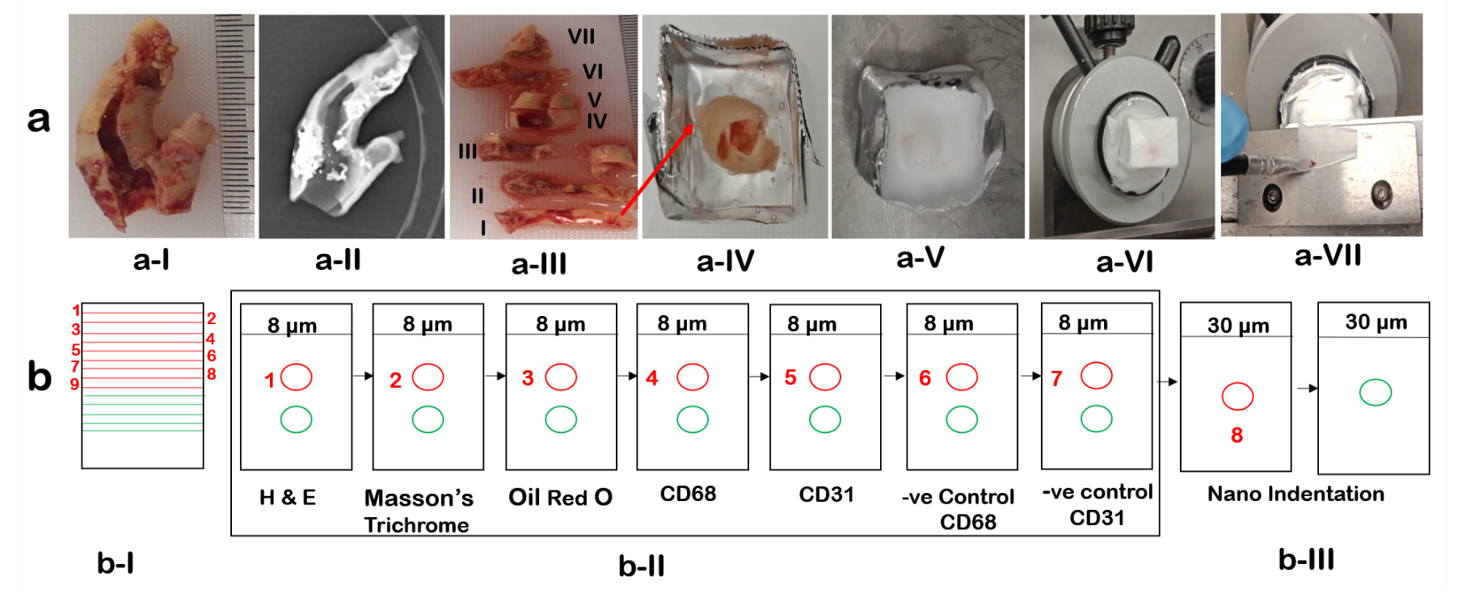
Fig I. Sample Preparation and Sectioning. (a-I) Sample obtained following CEA; (a-II) Low energy X-ray to identify the presence of calcium; (a-III) Cut segments for histological processing and mechanical testing; (a-IV) Sample embedded in OCT; (a-V) Snap frozen in liquid Nitrogen; (a-VI) Cryostat used for sectioning; (a-VII) Thin slices segmented; (b-I) Represents one segment of the plaque used for section slices of different thickness; (b-II) Represents slices for different histological stains (8 µm) and mechanical characterization (30 µm); (b-III) Represents the samples collected for nanoindentation test; Red colour indicates the first level of sectioning, Green colour indicates the second level of sectioning, Numbers in red colour indicate adjacent slides.

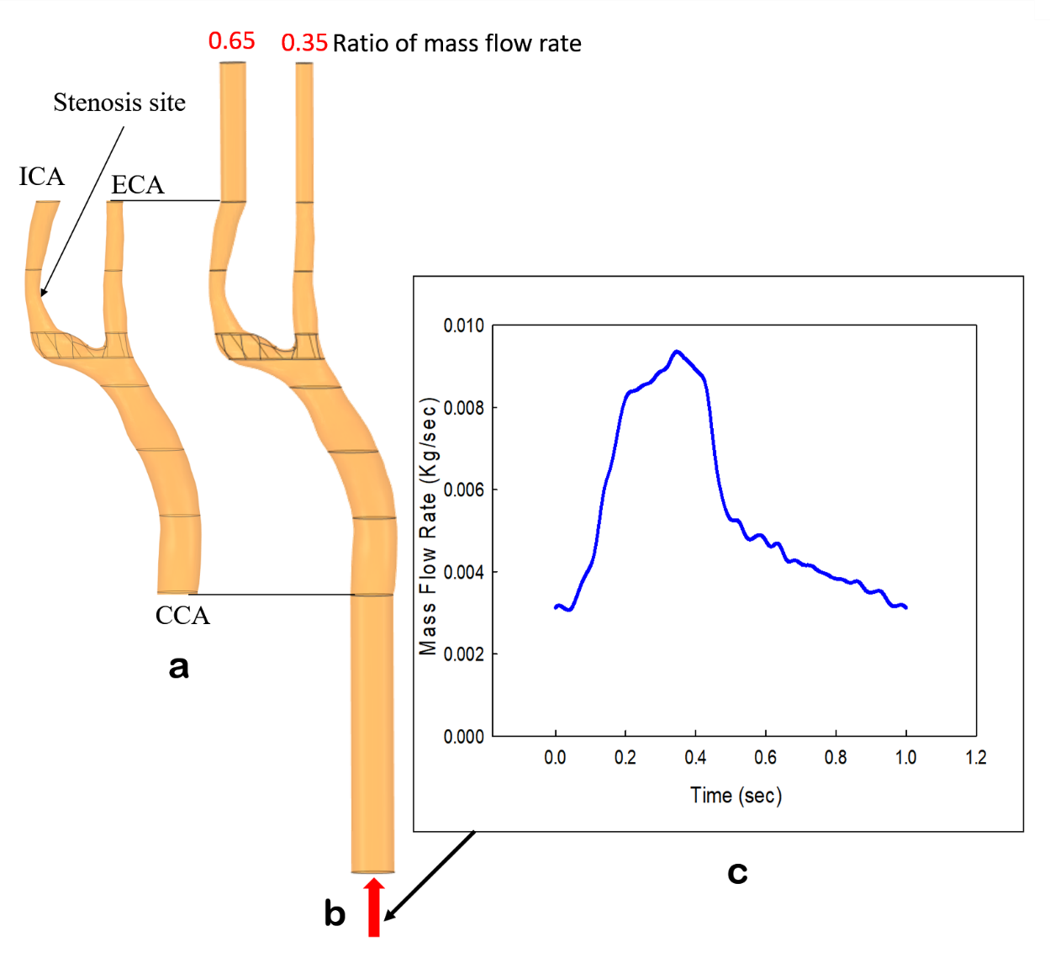
Fig II. CFD Model and boundary conditions. (a) Patient-specific carotid bifurcation model of a patient (P-II) representing CCA, ICA and ECA; (b) Extended model, and boundary conditions; (c) A time-dependent parabolic mass flow rate profile extracted from phase contrast-MRI (PC-MRI) was defined at the inlet of the CCA, and the outflow at the ICA (0.65) and ECA (0.35) was defined as the ratio of the inlet profile.
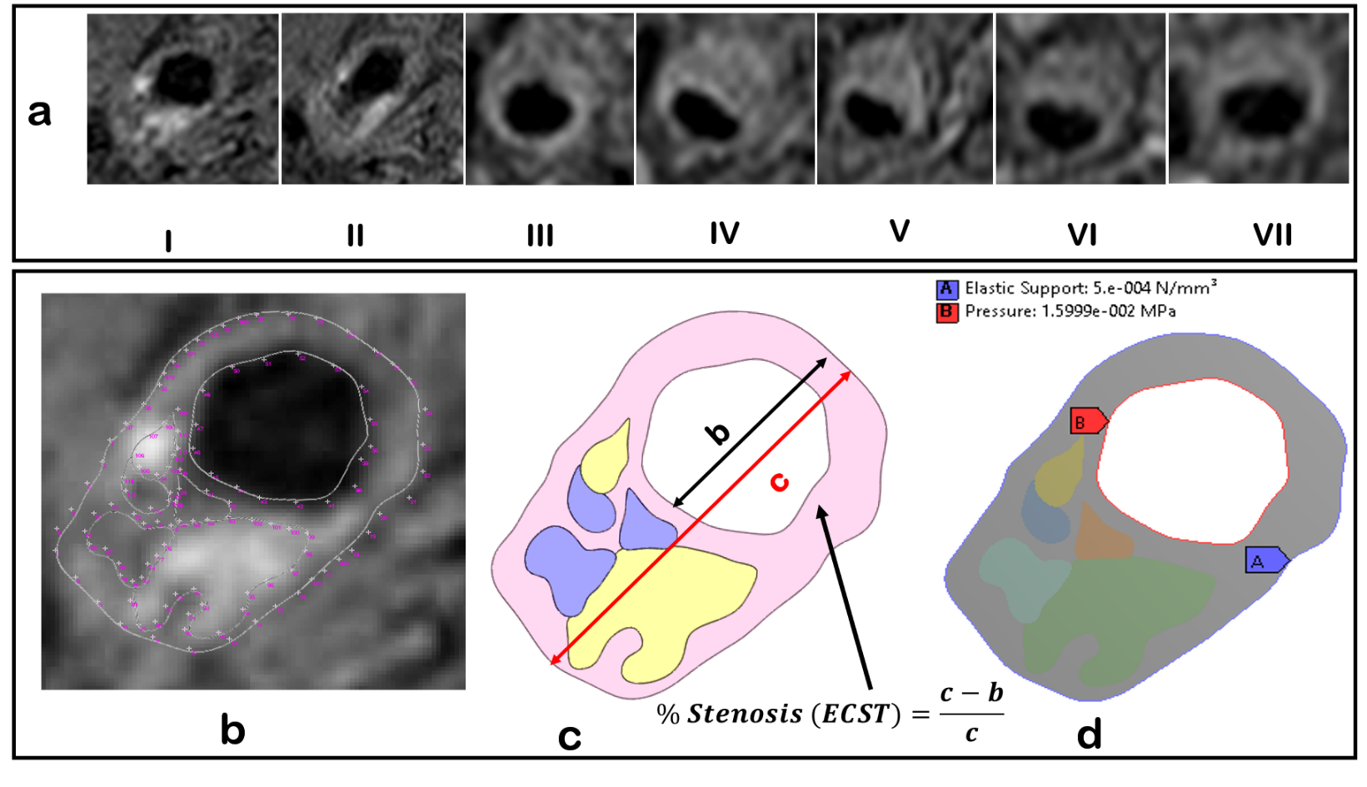
Fig III. Segmentation and Boundary Conditions for Structural Model. (a) Seven MRI sections along the length of the plaque tissue corresponding to histological sections; (b) Represents the MRI section of P-II highlighting the manual segmentation for geometry reconstruction; (c) Represents a reconstructed 2D geometry highlighting the methodology used for calculating the stenosis using ECST; (d) Represents the boundary conditions- Pressure on the lumen and elastic support on the outer wall of the artery.

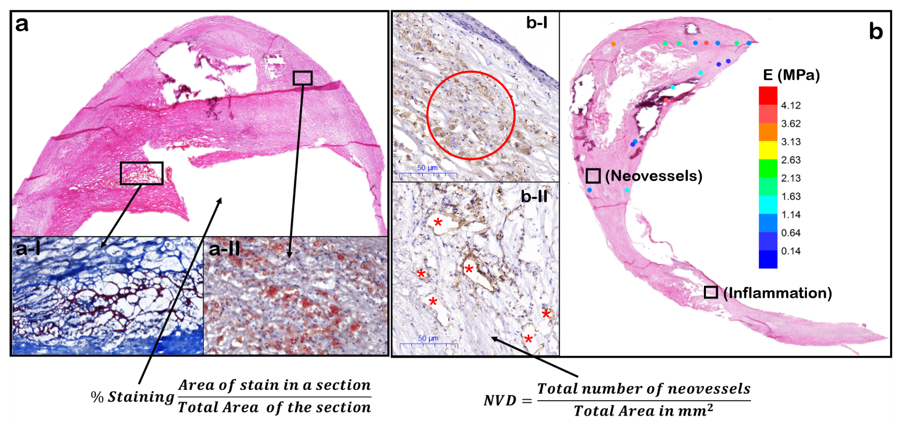

Fig IV. Histological Staining, Nanoindentation Mapping, Geometry Reconstruction for Stress Analysis & Data Analysis. (a) Represents H & E staining for a sample slice (P-II); (a-I) Portion of the slice represented in (a) highlighting the haemorrhage; (a-II) Portion of the slice represented in (a) highlighting the lipids; (b-I) Portion of the slice represented in (b) highlighting the CD68 staining showing the inflammation red circle; (b-II); Portion of the slice represented in (b) highlighting CD31 staining showing the neovascularization red * indicates neovessels; (b) Modulus values extracted from nanoindentation test mapped to the tissue type and values indicated by color coding and corresponding color map (P-II).

Table I: Patient Demographics
Patient | P-I | P-II | P-III | P-IV | P-V | P-VI
Side | Left | Right | Right | Right | Right | Right
Risk | High | Medium | Medium | Medium | Medium | High
Stenosis % | 95-99 | 50-79 | 51-70 | 50-70 | 50-79 | 80-90
Age | 42 | 77 | 76 | 61 | 76 | 78
Sex | M | M | M | M | M | M
Hypertension | Yes | Yes | Yes | No | Yes | Yes
High Cholesterol | Yes | Yes | Yes | Yes | Yes | Yes
Diabetes | No | No | Type2 | No | No | Type2
Smoking | Former | Former | Former | Former | Former | Former
Symptomatic |  | Ischemic Stroke | Transient Ischemic Attack | Ischemic Stroke | Acute Visual Loss, Haemorrhage at imaging
Asymptomatic | High Grade Stenosis at young age |  |  |  |  | 88% Stenosis at Imaging

References:
1. Mendieta, J.B., D. Fontanarosa, J. Wang, P.K. Paritala, T. McGahan, T. Lloyd, Z.J.B. Li, and M.i. Mechanobiology, The importance of blood rheology in patient-specific computational fluid dynamics simulation of stenotic carotid arteries. 2020: p. 1-14.
2. Paritala, P.K., P.K.D.V. Yarlagadda, J. Wang, Y. Gu, and Z. Li, Numerical investigation of atherosclerotic plaque rupture using optical coherence tomography imaging and XFEM. Engineering Fracture Mechanics, 2018. 204: p. 531-541.

