Online Supplementary Material
Supplementary Table 1. Search terms applied to publication databases and secondary sources.

No. | Search
1 | exp Carcinoma, Hepatocellular/ or exp Liver Neoplasms/
2 | HCC.mp.
3 | ((hepat* or liver) adj3 (neoplasm* or cancer* or tumo?r* or malignan* or carcinoma*)).mp.
4 | 1 or 2 or 3
5 | exp Sorafenib/
6 | (sorafenib or nexavar*).mp.
7 | (atezolizumab or tecentriq* or mpdl 3280* or mpdl3280* or rg 7446 or rg7446).mp.
8 | exp Nivolumab/
9 | (nivolumab or opdivo* or 'bms-936558' or 'mdx-1106' or 'ono-4538' or 'bms936558' or 'mdx1106' or 'ono4538').mp.
10 | exp Bevacizumab/
11 | (bevacizumab or avastin*).mp.
12 | (lenvatinib or lenvima* or kisplyx* or 'e 7080' or 'e7080').mp.
13 | ((arterial or transarterial) adj2 chemoemboli?ation*).mp.
14 | exp Chemoembolization, Therapeutic/
15 | TACE.mp.
16 | exp Radiotherapy/
17 | radiotherap*.mp.
18 | (radiation adj (therap* or treatment*)).mp.
19 | 5 or 6 or 7 or 8 or 9 or 10 or 11 or 12 or 13 or 14 or 15 or 16 or 17 or 18
20 | randomized controlled trial.pt.
21 | controlled clinical trial.pt.
22 | randomi#ed.ab.
23 | placebo.ab.
24 | randomly.ab.
25 | clinical trials as topic.sh.
26 | trial.ti.
27 | 20 or 21 or 22 or 23 or 24 or 25 or 26
28 | 4 and 19 and 27

Ovid MEDLINE and Epub Ahead of Print, In-Process & Other Non-Indexed Citations, Daily and Versions 1946 to 24 May 2019 (accessed 28 May 2019) and updated 12 March 2020 (with additional term: “limit 32 to yr="2019 -Current"”).

Supplementary Table 2. Secondary information sources examined in hand search.
Information Category | Specific information sources
Published systematic reviews | The Cochrane Database of Systematic Reviews
Scientific conference presentations (2016–2019) | - European Society for Medical Oncology  - American Society of Clinical Oncology (including the Gastrointestinal Cancers Symposium)  - American Association for Cancer Research  - International Society for Pharmacoeconomics and Outcomes Research  - Health Technology Assessment International  - Society for Medical Decision Making
Health technology assessment organization reports | - National Institute for Health and Care Excellence  - Scottish Medicines Consortium  - All Wales Medicines Strategy Group  - Pharmaceutical Benefits Advisory Committee  - Canadian Agency for Drugs and Technologies in Health (including the pan-Canadian Oncology Drug Review)
Clinical trial registries | International Clinical Trials Registry Platform

Supplementary Table 3. Characteristics of studies and participants included in the all-trials evidence network.
 | Finn et al (2020)  IMbrave150 | Kudo et al (2018)  REFLECT | Yau et al (2019)  CheckMate-459 | Cheng et al (2009)  Asia-Pacific | Llovet et al (2008)  SHARP | Chow et al (2018)  SIRveNIB | Vilgrain et al (2017)  SARAH | Kolligs et al (2015)  SIRTACE | Pitton et al (2015)
Network Intervention (n) | atezolizumab plus bevacizumab (336) | lenvatinib (478) | nivolumab (371) | Placebo/best supportive care (76) | Placebo/best supportive care (303) | SIRT (182) | SIRT (237) | TACE/DEB-TACE (13) | TACE/DEB-TACE (12)
Network comparator (n) | sorafenib (165) | sorafenib (476) | sorafenib (372) | sorafenib (150) | sorafenib (299) | sorafenib (178) | sorafenib (222) | SIRT (15) | SIRT (12)
Design | Open-label randomized, controlled trial | Open-label randomized, controlled trial | Open-label randomized, controlled trial | Blinded randomized, controlled trial | Blinded randomized, controlled trial | Open-label randomized, controlled trial | Open-label randomized, controlled trial | Open-label randomized, controlled trial | Open-label randomized, controlled trial
Age, mean or median | AB: 64 y, S:66y | L:63y, S:62y | N:65y, S:65y | S:51y, P:52y | S:65y, P:66y, | SIRT: 59.5 y, S:57.7y | SIRT: 66 y, S:65y | SIRT: 65.8 y, T:66.7y | SIRT: 72 y, T:70y
Age ≥ 65 years | AB: 48%, S:55% | L: 44% S: 41% | NA | NA | NA | NA | NA | NA | NA
Sex, male | AB: 82%, S:83% | L:85%, S:84% | N:85%, S:85% | S:85%, P:87% | S:87%, P:87% | SIRT: 81%, S:85% | SIRT: 89%, S: 91% | SIRT: 85%, T:87% | SIRT: 66%, T:83%
Follow-up, median, months | AB: 8.9  S: 8.1 | Overall: 27.7 | N: 15.2  S: 13.4 | Unclear | NA | Unclear | SIRT: 28.1  S: 27.9 | Overall: 10.7 | NA
Asia-Pacific region (excl. Japan) | AB: 40% S:41% | L:67%, S:67%* | N:40%, S:40%* | 100% | 0%† | 100% | 0% | 0% | 0%
Race, white | AB: 37%, S:32% | L:28%, S:30% | NA | NA | NA | 0% | NA | NA | NA
Race, Asian | AB: 56%, S:58% | L:70%, S:68% | NA | NA | NA | 100% | NA | NA | NA
ECOG PS, 0 | AB: 62%, S:62% | L:64%, S:63% | N:73%, S:70% | S:25%, P:28% | S:54%, P:54% | SIRT: 74%, S:79% | SIRT: 61%, S:63% | SIRT: 77%, T:80% | NA
ECOG PS, 1 | AB: 38%, S:38% | L:36%, S:37% | N:27%, S:30% | S:69%, P:67% | S:38%, P:39% | SIRT: 26%, S:21% | SIRT: 39%, S:37% | SIRT: 23%, T:20% | NA
HBV | AB: 49%, S:46% | L:53%, S:48% | N:31%, S:31% | S:71%, P:78% | S:19%, P:18% | SIRT: 51%, S:58% | SIRT: 5%, S:7% | NA | SIRT: 0%, T:8%
HCV | AB: 21%, S:22% | L:19%, S:26% | N:23%, S:23% | S:11%, P:4% | S:29%, P:27% | SIRT: 14%, S:11% | SIRT: 23%, S:22% | NA | SIRT: 42%, T:33%
Etiology, non-viral | AB: 30%, S:32% | L:28%, S:26% | N:45%, S:45% | S:19%, P: | S:52%, P:55% | SIRT: 33%, S:28% | SIRT: 62%, S:61% | NA | SIRT: 42%, T:42%
MVI and/or EHS | AB: 77%, S:73% | L:69%, S:71% | N:75%, S:70% | S:69%, P:68%‡ | S:70%, P:70% | SIRT: 31%, S:30% | SIRT: 63%, S:58% | NA | NA
AFP ≥ 200 µg/L | AB: 43%, S:45% | L:46%, S:39% | N:39%, S:43% | NA | NA | NA | NA | NA | NA
AFP ≥ 400 µg/L | AB: 38%, S:37% | NA | N:33%, S:38% | NA | NA | NA | NA | NA | NA
Child Pugh, A | AB: 99%, S:100% | L:99%, S:99% | N:100%, S:100% | S:97%, P:97% | S:95%, P:98% | SIRT: 91%, S:90% | SIRT: 83%, S:84% | SIRT: 38%, T:27% | SIRT: 83%, T:75%
Child Pugh, A5 | AB: 72%, S:73% | L:77%, S:75% | N:71%, S:70% | NA | NA | NA | NA | NA | NA
Child Pugh, A6 | AB: 28%, S:27% | L:22%, S:24% | N:29%, S:30% | NA | NA | NA | NA | NA | NA
BCLC, C | AB: 82% S:81% | L:78%, S:81% | N:82%, S:78% | S:95%, P:96% | S:82%, P:83% | SIRT: 48%, S:45% | SIRT: 68%, S:67% | SIRT: 23%, T:20% | SIRT: 0%, T:0%
PD-L1 ≥ 1% | AB: 64%, S:57% | NA | N:19%, S:18% | NA | NA | NA | NA | NA | NA
Prior external radiotherapy | AB: 10%, S:10% | L:10%, S:13% | N:12%, S:11% | NA | S:4%, P:5% | NA | NA | NA | NA
Prior locoregional therapy | AB: 52%, S:48% | NA | N:51%, S:56% | NA | S:43%, P:40% | NA | NA | NA | NA
AB, atezolizumab plus bevacizumab; AFP, alpha fetoprotein; BCLC, Barcelona Clinic Liver Cancer; DEB-TACE, drug-eluting bead transarterial chemoembolization; ECOG, Eastern Cooperative Oncology Group; EHS, extrahepatic spread; HBV, hepatitis B virus; HCV, hepatitis C virus; L, lenvatinib; MVI, macrovascular invasion; N, nivolumab; NA, not available or reported; P, placebo/best supportive care; S, sorafenib; SIRT, selective internal radiotherapy; T, TACE/DEB-TACE; TACE, transarterial chemoembolization.
*Included Japan
†Excluded Australasia
‡EHS only

Supplementary Table 4. Overall survival subgroup analyses results.
Hazard ratio  (95% CrI),  Probability of atezolizumab plus bevacizumab (A+B) being superior | Base case analysis | Asia-Pacific region  (excl. Japan)* | Non-Asia-Pacific region (excl. Japan)* | Hepatitis B virus | Hepatitis C virus | Etiology, non-viral | MVI negative and EHS negative | EHS negative | MVI positive or EHS positive or both
A+B versus lenvatinib | 0.63  (0.39–1.04),  97% | 0.61  (0.3–1.3)  92% | 0.56  (0.28–1.14)  95% | 0.52  (0.25–1.08)  97% | 0.41  (0.16–1.06)  97% | 0.91  (0.31–2.88)  56% | 0.68  (0.23–1.94)  77% | NA | 0.63  (0.35–1.15)  95%
A+B versus nivolumab | 0.68  (0.41–1.14),  94% | 0.71  (0.34–1.55)  84% | 0.66  (0.33–1.32)  90% | 0.55  (0.26–1.2)  94% | 0.53  (0.2–1.32)  91% | 0.99  (0.44–2.33)  51% | 0.62  (0.2–1.77)  81% | NA | 0.75  (0.41–1.37)  85%
A+B versus sorafenib | 0.58  (0.39–0.87),  99% | 0.53  (0.29–0.99)  98% | 0.61  (0.36–1.05)  97% | 0.43  (0.24–0.78)  99% | 0.37  (0.16–0.83)  99% | 0.94  (0.48–1.91)  57% | 0.71  (0.26–1.85)  76% | 0.92  (0.47–1.77)  59% | 0.55  (0.35–0.88)  99%
A+B versus SIRT† | 0.51  (0.32–0.82),  100% | 0.47  (0.23–1)  98% | 0.53  (0.27–1.05)  97% | 0.44  (0.21–0.94)  98% | 0.21  (0.07–0.66)  100% | NA‡ | 0.67  (0.23–1.89)  78% | 0.81  (0.4–1.66)  73% | NA
A+B versus TACE§ | NA | NA | NA | NA | NA | NA | NA | NA | NA
A+B versus placebo/best supportive care | 0.40  (0.25–0.64),  100% | 0.36|  (0.17–0.78)  99% | 0.42¶  (0.21–0.85)  99% | 0.32‡  (0.15–0.69)  99% | NA | NA | 0.36  (0.12–1)  98% | 0.48  (0.22–1)  98% | 0.42  (0.24–0.73)  100%
A+B, atezolizumab plus bevacizumab; EHS, extrahepatic spread; MVI, macrovascular invasion; NA, subgroup result not available/reported in source publication; OS, overall survival; SIRT, selective internal radiotherapy; TACE, transarterial chemoembolization.
*The REFLECT and CheckMate 459 trials included Japan; the SHARP trial excluded Australasia.
†Subgroup results were reported only in the SIRVENIB study which did not include non-viral etiology.
‡Subgroup results according to etiology were reported only in the Asia-Pacific study which did not include non-viral etiology and reported only hep B subgroup result.
§OS indirect comparisons with TACE were not feasible because the SIRTACE (TACE vs SIRT) and Pitton et al 2015 studies did not report HR for OS; therefore, the TACE comparison with SIRT could not provide an indirect comparison with the rest of the evidence network through the sorafenib common comparator (via SIRT and sorafenib direct comparison).
|Only Asia-Pacific results.
¶Based only on SHARP results.

Supplementary Table 5. Progression-free survival subgroup analyses results.
Hazard ratio (95% CrI),  Probability of atezolizumab plus bevacizumab (A+B) being superior | All-trials evidence analysis | Asia-Pacific region (excl. Japan)* | Non-Asia-Pacific region (excl. Japan)* | Hepatitis B virus | Hepatitis C virus | Etiology, non-viral | MVI negative and EHS negative | EHS negative
A+B versus lenvatinib | 0.91 (0.42–1.99),  64% | NA | NA | NA | NA | NA | NA | NA
A+B versus nivolumab | 0.63 (0.29–1.41),  92% | NA | NA | NA | NA | NA | NA | NA
A+B versus sorafenib | 0.59 (0.34–1.04),  97% | 0.47 (0.09–2.34)  93% | 0.69 (0.14–3.37)  85% | 0.47 (0.19–1.13)  96% | 0.54 (0.20–1.43)  92% | 0.82 (0.33–2.03)  72% | 0.75 (0.29–1.95)  77% | 0.66 (0.36–1.22)  92%
A+B versus SIRT† | 0.61 (0.31–1.22),  95% | 0.53 (0.06–5.03)  88% | 0.68 (0.07–6.28)  81% | NA | NA | NA‡ | NA | 0.69 (0.34–1.39)  88%
A+B versus TACE§ | NA | NA | NA | NA | NA | NA | NA | NA
A+B versus placebo/best supportive care† | NA | NA| | NA¶ | NA‡ | NA | NA | NA | NA
A+B, atezolizumab plus bevacizumab; EHS, extrahepatic spread; MVI, macrovascular invasion; NA, subgroup result not available/reported in source publication; SIRT, selective internal radiotherapy.
* The REFLECT and CheckMate 459 trials included Japan.
†Subgroup results were reported only in the SIRVENIB study which did not include non-viral etiology.
‡Subgroup results according to etiology were reported only in the Asia-Pacific study which did not include non-viral etiology and reported only hep B subgroup result.
§PFS indirect comparisons with TACE were not feasible because the SIRTACE (TACE vs SIRT) and Pitton et al 2015 studies did not report HR for PFS therefore, the TACE comparison with SIRT could not provide an indirect comparison with the rest of the evidence network through the sorafenib common comparator (via SIRT and sorafenib direct comparison).
|Only Asia-Pacific results.
¶Based only on SHARP results.

Supplementary Table 6. Objective response rate subgroup analyses results.
Odds ratio (95% CrI) | All-trials evidence analysis | Asia-Pacific region  (excl. Japan)* | Non-Asia-Pacific region  (excl. Japan)* | EHS negative
Objective response rate analysis
A+B versus lenvatinib | 0.83 (0.10–6.94),  39% | NA | NA | NA
A+B versus nivolumab | 1.17 (0.14–9.37),  59% | NA | NA | NA
A+B versus sorafenib | 2.76 (0.62–12.65),  94% | 7.74 (1.20–49.11),  98% | 1.61 (0.31–8.23),  83% | 1.80 (0.36–9.12),  82%
A+B versus SIRT† | 0.89 (0.10–4.54),  44% | 0.69 (0.05–9.74),  35% | 0.90 (0.09–9.22),  43% | 0.58 (0.07–3.42),  24%
A+B versus TACE‡ | NA | NA | NA | NA
A+B versus placebo/best supportive care† | NA | NA§ | NA| | NA
A+B, atezolizumab plus bevacizumab; EHS, extrahepatic spread; NA, subgroup result not available/reported in source publication; SIRT, selective internal radiotherapy; TACE, transarterial chemoembolization.
*The REFLECT and CheckMate 459 trials included Japan.
†Subgroup results were reported only in the SIRVENIB study which did not include non-viral etiology.
‡ORR indirect comparisons with TACE were not feasible because the SIRTACE (TACE vs SIRT) and Pitton et al 2015 studies did not report ORR according to RECIST 1.1; therefore, the TACE comparison with SIRT could not provide an indirect comparison with the rest of the evidence network through the sorafenib common comparator (via SIRT and sorafenib direct comparison).
§Only Asia-Pacific results.
|Based only on SHARP results.

Supplementary Table 7. Sensitivity analyses from restricted evidence networks.

Hazard ratio or odds ratio (95% CrI),  Probability of atezolizumab plus bevacizumab (A+B) being superior | Overall survival  (HR) | Progression-free survival (HR) | Objective response rate (OR)
Evidence network excluding locoregional therapies
A+B versus lenvatinib | 0.63 (0.38–1.09),  96% | 0.91 (0.42–1.99),  64% | 0.82 (0.19–3.62),  35%
A+B versus nivolumab | 0.68 (0.40–1.20),  92% | 0.63 (0.29–1.41),  92% | 1.14 (0.27–5.32),  60%
A+B versus sorafenib | 0.58 (0.38–0.89),  99% | 0.59 (0.34–1.04),  97% | 2.76 (0.97–8.19),  97%
A+B versus placebo/best supportive care | 0.40 (0.24–0.67),  100% | NA | NA
Evidence network including active systemic treatments only
A+B versus lenvatinib | 0.63 (0.32–1.25),  94% | 0.91 (0.23–3.65),  62% | 0.82 (0.19–3.62),  35%
A+B versus nivolumab | 0.68 (0.35–1.38),  90% | 0.63 (0.16–2.59),  86% | 1.14 (0.27–5.32),  60%
A+B versus sorafenib | 0.58 (0.35–0.99),  98% | 0.59 (0.23–1.58),  92% | 2.76 (0.97–8.19),  97%
A+B, atezolizumab plus bevacizumab; CrI, credible interval; HR, hazard ratio; NA, not analyzable; OR, odds ratio.

Supplementary Fig. 1. All-trials evidence network.
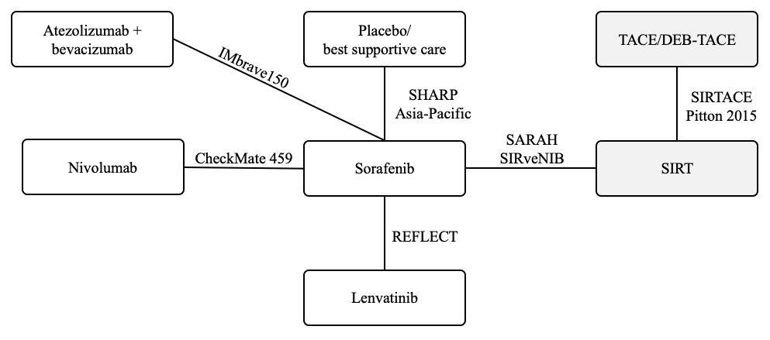

Supplementary Fig. 2. Evidence network excluding locoregional therapies.
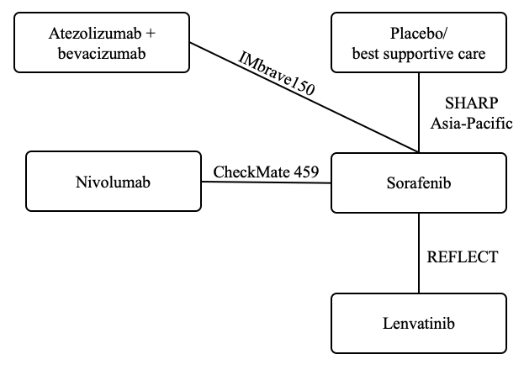

Supplementary Fig. 3. Evidence network including active systemic treatments only.

