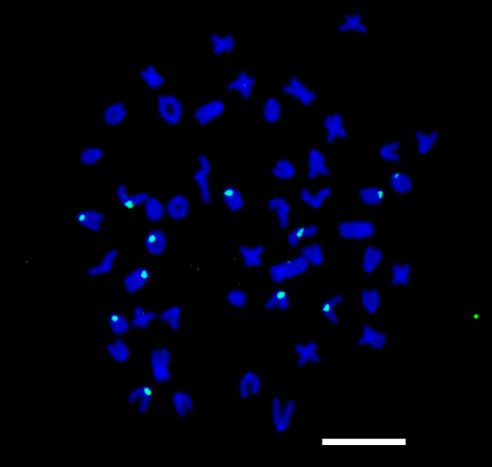
(b)
(a)

Supplementary Fig. S4. Two-color FISH with ManDra-A and ManDra-A 5 repeat probes in somatic cells of inter-group hybrids between wild type dojo loach groups A and B. Representative metaphase in somatic cells from inter-group hybrids between wild type dojo loach groups A and B after two-color FISH with ManDra-A signals (a) and ManDra-A 5 repeat signals (b). ManDra-A 5 repeat probe was labeled with biotin-16-dUTP and detected by streptavidin Alexa Fluor 488 conjugate (green). ManDra-A probe was labeled with digoxigenin-11-dUTP and detected by anti-digoxigenin-rhodamine, Fab fragments (red). All chromosomes were counterstained with DAPI (blue). Scale bars denote 10 μm.

