Supplement Material

Sampling and maintenance of isolates
Water samples were taken from two locations. From an artificial lily pond in the botanical garden Tübingen, Germany, one litre water was taken from the surface of the pond (50 cm from the edge, July 2018). The second sampling point was the Schwarzenbachtalsperre in Forbach, Germany, an artificial water reservoir with 2.5 km in length and 40 m in depth. At five different points, water was taken into 5 litre canisters. Sampling points 1-4 were 50 cm from the shore at the water surface and sampling point 5 was on the middle of the lake in the depth of 1 m. Water from both sampling sides was filtered over gauze to remove big particles like leaves and seeds. Through filtration, microorganisms were trapped on a 0.22 µm membrane filter. Small discs were punched out of the filter with a cork borer. This step intended to reduce the number of microorganisms per isolate. The samples from Forbach were filtrated in the volumes of 10, 20, 50, 100 and 200 ml of every of the five sampling points to get different amounts of cells per filter/disc. Every disc was considered as one isolate. For enrichment of the predatory microorganisms, the discs were placed upside down on a pre-grown lawn of A. variabilis on standard BG11 agar without nitrate [Rippka and Herdmann, 1992] and incubated at 12h diurnal illumination and standard conditions (photon flux density of 50 µmol/s at 28°C) until lysis zones occurred. To prepare lawn plates, round agar plates (diameter 9 cm) were inoculated with 80 µl of a liquid culture with OD₇₅₀ of 15 (concentrated via centrifugation, 4000 g for 5 min). They were incubated at continuous light and standard conditions for 5 days. For maintenance of the isolates, they were transferred regularly onto a fresh lawn plate by cutting out a piece of agar containing the edge of the lysis zone. The enrichment process is shown in Figure 1.

Characterization of isolates
After preliminary enrichment, the prey specificity of the isolates was also tested towards the cyanobacterial strains Anabaena PCC 7120, Synechococcus elongatus PCC 7942 and Synechocystis PCC 6803 (all strains obtained from the Pasteur Culture Collection, Paris, France). The unicellular cyanobacteria (Synechococcales) were cultivated in and tested on standard BG11 media supplemented with nitrate. Anabaena variabilis and Anabaena PCC 7120 (Nostocales) were cultivated in and tested on nitrate free BG11 medium. A. variabilis was additionally tested on nitrate supplemented media. The positive control for prey specificity was successful predation on A. variabilis on nitrate free media.
To determine the size of the predators, liquid cultures of A. variabilis (10 ml, OD₇₅₀ 0.5) were inoculated with the isolates by adding a piece of agar containing the edge of the lysis zone. After incubation (discontinuous light, without shaking) for 10 days or until the culture turned yellow, this was filtered through 1 µm (GE Healthcare, UK, Whatman™, Puradisc™ 25 mm, PES), 0.45 µm and 0.22 µm (Carl Roth, Germany, ROTILABO® 13 mm, PVDF) membrane filters. For every filtrate, drops of 15 µl were applied on a fresh lawn plate of without nitrate. The un-filtrated co-culture served as positive control. As the different isolates behaved differently in speed of lysis, the experiment ended when the positive control showed a clearly visible lysis zone. All experiments were performed in triplicates.
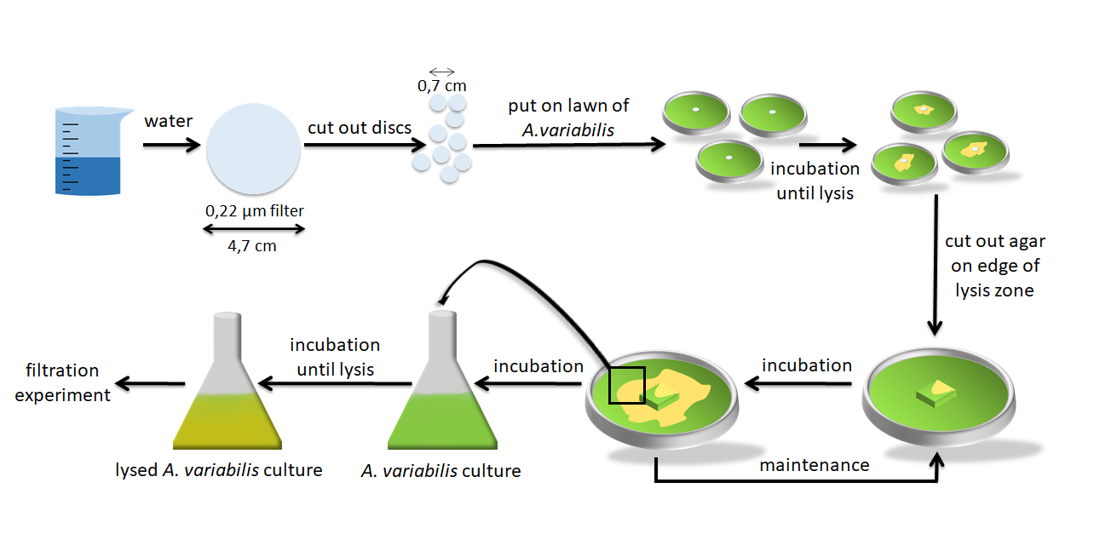
Fig.1. Isolation and enrichment of predatory microorganisms. Freshwater was filtered with a 0.22 µm pore sized membrane filter and cut into smaller discs. One disc was placed in the middle of a densely grown lawn of A. variabilis and incubated in 12h diurnal illumination (photon flux density of 50 µmol/s at 28°C) until lysis zones occurred. For maintenance, a piece of agar of a previous enrichment plate, containing the edge of the lysis zone, was placed on a fresh lawn plate. For filtration experiments, a liquid culture of A. variabilis was inoculated and incubated as previously described.

References:
Rippka R, Herdmann M. Catalogue of Strains. In: Pasteur I, editor. Pasteur Culture Collection of Cyanobacterial Strains in Axenic Culture. France1992. p. 103.

