SUPPLEMENTAL MATERIAL

Supplemental Figure 1. Catalonia acute stroke healthcare centers and regions.
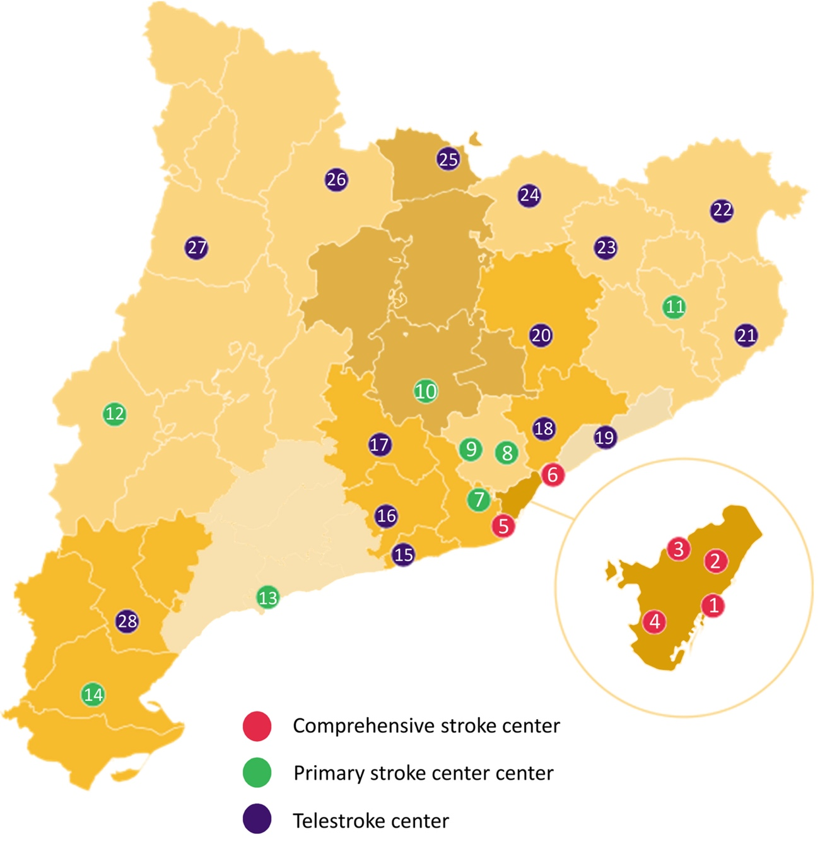

Catalonia acute stroke healthcare system is divided in eight different regions. Acute stroke care is provided in 28 Hospitals: 6 comprehensive stroke centers, 8 primary stroke centers and 14 telestroke centers.

Barcelona (1.821.570 habitants): Hospital del Mar – Parc de Salut Mar (1), Hospital de la Santa Creu i Sant Pau (2), Hospital Universitari Vall d’Hebron (3), Hospital Clínic (4)
Barcelona south metropolitan region (1.444.589 habitants): Hospital de Bellvitge (5), Hospital Comarcal de l’Alt Penedès (16), Hospital d’Igualada (17), Hospital de Sant Joan Despí Moisès Broggi (7), Consorci Sanitari Garraf (15)
Barcelona north metropolitan region (814.322 habitants): Hospital Germans Trias i Pujol (6), Hospital de Mataró (Consorci Sanitari del Maresme) (19)
Tarragona (775.734 habitants): Hospital Joan XXIII (13), Hospital de Tortosa Verge de la Cinta (14), Hospital Comarcal de Móra d’Ebre (28)
Central Catalonia (277.377 habitants): Centre Hospitalari de Manresa – Fundació Althaia (10), Hospital de la Cerdanya (25)
Girona (718.901 habitants): Hospital Universitari de Girona Josep Trueta (12), Hospital de Palamós (21), Hospital de Figueres – Fundació Salut Empordà (22), Hospital d’Olot i Comarcal de la Garrotxa (23), Hospital de Campdevànol (24)
Lleida (408.887 habitants): Hospital Universitari Arnau de Vilanova (12), Fundació Sant Hospital de la Seu d’Urgell (26), Hospital Comarcal del Pallars (27)
Vallès (1.257.525 habitants): Consorci Corporació Sanitària Parc Taulí de Sabadell (8), Hospital Universitari Mútua Terrassa (9), Hospital General de Granollers (18), Consorci Hospitalari de Vic (20)

Supplemental Table 1. Stroke Code activations and baseline characteristics
 | Control period | Pandemic | Relative Difference | P value
Number of Stroke Codes | 1033 | 805 | -22%
Age | 71.6±15 | 71.2±15 |  | 0.383
Gender, women, (% of stroke code activations) | 480 (46%) | 334 (41%) | -5% | 0.033
Unknown time from onset or wake-up  (% of stroke code activations) | 337 (33%) | 336 (42%) | +9% | <0.001
Diagnosis |  |  |  | <0.001
Ischemic | 663 | 503 | -24%
ICH | 125 | 156 | +24%
TIA | 47 | 41 | -12%
Mimic | 198 | 105 | -47%
Source of Stroke Code activation |  |  |  | <0.001
EMS with pre-notification | 547 | 406 | -26%
EMS without pre-notification | 117 | 159 | +36%
ED of no stroke-ready centers | 129 | 80 | -38%
ED of stroke-ready centers (private transport) | 175 | 106 | -39%
In-hospital (previously admitted) | 65 | 54 | -17%
Clinical characteristics
NIHSS | 7 [4-16] | 8 [4-17] |  | 0.083
NIHSS in ischemic stroke | 7 [3-14] | 8 [3-16] |  | 0.307
NIHSS in ICH | 11 [6-21] | 14 [5-21] |  | 0.913
Minor stroke (NIHSS 0-5)  (% of ischemic stroke) | 305 (46%) | 234 (47%) | +1% | 0.831
LVO (% of ischemic stroke) | 155 (23%) | 114 (23%) |  | 0.774

Legend: Data are presented as n (%) for categorical variables and as mean ± SD or median [interquartile range] for continuous variables. ICH: intracranial hemorrhage; TIA: transient ischemic attack; EMS: emergency medical system; ED: emergency department; NIHSS: National Institutes of Health Stroke Scale; LVO: large vessel occlusion.
Supplemental Table 2. Clinical characteristics of 90-days assessed patients depending on study period

 | Control period  n=334/1033 | Pandemic  n=362/805 | p value
Sex, women | 152 (45.5%) | 146 (40.3%) | 0.192
Age | 76 [65.8 – 82] | 76 [65 – 83] | 0.790
Baseline mRS | 0 [0 – 2] | 0 [0 – 1] | 0.065
Onset to arrival (minutes) | 43 [18 – 143] | 150 [72.7 – 510] | <0.001
NIHSS at arrival | 11 [6 – 19] | 13 [8 – 19] | 0.061
LVO | 118 (42.4%) | 95 (34.4%) | 0.011
Mortality at 90 days | 85 (25.4%) | 126 (34.8%) | 0.007
mRS≤2 at 90 days | 135 (40.4%) | 106 (29.3%) | 0.002

Legend: Data are presented as n (%) for categorical variables and median [interquartile range] for continuous variables. mRS: modified Rankin Scale; NIHSS: National Institutes of Health Stroke Scale; LVO: large vessel occlusion.

