Performance- versus Risk Factor-Based Approaches to Coronary Artery Disease Screening in Waitlisted Kidney Transplant Candidates

Supplemental Documents:

S1: Our center’s algorithm for coronary artery disease (CAD) screening prior to kidney transplantation. 2

S2: How a patient progressed from initial evaluation to inclusion in the study cohort. 3

S3: Baseline characteristics and outcomes of cohorts #2 and #3. 4

S4: Main analysis (aim #1), excluding patients with 6-minute walk test results of 0. 7

S5: Secondary analysis (aim #2), stratified by type of cardiac testing (non-invasive versus invasive). 8

Supplemental S1. Our center’s algorithm for coronary artery disease (CAD) screening prior to kidney transplantation.
 | Etiology of End-Stage Kidney Disease
 | Diabetic | Non-diabetic
Initial screening | Coronary angiography if any of:  Age ≥45 years  Diabetes mellitus ≥25 years  Smoker ≥5 years  Abnormal electrocardiogram  Non-invasive stress test otherwise | Non-invasive stress test if any of:  Age ≥50 years  Dialysis ≥5 years  Corticosteroid use  Obesity  Systemic lupus erythematosus  Autosomal dominant polycystic kidney disease  No testing otherwise
Repeat screening | Non-invasive stress test every year or coronary angiography every 3 years if any of:
 | Age ≥45 years  Known CAD  Diabetes mellitus ≥25 years  Smoker ≥5 years  Abnormal electrocardiogram | Age ≥50 years and Known CAD

Supplemental S2. How a patient progressed from initial evaluation to inclusion in the study cohort. Triangles represent cardiac ischemic testing: filled triangles represent tests we requested and performed based on our center criteria (see Supplemental S1); solid-rimmed, hollow triangles represent tests that we possibly (and inconsistently) performed earlier in the waitlist process; notch-rimmed, hollow triangles represent tests ordered by outside physicians for non-transplant purposes, which we reviewed and included if it fell within 6 months of TRAC evaluation.
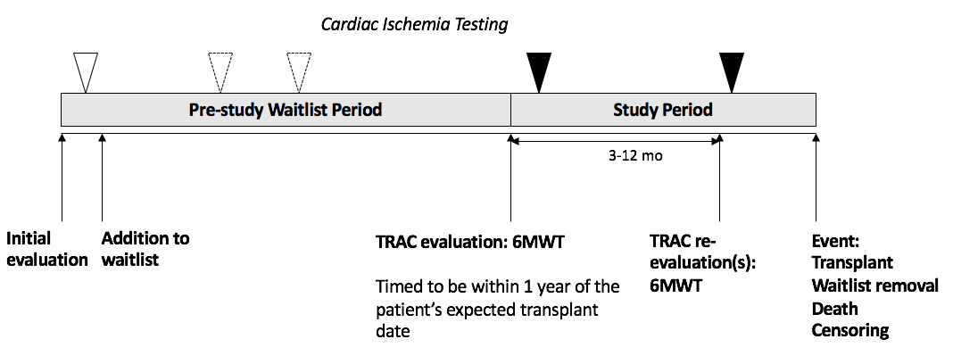

Supplement S3. Baseline characteristics and outcomes of cohorts #2 and #3, stratified by 6-minute walk test (6MWT) results.
Cohort 2
Baseline Characteristics | 6MWT <400 meters  N=107 | 6MWT ≥400 meters  N=89 | p-value
Demographics
Age (years) | 61±6 | 55±12 | <0.0001
Sex (% male) | 57 (53%) | 62 (68%) | 0.04
Race
White | 35 (14%) | 12 (13%) | 0.11
Black | 10 (9%) | 8 (9%)
Hispanic | 56 (51%) | 43 (47%)
Asian | 18 (17%) | 26 (29%)
Other | 10 (9%) | 2 (2%)
Time from listing (years) | 5.9±2.7 | 5.5±2.7 | 0.4
Cardiac Risk Factors and Comorbidities
CAD testing prior to visit | 83 (76%) | 65 (71%) | 0.4
Coronary artery disease with revascularization | 31 (29%) | 24 (26%) | 0.7
Any atherosclerotic disease (CAD equivalent)¹ | 56 (51%) | 34 (38%) | 0.05
Dialysis vintage (years) | 7.1±3.1 | 6.1±3.5 | 0.04
Dialysis modality |  |  | 0.3
Hemodialysis | 94 (87%) | 78 (91%)
Peritoneal dialysis | 14 (13%) | 8 (9%)
Diabetes mellitus | 78 (72%) | 35 (39%) | <0.0001
Hypertension | 96 (88%) | 83 (91%) | 0.5
Any history of smoking | 36 (33%) | 45 (49%) | 0.02
Non-cardiac factors affecting the 6MWT result | 48 (44%) | 23 (25%) | 0.006
Lung disease² | 12 (11%) | 14 (15%) | 0.4
Lower extremity amputation | 14 (13%) | 2 (2%) | 0.005*
Active orthopedic issue³ | 6 (6%) | 1 (1%) | 0.09*
Assistive walking device use⁴ | 18 (17%) | 2 (2%) | 0.003*
Cardiac Symptoms, Screening and Testing
Cardiac symptoms⁵ at rest | 8 (9%) | 5 (5%) | 0.9*
Cardiac symptoms⁵ during 6MWT | 10 (9%) | 1 (1%) | 0.01*
Meets AHA/ACCF criteria⁶ for screening | 100 (92%) | 80 (88%) | 0.04
CAD testing within 6 months | 107 (100%) | 89 (100%) | 1.0

Cohort 3
Baseline Characteristics | 6MWT <400 meters  N=38 | 6MWT ≥400 meters  N=51 | p-value
Demographics
Age (years) | 59±6 | 54±14 | 0.04
Sex (% male) | 22 (58%) | 32 (63%) | 0.6
Race
White | 7 (18%) | 7 (14%) | 0.7
Black | 5 (13%) | 4 (8%)
Hispanic | 16 (42%) | 26 (51%)
Asian | 8 (21%) | 13 (25%)
Other | 2 (5%) | 1 (2%)
Time from listing (years) | 5.4±2.8 | 5.5±2.8 | 0.9
Cardiac Risk Factors and Comorbidities
CAD testing prior to visit | 29 (76%) | 35 (67%) | 0.4
Coronary artery disease with revascularization | 5 (13%) | 10 (20%) | 0.4
Any atherosclerotic disease (CAD equivalent)¹ | 12 (43%) | 15 (29%) | 0.8
Dialysis vintage (years) | 6.3±3.1 | 6.1±3.8 | 0.8
Dialysis modality |  |  | 0.9
Hemodialysis | 29 (78%) | 42 (89%) | 0.2
Peritoneal dialysis | 8 (22%) | 5 (11%)
Diabetes mellitus | 19 (50%) | 14 (27%) | 0.03
Hypertension | 30 (79%) | 45 (88%) | 0.2
Any history of smoking | 18 (47%) | 22 (43%) | 0.69
Non-cardiac factors affecting the 6MWT result | 17 (45%) | 12 (24%) | 0.03
Lung disease² | 4 (11%) | 8 (16%) | 0.8*
Lower extremity amputation | 2 (5%) | 0 (0%) | 1.0*
Active orthopedic issue³ | 1 (3%) | 0 (0%) | 0.4*
Assistive walking device use⁴ | 10 (25%) | 0 (0%) | 0.0005*
Cardiac Symptoms, Screening and Testing
Cardiac symptoms⁵ at rest | 1 (3%) | 5 (10%) | 0.2*
Cardiac symptoms⁵ during 6MWT | 2 (5%) | 1 (2%) | 0.7*
Meets AHA/ACCF criteria⁶ for screening | 33 (87%) | 43 (84%) | 0.7
CAD testing within 6 months | 38 (100%) | 51 (100%) | 1.0
Outcomes
Follow-up time (days) | 573±281 | 564±228 | 0.9
Received a kidney transplant during follow-up | 18 (47%) | 26 (51%) | 0.7
Primary outcome: CAD-related event |  |  | 0.3
Cardiac death | 0 (0%) | 1 (2%)
Non-fatal MI | 1 (3%) | 1 (2%)
Type 1 | 1 | 1
Type 2 | 0 | 0
Revascularization | 2 (5%) | 1 (2%)
Urgent | 1 | 0
Non-urgent | 1 | 1
Removal from waitlist for advanced CAD | 1 (3%) | 1 (2%)
Removed from waitlist | 6 (16%) | 4 (8%) | 0.2
Non-cardiac death on the waitlist | 3 (8%) | 1 (2%) | 0.1
¹Any atherosclerotic disease (CAD equivalent): Any history of revascularized CAD, ischemic cerebrovascular accidents, or peripheral artery disease (active claudication, revascularization or amputation).
²Lung disease: Airway disease (chronic obstructive pulmonary disease, reactive airway disease, or adult asthma) or parenchymal lung disease.
³Active orthopedic issue or non-weight-bearing: Issues impairing locomotion, including fracture, casts/prosthesis/boots, or active lower extremity ulcer requiring non-weight-bearing.
⁴Assistive devise use: Cane or walker use.
⁵Cardiac symptoms: Chest pain, dyspnea on exertion, unexplained upper gastrointestinal symptoms with exertion, or fatigue requiring stopping during the 6MWT.
⁶AHA/ACCF criteria: From the 2012 American Heart Association / American College of Cardiology Foundation Scientific Statement endorsed by the American Society of Transplantation³ – High-risk is defined as having CAD or CAD-equivalent, diabetes mellitus, or 2 or more risk factors including hypertension, age (>45 for men or >55 for women), cigarette smoking, or left ventricular hypertrophy. Dyslipidemia and family history were two additional risk factors that we did not have in our database.
6MWT: 6-minute walk test. CAD: coronary artery disease.
*Calculated by fisher’s exact test due to small cell size.

Supplemental S4. Identification of a low-risk cohort: prediction of CAD-related event within 1 year in a cohort of 343 patients with 6MWT>0. Statistically significant results are bolded. AUC(t) refers to the area-under-the-curve for 1-year time-dependent receiver operator curve for the CAD-related event.
Predictor of Low Risk | N (%) meeting low-risk definition | sHR for CAD-related event | sHR for competing event | AUC(t)
6MWT result (continuous, per 50m) | n/a | 1.02 (0.91-1.15) | 0.62 (0.56-0.68) | 0.56
6MWT result ≥400m | 161 (47%) | 0.69 (0.38-1.24) | 0.11 (0.05-0.26) | 0.55
6MWT result ≥400m + no cardiac symptom during 6MWT | 159 (47%) | 0.70 (0.39-1.27) | 0.09 (0.04-0.23) | 0.51
No self-reported cardiac symptom | 292 (85%) | 0.80 (0.32-2.00) | 0.70 (0.32-1.52) | 0.50
Does not meet AHA/ACCF criteria | 32 (9%) | 0.12 (0.02-0.87) | 0.49 (0.20-1.20) | 0.54

Supplemental S5. Identification of a low-risk cohort: prediction of positive invasive or non-invasive cardiac ischemia test result within 6 months, stratified by type of cardiac testing (non-invasive versus invasive). All p-values for testing by interaction were >0.05, suggesting no detectable effect modification.
Predictor | Odds Ratio
 | Non-Invasive | Invasive
N (% positive) | 94 (11%) | 102 (33%)
6MWT result (continuous, per 50m) | 0.87 (0.62-1.22) | 1.12 (0.90-1.38)
6MWT result ≥400m | 0.58 (0.16-2.04) | 1.22 (0.51-2.92)
6MWT result ≥400m + no cardiac symptom during 6MWT | 0.58 (0.17-2.06) | 1.22 (0.51-2.92)

