Association between Circulating Protein C Levels and Incident Dementia:
the Atherosclerosis Risk in Communities Study
Supplementary Figures 1 to 4

Supplementary Figure 1. Flowchart of participant inclusion at the midlife baseline (1987-89, visit 1) with the number of participants excluded due to missing values in covariates, sample size in race-center combinations that were too small for analysis, and the use of warfarin. Prevalent dementia status at the midlife baseline was not assessed. Given that the age range of these participants at midlife were from 44 to 66, we assumed all participants did not have prevalent dementia at the midlife baseline.

Supplementary Figure 2. Flowchart of participant inclusion at the late-life baseline (2011-13, visit 5) with the number of participants excluded due to missing values in covariates, sample size in race-center combinations that were too small for analysis, and the use of anticoagulant.
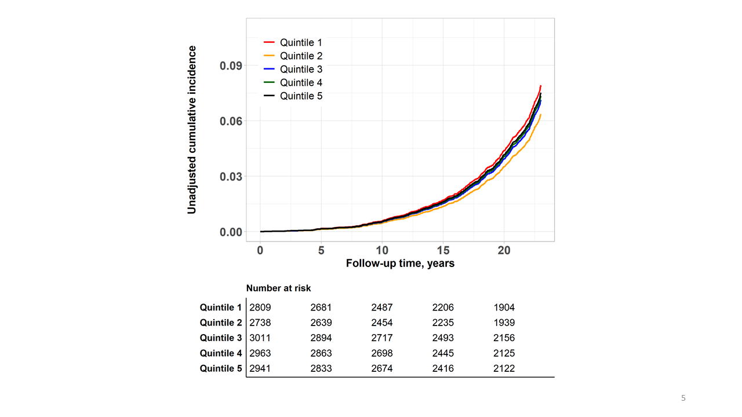
Supplementary Figure 3. Crude cumulative incident from the midlife baseline by quintiles of protein C levels

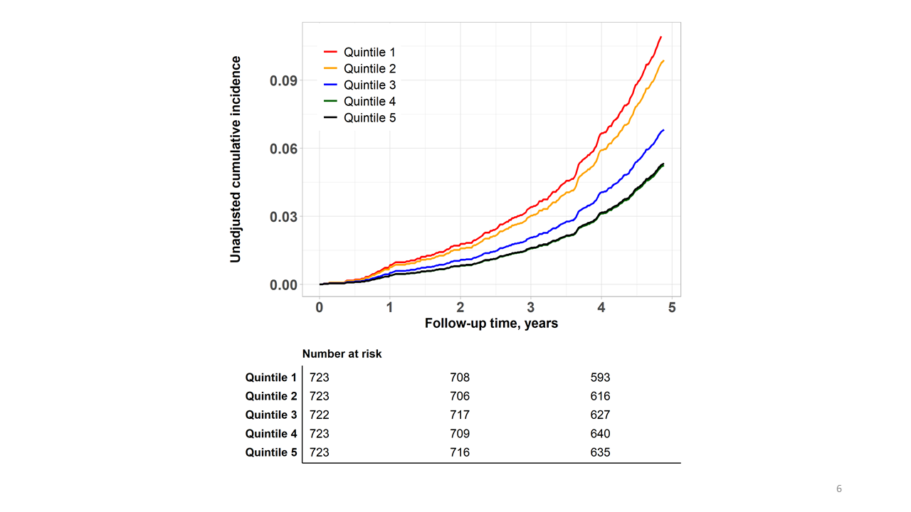
Supplementary Figure 4. Crude cumulative incident from the late-life baseline by quintiles of protein C levels. The curves of quintiles 4 and 5 overlapped.

