Supplementary materials

Immunological microenvironment predicts the survival of the patients with hepatocellular carcinoma treated with anti-PD-1 antibody

Masahiro Morita ¹, Naoshi Nishida ^{1*}, Kazuko Sakai ², Tomoko Aoki ¹, Hirokazu Chishina ¹, Masahiro Takita ¹, Hiroshi Ida ¹, Satoru Hagiwara ¹, Yasunori Minami ¹, Kazuomi Ueshima ¹, Kazuto Nishio ², Yukari Kobayashi ³, Kazuhiro Kakimi ³, and Masatoshi Kudo ¹

¹ Department of Gastroenterology and Hepatology, ² Department of Genome Biology, Kindai University Faculty of Medicine, 377-2 Ohno-Higashi Osaka-Sayama, 589-8511, Japan, ³ Department of Immunotherapeutics, The University of Tokyo Hospital, 7-3-1 Hongo, Bunkyo-ku, Tokyo 113-8655 Japan

Supplementary Materials and Methods
The antibodies and conditions of immunohistochemistry in this study

antibody | clone | (company) | dilution
β-catenin | β-catenin 1 | (DAKO) | 1:200
Glutamine Synthetase | 6/Glutamine Synthetase | (Abcam) | 1:400
CD8 | C8/144B | (Invitrogen) | 1:20
PD-L1 | 28-8 | (Abcam) | 1:200

For the evaluation of expression of molecules by immunohistochemistry, the presence of nuclear staining of β-catenin in greater than or equal to 5% of tumor cells, or diffuse strong staining of GS are considered as positive findings for activation in Wnt/β-catenin signaling.
For the expression of PD-L1, we counted the number of PD-L1 positive cells in tumor and tumor infiltered cells for the calculation of the combined positive score (CPS) as reported previously, where CPS was determined as the number of PD-L1-positive cells (tumor cells, lymphocytes, and macrophages) divided by the total number of viable tumor cells × 100.

Number of the tumor infiltrated lymphocytes (TILs) expressing CD8 are also counted. Cells expressing β-catenin, GS, PD-L1 and CD8 was visually counted and quantified at 400-fold magnification. CPS >1 was defined as high PD-L1-CPS and CPS <1 was defined as low PD-L1-CPS. Regarding the expression of CD8, the mean degree of CD8⁺ TILs was 28.4 cells/HPF (95%Cl: 16.3–40.5) in tumors; values above the mean (28.4 cells/HPF) were defined as high grade of CD8⁺ TILs.

Treatment and follow-up schedule of the patients
All patients were treated with anti-PD-1 antibody (nivolumab) in the clinical trial or real clinical practice. Briefly, 3 mg/kg or 240 mg/body of nivolumab (Ono pharmacological. Co., LTD) was intravenously administered every 2 weeks. The administration was continued until disease progression, unacceptable toxicity, consent withdrawal, or termination of the trial, whichever occurred first. Blood tests were performed before the start of treatment and at the time of the visit. The images were evaluated every 8 weeks for 48 weeks after the allocation date, and thereafter every 12 weeks until disease progression or discontinuation of administration, or every 6 weeks for the first year from allocation and every 12 weeks thereafter until disease progression.

Supplementary Table 1
Association between clinicopathological findings and achievement of objective response in HCC patients treated with anti-PD-1 antibody

Clinocopathological categories | Objective response |  | p value for univariate analysis ¹
 | with | without
Clinical backgrounds
Age (<65 / > 65) | 2 / 3 | 8 / 21 | 0.6181
Sex (male / female) | 3 / 2 | 25 / 4 | 0.2053
ECOG performance status (PS0 / PS1) | 5 / 0 | 28 / 1 | 1.0000*
HBV (Yes / No) | 1 / 4 | 8 / 21 | 1.0000
HCV (Yes / No) | 3 / 2 | 10 / 19 | 0.3476
Degree of differentiation (well / moderately - poorly) | 1 / 4 | 15 / 14 | 0.3402
PVTT (Yes / No) | 2 / 3 | 8 / 21 | 0.6181
EHS (Yes / No) | 1 / 4 | 13 / 16 | 0.3786
BCLC stage (B / C) | 2 / 3 | 12 / 17 | 1.0000
Pretreatment of sorafenib  (Yes /No) | 3 / 2 | 10 / 19 | 0.3476
Baseline blood chemical findings
AFP [High (>400 ng/mL) / Low (<400 ng/mL)] | 2 / 3 | 17 / 12 | 0.6343
Lymphocyte count [High (>1000 /µL) / Low (<1000 /µL)] | 2 / 3 | 17 / 12 | 0.6343
RDW [High (>16%) / Low (<16%)] | 3 / 2 | 4 / 25 | 0.0476
NLR [High (>5) / Low (<5)] | 1 / 4 | 3 / 26 | 0.4879
PLR [High (>200) / Low (<200)] | 2 / 3 | 5 / 24 | 0.2684
LDH [High (>upper normal limit / Low (<upper normal limit)] | 2 / 3 | 18 / 11 | 0.6272
Immunohistochemistry
Wnt/β-catenin activation (positive / negative) | 0 / 5 | 14 / 15 | 0.0629
Grade of CD8+ TILs (High / Low) | 3 / 2 | 6 / 23 | 0.1023
PD-L1-CPS [High (> 1) / Low (< 1)] | 3 / 1 | 10 / 16 | 0.2903

¹ P value by Fisher`s exact test. Bolds denote the p value < 0.05.
ECOG: Eastern Cooperative Oncology Group, HBV: hepatitis B virus, HCV, hepatitis C virus, well: well differentiated, moderately - poorly: moderately differentiated or poorly differentiated, PVTT: portal vein tumor thrombus, EHS: extrahepatic spread, BCLC stage: Barcelona Clinic Liver Cancer stage, RDW: red blood cell distribution width, NLR: neutrophil-to-lymphocyte ratio, PLR: platelet-lymphocyte ratio, TILs: tumor infiltrating lymphocyte, PD-L1-CPS: combined positive score of programmed cell death-ligand 1.

Supplementary Table 2
Association between clinicopathological findings and Wnt/β-catenin activation

Clinocopathological categories | Wnt/β-catenin activation |  | p value for univariate analysis ¹
 | presence | absence
Clinical backgrounds
Age (<65 / > 65) | 4 / 10 | 6 / 14 | 1.0000*
Sex (male / female) | 11 / 3 | 17 / 3 | 0.6722*
ECOG Performance Status  (PS0 / PS1) | 13 / 1 | 20 / 0 | 0.4118*
HBV (Yes / No) | 5 / 9 | 4 / 16 | 0.4351*
HCV (Yes / No) | 3 / 11 | 10 / 10 | 0.0916
Degree of differentiation  (well / moderately - poorly) | 8 / 6 | 8 / 12 | 0.3243
PVTT (Yes / No) | 4 / 10 | 6 / 14 | 1.0000*
EHS (Yes / No) | 7 / 7 | 7 / 13 | 0.3818
BCLC stage (B / C) | 6 / 8 | 8 / 12 | 0.8677
Pretreatment of sorafenib  (Yes /No) | 4 / 10 | 9 / 11 | 0.3320
Baseline blood chemical findings
AFP [High (>400 ng/mL) / Low (<400 ng/mL)] | 10 / 4 | 9 / 11 | 0.1266
Lymphocyte count [High (>1000 /µL) / Low (<1000 /µL)] | 8 / 6 | 11 / 9 | 0.9014
RDW [High (>16%) / Low (<16%)] | 0 / 14 | 7 / 13 | 0.0262*
NLR [High (>5) / Low (<5)] | 1 / 13 | 3 / 17 | 0.6272*
PLR [High (>200) / Low (<200)] | 3 / 11 | 4 / 16 | 1.0000*
LDH [High (>upper normal limit / Low (<upper normal limit)] | 9 / 5 | 11 / 9 | 0.5882
Immunohistochemistry
Grade of CD8+ TILs (High / Low) | 1 / 13 | 8 / 12 | 0.0504*
PD-L1-CPS [High (> 1) / Low (< 1)] | 4 / 9 | 9 / 8 | 0.2246

¹ P value by Pearson’s χ² test or Fisher`s exact test (The asterisk shows p value by Fisher's exact test). Bolds denote the p value < 0.05.
ECOG: Eastern Cooperative Oncology Group, HBV: hepatitis B virus, HCV, hepatitis C virus, well: well differentiated, moderately - poorly: moderately differentiated or poorly differentiated, PVTT: portal vein tumor thrombus, EHS: extrahepatic spread, BCLC stage: Barcelona Clinic Liver Cancer stage, RDW: red blood cell distribution width, NLR: neutrophil-to-lymphocyte ratio, PLR: platelet-lymphocyte ratio, TILs: tumor infiltrating lymphocyte, PD-L1-CPS: combined positive score of programmed cell death-ligand 1.
Supplementary Fig. 1. Survival of the patients classified by the serum AFP level.
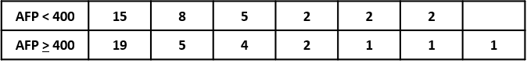
0
20
40
60
80
100
0
200
400
600
800
1000
1200
1400
(days)
AFP > 400 ng/mL
AFP < 400 ng/mL
Progression free survival (%)
A

0
20
40
60
80
100
Overall survival (%)
0
200
400
600
800
1000
1200
1400
1600
(days)
AFP > 400 ng/mL
AFP < 400 ng/mL
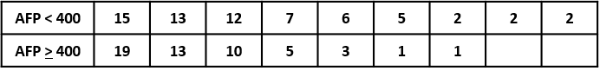
B

The median durations of progression free survival (PFS) are 84 days (95% Cl: 56-164) and 210 days (95% Cl: 55-460) in patients with AFP > 400 ng/mL and those with AFP <400 ng/mL, respectively (p = 0.2677 by log-rank test) (A). The median durations of overall survival (OS) are 430 days (95% Cl: 187-532) and 668.5 days (95% Cl: 466-1163) in patients with AFP > 400 ng/mL and those with AFP < 400 ng/mL (p = 0.0289 by log-rank test) (B).

Supplementary Fig. 2.
The immunogram of 40 HCC cases with and without mutation in the CTNNB1 gene according to the scores of 10 molecular profiles.
A
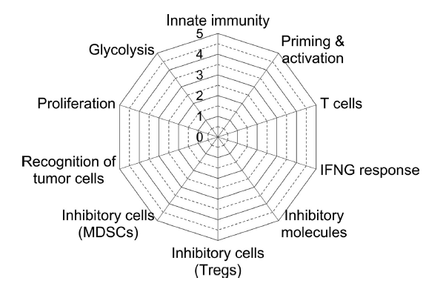
B
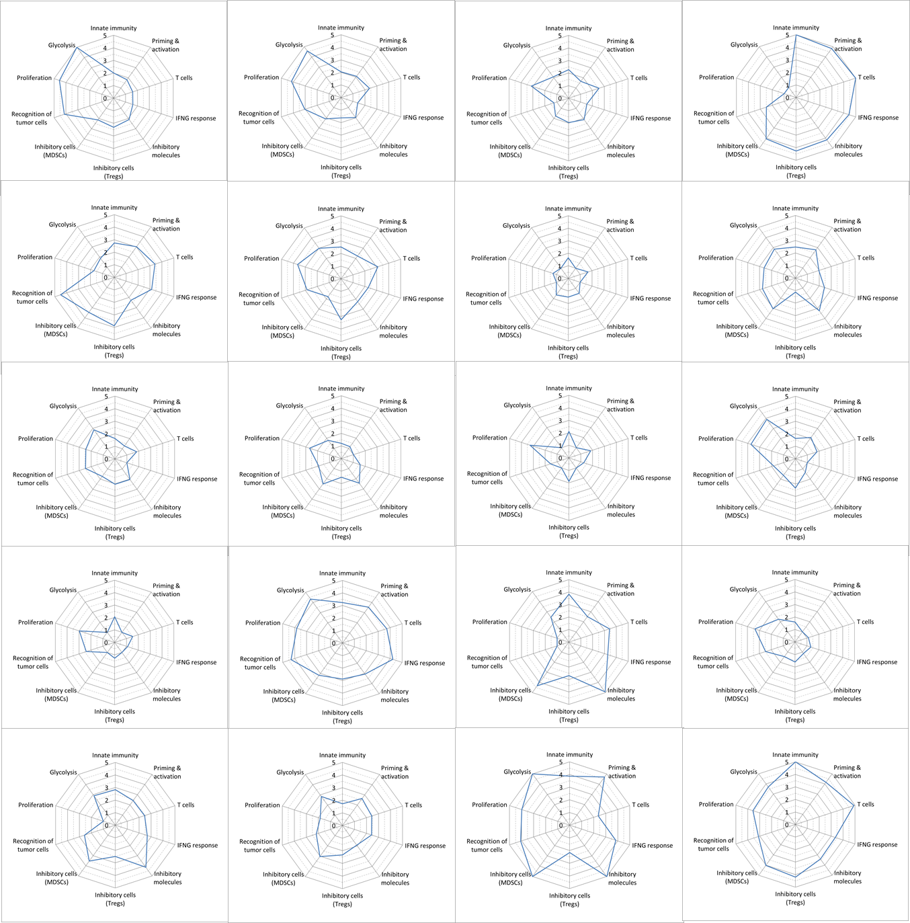
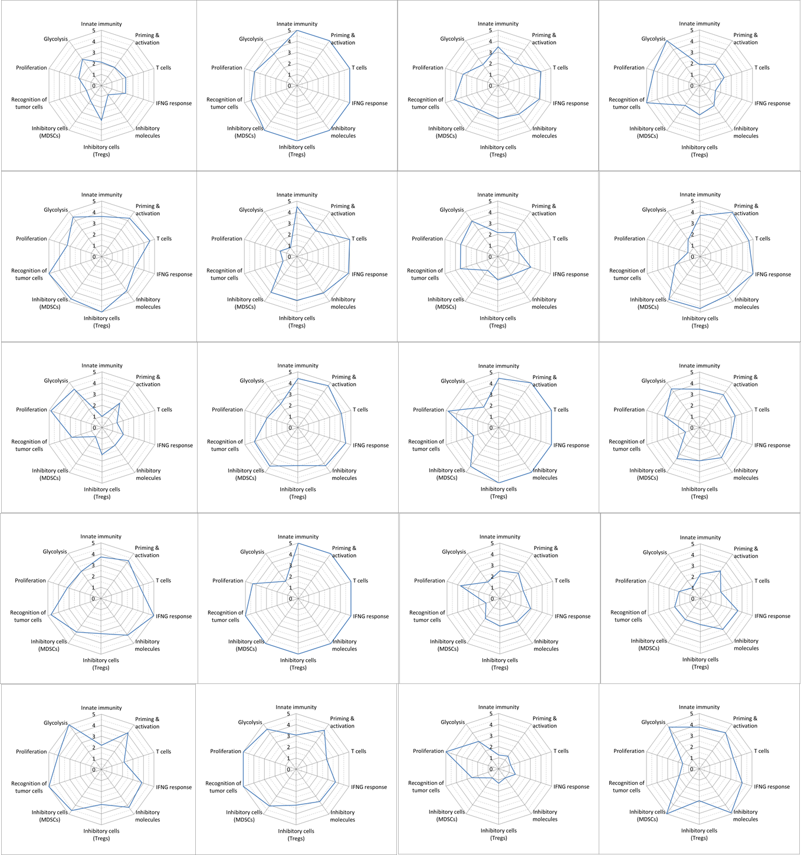
C
The immunogram represents the 10 kinds of immune status classified using the single-sample gene set enrichment analysis, and was shown in radar chart (A). Each immunogram for 20 HCCs with mutation in the CTNNB1 gene (B) and 20 HCCs without mutation in the CTNNB1 gene (C) is shown.

Supplementary Fig. 3. Hierarchical clustering analysis using immunogram score of 10 axes that correspond to each stage of the immune response.

A
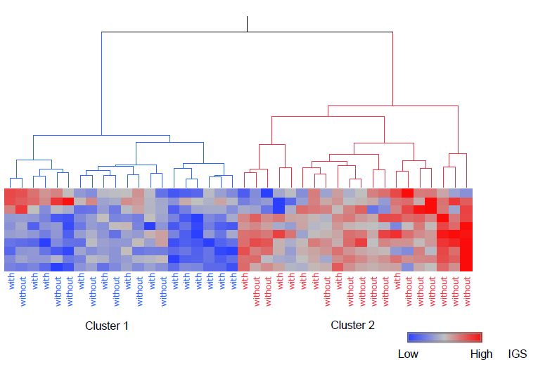
B
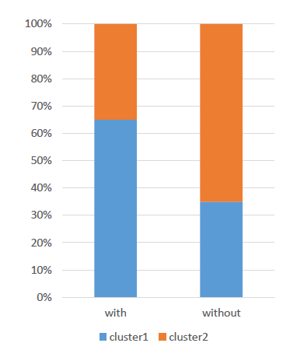
Hierarchical clustering analysis was performed using immunogram score (IGS) on each axis that represent the stage of the immune response, which successfully detected two clusters (cluster 1 and cluster 2) on heatmap (A). "With" denotes the presence of the CTNNB1 mutation and "without" denotes the absence of the mutation. HCCs with CTNNB1 mutation tended to be more predominant in cluster 1 that showed lower expression of immune related genes (p = 0.0578 by Pearson’s χ2 test) (B).

