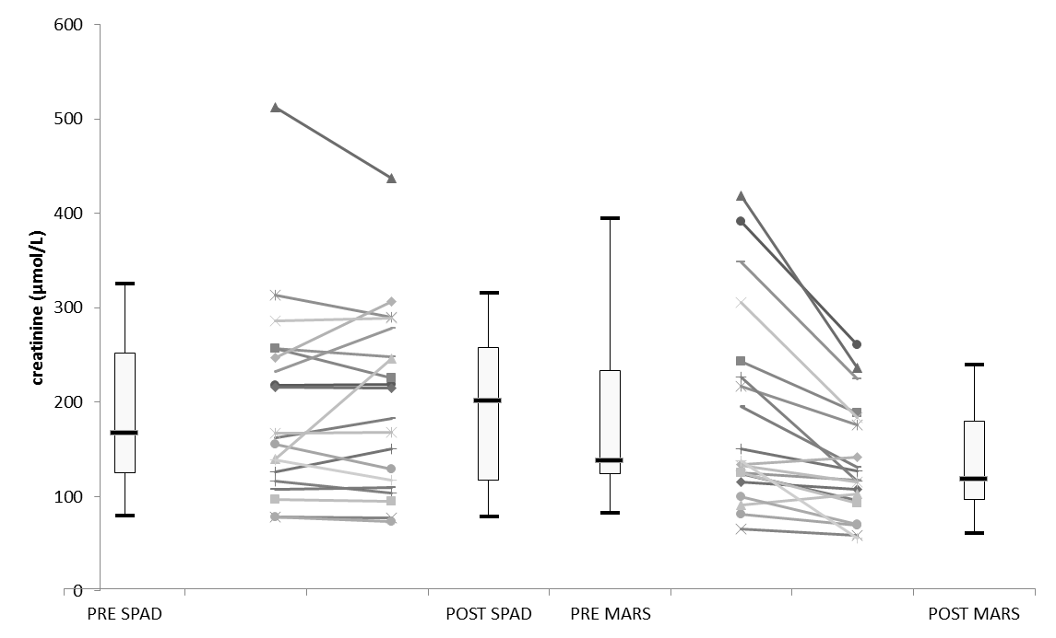
Fig s4. Creatinine changes
*
NS
NS
*

Changes in creatinine in both extracorporeal albumin dialysis (ECAD) devices. Box plots represent overall values including all performed ECAD cycles (5th, 25th, 75th, 95th percentile), and bounded dots mark changes of each individual ECAD session. MARS molecular adsorbents recirculating system, SPAD single-pass albumin dialysis, *: p< 0.05, NS: non-significant difference.

