Supplementary table 1: Primers used for genotype assessment using PCR-HRM
SNP | Primer Sequences (5’-3’) | Fragment size (bp)
ApaI | Forward GGGATAGAGAAGAAGGCACAGG  Reverse CTGCCGTTGAGTGTCTGTGTG | 89
BsmI | Forward GGAACTAGATAAGCAGGGTTCC  Reverse TAACAGGAATGTTGAGCCCAGT | 99
FokI | Forward CTGGCACTGACTCTGGCTCT  Reverse GTCAGGCAGGGAAGTGCTG | 86
TaqI | Forward GTGCCCACAGATCGTCCT  Reverse GGATGTACGTCTGCAGTGTGTT | 88

Supplementary table 2: PCR-HRM Thermal Cycling Conditions
SNP | ApaI | BsmI | FokI | TaqI
Holding (temperature/time) | 95ºC / 10 min | 95ºC / 10 min | 95ºC / 10 min | 95ºC / 5 min
Cycle | 1 | 1 | 1 | 1
PCR amplification (temperature/time) | 95ºC / 15 sec  64ºC / 15 sec | 95ºC / 10 sec  60ºC / 30 sec | 95ºC / 15 sec  60ºC / 30 sec | 95ºC / 10 sec  60ºC / 30 sec  72ºC / 3 sec
Cycles | 40 | 35 | 40 | 35
HRM (temperature/time) | 78-88ºC  - ºC increments  2 sec per step | 77-87ºC  0.1 ºC increments  2 sec per step | - ºC  0.1 ºC increments  2 sec per step | - ºC  0.1 ºC increments  2 sec per step
Cycle | 1 | 1 | 1 | 1

Supplementary table 3: Primers used for Sanger sequencing
SNP | Primer Sequences (5’-3’) | Fragment size (bp)
ApaI / TaqI | Forward AGCAGAGCAGAGTTCCAAGC  Reverse TCGGCTAGCTTCTGGATCAT | 490
BsmI | Forward ACCTGAAGGGAGACGTAGCA  Reverse TCACCTCTAACCAGCGGAAG | 383
FokI | Forward AGCTATGTAGGGCGAATCATGT  Reverse TGCAGCCTTCACAGGTCATAG | 340

Supplementary table 4: Hardy-Weinberg calculation of Vitamin D receptor (VDR) polymorphisms based on the Study Participants (N=98).
Variables | p | q | HWE(a) | P (x2 test with Yates' correction)
VDR genotypes
TaqI (rs731236) | 0.5533 | 0.4165 | 0.9698 | 0.7017
Apal (rs7975232) | 0.5533 | 0.4403 | 0.9936 | 0.9376
Bsml (rs1544410) | 0.4403 | 0.5249 | 0.9652 | 0.6361
FokI (rs2228570) | 0.6389 | 0.3780 | 1.0168 | 0.9047
a HWE values are expressed as p+q
Analysis was performed with HW_TEST, Santos, F. A. B., Lemes, R. B., & Otto, P. A. (2020). HW_TEST, a program for comprehensive HARDY-WEINBERG equilibrium testing. Genetics and Molecular Biology, 43(2).
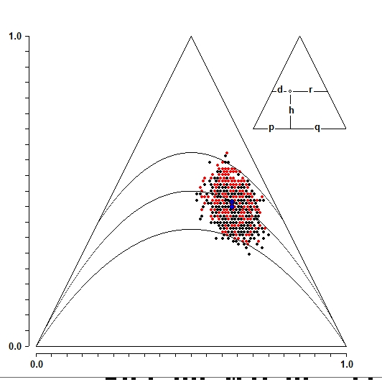
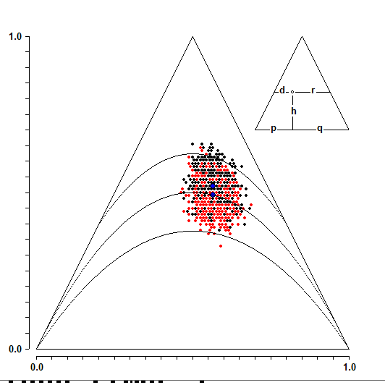
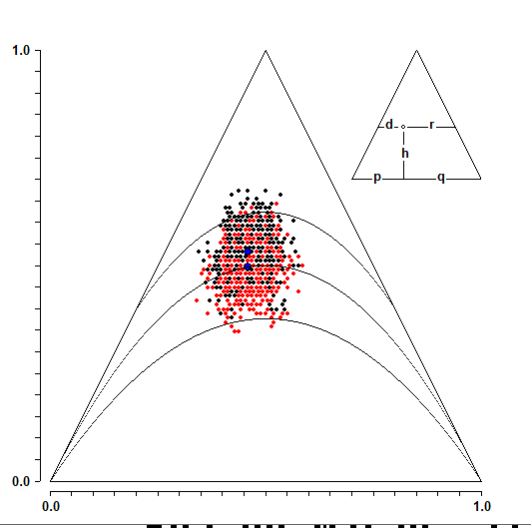
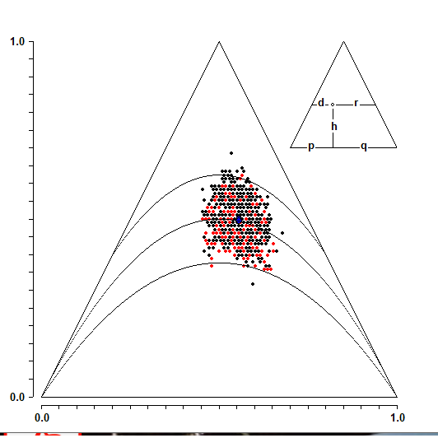
HWE Analysis ApaI
HWE Analysis BsmI
HWE Analysis FokI
HWE Analysis TaqI

