SUPPLEMENTARY MATERIAL

Supplementary Material 1 | STROBE Statement
Supplementary Material 2 | Association of %age-predicted CRF with CVD mortality in clinically relevant subgroups
Supplementary Material 3 | Association between percentage of age-predicted CRF and risk of CVD mortality, on excluding the first 5 years of follow-up
Supplementary Material 4 | Association between CRF and risk of cardiovascular mortality
Supplementary Material 5 | Risk discrimination and reclassification upon addition of %age-predicted CRF and absolute CRF to a CVD mortality risk prediction model containing conventional risk factors

Supplementary Material 1. STROBE Statement

Section/Topic | Item # | Recommendation | Reported on page #
Title and abstract | 1 | (a) Indicate the study’s design with a commonly used term in the title or the abstract | Page 1
 |  | (b) Provide in the abstract an informative and balanced summary of what was done and what was found | Page 2
Introduction
Background/rationale | 2 | Explain the scientific background and rationale for the investigation being reported | Page 3-4
Objectives | 3 | State specific objectives, including any pre-specified hypotheses | Page 3-4
Methods
Study design | 4 | Present key elements of study design early in the paper | Study design and participants
Setting | 5 | Describe the setting, locations, and relevant dates, including periods of recruitment, exposure, follow-up, and data collection | Study design and participants
Participants | 6 | (a) Give the eligibility criteria, and the sources and methods of selection of participants. Describe methods of follow-up | Study design and participants
 |  | (b) For matched studies, give matching criteria and number of exposed and unexposed | Not applicable
Variables | 7 | Clearly define all outcomes, exposures, predictors, potential confounders, and effect modifiers. Give diagnostic criteria, if applicable | Methods
Data sources/ measurement | 8* | For each variable of interest, give sources of data and details of methods of assessment (measurement). Describe comparability of assessment methods if there is more than one group | Methods
Bias | 9 | Describe any efforts to address potential sources of bias | Statistical analyses
Study size | 10 | Explain how the study size was arrived at | Statistical analyses
Quantitative variables | 11 | Explain how quantitative variables were handled in the analyses. If applicable, describe which groupings were chosen and why | Statistical analyses
Statistical methods | 12 | (a) Describe all statistical methods, including those used to control for confounding | Statistical analyses
 |  | (b) Describe any methods used to examine subgroups and interactions | Statistical analyses
 |  | (c) Explain how missing data were addressed | Not applicable
 |  | (d) If applicable, explain how loss to follow-up was addressed | Not applicable
 |  | (e) Describe any sensitivity analyses | Statistical analyses
Results
Participants | 13* | (a) Report numbers of individuals at each stage of study—eg numbers potentially eligible, examined for eligibility, confirmed eligible, included in the study, completing follow-up, and analysed | Study design and participants
 |  | (b) Give reasons for non-participation at each stage | Study design and participants
 |  | (c) Consider use of a flow diagram | Not applicable
Descriptive data | 14* | (a) Give characteristics of study participants (eg demographic, clinical, social) and information on exposures and potential confounders | Results; Table 1
 |  | (b) Indicate number of participants with missing data for each variable of interest
 |  | (c) Summarise follow-up time (eg, average and total amount) | Results
Outcome data | 15* | Report numbers of outcome events or summary measures over time | Results
Main results | 16 | (a) Give unadjusted estimates and, if applicable, confounder-adjusted estimates and their precision (eg, 95% confidence interval). Make clear which confounders were adjusted for and why they were included | Results; Table 2; Figures 1; Supplementary Materials 2-5
 |  | (b) Report category boundaries when continuous variables were categorized | Results; Table 2; Figures 1; Supplementary Materials 2-5
 |  | (c) If relevant, consider translating estimates of relative risk into absolute risk for a meaningful time period
Other analyses | 17 | Report other analyses done—eg analyses of subgroups and interactions, and sensitivity analyses | Results; Supplementary Materials 2-3
Discussion
Key results | 18 | Summarise key results with reference to study objectives | Discussion - Summary of main findings
Limitations
Interpretation | 20 | Give a cautious overall interpretation of results considering objectives, limitations, multiplicity of analyses, results from similar studies, and other relevant evidence | Discussion
Generalisability | 21 | Discuss the generalisability (external validity) of the study results | Discussion
Other information
Funding | 22 | Give the source of funding and the role of the funders for the present study and, if applicable, for the original study on which the present article is based | Page 15

Supplementary Material 2. Association of %age-predicted CRF with CVD mortality in clinically relevant subgroups

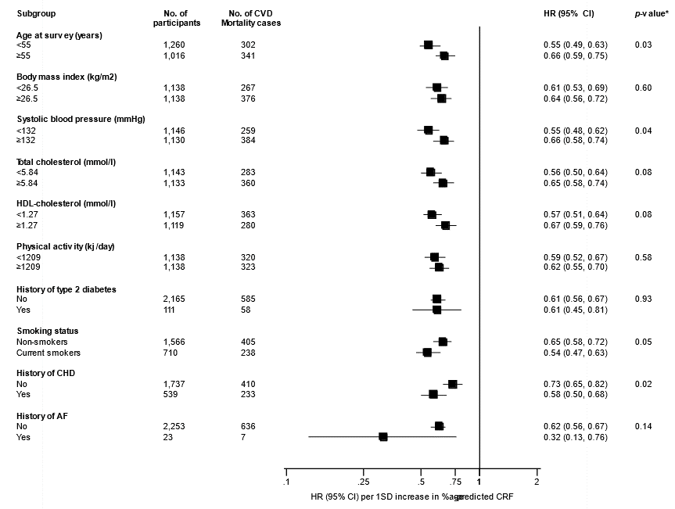
Hazard ratios were adjusted for smoking status, history of diabetes, systolic blood pressure, total cholesterol and high-density lipoprotein cholesterol; %age-predicted, percentage of age-predicted; AF, atrial fibrillation; CHD, coronary heart disease; CI, confidence interval; CVD, cardiovascular disease; HDL, high-density lipoprotein; HR, hazard ratio; *, P-value for interaction; cut-offs used for age, body mass index, systolic blood pressure, total cholesterol, high-density lipoprotein cholesterol; and physical activity are median values.

Supplementary Material 3. Association between percentage of age-predicted CRF and risk of CVD mortality, on excluding the first 5 years of follow-up

Percentage of age-predicted exercise capacity | Events/  Total | Model 1 |  | Model 2 |  | Model 3
 |  | HR (95% CI) | P-value | HR (95% CI) | P-value | HR (95% CI) | P-value
Per 1 SD increase | 223 / 2,171 | 0.65 (0.59 to 0.71) | <.001 | 0.73 (0.66 to 0.81) | .001 | 0.74 (0.67 to 0.82) | <.001
Quartile 1 | 215 / 543 | ref |  | ref |  | ref
Quartile 2 | 161 / 543 | 0.65 (0.53 to 0.80) | <.001 | 0.77 (0.62 to 0.95) | .02 | 0.78 (0.63 to 0.97) | .03
Quartile 3 | 107 / 543 | 0.42 (0.33 to 0.53) | <.001 | 0.53 (0.41 to 0.68) | <.001 | 0.55 (0.43 to 0.71) | <.001
Quartile 4 | 106 / 542 | 0.40 (0.31 to 0.51) | <.001 | 0.52 (0.40 to 0.68) | <.001 | 0.55 (0.42 to 0.71) | <.001

CI, confidence interval; CRF, cardiorespiratory fitness; CVD, cardiovascular disease; HR, hazard ratio; ref, reference; SD, standard deviation
Model 1: Adjusted for smoking status, history of type 2 diabetes, systolic blood pressure, total cholesterol and high-density lipoprotein-cholesterol
Model 2: Model 1 plus body mass index, fasting plasma glucose, alcohol consumption, prevalent coronary heart disease, use of cholesterol medication, prevalent atrial fibrillation, total physical activity and socioeconomic status
Model 3: Model 2 plus high-sensitivity C-reactive protein

Supplementary Material 4. Association between CRF and risk of cardiovascular mortality

CRF (ml/min) | Events/  Total | Model 1 |  | Model 2 |  | Model 3
 |  | HR (95% CI) | P-value | HR (95% CI) | P-value | HR (95% CI) | P-value
Per 1 SD increase | 643 / 2,276 | 0.69 (0.63 to 0.76) | <.001 | 0.70 (0.63 to 0.78) | <.001 | 0.71 (0.64 to 0.79) | <.001
Quartile 1 | 254 / 573 | ref |  | ref |  | ref
Quartile 2 | 176 / 565 | 0.60 (0.50 to 0.73) | <.001 | 0.63 (0.51 to 0.77) | <.001 | 0.63 (0.52 to 0.78) | <.001
Quartile 3 | 104 / 569 | 0.39 (0.31 to 0.49) | <.001 | 0.40 (0.31 to 0.51) | <.001 | 0.40 (0.32 to 0.52) | <.001
Quartile 4 | 109 / 569 | 0.47 (0.37 to 0.60) | <.001 | 0.48 (0.37 to 0.62) | <.001 | 0.50 (0.38 to 0.64) | <.001

CI, confidence interval; CRF, cardiorespiratory fitness; HR, hazard ratio; ref, reference; SD, standard deviation
Model 1: Adjusted for age, smoking status, history of type 2 diabetes, systolic blood pressure, total cholesterol and high-density lipoprotein-cholesterol
Model 2: Model 1 plus body mass index, fasting plasma glucose, alcohol consumption, prevalent coronary heart disease, use of cholesterol medication, prevalent atrial fibrillation, total physical activity and socioeconomic status
Model 3: Model 2 plus high-sensitivity C-reactive protein

Supplementary Material 5. Risk discrimination and reclassification upon addition of %age-predicted CRF and absolute CRF to a CVD mortality risk prediction model containing conventional risk factors

Discrimination | %age-predicted CRF | CRF
C-index (95% CI): conventional risk factors | 0.6797 (0.6550 to 0.7043) | 0.7086 (0.6846 to 0.7327)
C-index (95% CI): conventional risk factors plus exposure | 0.7240 (0.6998 to 0.7482) | 0.7326 (0.7085 to 0.7567)
C-index change (95% CI) | 0.0443 (0.0237 to 0.0650) | 0.0240 (0.0095 to 0.0385)
p-value | <.001 | .001
p-value for difference in -2 log likelihood | <.001 | <.001
Reclassification
Net reclassification index (95% CI) | 22.27% (16.72 to 27.82) | 5.56% (1.27 to 9.86)
p-value | <.001 | .01
Integrated discrimination index (95% CI) | 0.0534 (0.0430 to 0.0638) | 0.0303 (0.0227 to 0.0380)
p-value | <.001 | <.001

The model with conventional risk factors included age, systolic blood pressure, history of type 2 diabetes, total cholesterol, high-density lipoprotein cholesterol and smoking. Age was not included in the model for %age-predicted CRF
%age-predicted CRF, percentage of age-predicted cardiorespiratory fitness; CVD, cardiovascular disease

