Supplementary Materials
Table S1. Initial dose of DA.
Total weekly dose of ESA during Screening Period |  | Initial dose
rHuEPO | DA
≤2,250 IU/week | 10 µg/week | 10 µg/week
>2,250 IU/week and ≤3,000 IU/week | 15 µg/week | 15 µg/week
>3,000 IU/week and ≤4,500 IU/week | 20 µg/week | 20 µg/week
>4,500 IU/week and ≤6,000 IU/week | 30 µg/week | 30 µg/week
>6000 IU/week and ≤9000 IU/week | 40 µg/week | 40 µg/week

Table S2. Dose adjustment step.

Step | 1  (Lowest dose) |  | 2 |  | 3  (Initial dose) |  | 4 |  | 5  (Highest dose)
JTZ-951 | 1 mg | ←→ | 2 mg | ←→ | 4 mg | ←→ | 6 mg | ←→ | 8 mg
DA | Not administered | ←→ | 5 μg | ←→ | 10 μg | ←→ | 15 μg | ←→ | 20 μg
 | 5 μg |  | 10 μg |  | 15 μg |  | 20 μg |  | 30 μg
 | 10 μg |  | 15 μg |  | 20 μg |  | 30 μg |  | 40 μg
 | 15 μg |  | 20 μg |  | 30 μg |  | 40 μg |  | 50 μg
 | 20 μg |  | 30 μg |  | 40 μg |  | 50 μg |  | 60 μg

Table S3. Eligibility criteria.

Inclusion criteria
1 | Japanese patients aged ≥20 years at the time of consent
2 | Patients receiving hemodialysis (including hemodiafiltration) consistently three times a week for at least 12 weeks before Scr Visit 1
3 | Patients with TSAT >20% or ferritin >75 ng/mL at Scr Visit 1
4 | Patients who have continued to receive the treatment with the same ESA (epoetin alfa, epoetin beta, epoetin kappa [rHuEPO], or DA) for at least 4 weeks before Scr Visit 1
5 | Patients receiving ESA for at least 2 weeks before Scr Visit 1 satisfying following criteria:  - rHuEPO user: receiving rHuEPO once to thrice weekly (≥750 IU/week and ≤9,000 IU/week) and at a constant total weekly dose for 2 weeks before Scr Visit 1  - DA user: receiving DA once weekly (10 μg, 15 μg, 20 μg, 30 μg, or 40 μg) and at a constant total weekly dose for 2 weeks before Scr Visit 1
6 | Patients who have received the same ESA as received in most recent week before Scr Visit 1 during the period between Scr Visit 1 and the day before Week 0 at the same total dose and dosing frequency a week
7 | Patients with pre-dialysis Hb levels measured after the maximum interdialytic interval at Scr Visit 1 and Scr Visit 2 (2 weeks after the start of observation) of ≥9.5 g/dL and <12.0 g/dL and a difference (in absolute value) between Scr Visit 1 and Scr Visit 2 of ≤1.0 g/dL
Exclusion criteria
1 | Patients with poorly controlled hypertension (e.g., systolic blood pressure ≥180 mmHg and  diastolic blood pressure ≥110 mmHg at Scr Visit 1 and Scr Visit 2)
2 | Patients with severe hepatobiliary disease (e.g., AST or ALT ≥100 U/L at Scr Visit 1, hepatic cirrhosis, total bilirubin ≥1.8 mg/dL at Scr Visit 1)
3 | Patients with congestive heart failure (NYHA Class III or more severe) or unstable angina
4 | Patients who have developed myocardial infarction, cerebral infarction (excluding asymptomatic cerebral infarction), or venous thromboembolism (pulmonary embolism or deep vein thrombosis) during the period between 24 weeks before Scr Visit 1 and the registration to the treatment period
5 | Patients who will undergo an ophthalmological procedure (photocoagulation therapy or vitreous surgery) for the treatment of diabetic retinopathy, diabetic macular edema, or agerelated macular degeneration during the period between Scr Visit 1 and the end of the study
6 | Patients who have undergone erythrocyte transfusion during the period between 12 weeks  before Scr Visit 1 and the registration to the treatment period

Exclusion criteria (continued)
7 | Patients who have received protein anabolic hormones, testosterone enanthate, or mepitiostane during the period between 12 weeks before Scr Visit 1 and the registration to the treatment period
8 | Patients with severe hyperparathyroidism (e.g., intact-PTH ≥500 pg/mL at Scr Visit 1)
9 | Patients with severe infection, systemic blood disorder (e.g., myelodysplastic syndrome, aplastic anemia, abnormal hemoglobin disease), or hemolytic anemia, or patients with anemia caused by bleeding lesions (e.g., gastrointestinal hemorrhage)
10 | Patients who are suspected to have anemia caused by noninfectious chronic inflammatory disease (e.g., connective tissue disease)
11 | Patients with malignancy (including hematological malignancy) or previous history of  malignancy during the period between 5 years before Scr Visit 1 and the registration to the  treatment period
12 | Patients with previous history of a serious drug allergy such as anaphylactic shock or a hypersensitivity to DA
13 | Patients with current or previous history of drug dependence or alcohol dependence
14 | Patients who have received another investigational product (or study drug), have received treatment with an investigational device (or study device), or have participated in clinical research involving intervention (medical action beyond the scope of ordinary medical practice intended for research purposes) and received treatment during the period between 12 weeks before Scr Visit 1 and the registration to the treatment period
15 | Patients who have previously participated in a clinical study of JTZ-951 and received the investigational product (active drug)
16 | Patients who are pregnant, lactating, or may be pregnant (the possibility of pregnancy cannot be ruled out by the PI or the SI based on the results of pregnancy test at Scr Visit 1)
17 | Female patients of childbearing potential who have not agreed to use appropriate contraception methods from the time of signing of informed consent to the end of the study, or male patients who have not agreed to use appropriate contraception methods from the start of study treatment to the end of the study
18 | Other patients who, in the judgment of the PI or the SI, are ineligible for the study

Table S4. Mean values of RBC-related parameters (FAS).

mean (SD) | Enarodustat (n = 86) |  |  | DA (n = 86)
 | Week 0 | Week 4 | Week 24 | Week 0 | Week 4 | Week 24
Hb (g/dL) | 10.79 (0.65) | 11.01 (1.04) | 10.77 (0.94) | 10.87 (0.70) | 11.08 (0.78) | 10.79 (0.67)
Ht (%) | 32.57 (1.99) | 33.17 (3.25) | 32.27 (2.90) | 32.82 (2.28) | 33.47 (2.64) | 32.54 (2.11)
RBC (10⁴/μL) | 338.3 (26.0) | 343.5 (37.7) | 335.7 (36.3) | 343.9 (31.3) | 351.5 (36.0) | 343.8 (30.6)
MCV (fL) | 96.5 (4.9) | 96.8 (5.0) | 96.4 (5.8) | 95.7 (4.7) | 95.5 (4.6) | 94.9 (4.9)
MCH (pg) | 31.97 (1.64) | 32.14 (1.76) | 32.21 (2.06) | 31.71 (1.72) | 31.64 (1.75) | 31.51 (1.85)
MCHC (%) | 33.14 (0.50) | 33.20 (0.52) | 33.38 (0.61) | 33.12 (0.58) | 33.12 (0.56) | 33.18 (0.67)

Table S5. Median values of iron-related parameters.

median (Q1, Q3) | Enarodustat (n = 86) |  |  | DA (n = 86)
 | Week 0 | Week 4 | Week 24 | Week 0 | Week 4 | Week 24
Serum iron (μg/dL) | 65.5  (50.0, 80.5) | 84.0  (65.0, 109.0) | 77.0  (59.0, 89.0) | 64.0  (50.0, 81.0) | 60.0  (48.0, 76.0) | 63.5  (50.5, 84.0)
TIBC (μg/dL) | 233.0  (213.0, 256.0) | 289.0  (254.0, 334.0) | 289.5  (259.0, 331.0) | 243.0  (212.0, 271.0) | 242.0  (224.0, 286.0) | 251.0  (221.5, 285.0)
TSAT (%) | 27.0  (22.5, 35.0) | 29.0  (22.0, 38.0) | 26.0  (20.0, 33.0) | 27.0  (21.0, 34.0) | 26.0  (19.0, 32.0) | 24.5  (20.0, 34.0)
Ferritin (ng/mL) | 90.90  (49.60, 161.00) | 74.20  (37.00, 172.00) | 102.00  (57.20, 184.00) | 90.30  (45.20, 141.00) | 70.65  (34.90, 115.00) | 84.40  (38.30, 160.00)
Hepcidin (ng/mL) | 70.500  (27.700, 123.000) | 40.250  (8.140, 85.000) | 49.200  (15.700, 89.500) | 51.500  (25.300, 97.600) | 40.950  (19.900, 74.000) | 47.300  (21.800, 92.300)

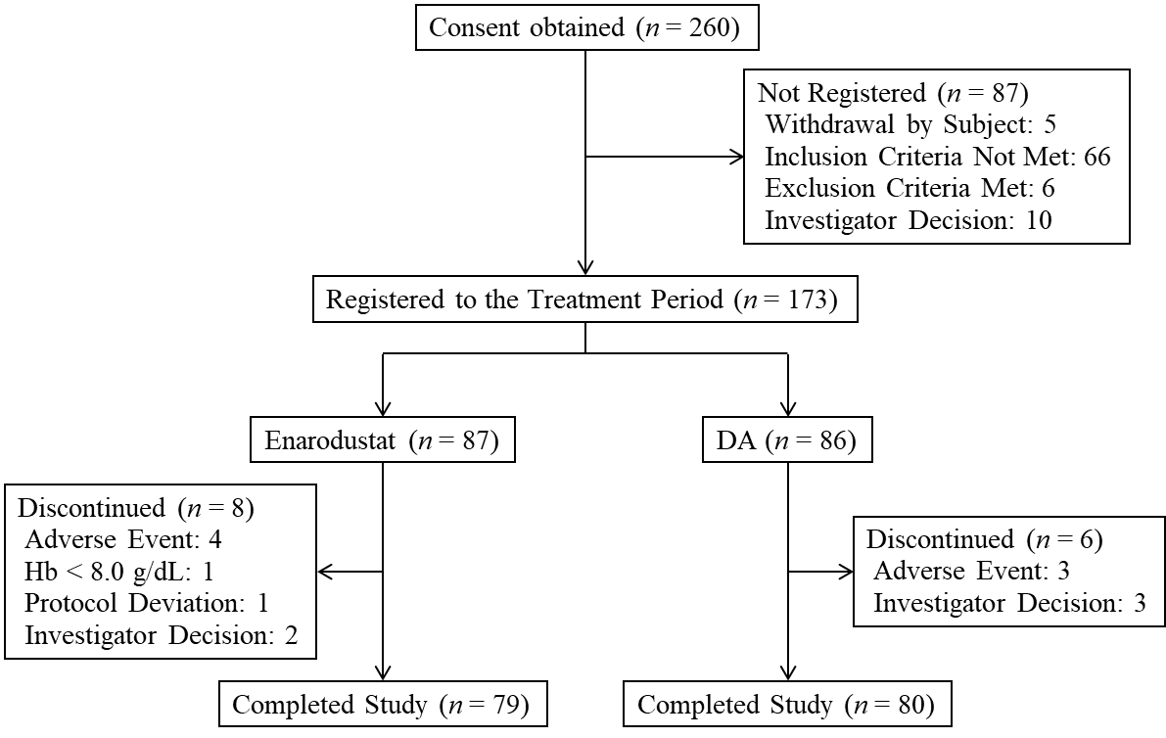

Figure S1. Subject disposition.
Hb, hemoglobin; DA, darbepoetin alfa.

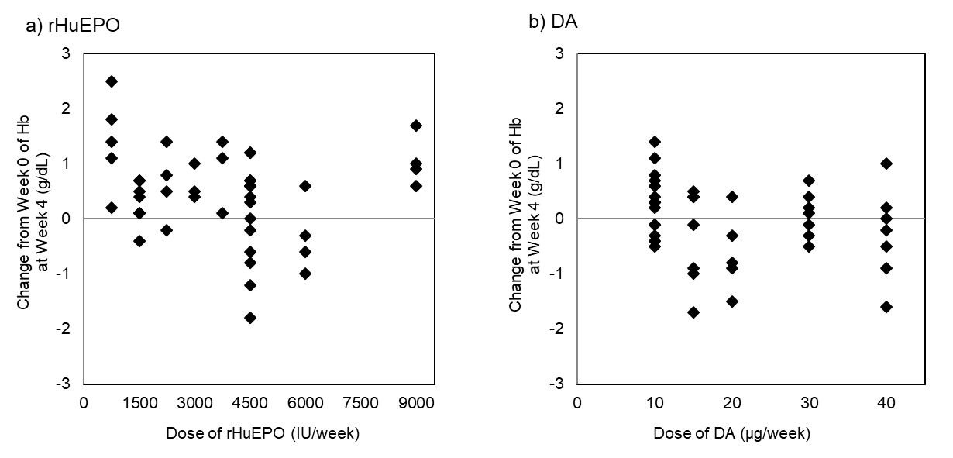

Figure S2. Scatter plot of ESA dose during the Scr period and change in Hb level at Week 4 from Week 0 in enarodustat arm.
a): rHuEPO user, b): DA user. rHuEPO, recombinant human erythropoietin; DA, darbepoetin alfa.

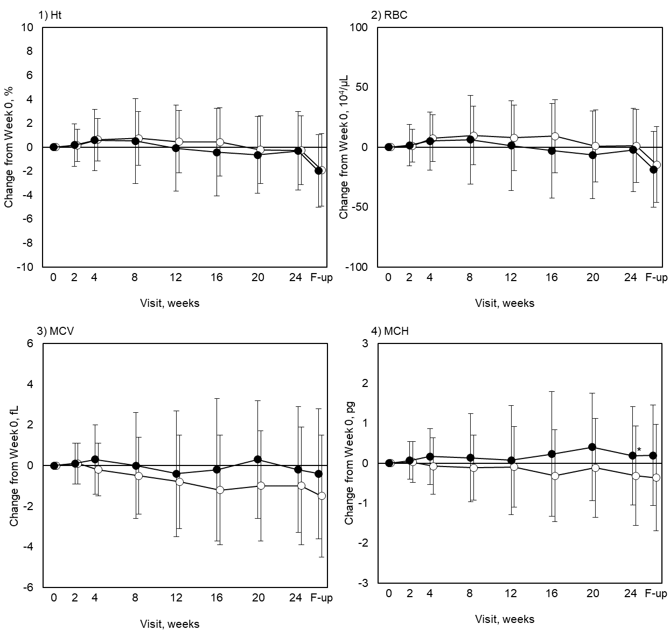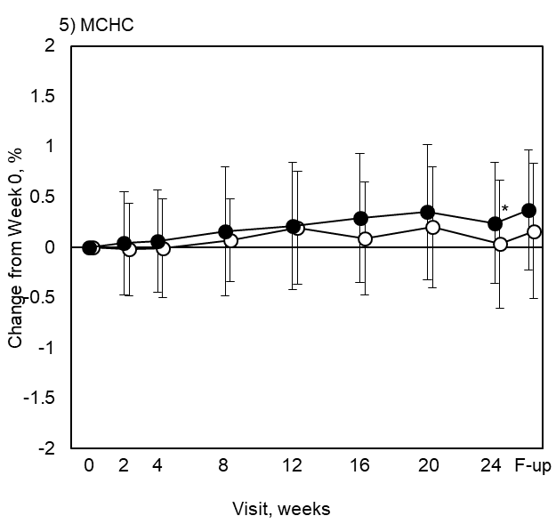
Figure S3. Changes in RBC-related parameters.
Each point indicates mean values in each treatment arm (closed circles: enarodustat arm, open circles: DA arm) on each observation day; bars indicate standard deviations. Inter-group comparisons of the changes at Week 24 between arms were performed for the post hoc analysis using t-test (significance level, 5% two-sided). *p < 0.05. F-up, follow-up; Ht, hematocrit; RBC, red blood cell; MCV, mean corpuscular volume; MCH, mean corpuscular hemoglobin; MCHC, mean corpuscular hemoglobin concentration.

