Table S1. Baseline characteristics before (entire cohort) and after propensity score matching (matched cohort)

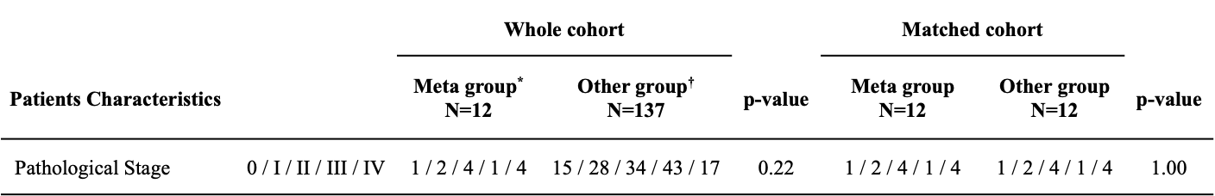
*Meta group: patients whose pulmonary nodules were metastatic
†Other group: patients whose pulmonary nodules were not metastatic

