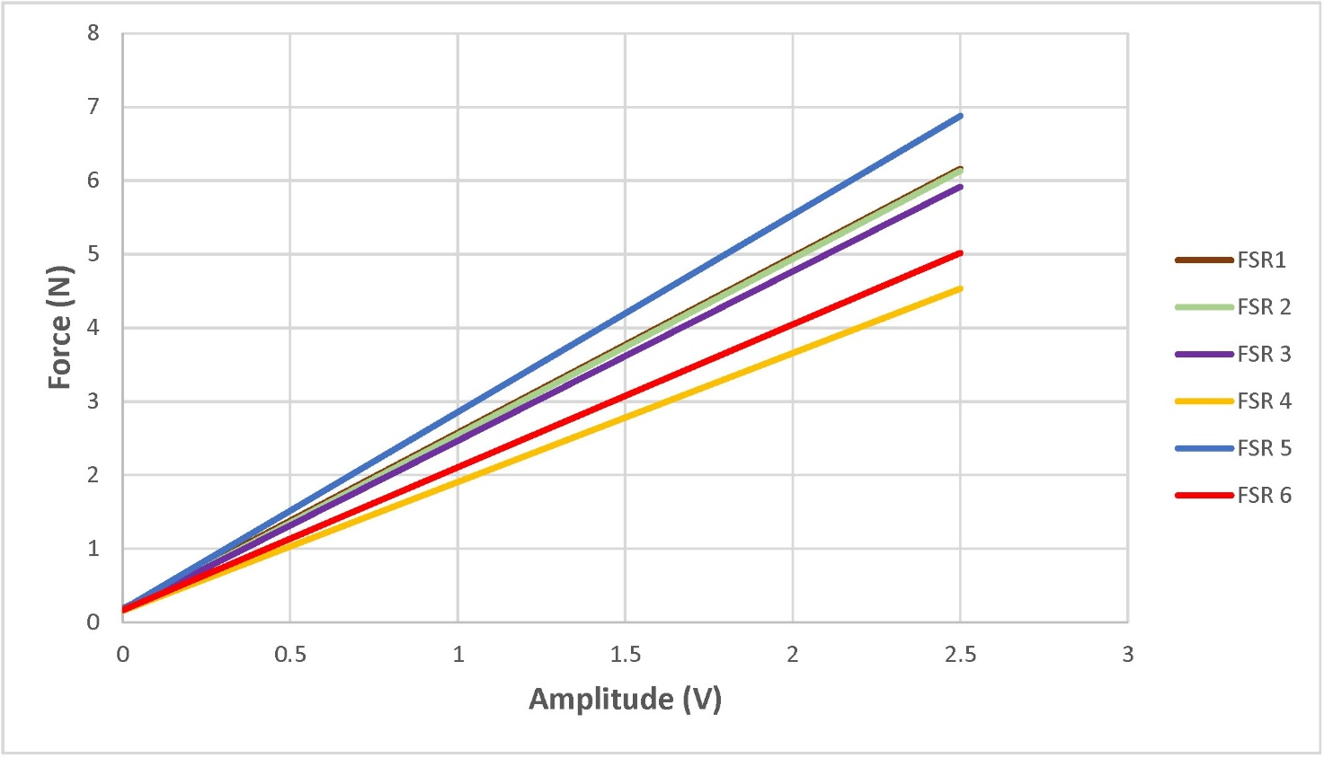

Figure S1. Plot of the correlation of applied force (N) and measured voltage (V) for each FSR resulting from the calibration of the six force sensors.

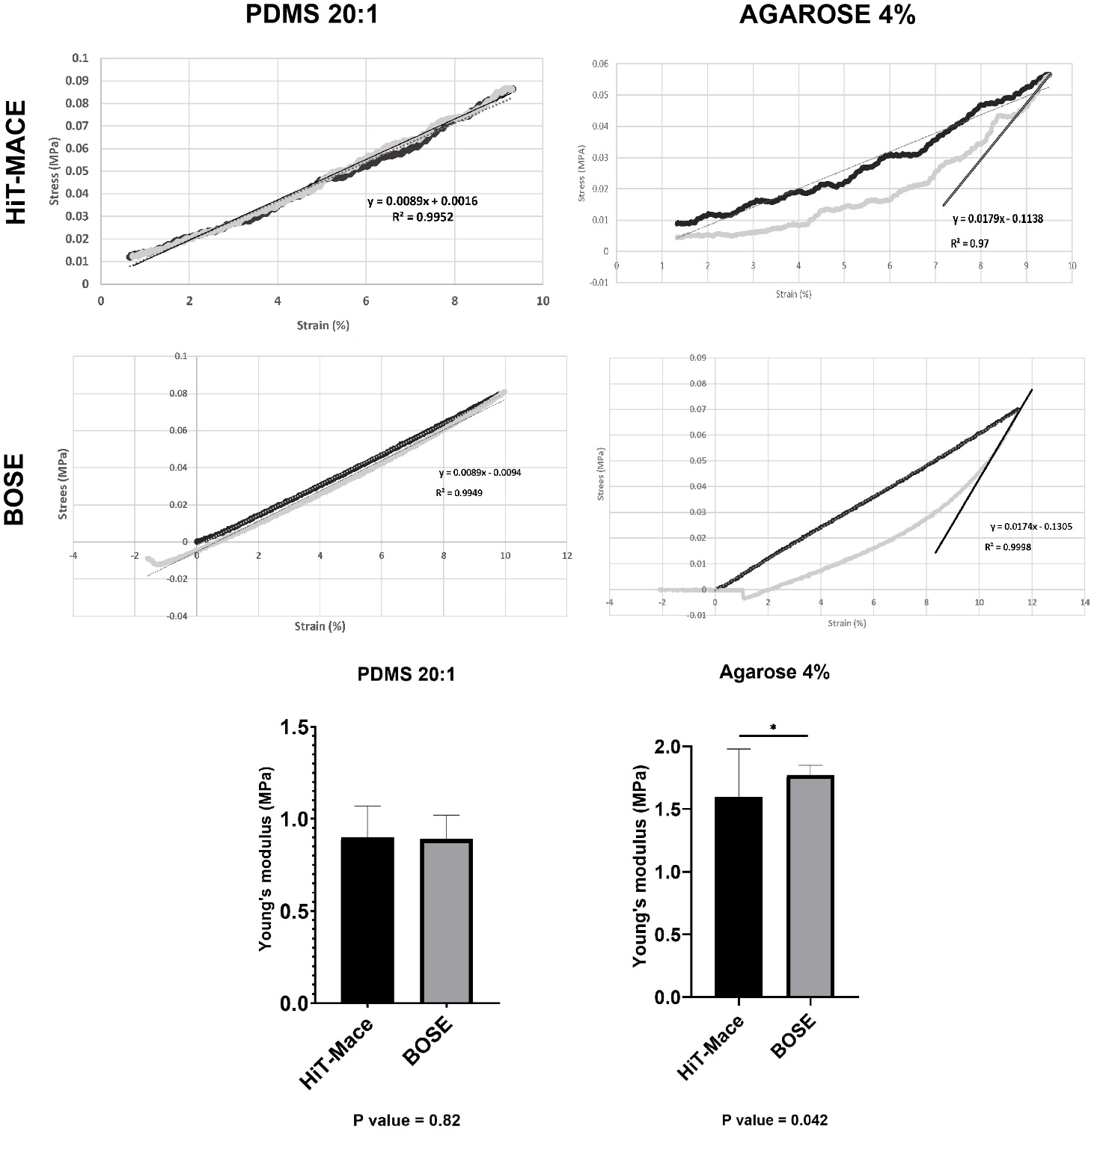

Figure S2. Stress-strain curve for PDMS 20:1 and Agarose 4% resulting from data collected by HiT-MACE loading (10% strain at 0.028 Hz for 30 seconds) and from data collected by the BOSE apparatus loading (10% strain with a 450N load cell at 0.1 mm/s rate). Both loading (black) and unloading (grey) are reported. Unloading curves were used to assess Young’s modulus. Statistical analysis (paired t-test) of the Young’s modulus for PDMS 20:1 and Agarose 4% do not show a statistically significant difference between the two mechanical devices for PDMS 20:1, but show a statistically significant difference (p<0.05) for the Agarose 4% that is characterized by a large strain hysteresis leading to a more variable mechanical response with HiT-MACE (larger standard deviation).

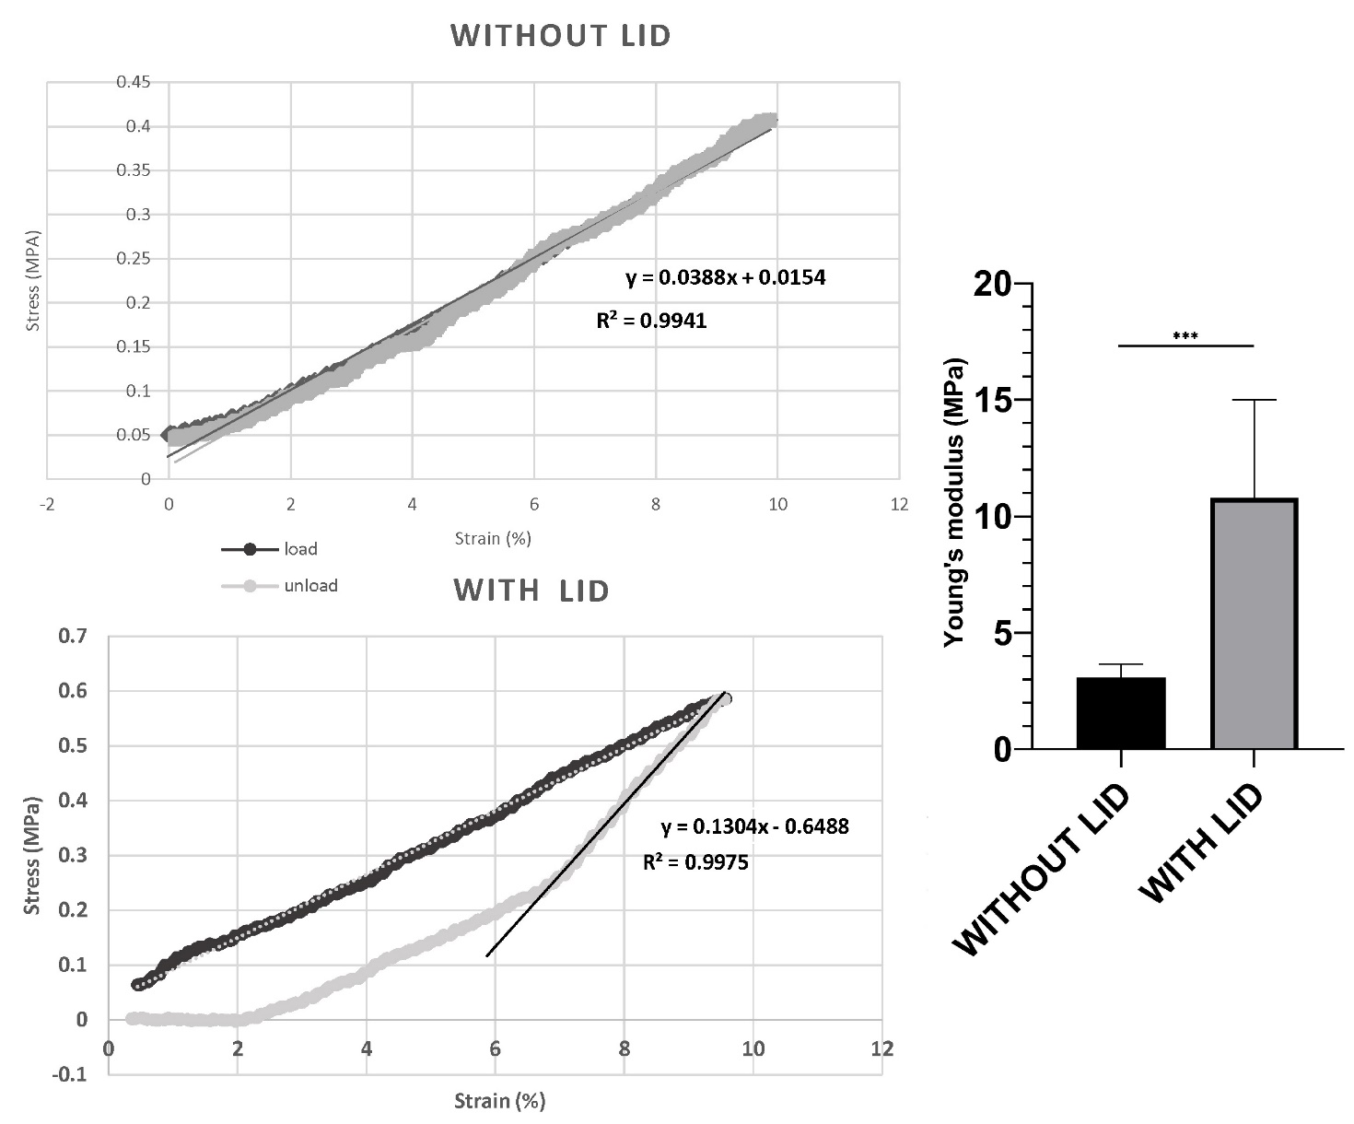

Figure S3. Stress-strain curve for PDMS 9:1 resulting from data collected by HiT-Mace loading (10% strain at 0.028 Hz for 30 seconds) without the use of the custom-made lid apparatus and with the use of the custom-made lid apparatus. Both loading (black) and unloading (grey) are reported. Unloading curves were used to assess Young’s modulus. Statistical analysis (paired t-test) for PDMS 9:1 shows a significant difference (p<0.001) between the Young’s modulus obtained with and without the use of the lid apparatus.

