All other ethics bodies that approved our study in the various centers involved:
1. The Institutional Review Board of Peking Union Medical College Hospital.
2. The Institutional Review Board of Beijing Tongren Hospital, Capital Medical University.
3. The Institutional Review Board of Beijing Tiantan Hospital affiliated to Capital Medical University.
4. The Institutional Review Board of Beijing Friendship Hospital, Capital Medical University.
5. The Institutional Review Board of Beijing Ditan Hospital, Capital Medical University.
6. The Institutional Review Board of Beijing Chaoyang Hospital, Capital Medical University.
7. The Institutional Review Board of Xuanwu Hospital, Capital Medical University.
8. The Institutional Review Board of Peking University Third Hospital.
9. The Institutional Review Board of Peking University First Hospital.
10. The Institutional Review Board of Peking University People’s Hospital.
11. The Institutional Review Board of China-Japan Friendship Hospital.
12. The Institutional Review Board of the 309th Hospital of Chinese People’s Liberation Army.
13. The Institutional Review Board of Beijing Shijitan Hospital, Capital Medical University.
14. The Institutional Review Board of Fuwai Hospital, China Academy of Medical Science and Peking Union Medical College.
15. The Institutional Review Board of Air Force General Hospital of Chinese People’s Liberation Army.
16. The Institutional Review Board of The First Affiliated Hospital of General Hospital of People’s Liberation Army.
17. The Institutional Review Board of Navy General Hospital.
18. The Institutional Review Board of The Luhe Teaching Hospital of the Capital Medical University.
19. The Institutional Review Board of Beijing Anzhen Hospital, Capital Medical University.
20. The Institutional Review Board of Beijing Hospital.
21. The Institutional Review Board of General Hospital of Armed Police Forces.
22. The Institutional Review Board of The General Hospital of People’s Liberation Army.
23. The Institutional Review Board of Beijing YouAn Hospital, Capital Medical University.
24. The Institutional Review Board of HuaXin Hospital, First Hospital of Tsinghua University.
25. The Institutional Review Board of Beijing Shunyi Hospital of China Medical University.
26. The Institutional Review Board of Beijing Geriatric Hospital.
27. The Institutional Review Board of Beijing No. 6 Hospital.
3107 eligible participants were enrolled from 30 ICUs at 28 hospitals
1584 patients developed AKI
1523 patients were excluded for non-AKI
55 patients had insufficient fluid data
25 did not have any fluid data from their ICU stay
2 lacked fluid data for the first day
28 lacked fluid data after the first day
1529 patients were included in the study
Fig. S1. Flowchart of included patients. AKI, acute kidney injury; ICU, intensive care unit.

Fig. S2. Fluid balance trajectories for excluding patients without baseline serum creatinine values during the first 7 days after ICU admission. FB, fluid balance.

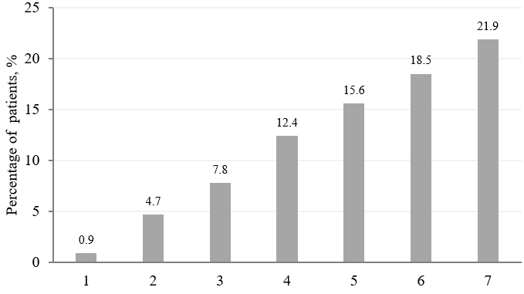
Fig. S3. Fluid overload during the first 7 days after admission

Fig. S4. Distribution of the maximum fluid overload. The maximum fluid overload showed a skewed distribution, with a median of 3.3% L/kg.

Table S1. Odds ratios for clinical outcomes with three different fluid balance trajectory patterns after excluding patients with AKI without baseline serum creatinine
Clinical outcomes | Trajectory groups | Events/Total | Unadjusted OR (95% CI) | P value | Adjusted OR (95% CI) | P value
Primary outcome
28-day mortality | Low FB | 280/1006 | 1.00 |  | 1.00
 | Decreasing FB | 21/125 | 0.52(0.32-0.85) | 0.009 | 0.40(0.23-0.69) | 0.001
 | High FB | 52/82 | 5.00(3.10-8.06) | < 0.001 | 2.61(1.53-4.42) | < 0.001
Secondary outcomes
Hospital mortality | Low FB | 275/1006 | 1.00 |  | 1.00
 | Decreasing FB | 26/125 | 0.70 (0.44-1.10) | 0.120 | 0.55(0.33-0.92) | 0.023
 | High FB | 54/82 | 5.13(3.18-7.26) | < 0.001 | 2.54(1.47-4.38) | 0.029
ICU mortality | Low FB | 216/1006 | 1.00 |  | 1.00
 | Decreasing FB | 17/125 | 0.58(0.34-0.98) | 0.042 | 0.44(0.24-0.81) | 0.008
 | High FB | 46/82 | 4.67(2.95-7.41) | < 0.001 | 2.20(1.29-3.75) | 0.004
AKI stage |  | Stage 1/2/3
 | Low FB | 466/244/296 | 1.00 |  | 1.00
 | Decreasing FB | 47/32/46 | 1.41(0.99-1.99) | 0.052 | 1.03(0.69-1.55) | 0.885
 | High FB | 24/18/40 | 2.21(1.44-3.38) | < 0.001 | 1.37(0.83-2.28) | 0.217
FB, fluid balance; ICU, intensive care unit; AKI, acute kidney injury, OR, odds ratio; CI, confidence interval.

Table S2. Odds ratios of fluid balance trajectory for clinical outcomes with stratification by characteristics

Clinical outcomes | Trajectory groups | Sepsis* |  | P for interaction | APACHE Ⅱ* |  | P for interaction
 |  | Yes | No |  | ≥20 | <20
Primary outcome
28-day mortality |  |  |  | 0.032 |  |  | 0.102
 | Low FB | 1.00 | 1.00 |  | 1.00 | 1.00
 | Decreasing FB | 0.52(0.30-0.92) | 0.84(0.35-2.00) |  | 0.55 (0.31-0.97) | 0.63(0.27-1.48)
 | High FB | 2.45(1.36-4.42) | 1.34(1.09-1.78) |  | 1.94(1.08-3.47) | 2.11(1.01-4.92)
Secondary outcomes
Hospital mortality |  |  |  | 0.496 |  |  | 0.534
 | Low FB | 1.00 | 1.00 |  | 1.00 | 1.00
 | Decreasing FB | 0.65(0.37-1.15) | 0.82(0.56-1.58) |  | 0.70(0.40-1.23) | 0.72 (0.41-2.05)
 | High FB | 1.69(1.04-3.16) | 1.27(1.00-1.62) |  | 1.52(1.05-2.72) | 2.54(1.07-6.05)
ICU mortality |  |  |  | 0.089 |  |  | 0.076
 | Low FB | 1.00 | 1.00 |  | 1.00 | 1.00
 | Decreasing FB | 0.68(0.38-1.20) | 0.52(0.25-1.26) |  | 0.55(0.31-0.99) | 0.60(0.21-1.68)
 | High FB | 1.80(1.01-3.19) | 1.17(0.98-3.27) |  | 1.78(1.07-2.45) | 3.17(1.26-3.98)
AKI stage |  |  |  | 0.378 |  |  | 0.654
 | Low FB | 1.00 | 1.00 |  | 1.00 | 1.00
 | Decreasing FB | 0.50(0.38-0.86) | 1.76(0.40-1.45) |  | 0.98(0.61-1.21) | 1.04(0.56-1.94)
 | High FB | 2.03(1.14-3.62) | 2.72(1.05-4.04) |  | 1.59(1.17-2.90) | 3.72(1.57-5.83)
FB, fluid balance; ICU, intensive care unit; AKI, acute kidney injury, OR, odds ratio; CI, confidence interval. * adjusted odds ratio and 95% confidence interval.

