Online supplementary material
Figure S1. Flowchart of included studies
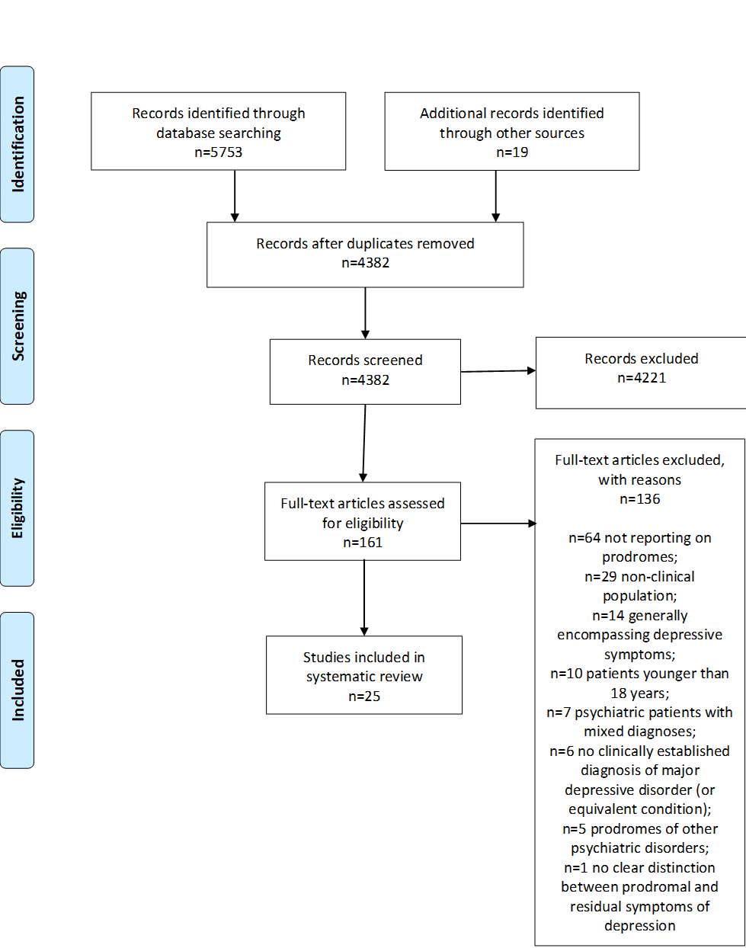

Table S1. Characteristics of retrospective studies
Study | Country | Sample | Female (%) | Setting | Depression diagnosis | Assessment instruments | Assessment time(s)
Cadoret et al. [14] | US | n=117 patients with a diagnosis of depression (mean age: 40.1 years; range: 9-86 years) | 71.8 | outpatients | NA | Source: medical records | 3-6 months before a diagnosis of depression
Eaton et al. [20] | US | n=71 individuals at their first MDE (≥ 18 years) | 75 | community residents | DSM-IV criteria | DIS and LCI Source: patients | ≤15 years before a diagnosis of MDD
Fava et al. [16] | Italy | n=15 patients at their first MDE (mean age: 45±11.7 years) | 40 | outpatients | RDC criteria | CID Sources: patients and family members | 6 months before a diagnosis of MDD
Fava et al. [17] | Italy | n=40 remitted patients  with MDD (mean age: 46.1±2.8 years) | 67.5 | outpatients | RDC criteria | CID Source: patients | NA
Hays [7] | UK | n=81 patients with endogenous depression | NA | inpatients | Department classification | Source: medical records | 3 months before a diagnosis of endogenous depression
Hegerl et al. [11] | Germany | n=108 patients with MDD (mean age: 47.6±14.1 years)  n=50 patients with BD and at least 1 MDE (mean age: 48.9±11.7 years) | 63 (MDD)  48 (BD) | outpatients and inpatients | DSM-IV and/or ICD-10 criteria | ODI Source: patients | NA
Hopkinson [21] | UK | n=100 patients with depressive psychosis (>50 years old) | NA | inpatients | NA | Source: patients or medical records | NA
Hopkinson [9] | UK | n=43 patients with depressive psychosis (<50 years old; mean age: 29.3 years; range: 18-48 years) | 67.4 | inpatients | Mayer-Gross criteria | NA | NA
Pede et al. [18] | India | n=80 remitted patients with MDD (mean age: 41.3±8.6 years) | 80 | outpatients | ICD-10 criteria | CIDRS Sources: patients, caregivers, medical records | NA
Sahoo et al. [13] | India | n=30 remitted patients with recurrent MDD (mean age 39±9.3 years).  n=30 remitted patients with BD (mean age 33.8±9.1 years). | 43.3 (MDD, recurrent)  30 (BD) | outpatients | DSM-IV criteria | Ad-hoc questionnaire, unstructured interview Sources: patients, relatives, medical records | ≤6 months before current MDE
Strauss et al. [12] | Germany | n=42 patients at their first MDE (mean age: 43.3±18.2 years)  n=80 patients with recurrent MDD (mean age: 49.8±16.2 years)  n=24 patients with BD (mean age: 52.7±15.7 years) | 57.1 (first MDE)  66.3  (MDD, recurrent)  54.2 (BD) | inpatients | ICD-10 criteria | ODI Source: patients | NA
Widmer and Cadoret [8] | US | n=154 patients with depression (mean age: 50.2 years; range: 17-86 years) | 67.5 | outpatients | NA | Source: medical records | 19 months before a diagnosis of depression
Wilson et al. [15] | US | n=101 patients with depression | 72.3 | outpatients | NA | Source: medical records | ≤18 months before a diagnosis of depression
Winokur [10] | US | n=36 patients with depression spectrum disease  n=172 patients without a depression spectrum disease | 60 | inpatients | NA | NA | NA
Young et al. [19] | US | n=53 patients with ‘winter depression’ (mean age: 36.5±8.6 years; range: 21-54 years) | 74 | community residents and outpatients | DSM-III-R and Rosenthal’s criteria | Symptoms cards Source: patients | NA
BD = bipolar disorder; CID = Clinical Interview for Depression; CIDRS = Clinical Interview for Depression and Related Syndromes; DIS = Diagnostic Interview Schedule; DSM = Diagnostic and Statistical Manual of Mental Disorders; F = female; ICD = International Classification of Diseases; LCI = Life Chart Interview; MDD = major depressive disorder; MDE = major depressive episode; NA = not addressed; RDC = Research Diagnostic Criteria; ODI = Onset-of-Depression Inventory.

Table S2. Characteristics of prospective studies

Study | Country | Sample | Female (%) | Setting | Depression diagnosis | Assessment instruments | Assessment time(s)
Chaudron et al. [32] | US | n=465 not currently depressed pregnant women (12-25 weeks) (mean age: 29±4.4 years) | 100 | outpatients | DSM-III-R criteria and/or CES-D score ≥ 16 and/or use of AD | HRS, DIS, CES-D  Source: patients | 4 months after delivery
Fava et al. [16] | Italy | n=15 patients at their first MDE (mean age: 45±11.7 years) | 40 | outpatients | RDC criteria | CID Source: patients and family members | 6 months after AD discontinuation
Gulec et al. [27] | Turkey | n=60 remitted, partially remitted, or recovered patients with MDD (mean age: 29.3±9.5 yeas) | 80 | outpatients | DSM-IV-TR criteria | CGI-S, BDI, HDRS-17, PSQI, and ISI  Source: patients | 28 weeks after AD discontinuation
Iacoviello et al. [29] | US | n=160 individuals who developed at least 1 MDE or minor depression (mean age: 18.8±1.45 years) | 72.7 | college students | DSM-IV and RDC criteria | SADS-C and SADS-L  Source: patients | 30-month follow-up
Iacoviello et al. [30] | US | n=65 individuals who developed at least 1 MDE or minor depression (mean age: 18.8±1.4 years) | 62.9 | college students | DSM-III-R criteria and Alloy’s criteria | SADS-C and SADS-L  Source: patients | 30-month follow-up
Judd et al. [31] | US | n=449 individuals with subsyndromal depressive symptoms (mean age: 43.6±1.01 years) | 65 | community residents | DSM-III and DSM-IV criteria | DIS  Source: patients | 1-year follow-up
Kumagai et al. [28] | Japan | n=89 remitted patients with recurrent MDD, (mean age: 44.3±10.8 years) | 44.9 | outpatients | DSM-5 criteria | Lifelog data, K6, and PHQ-9  Source: patients | 1-year follow-up
Okun et al. [33] | US | n=51 not currently depressed pregnant women (at week 36) with past histories of MDD/PPMD (mean age: 31.2±4 years; range: 21-39 years) | 100 | outpatients | DSM-IV-TR criteria | PSQI and HDRS-21  Source: patients | 28 weeks after delivery
Okun et al. [34] | US | n=56 not currently depressed pregnant women (at week 36) with past histories of MDD/PPMD (mean age: 31.1±4.1 years) | 100 | outpatients | DSM-IV-TR criteria | PSQI, HDRS-21, estradiol, prolactin, cortisol, and IL-6  Source: patients | 17 weeks after delivery
Perlis et al. [25] | US | n=14 remitted patients with MDD (mean age: 38.5 years; range: 27-49 years) | 71.4 | NA | DSM-III and RDC criteria, and HDRS-17 scores ≥ 14 | BDI  Source: patients | 5 weeks
Smit et al. [26] | The Netherlands | n=6 patients with history of MDD | NA | NA | SCL-90 | Item 'I feel restless' on a visual analogue scale  Source: patients | 95-183 days (during and after open-label tapering of AD)
AD = antidepressants; BDI = Beck Depression Inventory; CES-D = Center for Epidemiologic Studies Depression Scale; CGI-S = Clinical Global Impression-Severity Scale; CID = Clinical Interview for Depression; DIS = Diagnostic Interview Schedule; DSM = Diagnostic and Statistical Manual of Mental Disorders; EMA=Ecological Momentary Assessment; F = female; HRS = Health Responses Scale; IL-6 = Interleukin 6; ISI = Insomnia Severity Index; K6 = Kessler Psychological Distress Scale; MDD = major depressive disorder; MDE = major depressive episode; NA = not addressed; PHQ-9 = Patient Health Questionnaire-9; PPMD = Post-partum major depression; PSQI = Pittsburgh Sleep Quality Index; RDC = Research Diagnostic Criteria; SADS-C = Schedule for Affective Disorders and Schizophrenia, Change; SADS-L = Schedule for Affective Disorders and Schizophrenia, Lifestyle version; SCL-90 = Symptom Checklist-90.

Table S3. Frequency and duration of prodromal symptoms in unipolar depression
Study | Overall frequency (%) | Symptom frequency  (% total sample) | Symptom duration
Retrospective studies
Eaton et al. [20] | 29.6 | Dysphoria (88.7), sleep (87.3), appetite (78.9), thinking problems (76.1), suicidal thoughts and behaviors (69), tired (66.2), anhedonia (60.6), slow or restless (53.2), worthless (49.3) | Median: 1 year for anhedonia, sleep, slow or restless, tired, worthless, thinking problems.  Median: 2 years for appetite, suicidal thoughts and behaviors.  Median: 5 years for dysphoria
Fava et al. [16] | 100 | Generalized anxiety (86.7), irritability (60) | NA
Fava et al. [17] | NA | Generalized anxiety (65), irritability (35), and somatic anxiety (25) | NA
Hays [7] | NA | NA | Range: 6 weeks-several months
Hegerl et al. [11] | NA | NA | Range: 1-4 months
Hopkinson [21] | 26 | Tension and anxiety (26), vague complaint of gastro-intestinal discomfort (8), general feeling of discomfort (3), diarrhea (2) | Mean: 33.5 months  Range: 8 months-10 years
Hopkinson [9] | 30.2 | Tension and vague feelings of anxiety (18.6), indecision and impaired concentration (4.7), vague feelings of lassitude and ill health (4.7), sensitive ideas of reference (2.3) | Mean: 23 months  Range: 2 months-7 years
Pede et al. [18] | 100 | Irritability, initial insomnia (all 45), reduced energy (43.8) | Mean: 115±64.46 days  Range: 20-300 days
Sahoo et al. [13] | 93 | Sadness (90), talking less, lassitude, worrying over trifles (all 77), autonomic disturbances (73), indecision (70), reduced appetite, difficulty concentrating, slowness of movement, not feel like seeing people (all 67), fatigue (60), inability to feel, decreased sleep (all 57), irritability, decreased self-care, pessimistic thoughts (all 50), inner tension and agitation, decreased sexual interest, diurnal variation of symptoms-worsening in the morning (all 43), less responsible (37), less affectionate (33) | Mean: 42.7±38.1 days  Median: 21 days  Range: 1-150 days
Strauss et al. [12] | NA | NA | Median (all MDD patients): 28 days  Median (patients at their first MDE): 38.5 days  Median (patients with recurrent MDD): 28 days
Prospective studies
Gulec et al. [27] | NA | Subjective insomnia (83.3) | NA
Iacoviello et al. [29] | NA | NA | Mean: 44.8±39.7 days
Perlis et al. [25] | NA | Sleep disturbances (85.7) | NA
MDD = major depressive disorder; MDE = major depressive episode; NA = not addressed

