Supplementary Material

FISH-based Karyotype Analyses of Four Dracaena Species

Hongyou Zhao^{a,b,c}, Shuang Li^{b,c}, Chunyong Yang^{b,c}, Ge Li^{b,c}, Yanfang Wang^{b,c}, Jianming Peng^{b,c}, Zhen Yan^{b,c}, Rongying Li^{b,c}, Yanqian Wang^{b,c}, Lixia Zhang^{b,c}

ª College of Pharmaceutical Science, Yunnan University of Chinese Medicine, Kunming, China
^{b} Yunnan Branch, Institute of Medicinal Plant Development, Chinese Academy of Medical Sciences & Peking Union Medical College, Jinghong, China
^{c} Yunnan Key Laboratory of Southern Medicinal Resources, Jinghong, Yunnan, China

Corresponding Authors:
Yanqian Wang and Lixia Zhang
Yunnan Branch, Institute of Medicinal Plant Development
Chinese Academy of Medical Sciences & Peking Union Medical College
Xuanwei Road 138
Jinghong, Yunnan, 666100, China
Tel: +86 15887608706
E-mail: yanqwang@implad.ac.cn, lxzhang@implad.ac.cn
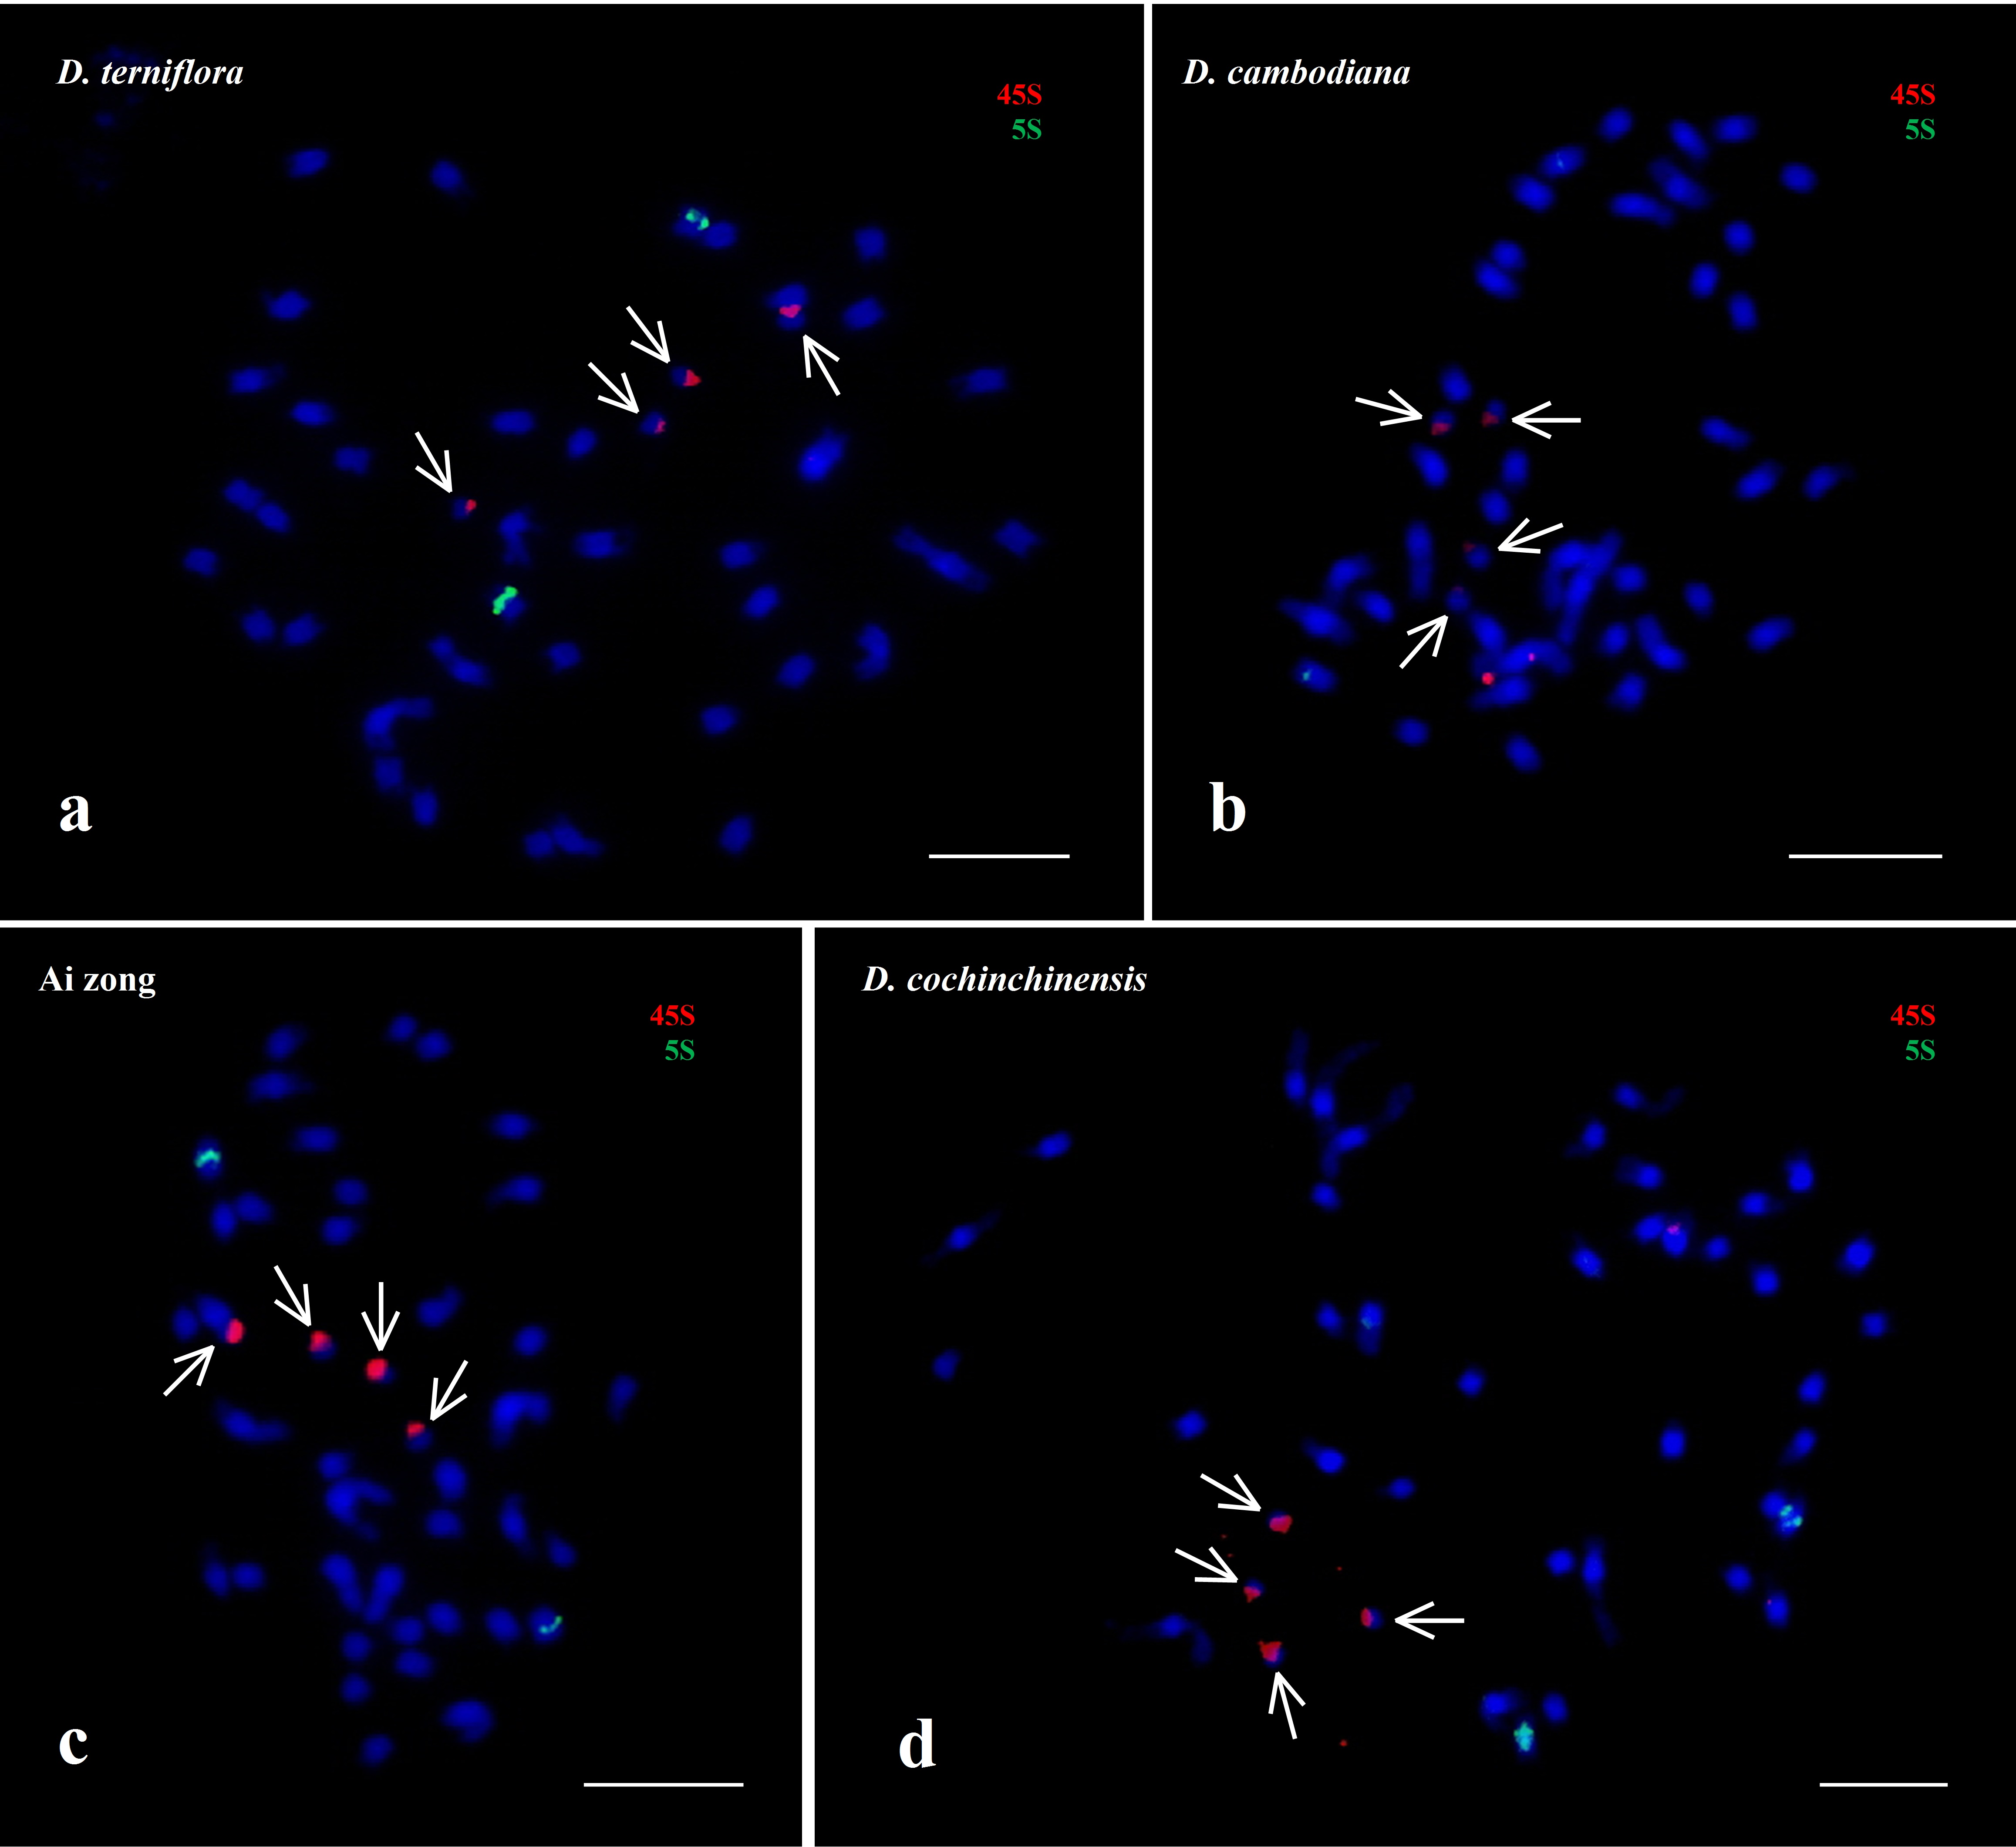
Fig. S1. Broken chromosomes of the four indicated Dracaena species (arrows). Green, 5S; red, 45S. Scale bar = 5 μm.

