Trends of the literature on cerebral bypass surgery: a systematic review

Supplementary Materials

**Supplementary Figure 1: Number of publications using direct, indirect and combined bypass for treatment of moyamoya.**

The pie chart shows the percentual distribution for all bypass studies addressing moyamoya vasculopathy and the histogram shows the number of publications annually. Direct bypass is most often reported whereas indirect procedures peaked in the late 1990ies and have become popular again in the last 4 years.

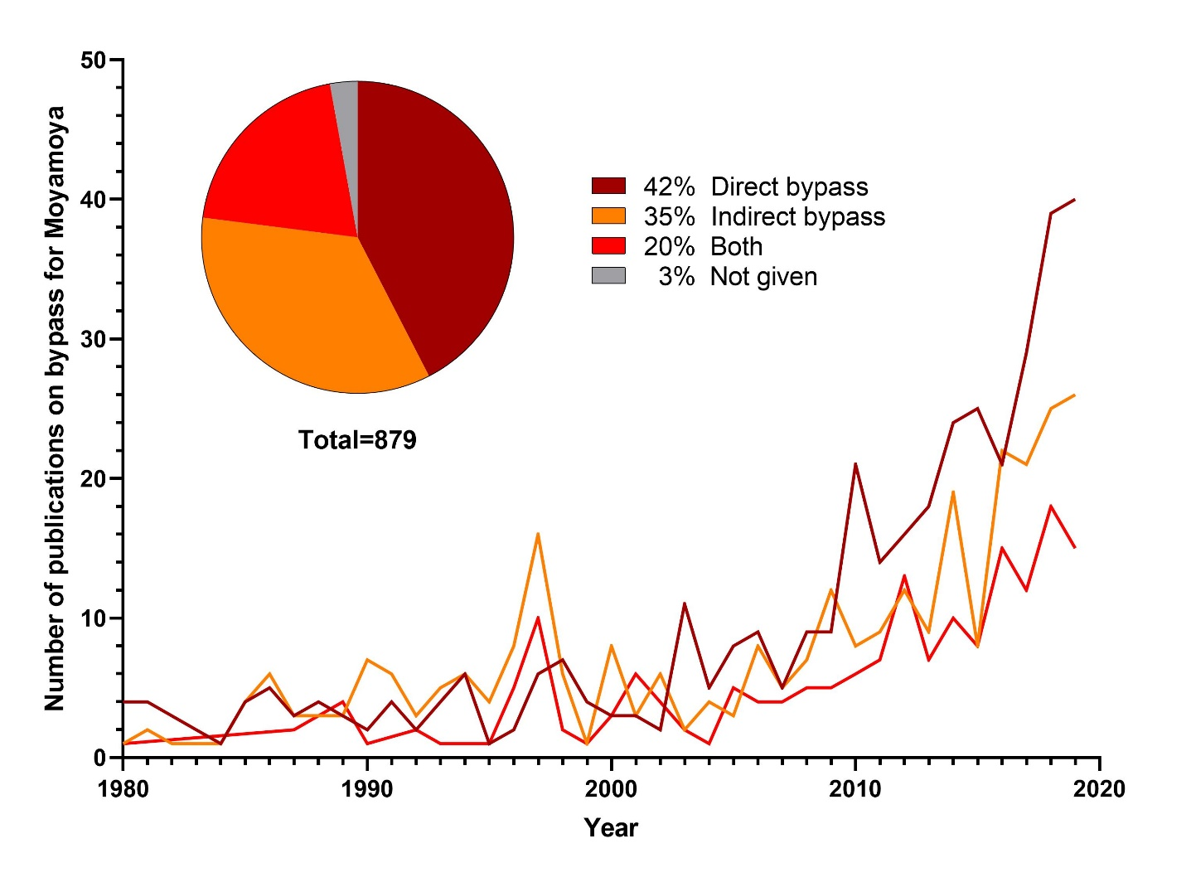

**Supplementary Figure 2: Flow characteristics of bypasses used in aneurysm surgery.**

The pie chart shows the percentual distribution for all studies reporting on flow-preservation bypass for managing intracranial aneurysms. The histogram shows the number of publications annually. Low flow bypass is the most used for managing intracranial aneurysms. However, articles on high and intermediate flow bypass are becoming increasingly popular.

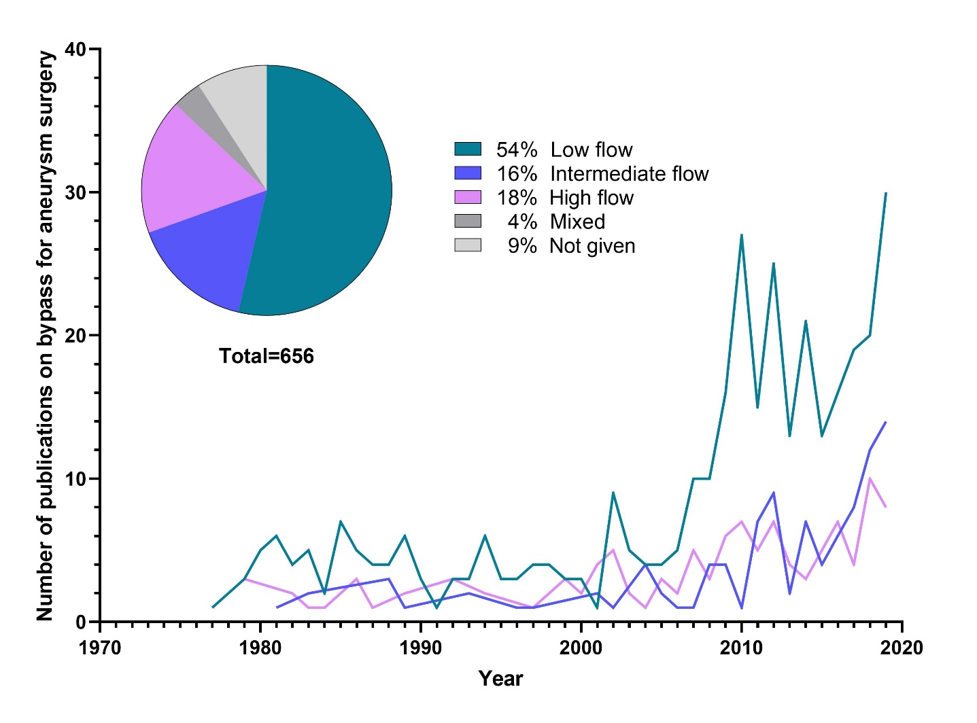

**Supplementary Figure 3: Frequency of the revascularized territory**

The pie chart shows publications distribution according to revascularized territory for all publications. Altogether, direct low flow bypass in the anterior circulation is most frequently reported, by far.

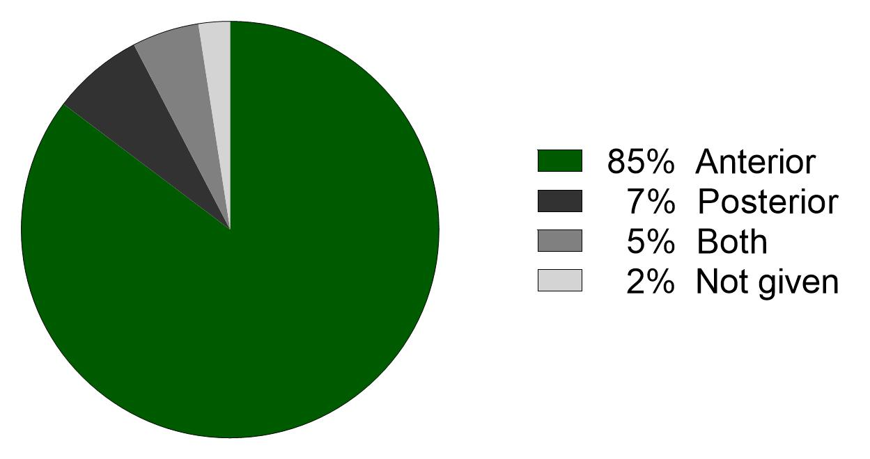

**Supplementary Table 1: Most commonly used words and most frequently cited studies per decade**

The table lists the focus of every decade, a word cloud of all words used in all titles of published studies, as well as the three most frequently cited studies per decade. To generate word clouds, words were extracted from all included manuscript titles by excluding common English stop and linking words as well as unspecific terms (e.g. bypass, surgery, surgical, paper, report, disease, cerebral) and by harmonizing different spellings of the same terms. For clarity reasons, only the most common 45 keywords (which appeared at least 5 times) were plotted. Type size reflects frequency of appearance.

|  |  |  |  |
| --- | --- | --- | --- |
| **Decade** | **Focus of period** | **Word cloud** | **Most frequently cited studies** |
| 1970-1979 | Pioneering, technique and applicability |  | * Sundt et al.: Bypass surgery for vascular disease of the carotid system[1] * Yasargil et al.: Results of microsurgical extra-intracranial arterial bypass in the treatment of cerebral ischemia[2] * Schmiedek et al.: Selection of patients for extra-intracranial arterial bypass surgery based on rCBF measurements[3] |
| 1980-1989 | (Failure in) steno-occlusive disease |  | * [EC/IC Bypass Study Group](https://pubmed.ncbi.nlm.nih.gov/?sort=pubdate&term=EC%2FIC+Bypass+Study+Group%5BCorporate+Author%5D): Failure of extracranial-intracranial arterial bypass to reduce the risk of ischemic stroke. Results of an international randomized trial[4] * Baron et al.: Reversal of focal 'misery-perfusion syndrome' by extra-intracranial arterial bypass in hemodynamic cerebral ischemia. A case study with 15O positron emission tomography [5] * Fox et al.: Use of detachable balloons for proximal artery occlusion in the treatment of unclippable cerebral aneurysms[6] |
| 1990-1999 | moyamoya |  | * Lawton et al.: Revascularization and aneurysm surgery: current techniques, indications, and outcome[7] * Matsuhima et al.: Surgical treatment of moyamoya disease in pediatric patients--comparison between the results of indirect and direct revascularization procedures[8] * Schmiedek et al.: Improvement of cerebrovascular reserve capacity by EC-IC arterial bypass surgery in patients with ICA occlusion and hemodynamic cerebral ischemia[9] |
| 2000-2009 | Aneurysm and moyamoya |  | * Scott et al.: Long-term outcome in children with moyamoya syndrome after cranial revascularization by pial synangiosis[10] * Guzman et al.: Clinical outcome after 450 revascularization procedures for moyamoya disease. Clinical article[11] * Woizik et al.: Intraoperative control of extracranial-intracranial bypass patency by near-infrared indocyanine green videoangiography[12] |
| 2010-2019 | Stroke prevention, moyamoya, and aneurysm |  | * Powers et al.: Extracranial-intracranial bypass surgery for stroke prevention in hemodynamic cerebral ischemia: The carotid occlusion surgery study randomized trial[13] * Miyamoto et al.: Effects of extracranial-intracranial bypass for patients with hemorrhagic Moyamoya disease: results of the Japan Adult moyamoya Trial[14] * Duan et al.: Moyamoya disease in China: its clinical features and outcomes[15] |

**References**

1 Sundt TM, Jr., Siekert RG, Piepgras DG, Sharbrough FW, Houser OW. Bypass surgery for vascular disease of the carotid system. Mayo Clin Proc. 1976 Nov;51(11):677-92.

2 Yasargil MG, Yonekawa Y. Results of microsurgical extra-intracranial arterial bypass in the treatment of cerebral ischemia. Neurosurgery. 1977 Jul-Aug;1(1):22-4.

3 Schmiedek P, Gratzl O, Spetzler R, Steinhoff H, Enzenbach R, Brendel W, et al. Selection of patients for extra-intracranial arterial bypass surgery based on rCBF measurements. Journal of neurosurgery. 1976 Mar;44(3):303-12.

4 Failure of extracranial-intracranial arterial bypass to reduce the risk of ischemic stroke. Results of an international randomized trial. N Engl J Med. 1985 Nov 7;313(19):1191-200.

5 Baron JC, Bousser MG, Rey A, Guillard A, Comar D, Castaigne P. Reversal of focal "misery-perfusion syndrome" by extra-intracranial arterial bypass in hemodynamic cerebral ischemia. A case study with 15O positron emission tomography. Stroke; a journal of cerebral circulation. 1981 Jul-Aug;12(4):454-9.

6 Fox AJ, Viñuela F, Pelz DM, Peerless SJ, Ferguson GG, Drake CG, et al. Use of detachable balloons for proximal artery occlusion in the treatment of unclippable cerebral aneurysms. Journal of neurosurgery. 1987 Jan;66(1):40-6.

7 Lawton MT, Hamilton MG, Morcos JJ, Spetzler RF. Revascularization and aneurysm surgery: current techniques, indications, and outcome. Neurosurgery. 1996 Jan;38(1):83-92; discussion 92-4.

8 Matsushima T, Inoue T, Suzuki SO, Fujii K, Fukui M, Hasuo K. Surgical treatment of moyamoya disease in pediatric patients--comparison between the results of indirect and direct revascularization procedures. Neurosurgery. 1992 Sep;31(3):401-5.

9 Schmiedek P, Piepgras A, Leinsinger G, Kirsch CM, Einhüpl K. Improvement of cerebrovascular reserve capacity by EC-IC arterial bypass surgery in patients with ICA occlusion and hemodynamic cerebral ischemia. Journal of neurosurgery. 1994 Aug;81(2):236-44.

10 Scott RM, Smith JL, Robertson RL, Madsen JR, Soriano SG, Rockoff MA. Long-term outcome in children with moyamoya syndrome after cranial revascularization by pial synangiosis. Journal of neurosurgery. 2004 Feb;100(2 Suppl Pediatrics):142-9.

11 Guzman R, Lee M, Achrol A, Bell-Stephens T, Kelly M, Do HM, et al. Clinical outcome after 450 revascularization procedures for moyamoya disease. Clinical article. Journal of neurosurgery. 2009 Nov;111(5):927-35.

12 Woitzik J, Horn P, Vajkoczy P, Schmiedek P. Intraoperative control of extracranial-intracranial bypass patency by near-infrared indocyanine green videoangiography. Journal of neurosurgery. 2005 Apr;102(4):692-8.

13 Powers WJ, Clarke WR, Grubb RL, Jr., Videen TO, Adams HP, Jr., Derdeyn CP. Extracranial-intracranial bypass surgery for stroke prevention in hemodynamic cerebral ischemia: the Carotid Occlusion Surgery Study randomized trial. Jama. 2011 Nov 9;306(18):1983-92.

14 Miyamoto S, Yoshimoto T, Hashimoto N, Okada Y, Tsuji I, Tominaga T, et al. Effects of extracranial-intracranial bypass for patients with hemorrhagic moyamoya disease: results of the Japan Adult Moyamoya Trial. Stroke; a journal of cerebral circulation. 2014 May;45(5):1415-21.

15 Duan L, Bao XY, Yang WZ, Shi WC, Li DS, Zhang ZS, et al. Moyamoya disease in China: its clinical features and outcomes. Stroke; a journal of cerebral circulation. 2012 Jan;43(1):56-60.