SUPPLEMENTAL MATERIAL: Ferric Citrate Dosing in Iron Deficiency Anemia in Non–Dialysis-Dependent Chronic Kidney Disease

Table of Contents
Supplemental Figure 1 A, B, C Dosing Algorithms
A. Serum phosphorus <2.0 mg/dL
B. Serum phosphorus ≥2.0 to <2.5 mg/dL
C. TSAT ≥50%
Supplemental Table 1 Changes in Hb, iron parameters, and serum phosphate by dosing sequence in the PP population.

Supplemental Figure 1. Dosing algorithms
The dosing algorithms depicted in Supplemental Figure 1 A, B, and C aimed to assist the investigator with decision making about dose modification in the presence of laboratory abnormalities or adverse events. They were not intended to define a standard of care, nor were they interpreted as prescribing an exclusive course of management. Investigators were responsible for evaluating the appropriateness of applying these guidelines to any particular clinical situation for an individual patient. Dose interruption referred to holding of the drug, usually for a short term, with the intent to resume dosing when possible.
A. Serum phosphorus <2.0 mg/dL
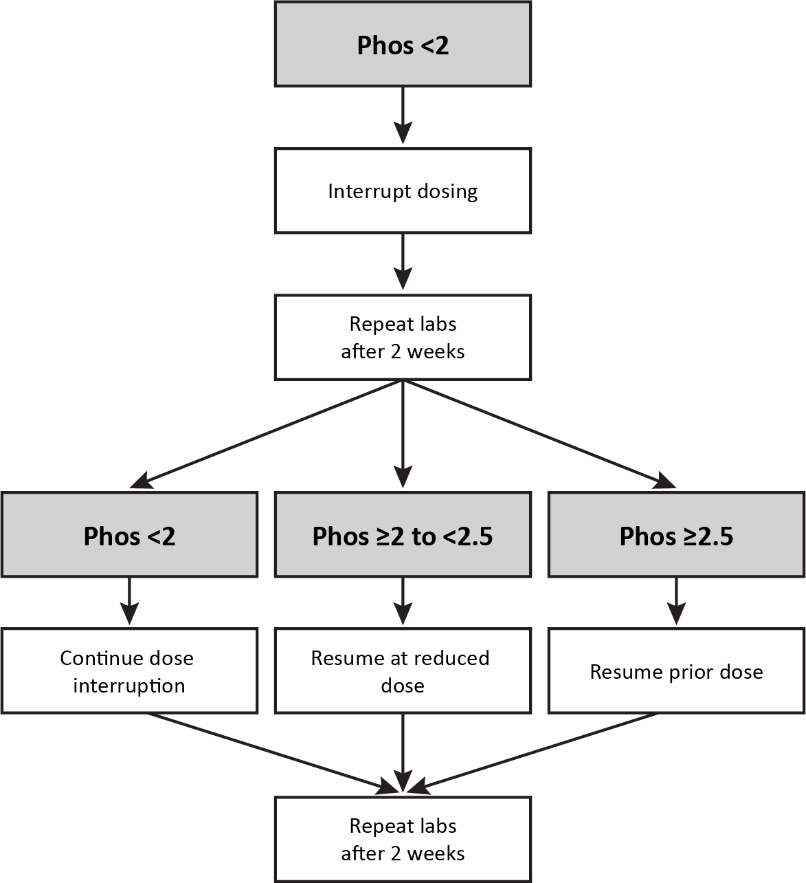

B. Serum phosphorus ≥2.0 to <2.5 mg/dL
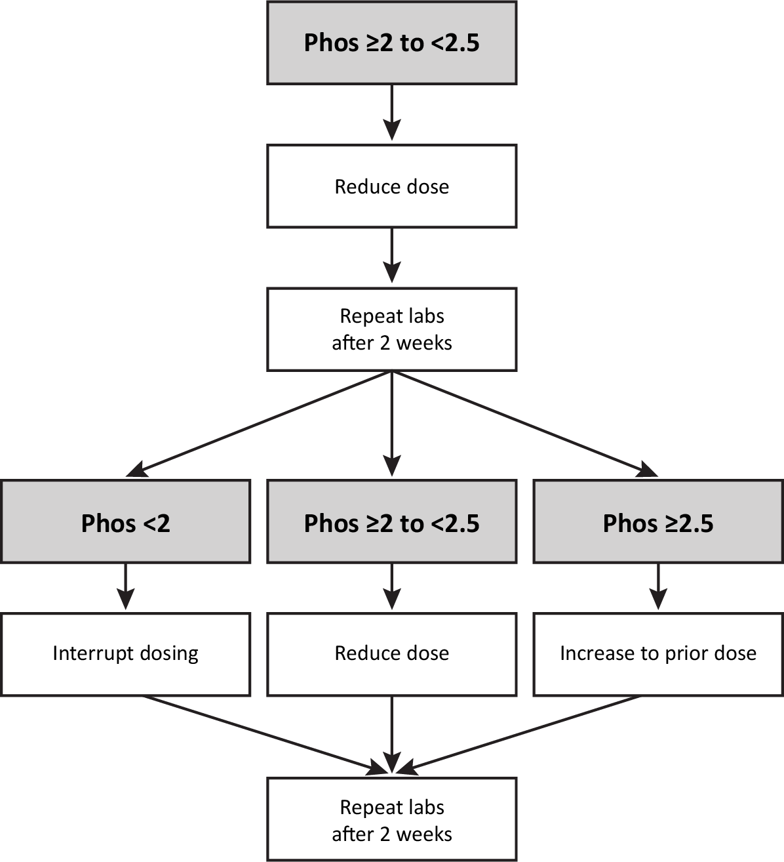

C. TSAT ≥50%
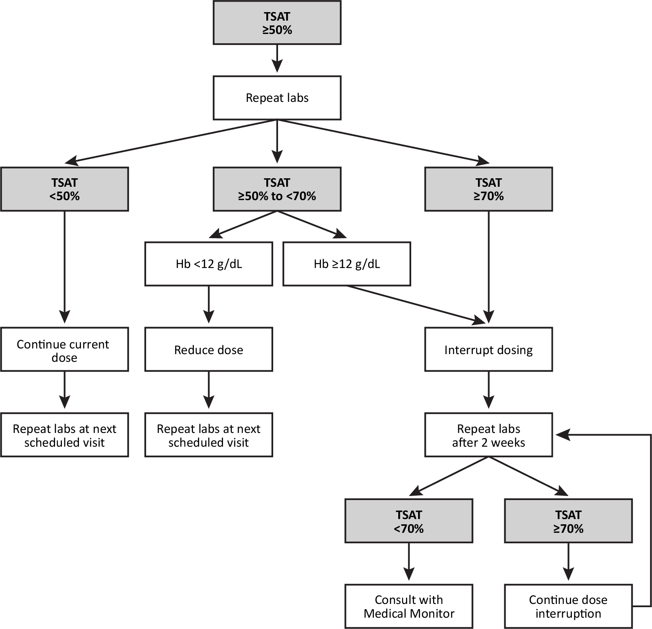
Hb, hemoglobin; Phos, serum phosphorus; TSAT, transferrin saturation.
All serum phosphorus values are presented in mg/dL.
Decisions about resuming or increasing dosing, and at which dose, the absolute levels, and trends of the serum phosphorus were taken into consideration in the context of the prior dose changes as well as Hb and TSAT.

Supplemental Table 1. Changes in Hb, iron parameters, and serum phosphate by dosing sequence in the PP population
 | Dosing Sequence
 | FC TID 3 g/d to 3 g/d |  | FC TID 3 g/d to 6 g/d |  | FC BID 4 g/d to 4 g/d |  | FC BID 4 g/ to 6 g/d
Parameter | n | Mean (SD) | n | Mean (SD) | n | Mean (SD) | n | Mean (SD)
Hb, g/dL
Baseline | 56 | 10.27 (0.69) | 41 | 10.57 (0.81) | 49 | 10.40 (0.67) | 37 | 10.65 (0.81)
Week 24
Mean Hb | 41 | 11.32 (0.91) | 33 | 10.98 (0.95) | 36 | 11.66 (1.28) | 34 | 10.84 (0.90)
Change from baseline |  | 1.05 (0.77) |  | 0.41 (0.79) |  | 1.24 (0.92) |  | 0.13 (0.69)
LS mean change from baseline (95% CI)ª |  | 0.97 (0.72, 1.23) |  | 0.46 (0.18, 0.73) |  | 1.12 (0.86, 1.38) |  | 0.17 (–0.11, 0.45)
Week 48
Mean Hb | 38 | 11.30 (1.04) | 29 | 10.79 (0.70) | 34 | 11.44 (1.34) | 27 | 10.92 (1.07)
Change from baseline |  | 1.01 (0.95) |  | 0.19 (0.61) |  | 1.00 (1.16) |  | 0.21 (0.89)
LS mean change from baseline (95% CI)ª |  | 0.87 (0.57, 1.16) |  | 0.32 (0.00, 0.65) |  | 0.88 (0.58, 1.19) |  | 0.20 (–0.14, 0.54)
TSAT, %
Baseline | 56 | 16.8 (5.27) | 41 | 19.2 (5.70) | 48 | 15.3 (5.67) | 37 | 20.1 (5.64)
Week 24
Mean TSAT | 41 | 24.8 (10.10) | 34 | 24.6 (10.30) | 36 | 23.6 (8.40) | 34 | 25.4 (10.28)
Change from baseline |  | 8.1 (9.93) |  | 5.6 (9.96) |  | 8.9 (8.92) |  | 5.1 (7.99)
LS mean change from baseline (95% CI)ª |  | 6.92 (4.15, 9.69) |  | 5.51 (2.48, 8.54) |  | 7.50 (4.45, 10.55) |  | 6.06 (2.93, 9.19)
Week 48
Mean TSAT | 39 | 26.6 (7.73) | 29 | 26.3 (9.17) | 34 | 26.1 (9.32) | 28 | 31 (12.95)
Change from baseline |  | 9.9 (7.26) |  | 7.3 (9.68) | 33 | 11.3 (8.16) |  | 10.7 (12.17)
LS mean change from baseline (95% CI)ª |  | 8.41 (5.62, 11.12) |  | 7.34 (4.18, 10.51) |  | 10.18 (7.10, 13.26) |  | 11.24 (7.93, 14.55)
Ferritin, ng/dL
Baseline | 56 | 129.4 (128.08) | 41 | 155.9 (129.25) | 49 | 96.7 (87.91) | 37 | 177.9 (124.14)
Week 24
Mean ferritin | 41 | 277.7 (205.24) | 34 | 274.7 (176.61) | 36 | 237.6 (138.02) | 34 | 346.2 (203.79)
Change from baseline |  | 145.7 (104.36) |  | 132.2 (139.44) |  | 144.8 (104.77) |  | 162.6 (137.69)
LS mean change from baseline (95% CI)ª |  | 142.51 (106.06, 178.96) |  | 129.67 (91.08, 168.26) |  | 151.93 (112.73, 191.14) |  | 156.83 (115.83, 197.83)
Week 48
Mean ferritin | 39 | 402.8 (282.91) | 30 | 415.6 (321.26) | 34 | 391.0 (265.13) | 28 | 606.9 (357.45)
Change from baseline |  | 266.6 (208.53) |  | 280.0 (307.01) |  | 295.3 (250.31) |  | 416.2 (295.74)
LS mean change from baseline (95% CI)ª |  | 249.47 (169.61, 329.34) |  | 256.83 (171.61, 342.04) |  | 315.31 (229.14, 401.49) |  | 370.54 (279.45, 461.63)
Serum phosphate, mg/dL
Baseline | 56 | 3.91 (0.547) | 41 | 3.92 (0.613) | 49 | 3.78 (0.550) | 37 | 4.04 (0.529)
Week 24
Mean serum phosphate | 41 | 3.66 (0.540) | 35 | 3.81 (0.631) | 36 | 3.53 (0.451) | 32 | 3.82 (0.771)
Change from baseline |  | -0.23 (0.732) |  | -0.10 (0.718) |  | -0.27 (0.654) |  | -0.33 (0.669)
LS mean change from baseline (95% CI)ª |  | -0.25 (-0.42, -0.07) |  | -0.11 (-0.30, 0.07) |  | -0.33 (-0.52, -0.15) |  | -0.15 (-0.36, 0.05)
Week 48
Mean serum phosphate | 39 | 3.79 (0.629) | 30 | 3.91 (0.671) | 34 | 3.54 (0.551) | 28 | 3.96 (0.689)
Change from baseline |  | -0.12 (0.701) |  | -0.01 (0.811) |  | -0.25 (0.787) |  | -0.21 (0.751)
LS mean change from baseline (95% CI)ª |  | -0.10 (-0.29, 0.10) |  | -0.02 (-0.24, 0.20) |  | -0.32 (-0.54, -0.11) |  | -0.04 (-0.27, 0.19)
BID, twice daily; CI, confidence interval; FC, ferric citrate; Hb, hemoglobin; LS, least squares; PP, per protocol; SD, standard deviation; TID, three times daily; TSAT, transferrin saturation.

