Supplementary Material

Advanced machine learning tools to monitor biomarkers of dysphagia: A wearable sensor proof-of-concept study
Megan K. O’Brien^{a,b} *, Olivia K. Botonisª *, Elissa Larkin^{c}, Julia Carpenter^{c}, Bonnie Martin-Harris^{d}, Rachel Maronatiª, KunHyuck Lee^{e}, Leora R. Cherney^{b,c,d}, Brianna Hutchison^{f}, Shuai Xu^{g}, John A. Rogers^{g}, Arun Jayaraman^{a,b}

ª Max Nader Lab for Rehabilitation Technologies and Outcomes Research, Shirley Ryan AbilityLab, Chicago, (IL,) USA
^{b} Department of Physical Medicine and Rehabilitation, Northwestern University, Chicago, (IL,) USA
^{c} Think and Speak Lab, Shirley Ryan AbilityLab, Chicago, (IL,) USA
^{d} Department of Communication Sciences and Disorders, Northwestern University, Evanston, (IL,) USA
^{e} ImpriMed, Palo Alto, (CA,) USA
^{f} Department of Biomedical Engineering, Case Western Reserve University, Cleveland, (OH,) USA
^{g} Center for Bio-Integrated Electronics, Departments of Materials Science and Engineering, Biomedical Engineering, Electrical Engineering and Computer Science, Northwestern University, Evanston, (IL,) USA
* These authors should be considered co-first authors

Corresponding Author:
Arun Jayaraman
Max Nader Lab for Rehabilitation Technologies and Outcomes Research
Shirley Ryan AbilityLab
355 E. Erie St.
Chicago, IL, 60611, USA
Tel: 312-238-6875
E-mail: ajayaraman@sralab.org

Supplementary Methods
Devices
The axis-specific sampling rates of the devices (1600 Hz in z-axis, 200 Hz in x- and y-axes) were tuned specifically to capture the frequency ranges of interest during swallowing for efficient memory and battery use. The anteroposterior plane (aligned with the device z-axis) consistently demonstrates higher spectral content during swallowing compared to other planes, which hold content below 100 Hz [1,2].
Sensor data were manually time-stamped by a researcher using the custom smartphone app. Timestamps were recorded to demarcate (1) the beginning of a task, designated by presentation of the bolus into the participant’s mouth, (2) the approximate timing of any swallows, identified by the SLP while palpating for laryngeal movement, and (3) the end of a task, determined as the completion of swallowing activity and clearance of the bolus from the oral cavity. These timestamps provided the sensor data window to identify the contained individual swallow event and confirm that the signal input for the supervised learning models lined up with known swallow events.

Protocol
Inpatients were assessed for dysphagia severity during each session in accordance with the Mann Assessment of Swallowing Ability (MASA) [3], a widely acknowledged and validated bedside tool to evaluate swallowing impairment in stroke [4]. The MASA is comprised of 24 clinical tasks designed to assess the four main areas of general patient status (e.g. alertness, cooperation, language, and speech); oral preparatory phase (e.g. saliva management, lip seal, lingual movement, strength, and coordination, oral bolus preparation, respiration and respiratory rate for swallowing); oral phase (e.g. gag reflex, palatal motility, bolus clearance and oral transit time); and pharyngeal phase of the swallow (e.g. reflexive and voluntary cough, vocal quality, presence or absence of a tracheostomy, and pharyngeal timing and response). The MASA is scored on a scale of 200 points, with cutoff scores to classify dysphagia severity: none (≥178), mild (168–177), moderate (139–167), or severe dysphagia (≤138). The MASA severity rating served as ground truth for model training and was obtained at each data collection session.
Although all participants were diagnosed as dysphagic in their medical records, the MASA recorded in the Admission session (Supplementary Table 1) may have indicated no dysphagia due to fluctuating or improved swallow behavior since the hospital intake evaluation and the start of rehabilitation.

Data Preparation and Processing
Data cleaning and preprocessing was performed in MATLAB R2019 (MathWorks; Natick, MA, USA). Data from the throat sensor were resampled to 1600 Hz using spline interpolation, filtered using a 5th-order high-pass Butterworth filter at 3 Hz, denoised by a 7-level wavelet decomposition (sym5, universal thresholding rule, soft thresholding), and stored as a vector magnitude. Data from the ribcage sensor were filtered using a 4th-order, bandpass Butterworth filter (0.1−0.5 Hz) along the z-axis, and stored as the z-axis component only (to capture dynamic respiration from inward and outward motion relative to the body frame). The cleaned and filtered data was then segmented using the beginning and end timestamps for each swallowing task.
Additional processing and analysis were performed in Python 3.6. For each task, the throat sensor signal was clipped around the swallow itself, removing data from chewing and oral preparation or data between multiple swallows for a single bolus. To clip swallows, signal peaks in the throat sensor data were first detected using the find peaks function in Python’s SciPy library (version 1.3.1). The most prominent peak prior to the timestamp marking laryngeal movement was considered a landmark for the true swallowing activity, thereby accounting for the time delay between the SLP’s verbal confirmation of a swallow and another researcher manually timestamping the data. The signal was clipped on either side of this peak to include the peak area under the curve lying above the signal baseline (signal intersection evaluated from a height at 95% of the peak prominence height subtracted from the height of the peak). Ribcage data were clipped to 15 seconds before and after the peak swallow acceleration to capture the surrounding respiratory dynamics. To mitigate inter- and intra-subject variability in the acceleration signal magnitude due to variations in sensor placement [5], each subject’s sensor data were normalized by a standardized within-session task. Namely, throat and ribcage data from each session were min-max normalized using the averaged minimum and maximum accelerations from the throat sensor during all saliva swallows, or from the ribcage sensor during baseline respiration, respectively.
Trials that contained competing peaks near the swallow timestamp or excessively noisy signals were discarded to ensure models were trained using sensor data that was confidently attributable to swallowing. Noisy signals are defined as those exceeding a sample entropy threshold, defined as:

$$SampEn= -log⁡(A/B)$$ | (1)

where $A/B$ is the conditional probability that a dataset repeating itself within a tolerance $r$ for $m$ points will also repeat itself for $m+1$ points, without self-matches [6]. We chose $m=2$ and $r$ as the mean derivative of acceleration for the clipped swallow signal. After removing uncertain or noisy signals, 505 swallowing instances were available for machine learning, including 184 swallows from non-dysphagic controls and 321 swallows from post-stroke patients with no, mild, or moderate impairment.

Feature Extraction
Twenty-four swallowing features were extracted from the clipped, normalized throat sensor signal recorded during each swallow (Supplementary Table 2). Time-domain features from the throat data included: swallow duration, max, min, median, mean, standard deviation, skewness, kurtosis, root mean square (RMS), interquartile range (IQR), peak width at half maximum (PWHM), absolute difference of the median and mean, sample entropy, and Lempel-Ziv complexity. Frequency-domain features were computed from the power spectral density (PSD) estimated via Welch’s method and included the following: peak frequency, normalized peak frequency, peak frequency magnitude, total power, mean frequency, standard deviation, skewness, kurtosis, entropy, and central frequency.
Twelve respiratory features were extracted from the normalized ribcage sensor signal recorded before, during, and after each swallow (Supplementary Table 3). General respiratory events, including inhalation, exhalation, and breathing apneas, were determined from the acceleration profiles corresponding to ribcage expansion and contraction. Respiratory-swallow coordination features were selected to capture clinically-relevant information about risk of aspiration during swallowing, including the timing of the swallow within the respiratory cycle [7,8] and the presence and timing of the necessary breathing cessation that occurs during swallowing (apnea) [8]. To locate the swallowing apnea, we assessed the 10-second window in the respiration signal that occurred immediately prior to the swallowing peak. Interruptions to the respiratory cycle were identified as segments of data when the first derivative of acceleration fell below the mean first derivative of the full 10-second window. The segment that was closest in time to the corresponding laryngeal swallow peak was selected as the swallowing apnea. Inhalation-Exhalation (I-E) patterns observed at the swallow apnea, as well as normalized inhalation cycles preceding or following the swallow peak, were recorded as features, as these are known to be influenced by factors such as age [9,10], disease [11,12], and bolus characteristics [13–16]. For instance, an increased frequency of swallows occurring during inhalation demonstrates a risk for aspirating, while post-swallow exhalation can be viewed as a second-round defensive mechanism for pharyngeal removal of residual material [17]. Inhale-exhale patterns correlated to timely dynamics of swallow initiation, apnea duration, or post-swallow phase resetting within dysphagia [18] may present important feature relationships to be learned by machine learning algorithms. Respiratory dynamics, such as normalized range of acceleration and pre-swallow respiration velocity, were also included.
Correlation-based feature selection was implemented to reduce model complexity and remove redundant variables. Features with strong correlations (Pearson correlation coefficient $|ρ|$ ≥ 0.6) and with the most frequent correlations to another feature were removed.

Model Development
Features for each model were scaled using a robust scaling method less sensitive to the presence of outliers, by removing the median value and dividing by the interquartile range:

$$x_{\text{scaled}}= \frac{x-\text{Q}2}{\text{Q}3-\text{Q}1}$$ | (2)

where $x$ is a given feature value and $\text{Q}1$, $\text{Q}2$, and $\text{Q}3$ are the 25th, 50th (median), and 75th percentiles, respectively.
To explore the separability between severity classes, we applied linear discriminant analysis (LDA) to project the task-specific swallowing and respiration features to a lower-dimensional subspace. LDA is a supervised dimensionality reduction technique that maximizes separation between classes while minimizing within-class variance [19]. In the two-dimensional subspace represented by the first two linear discriminant components, separation among MASA severity labels was improved by applying LDA on scaled sensor data from each swallowing task, rather than on data of all tasks together. Additionally, feature distributions were more normally distributed on a per-task basis, which is an important precursor to ensuring LDA stability in a model. This is likely due to the between-task differences in swallowing effort and respiratory dynamics captured in the feature set, which have been physiologically understood to vary in range depending on the bolus amount and viscosity [14]. For this reason, separate models were developed for each task.

Severity Probability Model
The Severity Probability Model evaluates the presence and severity of dysphagia using a Random Forest (RF) supervised learning algorithm, a decision tree classifier for a given number of trees which uses randomized subsets of data to predict the aggregated mean class label [20]. RF was chosen for its lower risk of overfitting, suitability for small datasets, and handling of imbalanced classes. Seven task-specific models were trained using combined data from similar bolus consistencies and oral presentation methods. The models were: saliva (dry swallow and effortful saliva), liquid (2 .5 ml and 5 ml), liquid (natural sip), liquid (straw sip), puree (spoonful), soft solid (spoonful) and hard solid (natural bite). Hyperparameters were tuned for each model using a leave-one-subject-out nested cross-validation, using GridSearchCV to iteratively test combinations of the number of trees, maximum depth, and maximum number of leaf nodes. The best-performing set of hyperparameters was chosen as the set that maximized the F1-score, which balances model recall and precision, for the non-dysphagic control data. We selected the non-dysphagic control data for tuning to account for the likelihood that the vast majority of swallows from the control group would reflect the true ground-truth label (no impairment), whereas patients with mild and moderate dysphagia would not exhibit the labelled impairment level for every swallow. An inner cross-validation loop determined the best hyperparameter combination, and an outer testing loop implemented the resulting model on a separate, held-out subject, iterated across participants. In total, 133 models were optimized for a leave-one-subject-out nested cross-validation scheme (7 tasks across 19 left-out subjects). To provide an example of the hyperparameters that were obtained during optimization, Supplementary Table 4 shows values obtained from tuning on all participant data (non-nested scheme). For the nested leave-one-subject-out model scheme, the average feature importance (Gini Index) for each task-specific model was computed across the outer subject loop (Supplementary Table 5).
Representative model output from a clinical swallowing evaluation is illustrated in Figure 2. Each swallow is analyzed independently, with a predicted probability of belonging to each possible dysphagia severity rating. The processed acceleration signal from the throat sensor is compared to the average acceleration profile from the control group, computed via a moving window average (window size = 3) for all task-specific swallows after aligning to the maximum swallow peak. Additionally, features extracted from the ribcage sensor (apnea duration, swallow latency, I-E pattern) provide clinically relevant, comparative characteristics on swallow-respiratory coordination.

Distance Model
The Distance Model employs a single-class Support Vector Machine (SVM) trained on task-specific sensor features from a single, confident class – namely, the non-dysphagic controls – and maps all patient samples to a measurable distance from the learned boundary of this class. The single-class SVM is an unsupervised algorithm which learns the decision boundary of the training data and evaluates test data as belonging to the trained class or identifying it as an out-of-class sample [21]. SVMs provide robust outlier detection for small datasets and were implemented to differentiate swallows that did not share characteristics of healthy swallowing. For each swallowing task, training and testing data were split for leave-one-subject-out cross-validation. Normalized sensor features were transformed to a two-dimensional subspace using the first two linear discriminant components. Regularization was introduced to the LDA fit via a shrinkage parameter, using the Ledoit-Wolf method to minimize risk of overfitting by reducing the number or weight of the features [22]. A single-class nonlinear SVM with radial basis function kernel was then fit to the control sample LDA cluster to learn the hyperplane that separated the control samples from the remaining feature subspace. Each patient swallowing instance can then be represented as a measureable distance $d$ to the learned hyperplane. Small distances indicate proximity to the healthy boundary, while increasing magnitude indicates greater deviation from healthy swallowing behavior. Inliers of the decision boundary were assigned a zero value ($d=0$) to designate the swallow behavior as being within the feature space of the control dataset – i.e., located within the target region.

Supplementary Figures

Supplementary Figure 1: Data processing pipeline. Sensors placed on the throat and ribcage collect raw accelerometer data during various swallowing tasks. The data is processed, segmented, and cleaned for feature extraction. Final features are paired with ground truth dysphagia severity ratings to train machine learning models.

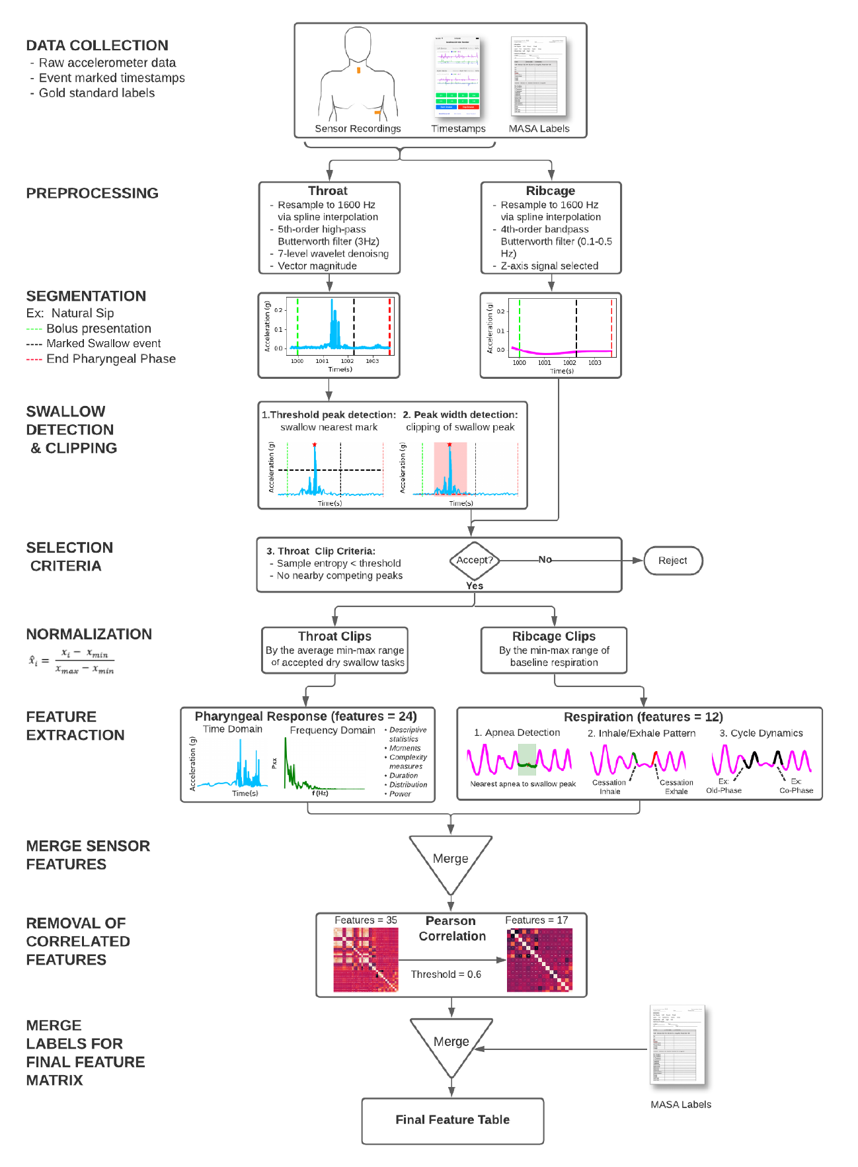

Supplementary Figure 2: Inter- and intra-subject swallow variability. Swallow data from representative patients and tasks demonstrate observable variations between trials and sessions, while also showing some consistency in the relative shape, pattern, and timing within the same patient. All swallows are aligned to the detected swallow peak at 0 seconds.

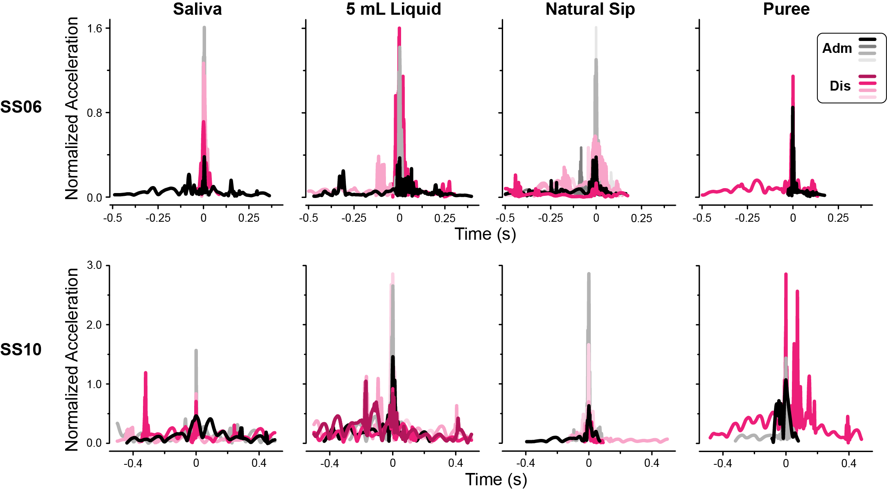

Supplementary Tables

Supplementary Table 1. Patient demographics, stroke characteristics, and dysphagia severity.

ID | Sex | Age | Stroke Type | Stroke Latency  at Admission  (days) | Duration Inpatient Stay  (days) | Admission |  |  |  | Discharge
 |  |  |  |  |  | MASA  TNS | MASA  Dysphagia  Severity | MASA  ORR | Physician-ordered  Diet [23] | MASA  TNS | MASA  Dysphagia  Severity | MASA  ORR | Physician-ordered  Diet [23]
SS02 | F | 59 | HEM | 33 | 23 | 174 | Mild | Unlikely | Regular solid;  Thin liquid | 186 | None | Unlikely | Regular solid;  Thin liquid
SS05* | M | 76 | HEM | 39 | - | 161 | Moderate | Possible | Regular solid;  Thin liquid | Early discharge from inpatient therapy
SS06 | M | 67 | HEM | 276 | 30 | 176 | Mild | Unlikely | Regular solid;  Thin liquid | 187 | None | Unlikely | Regular solid;  Thin liquid
SS07 | M | 59 | ISC | 52 | 35 | 179 | None | Unlikely | Soft, bite sized solid;  Mildly thick liquid | 189 | None | Unlikely | Regular solid;  Thin liquid
SS08 | F | 43 | ISC | 16 | 37 | 168 | Mild | Possible | Pureed solid;  Mildly thick liquid | 191 | None | Unlikely | Regular solid;  Thin liquid
SS09* | F | 45 | ISC | 18 | - | 166 | Moderate | Possible | Regular solid;  Thin liquid | Change in medical status
SS10 | F | 76 | ISC | 8 | 73 | 153 | Moderate | Possible | Pureed solid;  Mildly thick liquid | 162 | Moderate | Possible | _
SS11 | M | 52 | ISC | 18 | 34 | 178 | None | Unlikely | Regular solid;  Thin liquid | 169 | Mild | Possible | Regular solid;  Thin liquid
SS12 | M | 58 | ISC | 15 | 23 | 183 | None | Unlikely | _ | 183 | None | Unlikely | Regular solid;  Thin liquid
ISC = Ischemic; HEM = Hemorrhagic; MASA = Mann Assessment of Swallowing Ability; TNS = Total Numeric Score; ORR = Ordinal Risk Rating (i.e. risk of aspiration)
*Rated as moderate by the MASA but demonstrated clinically safe management of a regular diet as judged by a clinician

Supplementary Table 2. Swallow features computed from the Throat sensor data (normalized by average acceleration range during dry swallow trials).

Feature | Description | Included in Final Model (*)
Min | Minimum, maximum, median, mean, and interquartile range of the swallow signal [24–26].
Max
Median
Mean
IQR
Standard Deviation | Measures of the spread, symmetry, and sharpness of the signal distribution [24–29].
Skewness
Kurtosis |  | *
Peak width at half maximum | Width of the swallow signal measured at 50% of the peak prominence height $\left[s\right].$ | *
Absolute difference | Absolute value of the difference between the mean and median acceleration [25].
Root mean square | Square root of the mean square signal.
Sample entropy | Measure of signal regularity, independent of data length. | *
Lempel-Ziv complexity | Measure of signal complexity or randomness, recursively identifying new substrings and their reoccurrence in the data sequence [24–29]. | *
Swallow duration | Full duration (width) of the swallow, measured from the lower contour line of the signal about the peak swallow acceleration [28].
Power spectra: Standard deviation, Skewness, Kurtosis | Measures of the spread, symmetry, and sharpness of the power spectral distribution [28].
Power spectra peak frequency | Frequency corresponding to the maximum power density of the signal [25–29]. | *
Power spectra peak frequency magnitude | Peak magnitude of the power spectral density [25].
Power spectra normalized peak frequency | Power of the peak frequency divided by the total power of the signal. | *
Power spectra total power | Sum of all power spectra density values squared [28]. | *
Power spectra mean frequency | Mean power spectral density of the frequency domain signal.
Power spectra centroid | Frequency at which the power spectral density is centered upon, i.e. power spectra center of mass [26,27,29]. | *
Power spectra entropy | Complexity measure to convey information contained within the power spectral entropy domain of the swallow signal.

Supplementary Table 3. Respiratory features computed from the Ribcage sensor data before, during, and after swallow (normalized by average acceleration range during quiet sitting).
Feature | Description | Included in Final Model (*)
Apnea duration | Duration of the swallowing apnea [7,8].
Swallow latency | Duration from the start of the swallowing apnea to the time of the swallow peak [8]. | *
Post-swallow apnea sustention | Duration from the time of the swallow peak to the end of the swallowing apnea. | *
Apnea jerk | The mean first derivative of acceleration during the swallowing apnea. | *
Pre-swallow I-E pattern | Inhale or exhale occurring prior to the swallowing apnea [7,8]. | *
Post-swallow I-E pattern | Inhale or exhale occurring prior to the swallowing apnea [7,8]. | *
Old-Phase | Duration of the inhale prior to the swallowing apnea until the start of the swallow apnea, normalized by the average respiratory cycle duration during rest [7,8]. | *
Co-Phase | Duration from the end of the swallowing apnea to the next post-swallow inhale, normalized by the average respiratory cycle duration during rest [7,8].
Pre-swallow respiration range | Range of signal during breath (inhale or exhale) taken prior to the swallow.
Pre-swallow respiration velocity | Trapezoidal integration of the inhale or exhale preceding the swallowing apnea. | *
Relative pre-swallow breathing cessation | Duration from start of the swallowing apnea to the preceding acceleration zero-crossing, normalized by the average respiratory cycle duration during rest. | *
Relative post-swallow breathing onset | Duration from the end of the swallowing apnea to the next acceleration zero-crossing, normalized by the average respiratory cycle duration during rest. | *

Supplementary Table 4. Optimized hyperparameters for Severity Probability Model (all training data).

Task | Max Depth | Max Leaf Nodes | Number of Estimators
Saliva: Natural dry swallow + effortful dry swallow | 10 | 25 | 100
Liquid: 2.5 mL + 5 mL | 50 | 25 | 25
Liquid: Natural sip | 10 | 75 | 50
Liquid: Straw sip | 5 | 10 | 25
Puree: Spoonful + spoonful with effortful swallow | 25 | 75 | 50
Soft solid: Spoonful | 25 | 75 | 100
Hard solid: Natural bite | 10 | 100 | 10

Supplementary Table 5. Average feature importance for the Severity Probability Model.
Feature | Model Type |  |  |  |  |  |  | Average  (SD)
 | Saliva | Liquid  (tsp) | Liquid  (sip) | Liquid  (straw) | Puree  (spoonful) | Soft Solid  (spoonful) | Hard Solid  (bite)
Power spectra total power | 0.118 | 0.100 | 0.067 | 0.062 | 0.108 | 0.114 | 0.087 | 0.094  (0.022)
Old-Phase | 0 .111 | 0.106 | 0.064 | 0.108 | 0.090 | 0.091 | 0.070 | 0.091  (0.019)
Apnea jerk | 0.071 | 0.046 | 0.072 | 0.081 | 0.080 | 0.076 | 0.130 | 0.079  (0.025)
Kurtosis | 0.033 | 0.077 | 0.061 | 0.075 | 0.050 | 0.084 | 0.162 | 0.078  (0.041)
Relative pre-swallow breathing cessation | 0.068 | 0.087 | 0.073 | 0.131 | 0.060 | 0.064 | 0.046 | 0.076  (0.027)
Relative post-swallow breathing cessation | 0.059 | 0.111 | 0.069 | 0.038 | 0.100 | 0.071 | 0.067 | 0.074  (0.025)
Lempel-Ziv complexity | 0.133 | 0.047 | 0.078 | 0.054 | 0.049 | 0.059 | 0.044 | 0.066  (0.032)
Pre-swallow respiration velocity | 0.051 | 0.061 | 0.074 | 0.046 | 0.090 | 0.071 | 0.046 | 0.063  (0.016)
Power spectra centroid | 0.037 | 0.042 | 0.086 | 0.046 | 0.062 | 0.066 | 0.088 | 0.061  (0.020)
Swallow latency | 0.083 | 0.077 | 0.060 | 0.059 | 0.052 | 0.037 | 0.038 | 0.058  (0.017)
Post-swallow apnea sustention | 0.060 | 0.053 | 0.061 | 0.082 | 0.081 | 0.034 | 0.035 | 0.058  (0.019)
Sample entropy | 0.047 | 0.046 | 0.055 | 0.054 | 0.048 | 0.061 | 0.070 | 0.054  (0.009)
Power spectra normalized peak frequency | 0.043 | 0.047 | 0.057 | 0.071 | 0.044 | 0.057 | 0.051 | 0.053  (0.010)
Peak width at half maximum | 0.039 | 0.059 | 0.065 | 0.029 | 0.054 | 0.049 | 0.035 | 0.047  (0.013)
Power spectra peak frequency | 0.019 | 0.021 | 0.041 | 0.037 | 0.017 | 0.032 | 0.020 | 0.027  (0.010)
Pre-swallow I-E pattern | 0.017 | 0.009 | 0.011 | 0.017 | 0.007 | 0.017 | 0.005 | 0.012  (0.005)
Post-swallow I-E pattern | 0.011 | 0.009 | 0.006 | 0.010 | 0.007 | 0.016 | 0.004 | 0.009  (0.004)

Supplementary References

1 Lee J, Steele CM, Chau T. Time and time-frequency characterization of dual-axis swallowing accelerometry signals. Physiol Meas. 2008 Sep;29(9):1105–20.
2 Lee KH, Ni X, Lee JY, Arafa H, Pe DJ, Xu S, et al. Mechano-acoustic sensing of physiological processes and body motions via a soft wireless device placed at the suprasternal notch. Nat Biomed Eng. 2020 Feb;4(2):148–58.
3 Mann G. MASA : the Mann assessment of swallowing ability. Clifton Park, NY: Thomson Learning; 2002.
4 Garand KL, McCullough G, Crary M, Arvedson JC, Dodrill P. Assessment across the life span: The clinical swallow evaluation. Am J Speech-Language Pathol. 2020;29(2S):919–33.
5 Mamun KA, Steele CM, Chau T. Swallowing accelerometry signal feature variations with sensor displacement. Med Eng Phys. 2015 Jul;37(7):665–73.
6 Richman JS, Lake DE, Moorman JR. Sample Entropy. Methods Enzymol. 2004 Jan;384:172–84.
7 Paydarfar D, Gilbert RJ, Poppel CS, Nassab PF. Respiratory phase resetting and airflow changes induced by swallowing in humans. 1995.
8 Yagi N, Oku Y, Nagami S, Yamagata Y, Kayashita J, Ishikawa A, et al. Inappropriate Timing of Swallow in the Respiratory Cycle Causes Breathing–Swallowing Discoordination. Front Physiol. 2017 Sep;8(SEP):676.
9 Tracy JF, Logemann JA, Kahrilas PJ, Jacob P, Kobara M, Krugler C. Preliminary observations on the effects of age on oropharyngeal deglutition. Dysphagia. 1989 Jun;4(2):90–4.
10 Martin-Harris B, Brodsky MB, Michel Y, Ford CL, Walters B, Heffner J. Breathing and swallowing dynamics across the adult lifespan. Arch Otolaryngol - Head Neck Surg. 2005 Sep;131(9):762–70.
11 Hadjikoutis S, Pickersgill TP, Dawson K, Wiles CM. Abnormal patterns of breathing during swallowing in neurological disorders. Brain. 2000 Sep;123(9):1863–73.
12 Leslie P, Drinnan MJ, Ford GA, Wilson JA. Swallow respiration patterns in dysphagic patients following acute stroke. Dysphagia. 2002 Jun;17(3):202–7.
13 McFarland DH, Lund JP, Gagner M. Effects of posture on the coordination of respiration and swallowing. J Neurophysiol. 1994;72(5):2431–7.
14 Eyigör S, Perlman AL, He X. Effects of Age, Gender, Bolus Volume and Viscosity on Acoustic Signals of Normal Swallowing. Turkish J Phys Med Rehabil. 2007;53(3):94–9.
15 Hammoudi K, Boiron M, Hernandez N, Bobillier C, Morinière S. Acoustic study of pharyngeal swallowing as a function of the volume and consistency of the bolus. Dysphagia. 2014 Apr;29(4):468–74.
16 Jestrović I, Dudik JM, Luan B, Coyle JL, Sejdić E. The effects of increased fluid viscosity on swallowing sounds in healthy adults. Biomed Eng Online. 2013 Sep;12(1):90.
17 Gross RD, Atwood CW, Ross SB, Eichhorn KA, Olszewski JW, Doyle PJ. The coordination of breathing and swallowing in Parkinson’s disease. Dysphagia. 2008 Jun;23(2):136–45.
18 Bautista TG, Sun QJ, Pilowsky PM. The generation of pharyngeal phase of swallow and its coordination with breathing: Interaction between the swallow and respiratory central pattern generators. Prog Brain Res. 2014;212:253–75.
19 Scholkopf B, Smola AJ. Learning with Kernels: Support Vector Machines, Regularization, Optimization. Cambridge, MA: The MIT Press; 2002.
20 Breiman L. Random forests. Mach Learn. 2001 Oct;45(1):5–32.
21 Hastie T, Tibshirani R, Friedman J. The Elements of Statistical Learning: Data Mining, Inference, and Prediction. Second Edi. New York City, NY: Springer-Verlag; 2009.
22 Ledoit O, Wolf M. A well-conditioned estimator for large-dimensional covariance matrices. J Multivar Anal. 2004 Feb;88(2):365–411.
23 The International Dysphagia Diet Standardisation Initiative. IDDSI Framework [Internet]. 2019Available from: https://iddsi.org/framework/
24 Nikjoo MS, Steele CM, Sejdić E, Chau T. Automatic discrimination between safe and unsafe swallowing using a reputation-based classifier. Biomed Eng Online. 2011 Nov;10(1):100.
25 Celeste M, Azadeh K, Sejdić E, Berall G, Chau T. Quantitative classification of pediatric swallowing through accelerometry. J Neuroeng Rehabil. 2012;9(1):34.
26 Jestrovi´c IJ, Dudik JM, Luan B, Coyle JL, Sejdi´c ES. The effects of increased fluid viscosity on swallowing sounds in healthy adults. 2013.
27 Kurosu A, Coyle JL, Dudik JM, Sejdic E. Detection of Swallow Kinematic Events From Acoustic High-Resolution Cervical Auscultation Signals in Patients With Stroke. Arch Phys Med Rehabil. 2019 Mar;100(3):501–8.
28 Dudik JM, Coyle JL, Sejdic E. Dysphagia Screening: Contributions of Cervical Auscultation Signals and Modern Signal-Processing Techniques. IEEE Trans Human-Machine Syst. 2015 Aug;45(4):465–77.
29 Donohue C, Mao S, Sejdić E, Coyle JL. Tracking Hyoid Bone Displacement During Swallowing Without Videofluoroscopy Using Machine Learning of Vibratory Signals. Dysphagia. 2020 May;1:3.

