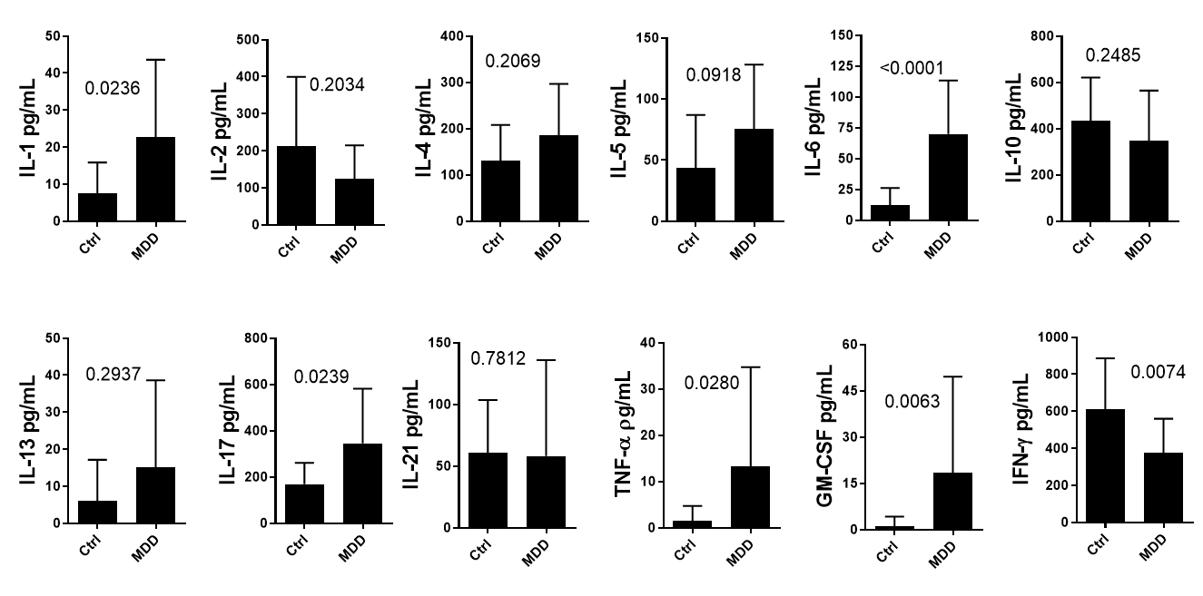
Figure S2. The impact of MDD on cytokine production by T cells from nonallergic subjects. PBMC cultures (1 x 10⁶/mL) from healthy individuals (Ctrl, n=16) and depressed subjects (MDD, n=16), both groups without allergic diseases, were activated with anti-CD3/anti-CD28 beads (10 μL/mL) for 3 days. The levels of different cytokines (IL-1β, IL-6, TNF-α, GM-CSF, Il-17, IL-2, IFN-γ, IL-4, IL-5, IL-13 and IL-10) were quantified by Luminex. The mean values ​​were compared and the p value shown in the figures.

