Supplementary Material
Research title: Reversal of root caries with CPP-ACP and fluoride varnish in xerostomia
Authors: Ahmed Sleibi, Anwar R Tappuni, Aylin Baysan

Groups | Varnishes | Active Ingredients | Additional Ingredients
Group 1 | MI varnish  (GC, Japan) | 5% NaF, CPP-ACP | Polyvinyl Acetate, Hydrogenated  rosin, Ethanol, Silicon Dioxide
Group 2 | NUPRO White NaF  (DENTSPLY, USA) | 5% NaF | Urethane Methacrylate, Hydrogenated Rosin, Resin, Isopropanol, Sodium, Sucralose, Flavour, Titanium Dioxide
Table S1. Composition of dental varnishes

Table S2. Intra and Inter-examiner reliability for study variables.
Variables/ Intra-examiner | Correlation (p value)
Oral dryness score⁺⁺  USWS buffer⁺⁺  USWS pH⁺⁺ | 0.94 (p<0.01)**  0.86 (p=0.01)**  0.93 (p<0.01)**
Texture⁺ | 1 (p<0.01)**
Cavitation⁺⁺ | 0.81 (p<0.01)**
Colour⁺ | 0.76 (p<0.01)**
Dimension⁺⁺ | 0.76 (p<0.01)**
Hardness⁺ | 1 (p<0.01)**
Gingival distance⁺⁺ | 0.74 (p<0.01)**
Severity index⁺ | 0.89 (p<0.01)**
DIAGNOdent⁺⁺ | 0.99 (p<0.01)**

⁺ Kappa coefficient, ⁺⁺ correlation coefficient
**Highly significant p<0.01

Variables/Inter-examiner reliability | Baseline  correlation (p value) | 3 or 6 months  Correlation (p value)
Oral dryness score⁺⁺  USWS buffer⁺⁺  USWS pH⁺⁺ | 0.95 (p<0.01)**  0.96 (p<0.01)**  0.97 (p<0.01)** | NA  0.86 (p<0.01)**  0.93 (p<0.01)**
Plaque index⁺⁺  Texture⁺ | NA  1 (p<0.01)** | 0.95 (p<0.01)**  0.64 (p=0.02)*
Cavitation⁺⁺ | 0.87 (p<0.01)** | 0.87 (p<0.01)**
Colour⁺ | 0.78 (p<0.01)** | 0.83 (p<0.01)**
Dimension⁺⁺ | 0. 95 (p<0.01)** | 0.95 (p<0.01)**
Hardness⁺ | 1 (p<0.01)** | 0.79 (p<0.01)**
Gingival distance⁺⁺ | 0.86 (p<0.01)** | 0.86 (p=0.03)*
Severity index⁺  DIAGNOdent⁺⁺ | 0.81 (p<0.01)**  0.94 (p<0.01)** | 0.67 (p<0.01)**  0.98 (p<0.01)**

⁺ Kappa coefficient, ⁺⁺ correlation coefficient
*Significant p<0.05 **Highly significant p<0.01, NA: Non-applicable (not assessed)
Table S3. Patients’ demography, social status, saliva test between the two groups at baseline (p>0.05).

Patient criteria | Group 1  (n=41) | Group 2  (n=39) | Over all  (n=80) | p value
Age (years)  Mean ±SD  Median (minimum-maximum)  n (%)  <65 years  ≥65 years | 65.70 ±12.77  67 (29 – 92)  17 (41.46%)  24 (58.54%) | 64.38 ±9.33  64 (45-82)  21 (53.85%)  18 (46.15%) | 65.06 ±11.18  65 (29 – 92)  38 (47.50%)  42 (52.50%) | 0.26
Gender n (%)  Male  Female | 18 (43.90%)  23 (56.10%) | 24 (61.50%)  15 (38.50%) | 42 (52.50%)  38 (47.50%) | 0.11
Occupation n (%)  Employed  Non-employed | 16 (39.03%)  25 (60.97%) | 12 (30.77%)  27 (69.23%) | 28 (35.00%)  52 (65.00%) | 0.43
Attendance to the dentist n (%)  Regular  Irregular | 28 (68.29%)  13 (31.71%) | 23 (58.97%)  16 (41.03%) | 51 (63.75%)  29 (36.25%) | 0.38
Conditions causing xerostomia n (%)  Diabetes  SS  Radiotherapy  High blood pressure | 28 (68.29%)  10 (24.39%)  1 (2.44%)  2 (4.88%) | 23 (58.97%)  11 (28.20%)  4 (10.26%)  1 (2.57%) | 51 (63.75%)  21 (26.25%)  5 (6.25%)  3 (3.75%) | 0.59
Smoking status n (%)  Smokers  Non-smokers  Previous smokers | 4 (9.76%)  31 (75.61%)  6 (14.63%) | 9 (23.08%)  28 (71.79%)  2 (5.13%) | 13 (16.25%)  59 (73.75%)  8 (10.00%) | 0.13

Removable partial prosthesis n (%)  Wearing denture  Non-wearing denture | 11 (26.83%)  30 (73.17%) | 11 (28.21%)  28 (71.79%) | 22 (27.50%)  58 (72.50%) | 0.89
Medication n (%)  No medication  1-2 medication  3-4 medication  ≥5 medication | 3 (7.32%)  6 (14.63%)  11 (26.83%)  21 (51.22%) | 2 (5.13%)  5 (12.82%)  9 (23.08%)  23 (58.97%) | 5 (6.25%)  11 (13.75%)  20 (25.00%)  44 (55.00%) | 0.90
Toothpaste used during study (g)  Mean ±SD | 363.13 ±152 | 357.56 ±129 | 360.31 ±140 | 0.87
Saliva test Mean ±SD  USWS (ml/min)  Number of sample  pH  Number of sample  Buffer capacity  Number of sample | 0.09 ±0.05  41  6.67 ±0.51  38  6.00 ±0.93  35 | 0.10 ±0.06  39  6.52 ±0.65  35  5.63 ±0.96±  30 | 0.09 ±0.05  80  6.6 ±0.58  73  5.8 ±0.96  65 | 0.59  0.28  0.12

Table S4. Mean±SD or number in percentages for plaque index, clinical criteria of root caries and DIAGNOdent measurements and the difference between the two groups at lesion level at baseline.
Variables | Group 1  n=73 lesion  (36 patient) | Group 2  n=95 lesion  (36 patient) | Overall  n=168 lesion  (72 patient) | p value
Plaque index Mean$±SD$ | 1.14 (0.82) | 1.71 (0.87) | 1.47 (0.89) | <0.01**
Roughness n (%)  Rough surface  Smooth surface | 72 (98.63%)  1 (1.37%) | 95 (100%)  0 | 167 (99.40%)  1 (0.60%) | 0.25
Cavitation n (%)  Non-cavitated  0 mm  Cavitated  0.5 mm  1.0 mm  1.5 mm  ≥2 mm | 29 (39.73%)  26 (35.62%)  9 (12.33%)  4 (5.48%)  5 (6.85%) | 36 (37.89%)  33 (34.74%)  15 (15.79%)  4 (4.21%)  7 (7.37%) | 65 (38.69%)  59 (35.12%)  24 (14.29%)  8 (4.76%)  12 (7.14%) | 0.80
Colour n (%)  Yellow  Light brown  Dark brown  Black | 0  59 (80.82%)  1 (1.37%)  13 (17.81%) | 2 (2.10%)  58 (61.05%)  7 (7.38%)  28 (29.47%) | 2 (1.19%)  117 (69.64%)  8 (4.76%)  41 (24.41%) | 0.02*
Dimension  ≤ 3 mm n (%)  3-6 mm n (%)  6-9 mm n (%)  > 9 mm n (%)  Mean$±SD$ mm | 26 (35.61%)  29 (39.73%)  3 (4.11%)  15 (20.55%)  6.85 ±6.35 | 28 (29.47%)  31 (32.63%)  9 (9.47%)  27 (28.43%)  7.88 ±6.97 | 54 (32.14%)  60 (35.72%)  12 (7.14%)  42 (25.00%)  7.43 ±6.71 | 0.32  0.19

Hardness n (%)  Soft  Leathery  Hard | 0  73 (100%)  0 | 0  95 (100%)  0 | 0  168 (100%)  0 | NA
Gingival distance  ≤ 1 mm n (%)  > 1 mm n (%)  Mean$±SD$mm | 65 (89.00%)  8 (11.00%)  0.55 ±0.76 | 85 (89.50%)  10 (10.50%)  0.53 ±0.96 | 150 (89.30%)  18 (10.70%)  0.54 ±0.88 | 0.92  0.38
Root caries SI n (%)  SI 0  SI 1  SI 2  SI 3  SI 4 | 0  45 (61.64%)  20 (27.40%)  8 (10.96%)  0 | 0  44 (46.32%)  33 (34.74%)  18 (18.94%)  0 | 0  89 (53%)  53 (31.5%)  26 (14.1%)  0 | 0.12
DIAGNOdent measurements  Mean$±SD$ | 42.16 ±25.99 | 51.58 ±27.86 | 47.52 ±27.39 | 0.02*

*Significant p<0.05 **Highly significant p<0.01

Figure S1. Mean$±SE$changes in lesion dimension during the study.

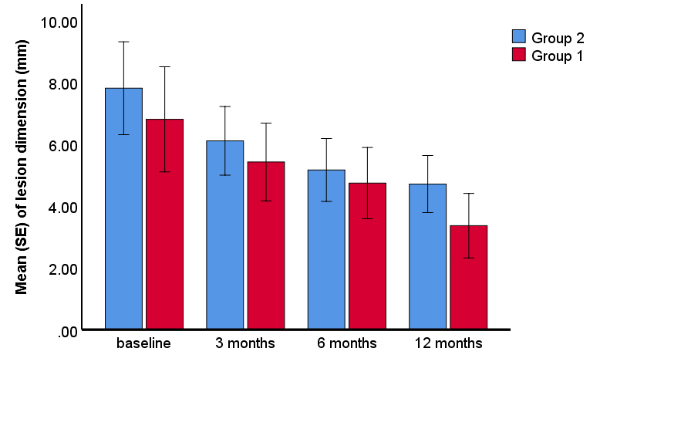

Figure S2. Mean$±SE$changes in lesion distance from the gingival margin during the study.

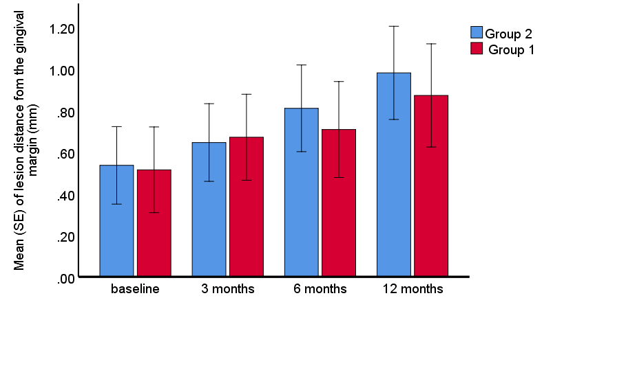

Figure S3. Mean$±SE$changes in DIAGNOdent measurements during the study.

