SUPPLEMENTARY MATERIAL
Table S1: Demographic and clinical characteristics of the study sample (363 women).
Characteristic | Outcome present  (n= 47) | Outcome absent  (n= 316) | Significant difference  (p< 0.05)
Number of measurements | 1 (1-2) | 1 (1-2) | No
Age (years) | 34 (29-38) | 34 (30-38) | No
BMI (kg/m²) | 29.7 (27.7-30.8) | 29,7 (26,2 – 34,3) | No
Pre-existing diabetes, n (%) | 1 (2.1%) | 18 (5,7%) | No
Nulliparity, n (%) | 40 (85.1%) | 194 (61,4%) | Yes
In vitro fertilization, n (%) | 3 (6.4%) | 26(8,2%) | No
PE in previous pregnancy, n (%) | 1 (2.1%) | 28 (8,9%) | No
Chronic hypertension, n (%) | 6 (12.8%) | 24 (7,6%) | No
Intrauterine growth restriction, n (%) | 15 (31.9%) | 63 (19,9%) | No
Platelets (10³/μl) | 201 (178-214) | 239 (200 – 283) | Yes
Data at delivery
GA (weeks) | 32.0 (30.8-31.9) | 38.4 (37.0-39.9) | Yes
Hypertension, n (%) | 31 (66,0%) | 59 (18,7%) | Yes
Proteinuria, n (%) | 39 (83.0%) | 23 (7,3%) | Yes
Reason for suspected preeclampsia§
New-onset hypertension, n (%) | 33 (70.2%) | 152 (48.1%) | Yes
Worsening of chronic hypertension, n (%) | 4 (8.5%) | 5 (1.6%) | Yes
New-onset proteinuria, n (%) | 33 (68.1%) | 53 (16.8%) | Yes
Intrauterine growth restriction, n (%) | 14 (29.8%) | 42 (13.3%) | Yes
Symptoms¶, n (%) | 3 (6.4%) | 42 (13.3%) | No
Abnormal uterine perfusion, n (%) | 9 (19.1%) | 113 (35.8%) | Yes
Data are given as median (interquartile range) or %. Outcome present if early-onset preeclampsia leading to delivery within one week from last measurement. §: There may have been more than one reason for suspected preeclampsia. ¶: The majority of symptoms were feet edema. GA, gestational age; BP, blood pressure.
Table S2: Marker median values at each gestational week and their formulae.
Variable | Gestational weeks + days |  |  |  | Formula | r²  (adjustment)
 | 28+0 | 30+0 | 32+0 | 33+4
sFlt-1 (pg/mL) | 1421.5 | 1633 | 1886 | 2362 | F(X)= 21122.3650-203.8084X+0.5275X2 | 0.986
PlGF (pg/mL) | 369.55 | 326.80 | 311.90 | 212.50 | F(X)= -3634.0547+40.4397X-0.1023X2 | 0.912
sFlt-1/PlGF ratio | 4 | 4 | 6 | 12 | F(X)=Exp(55.1863-0.5273X+0.0013X2) | 0.999
Samples | 60 | 71 | 80 | 63
The calculation excludes pregnancies that developed preeclampsia or intrauterine growth restriction. Repeated samples in each gestational age group have also been excluded. sFlt-1, soluble FMS-like tyrosine kinase-1; PlGF, placental growth factor; X, gestational age in days.
Table S3: Selected model description.
Predictors | Estimate | Standard error | p-value
intercept | -6.7278 | 1.6344 | < 0.001
gestational age (GA) | 0.2211 | 0.0948 | 0.020
log (NT-proBNP) | 0.6611 | 0.1844 | < 0.001
log (sFlt-1 MoM) | 1.0039 | 0.3750 | 0.007
Fixed effects coefficients of the selected linear mixed model built from 213 observations from 123 pregnancies with probit link function. As fixed effects, we entered gestational age at determination (GA), log transformed values of NT-proBNP and sFlt-1 MoM (without interaction terms) into the model. As random effects, we had intercepts for each pregnancy. The random effect variance between pregnancies was 0.3. Akaike information criterion was 153.1. From the y value provided by the model, the posterior risk (π) for delivery with early-onset preeclampsia within one week is given by the formula π= ɸ(y), where ɸ is the cumulative distribution function of the standard normal distribution. Visual inspection of residual plots did not reveal any obvious deviations from homoscedasticity or normality.
Figure S1: Distribution of number of samples per patient.
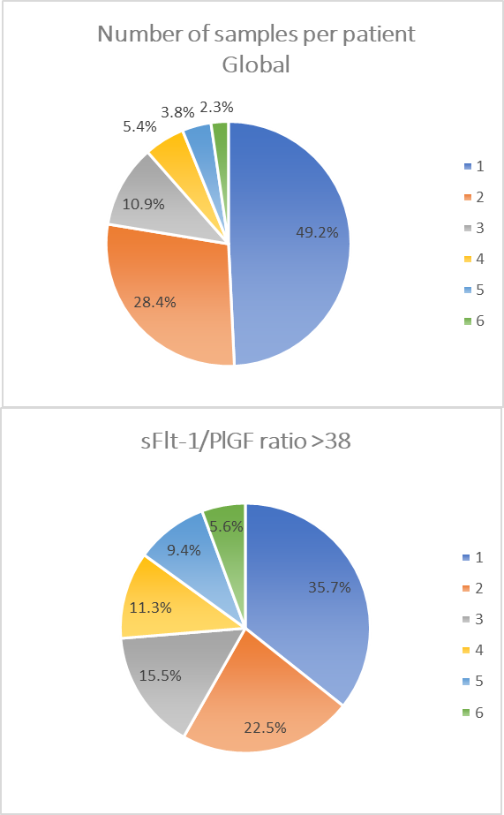
Figure S2: Distribution of NT-proBNP against gestational age at determination in 250 pregnancies that did not develop preeclampsia. Pearson correlation of -0.092 (p= 0.149).
Figure S3: ROC curves for early-onset preeclampsia leading to delivery within one week of linear mixed models based on gestational age (GA) and sFlt-1 MoM with and without NT-proBNP in the subcohort with an sFlt-1/PlGF ratio above 38 and intrauterine growth restriction (93 samples, 14 of which developed the assessed outcome) in the left panel and with chronic hypertension (20 samples, 4 of which developed the assessed outcome) in the right panel.

