Supplementary information
Supplementary Fig. 1. Study flow diagram and different analysis datasets according to persistence on liraglutide.
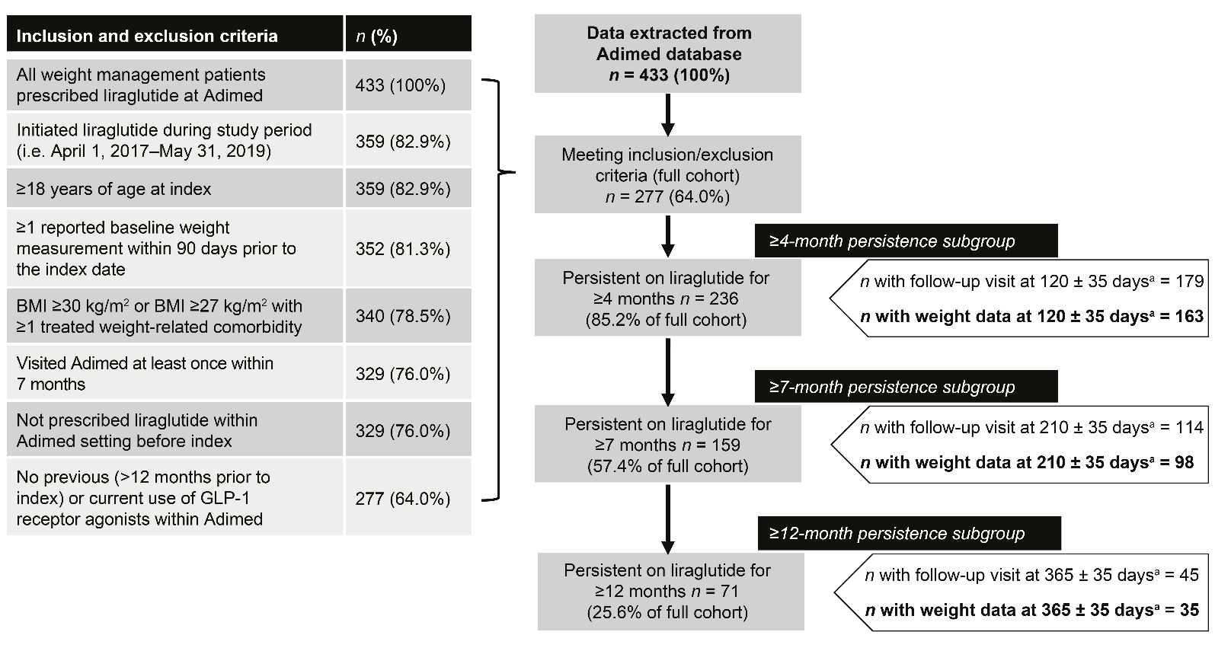

ªAfter start of liraglutide treatment (index date).
GLP-1, glucagon-like peptide-1.

