e-Table 1: ICD-9-CM codes used for acute organ dysfunctions
Organ Failure | ICD-9-CM Code | Description
Respiratory | 518.81 | Acute respiratory failure
 | 518.82 | Other pulmonary insufficiency, not elsewhere classified. Includes - Acute respiratory distress, Acute respiratory insufficiency, Adult respiratory distress syndrome NEC
 | 518.84 | Acute and chronic respiratory failure
 | 518.5 | Pulmonary insufficiency following trauma and surgery
 | 786.09 | Respiratory distress NOS
 | 799.1 | Respiratory arrest
 | 96.7, 96.70, 96.71, 96.72 | Ventilator management
Cardiovascular | 785.5 | Shock without mention of trauma
 | 785.50 | Shock unspecified
 | 785.59 | Other shock without trauma (includes Hypovolemic Shock)
 | 785.51 | Cardiogenic shock
 | 785.52 | Septic shock
 | 427.5 | Cardiac arrest
 | 458.0, 458.8, 458.9, 796.3 | Hypotension NOS
Renal | 584, 584.5, 584.6, 584.7, 584.8, 584.9 | Acute Kidney Injury
Hepatic | 570 | Acute hepatic failure or necrosis
 | 572.2 | Hepatic encephalopathy
 | 573.4 | Hepatic infarction
Hematologic | 286.6 | Defibrination Syndrome
 | 286.9 | Other coagulation defect
 | 287.4, 287.5 | Thrombocytopenia - secondary or unspecified
Metabolic | 276.2 | Acidosis – metabolic or lactic
Neurologic | 293, 293.0, 293.1, 293.8, 293.81, 293.82, 293.83, 293.84, 293.89, 293.9 | Transient organic psychotic conditions
 | 348.1 | Anoxic brain injury
 | 348.3, 348.30, 348.31, 348.39 | Acute encephalopathy
 | 780.01 | Coma
 | 780.09 | Altered consciousness - unspecified

e-Table 2: ICD-9-CM codes used to identify hospitalizations with cardiogenic shock, cardiac surgery or heart transplant*
Diagnosis Group | Type of Code | Codes | Description of codes used | Other Criteria
Cardiac Surgery | ICD-9-CM (Procedure) | 35.X | Operations on valves and septa of Heart
 |  | 36.X | Operation on vessels of heart
 |  | 37.1X | Cardiotomy and Pericardiotomy
 |  | 37.3X | Pericardiectomy and Excision of Lesion of Heart
Heart Transplant | ICD-9-CM (Procedure) | 37.51 | Heart Transplantation | Absence of codes for Lung Transplant procedure (33.5 or 33.6)
Cardiogenic Shock | CCS* diagnoses | 107 | Cardiac arrest and ventricular fibrillation | Without any codes for cardiac, heart/lung transplant surgery  AND  Either without CCS codes for respiratory failure (3, 122, 123, 126, 130, 131, 132)  Or with the CCS codes for cardiogenic shock in primary location
 |  | 108 | Congestive heart failure, not hypertensive
 |  | 100 | Acute Myocardial Infarction
 |  | 97 | Pericarditis, endocarditis and myocarditis
 |  | 106 | Cardiac dysrhythmia
 |  | 101 | Coronary atherosclerosis and other heart disease
 |  | 103 | Pulmonary heart disease
*Clinical Classification Software codes as developed by developed by Healthcare Cost and Utilization Project (available at https://www.hcup-us.ahrq.gov/toolssoftware/ccs/ccs.jsp)

e-Table 3: Risk Factors for development of AKI*
Risk Factor |  | Odds Ratio | 95 % Confidence Interval
Sex | Male | 1
 | Female | 0.70 | 0.58-0.84
Race | White | 1
 | Black | 1.19 | 0.90-1.57
 | Hispanic | 0.79 | 0.58-1.08
 | Asian or Pacific Islander | 0.95 | 0.48-1.86
 | Native American | 0.37 | 0.13-1.04
 | Others | 1.01 | 0.70-1.46
Primary Payer | Medicare | 1
 | Medicaid | 0.79 | 0.57-1.11
 | Private | 0.97 | 0.72-1.30
 | Self-pay | 0.92 | 0.56-1.52
 | No charge | 0.94 | 0.23-3.74
 | Others | 0.85 | 0.49-1.46
Hospital Location and Teaching Status | Urban Teaching | 1
 | Urban Non Teaching | 0.84 | 0.59-1.20
 | Rural | 0.33 | 0.08-1.30
Hospital Bedsize | Small | 1
 | Medium | 1.65 | 0.92-2.95
 | Large | 2.28 | 1.33-3.89
Hospital Region | Northeast | 1
 | Midwest | 0.94 | 0.65-1.34
 | South | 1.20 | 0.95-1.51
 | West | 1.23 | 0.94-1.61
Charlson’s Score |  | 1.07 | 1.01-1.13
Admission Type | Non elective | 1
 | Elective | 0.91 | 0.73-1.14
Acute Respiratory Dysfunction |  | 2.52 | 1.93-3.28
Acute Cardiovascular Dysfunction |  | 1.75 | 1.42-2.16
Acute Hepatic Dysfunction |  | 4.67 | 3.56-6.12
Acute Hematological Dysfunction |  | 2.12 | 1.76-2.55
Acute Metabolic Dysfunction |  | 2.30 | 1.91-2.78
Acute Neurological Dysfunction |  | 1.42 | 1.10-1.83
Presence of Cardiogenic Shock, Cardiac Surgery or Heart Transplant that admission |  | 0.82 | 0.68-0.99
Year of Admission | 2003 | 1
 | 2004 | 0.56 | 0.25-1.24
 | 2005 | 0.77 | 0.33-1.80
 | 2006 | 0.68 | 0.26-1.73
 | 2007 | 0.59 | 0.24-1.46
 | 2008 | 0.53 | 0.20-1.38
 | 2009 | 0.65 | 0.31-1.35
 | 2010 | 0.72 | 0.35-1.47
 | 2011 | 0.53 | 0.26-1.05
 | 2012 | 0.52 | 0.26-1.04
 | 2013 | 0.76 | 0.38-1.52
 | 2014 | 0.71 | 0.35-1.41
*Model also adjusted for age with age as a restricted cubic spline (Fig 3a)

e-Table 4: Risk Factors for development of AKI requiring dialysis*
Risk Factor |  | Odds Ratio | 95 % Confidence Interval
Sex | Male | 1
 | Female | 0.86 | 0.68-1.09
Race | White | 1
 | Black | 1.16 | 0.82-1.63
 | Hispanic | 1.01 | 0.68-1.50
 | Asian or Pacific Islander | 1.37 | 0.68-2.74
 | Native American | 0.40 | 0.08-2.01
 | Others | 1.09 | 0.68-1.77
Primary Payer | Medicare | 1
 | Medicaid | 0.87 | 0.56-1.35
 | Private | 0.98 | 0.73-1.31
 | Self-pay | 1.02 | 0.60-1.75
 | No charge | 5.06 | 1.43-17.87
 | Others | 0.77 | 0.40-1.47
Hospital Location and Teaching Status# | Urban Teaching | 1
 | Urban Non Teaching | 0.84 | 0.50-1.42
Hospital Bedsize | Small | 1
 | Medium | 0.71 | 0.33-1.52
 | Large | 0.78 | 0.40-1.52
Hospital Region | Northeast | 1
 | Midwest | 2.84 | 1.84-4.38
 | South | 1.73 | 1.15-2.60
 | West | 2.26 | 1.42-3.58
Charlson’s Score |  | 1.04 | 0.97-1.10
Admission Type | Non elective | 1
 | Elective | 0.95 | 0.71-1.27
Acute Respiratory Dysfunction |  | 2.61 | 1.63-4.19
Acute Cardiovascular Dysfunction |  | 1.70 | 1.26-2.29
Acute Hepatic Dysfunction |  | 2.29 | 1.84-2.86
Acute Hematological Dysfunction |  | 1.57 | 1.25-1.98
Acute Metabolic Dysfunction |  | 1.63 | 1.29-2.04
Acute Neurological Dysfunction |  | 1.41 | 1.12-1.78
Presence of Cardiogenic Shock, Cardiac Surgery or Heart Transplant that admission |  | 0.66 | 0.51-0.85
Year of Admission | 2003 | 1
 | 2004 | 0.70 | 0.29-1.71
 | 2005 | 1.33 | 0.61-2.88
 | 2006 | 1.05 | 0.31-3.52
 | 2007 | 0.29 | 0.09-0.93
 | 2008 | 0.55 | 0.23-1.32
 | 2009 | 0.46 | 0.17-1.19
 | 2010 | 0.72 | 0.32-1.63
 | 2011 | 0.39 | 0.16-0.94
 | 2012 | 0.33 | 0.15-0.72
 | 2013 | 0.40 | 0.18-0.88
 | 2014 | 0.40 | 0.18-0.84
*Model also adjusted for age with age as a restricted cubic spline (Fig 3b)
#No ECMO patients in Rural Hospitals received Dialysis

Supplemental Figure Legends:
e-Fig 1a: Age as a predictor for AKI in adjusted analysis when missing values of race were included as a separate level of race in the analysis
e-Fig 1b: Age as a predictor for AKI-D in adjusted analysis when missing values of race were included as a separate level of race in the analysis
e-Fig 1c: Age as a predictor for AKI in adjusted analysis when patients 65 years or older were excluded
e-Fig 1d: Age as a predictor for AKI-D in adjusted analysis when patients 65 years or older were excluded
e-Fig 1e: Age as a predictor for AKI in adjusted analysis when patients who died within 2 days of ECMO cannulation were excluded
e-Fig 1f: Age as a predictor for AKI-D in adjusted analysis when patients who died within 2 days of ECMO cannulation were excluded
e-Fig 1g: Age as a predictor for AKI in adjusted analysis when the sample was restricted to years 2010 – 2014
e-Fig 1h: Age as a predictor for AKI-D in adjusted analysis when the sample was restricted to years 2010 – 2014
e-Fig 2: Age as a predictor for Mortality in adjusted analysis when missing values of race were included as a separate level of race in the analysis

e-Fig 1a
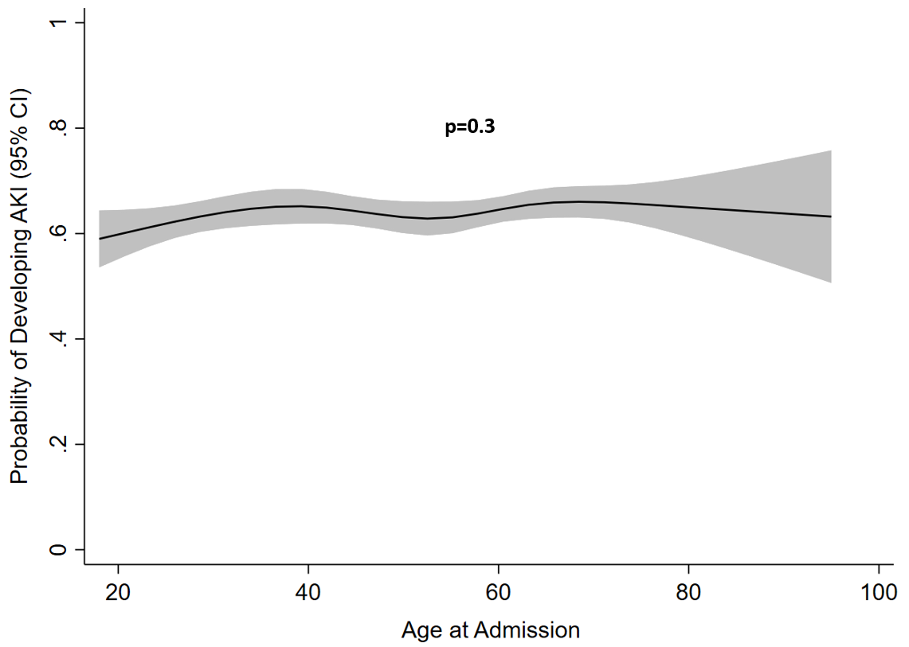

e-Fig 1b
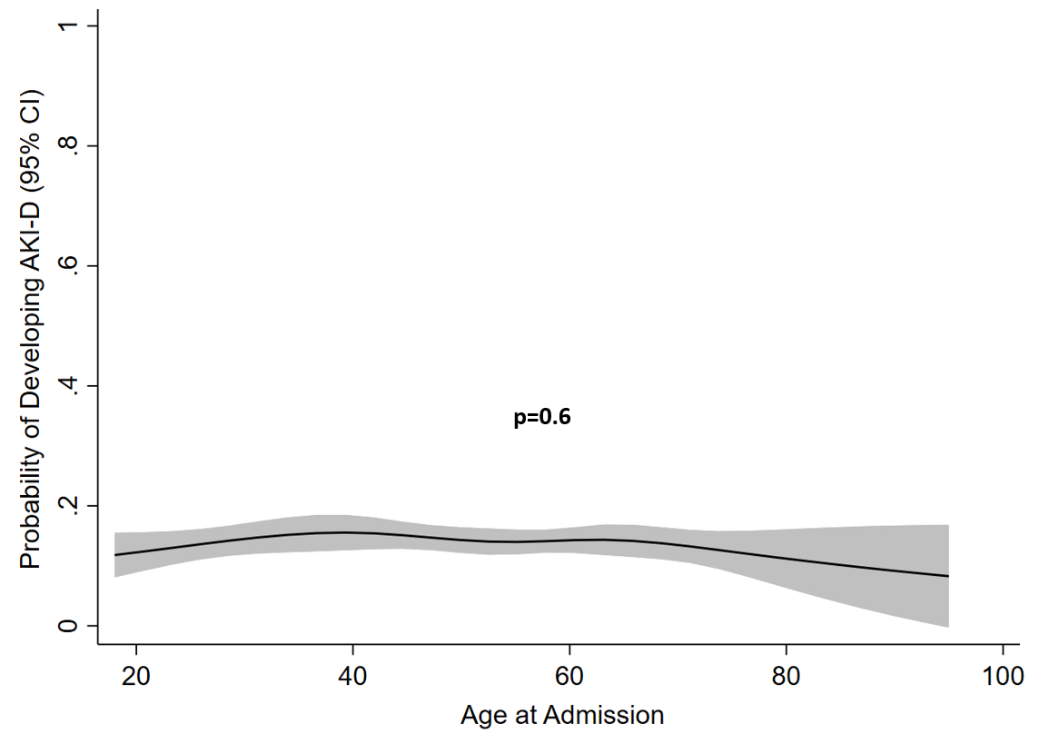

e-Fig 1c
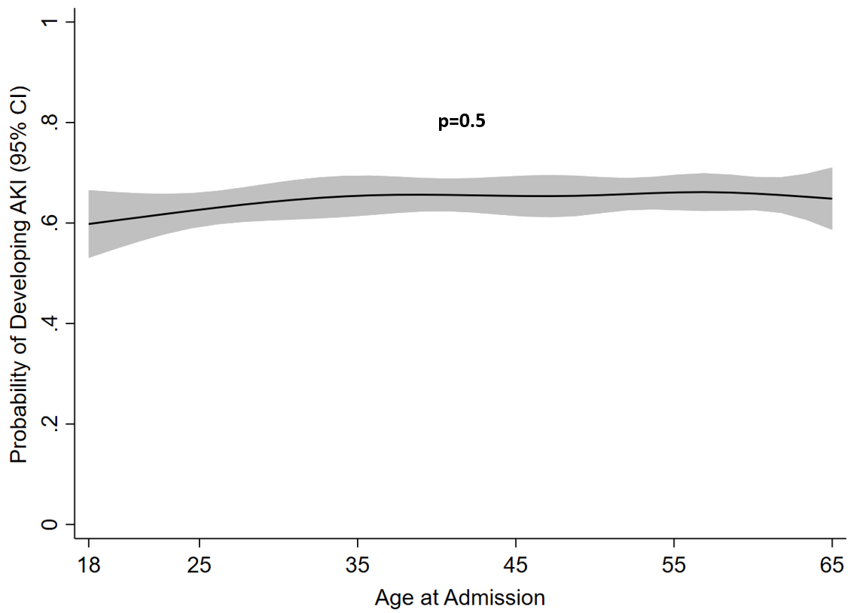

e-Fig 1d
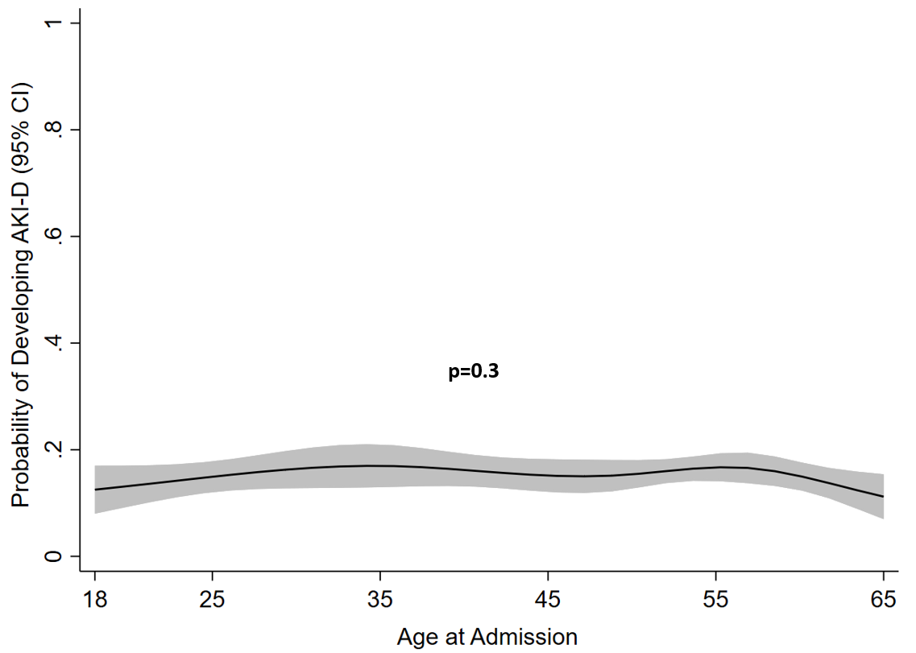

e-Fig 1e
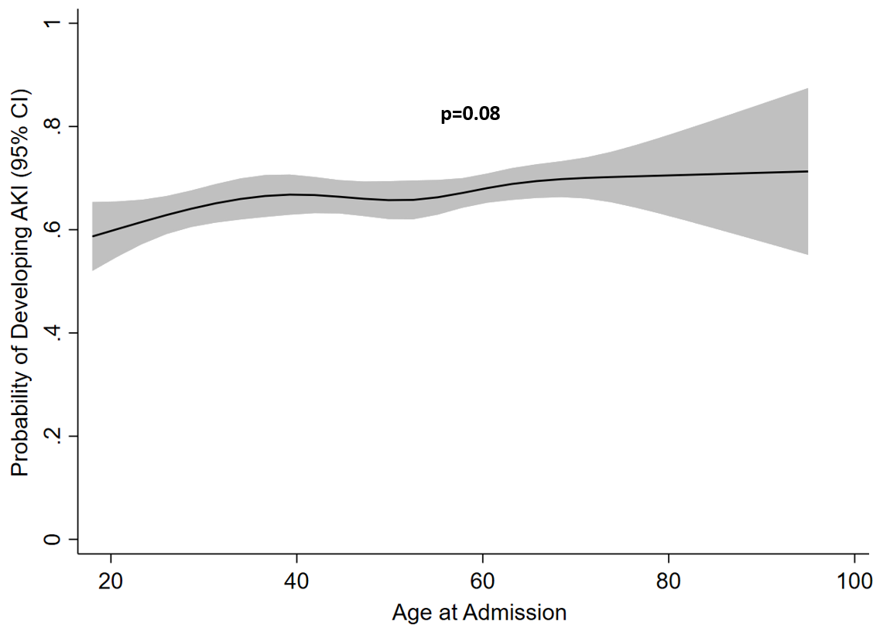

e-Fig 1f
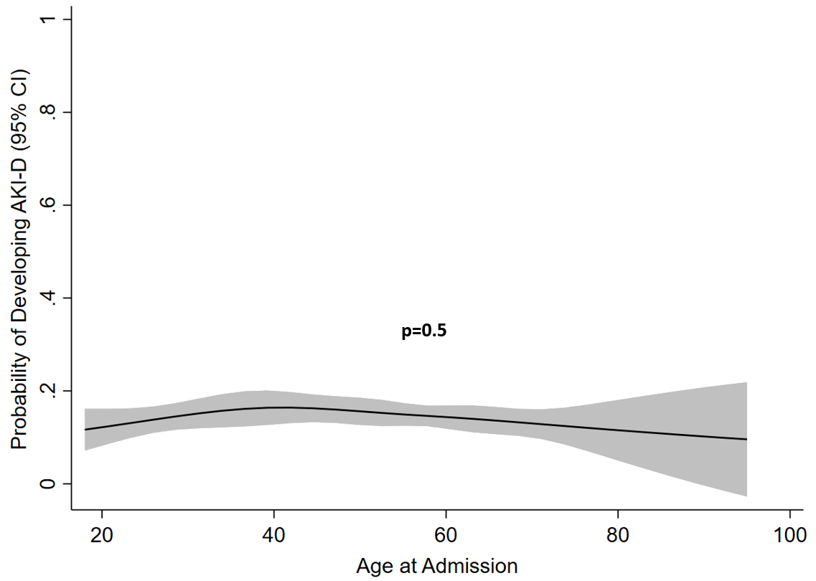

e-Fig 1g

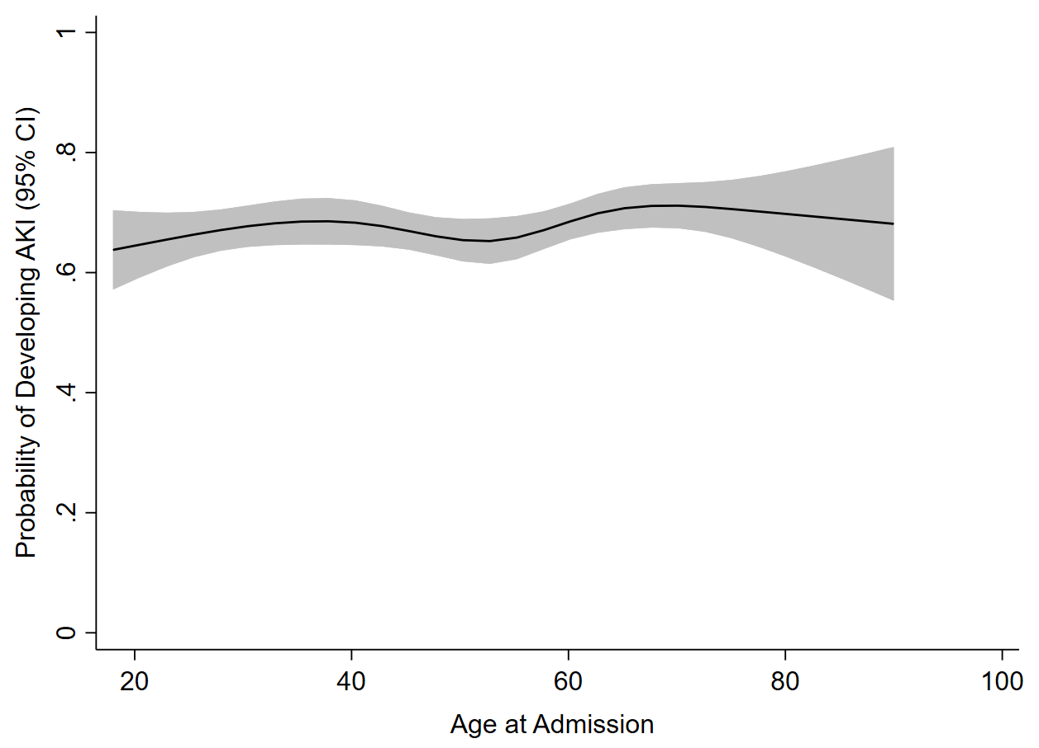

e-Fig 1h
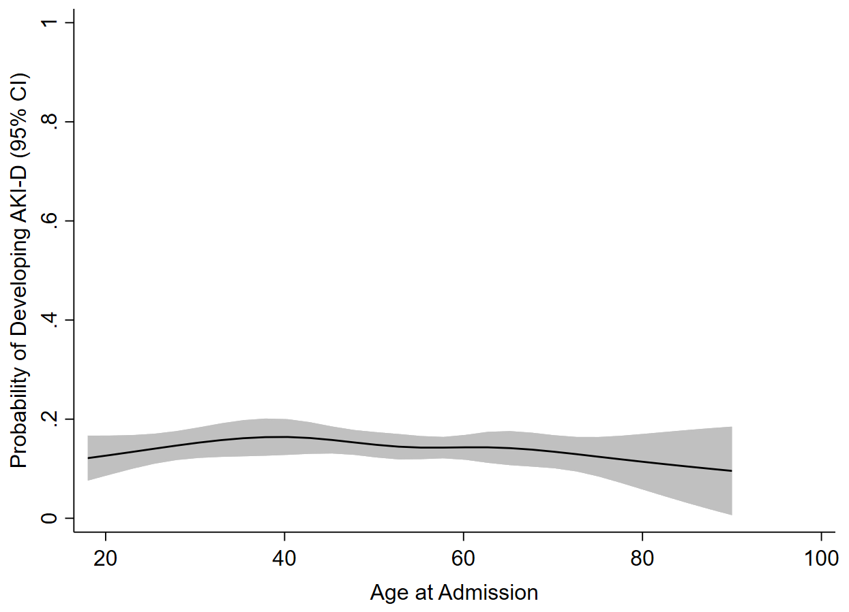

e-Fig 2
