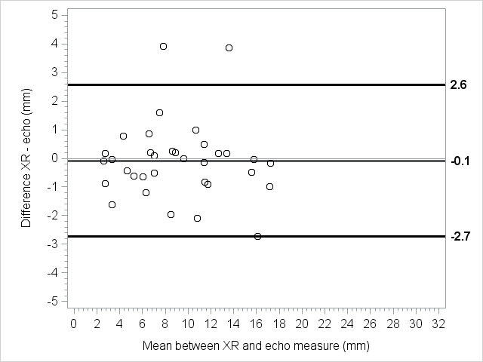
Online Supplementary eFigure 1 - Patients with BW < 1000 g: on the X axis, the mean [(US + X-ray)/2] distance between the carina and the tip of the ETT; on the Y axis, the corresponding difference between US and X-ray measurements of the tip’s distance from the carina (XR – US). The graph shows a good correlation between the two measurements, both when the tip is too deep and when it is too high. Evaluated mean difference – 0.1 with limits of agreement of 2.6 mm and -2.7 mm and differences ranging between 3.9 mm and -2.7 mm

