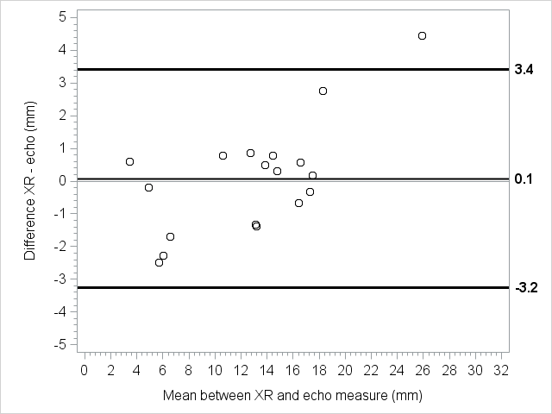 Online Supplementary eFigure 2 - Patients with BW 1000-2000 g: on the X axis, the mean [(US + X-ray)/2] distance between the carina and the tip of the ETT; on the Y axis, the corresponding difference between US and X-ray measurements of the tip’s distance from the carina (XR – US). The graph shows a good correlation between the two measurements, both when the tip is too deep and when it is too high. The mean difference between the two measurements was almost null (0.1 mm), and the limits of agreement were 3.4 mm and -3.2 mm. The difference ranged from -2.5 to 4.5 mm.

