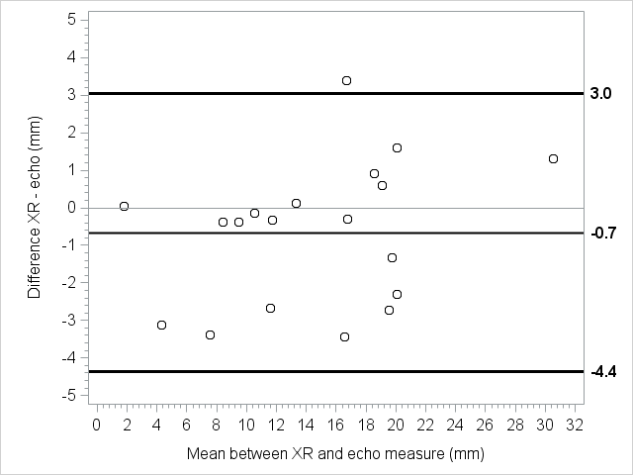 Online Supplementary eFigure 3 - Patients with BW >2000 g: on the X axis, the mean [(US + X-ray)/2] distance between the carina and the tip of the ETT; on the Y axis, the corresponding difference between US and X-ray measurements of the tip’s distance from the carina (XR – US). The graph shows a good correlation between the two measurements, both when the tip is too deep and when it is too high. The mean difference between the two measurements was minimal (-0.7 mm), and the limits of agreement were 3.0 mm and -4.4 mm. The difference ranged from -3.4 mm to 3.4 mm.

